Proposal

- Eliminate the current Annual Program Plan and 6-year Comprehensive Program Review
- Establish a Biennial Program Review (programs will be assigned to even or odd years)
- Resource Requests will occur annually, as needed
- Data packets for all programs will be available every year

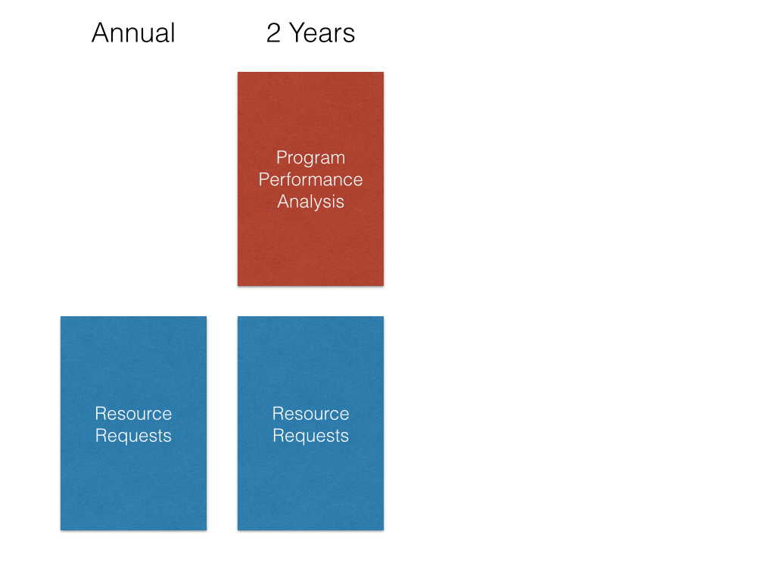

Program Review

Program Title ______________________________________

Lead Contact Person ______________________________________

Writing Team ______________________________________

Executive Summary
Please summarize your program’s strengths, opportunities/challenges, and action plans. This information will be presented to the Board of Trustees. (1000 word limit)
Program Context

- Mission: Please identify how your program aligns with the college’s mission by selecting the appropriate check box(es):
__ Career Technical, __ Basic Skills, __ Transfer, __ Lifelong Learning
If your program has a mission statement, include it here.

- Articulation: Describe how your program’s articulation may be impacted by changes in curriculum and degree requirements at high schools and 4-year institutions. Describe your efforts to accommodate these changes.
- Community and Labor Needs: Describe how changes in community needs, employment needs, technology, licensing, or accreditation affect your program. CTE programs should identify the dates of their advisory group meetings.

Looking Back

- Curricular Changes: List any significant changes that have occurred in your program’s curricular offerings, scheduling, or mode of delivery. Explain the rationale for these changes.
- Progress Report: Provide your responses to all recommendations received on your last program review and report on progress made on previous action plans and toward your 3-year strategic goals.
- Impact of resource allocations: Describe the impact to-date that each new resource (staff, non-instructional assignment, equipment, facilities, research, funding) has had on your program and measures of student success.

Current State of the Program

- Connection & Entry:
  - Observation: Describe trends in program and course enrollments, FTES, LOAD and Fill Rates. Cite quantitative data and specific tables from the data packets.
  - Evaluation: What changes could be implemented, including changes to course scheduling (times/days/duration/delivery mode/number of sections), marketing, and articulation that may improve these trends? [Strategic Enrollment Plan]
- Progress & Completion:
  - Observation: Describe trends in student success and retention disaggregated by: ethnicity, gender, age, enrollment status, day/evening. Cite quantitative data and specific tables from the data packets.
  - Observation: For online courses describe any significant differences in the success and retention of students who are taking online courses compared to face-to-face courses.
  - Evaluation: Based on these trends, what do you feel are significant factors or barriers influencing student success in your courses and program? What changes (e.g. in curriculum, pedagogy, scheduling, modality) could be implemented to improve these trends? [Student Equity Plan]
- SLO Assessment:
  - Are all course SLOs being systematically assessed at least once/4 years? Describe the coordination of SLO assessment across sections and over time.
  - Summarize the dialogue that has resulted from these assessments. What are some improvements in your courses that have been implemented through SLO assessment? How has student learning been improved by changes in teaching? Cite specific examples.
- PLO Assessment:
- Describe your program’s Program Learning Outcomes assessment plan.
- Summarize the major findings of your program’s PLO assessments. What are some improvements that have been, or can be, implemented as a result of PLO assessment?

Looking Ahead

- Strategic action plans:
  - How will you address the opportunities for improvement that you identified above in Articulation, Community & Labor Needs, Connection & Entry, Progress & Completion and PLO Assessment? Identify timelines for implementation, responsible party, resource requirements.
Action Plan | Timeline | Responsible party | Resources required

Resource Requests

- Personnel:
  - List the current and near-future new or replacement faculty/staff positions that you anticipate requesting. Identify the term or year in which you anticipate submitting the staffing request.
  - Identify any non-instructional assignments that are currently allocated to any of your program’s faculty. Describe the impact (positive and negative) that this reassigned time has on your program.
  - Links to position request application and non-instructional assignment application
- Instructional Equipment:
  - Provide a list of all equipment needed. In order to be funded, requests must include all the required purchasing information.
Item name | New/Repair/Replacement | Vendor | Catalog number | Unit Price | # Needed | Justification

  - Will additional space be needed to accommodate the requested equipment? Will the requested equipment require maintenance agreements and or support personnel? If so what are the projected costs?
- Information Technology:
  - Provide a list of all software and hardware needed. In order to be funded, requests must include all the required purchasing information.
Item name | New/Upgrade | Vendor | Catalog number | Unit Price | # Needed | Justification

  - Will additional space be needed to accommodate the requested equipment? Will the requested equipment require maintenance agreements and or support personnel? If so what are the projected costs?
- Facilities: Identify your program’s facilities needs (custodial services, maintenance, remodeling, or new construction) and provide a brief explanation/justification. Please identify if the needs address ADA, safety, or utility concerns.
- Professional Development:
- What professional development is needed to strengthen your program’s offerings?
- How can CIETL support groups of program faculty and/or faculty at large, through workshops and Flex days? Explain how these activities can contribute to program success and/or support the college’s planning initiatives?
- PRIE Research: Identify your program’s specific research needs. Explain how the research will contribute to program/student support and/or support institutional plan initiatives.
- Funding: Describe any projects that your program would like to pursue that are currently unfunded or not fully funded. Explain how such a project would support program needs and align with the college’s strategic plans.

