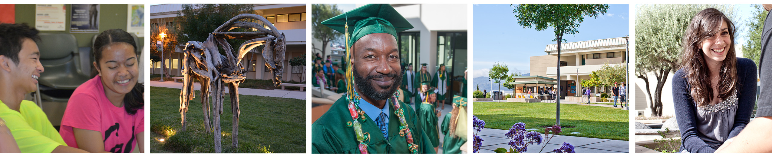

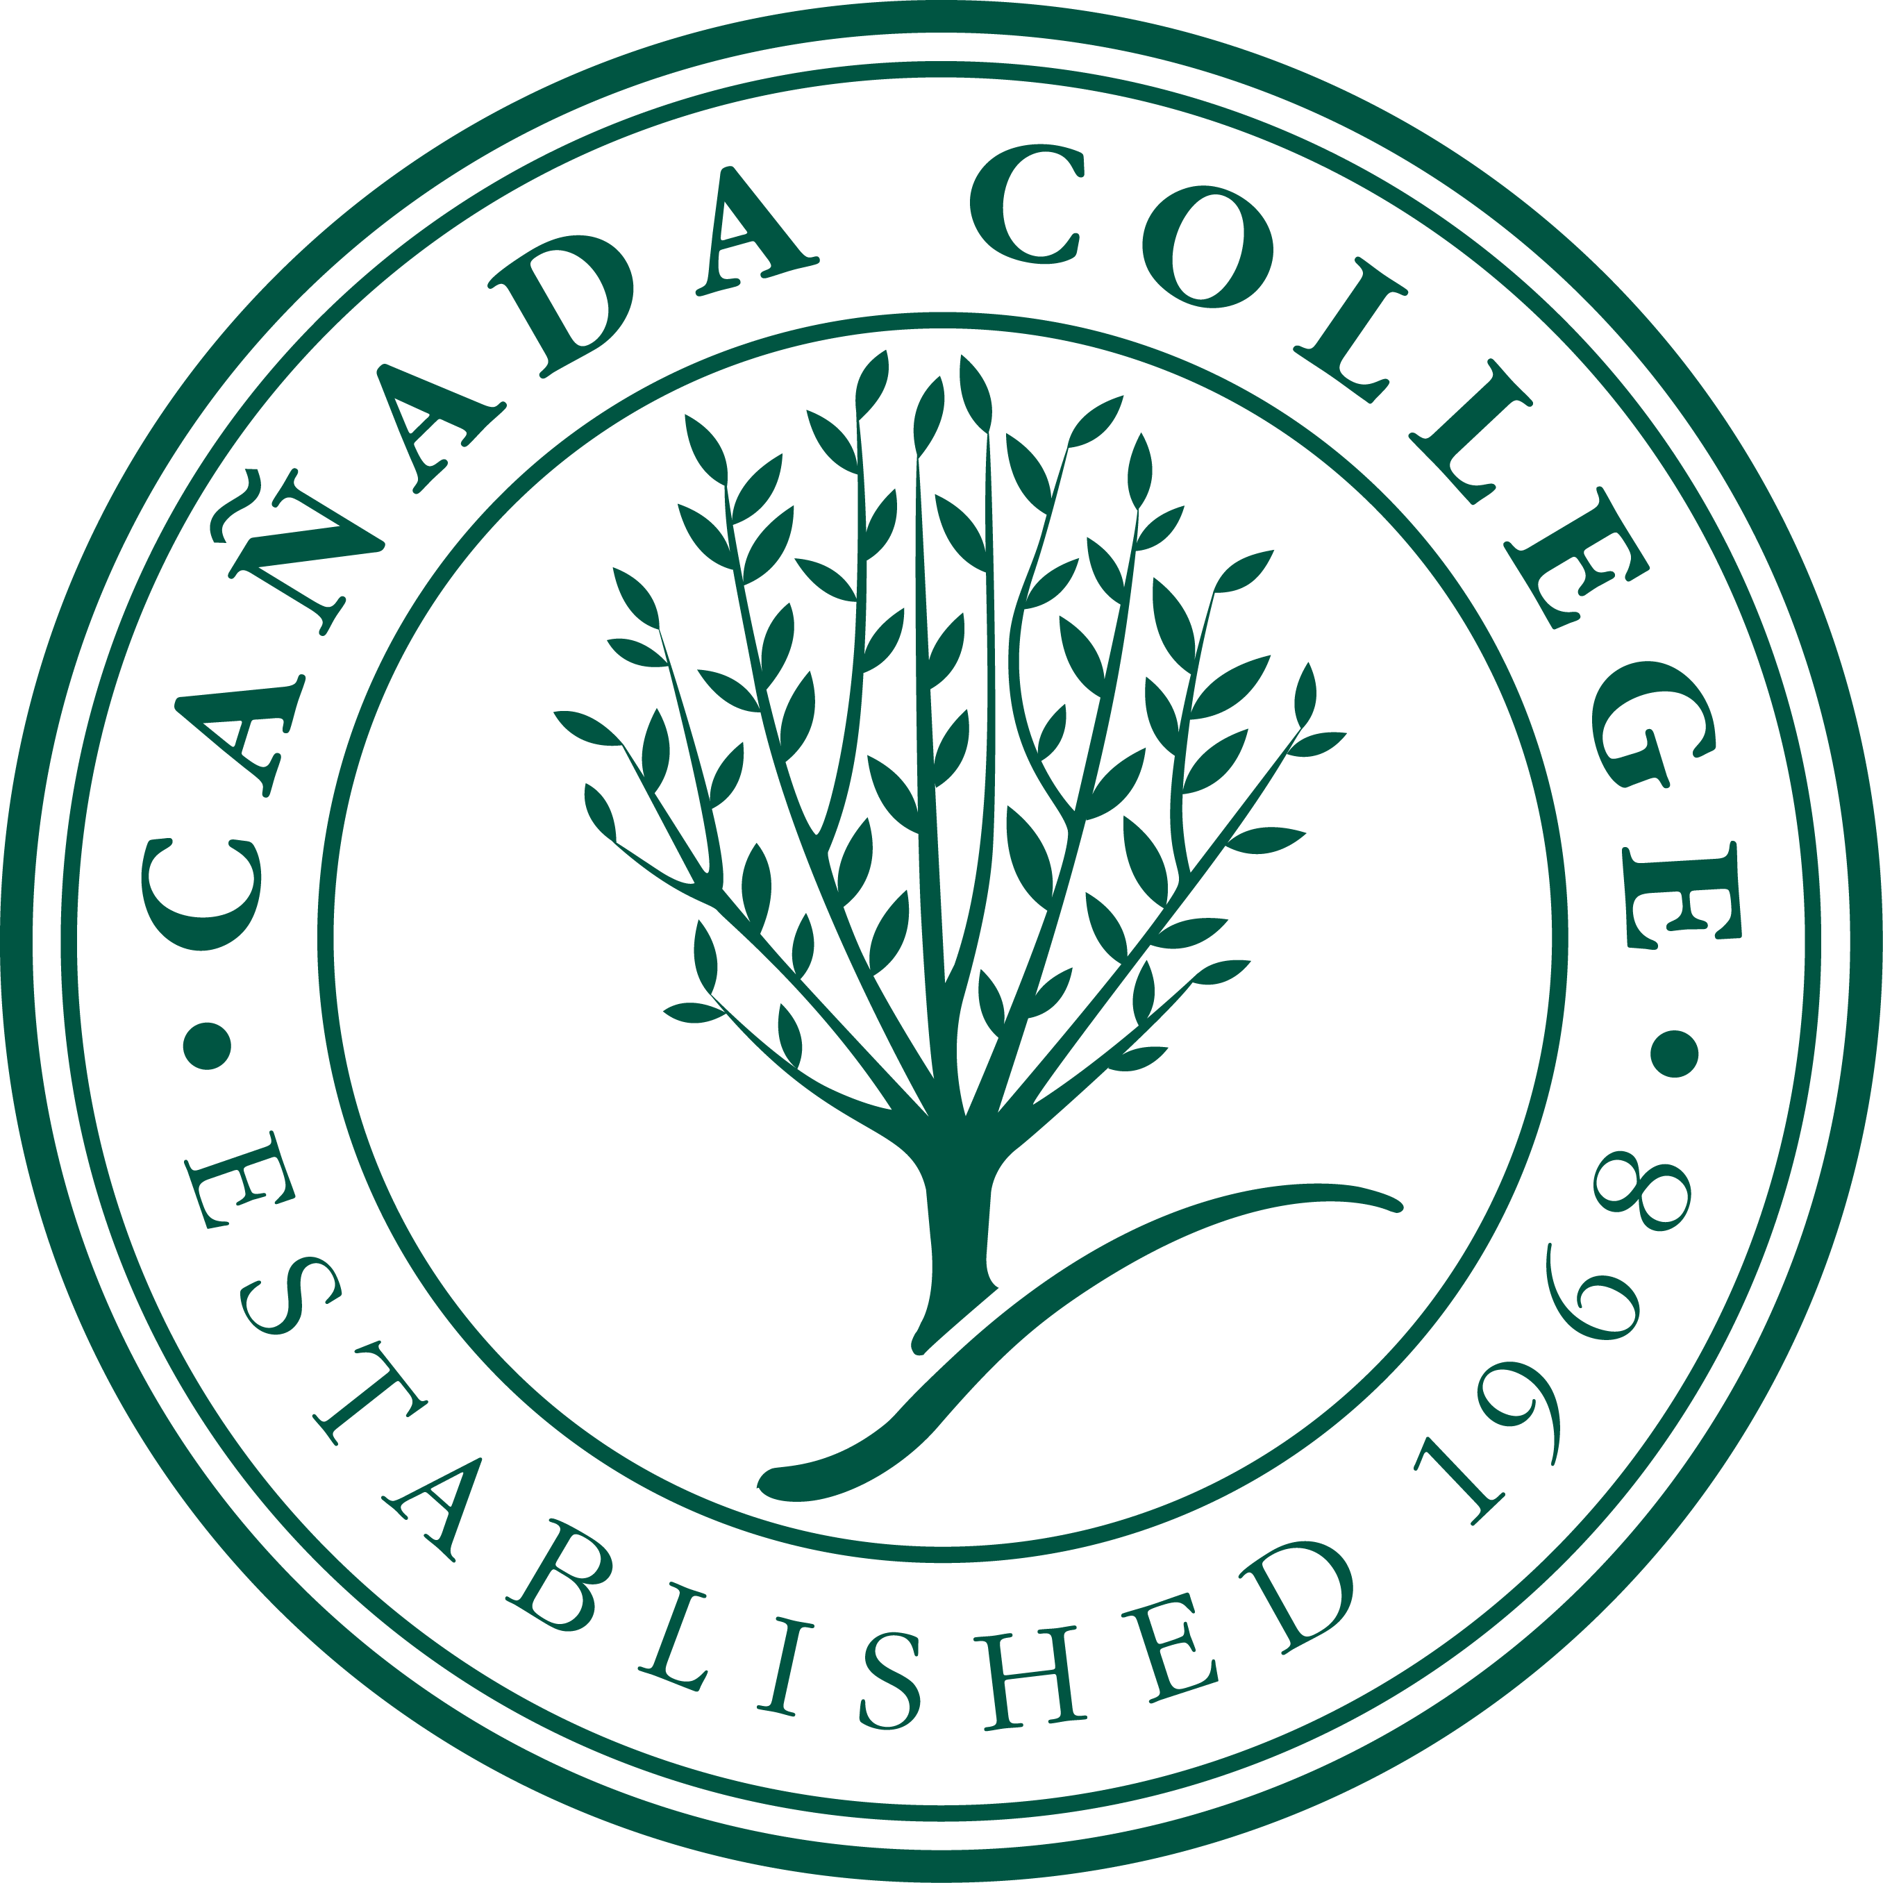
~
Canada College
Midterm Report 2016

Midterm Report 2016

To
Accrediting Commission for Community and junior Colleges
Western Association of Schools and Colleges

Submitted by
Cañada College
4200 Farm Hill Boulevard
Redwood City, CA 94061

650.306.3100
www.canadacollege.edu

September 2016

Midterm Report 2016 – Certification Page

Date: September 2016

This Midterm Report 2016 is submitted to the Accrediting Commission for Community and Junior Colleges/Western Association of School (ACCJC/WASC) for the purpose of fulfilling the Commission’s requirement to produce a Midterm Report in the third year after the College’s comprehensive evaluation.

We certify that there was broad participation by the campus community and believe that this report accurately reflects the nature and substance of Cañada College.
Signed:

_____________________________________________________________
Dave Mandelkern, President, Board of Trustees

______________________________________________________________
Ron Galatolo, Chancellor

____________________________________________________________
Jamillah Moore, Ed.D. College President

______________________________________________________________
Douglas Hirzel, President, Academic Senate

______________________________________________________________
Debbie Joy, President, Classified Senate

______________________________________________________________
Cindy Streitenberger, President, Associated Students of Cañada College

______________________________________________________________
Chialin Hsieh, Ed.D. Accreditation Liaison Officer/Dean of Planning, Research and Institutional Effectiveness
Table of Contents

Midterm Report 2016 – Certification Page 3
Report Preparation 6
Background 6
Preparation of the Midterm Report 2016 6
Acknowledgements 7
Response to 2013 Visiting Team Recommendations 9
College Recommendation #2 9
Actions Completed to Fully Address Recommendation 9
Follow-Up Report 2014 9
Continuous Improvement 9
Conclusion 10
Evidence 11
College Recommendation #1 12
Background 12
Actions Completed to Fully Address Recommendation 12
Documenting Human Resource Allocations 13
Documenting Space Allocation Decisions 13
Documenting Continual Improvement of Program Review 14
Documenting Discussions on Enrollment Management 14
Documenting Reassigned Time 15
Conclusion 15
Evidence 15
District Report Preparation 16
District Response to Commission Action Letter 17
District Recommendation #1 17
Conclusion 17
Evidence 17
District Recommendation #2 18
Conclusion 20
Evidence 20
District Recommendation #3 21
Conclusion 22
Evidence 22

Report Preparation

Background
Cañada College submitted its Self Evaluation Report in July 2013, which was followed by an evaluation team visit on October 22-24, 2013. On February 7, 2014, the Accrediting Commission for Community and Junior Colleges (the Commission) reaffirmed the College’s accreditation with the requirement of a Follow-Up Report due October 15, 2014, which would address resolution of recommendation relating to the following specific area:
College Recommendation 2
In order to meet the Standard, the College must review its system for identifying course outlines of record that are out of date to improve and implement a curriculum process that ensures all Course Outlines of Record are reviewed and curriculum currency is maintained. (II.A.2.e)
The College submitted its Follow-Up Report 2014 to the Commission on October 8, 2014, which was followed by an evaluation team visit on November 12, 2014. On February 6, 2015, the Commission found that the College had addressed 2013 Recommendation 2, resolved the deficiencies, and met Standard II.A.2.e.

Preparation of the Midterm Report 2016
In March 2015, the College began preparations for this Midterm Report which serve to update the Commission on the College’s progress on all recommendations noted in the ACCJC reaffirmation letter.
College Recommendation 2 (which was addressed via the Follow-Up Report and a visit in 2014 resulting in the reaffirmation from the Commission resolving the deficiencies and meeting Standard II.A.2.e.)
In order to meet the Standard, the College must review its system for identifying course outlines of record that are out of date to improve and implement a curriculum process that ensures all Course Outlines of Record are reviewed and curriculum currency is maintained. (II.A.2.e)
The following are additional recommendations for both the College and the District.
College Recommendation 1
In order to improve institutional effectiveness the College should provide evidence of the robust dialogue that exists at the College between planning councils and governance groups, particularly the exchanges that relate to planning and resource allocation outcomes and processes. (I.B.4)

District Recommendation 1
In order to increase effectiveness the District and Colleges should broadly communicate the modification of the evaluation process for faculty and others directly responsible for student progress, which includes student learning outcomes, and ensure that the process is fully implemented. (III.A.1.c)
District Recommendation 2
In order to improve institutional effectiveness, the Board of Trustees should develop goals for increasing its professional development and orientation of new Trustees. (IV.B.1.f)
District Recommendation 3
In order to improve institutional effectiveness, the District should establish a regular cycle for the evaluation of its services and provide documentation regarding the outcomes of the evaluations. (IV.B.3.b, IV.B.3.g)
In order to prepare this report, the College President led a College-wide conversation about the recommendations for improvement, established a timeline for the report’s completion, identified responsible parties for each recommendation, reviewed processes, provided adequate support, and finalized the details of the preparation plan in fall 2015. The ad hoc committee, Accreditation Oversight Committee (AOC) under The Planning and Budgeting Council (PBC), was established with members serving as liaisons to, and providing support for, specific committees assigned to address each recommendation. Further, the College President emphasized to the AOC members that the completion of the Midterm Report 2016 required broad participation from constituent groups, including participatory governance committees, faculty, staff, and students.
During the month of April 2016, the final draft of the Midterm Report 2016 was disseminated for feedback to members of the Academic Senate, the Classified Senate, the Student Senate, all the Planning Councils, and the President’s Cabinet. Planning and Budgeting Council approved the report at their meeting on May 4, 2016. The approved report was sent to the Chancellor’s Council for review and approval.
Lastly, the Midterm Report 2016 was submitted to the Board of Trustees who approved it on September, 28, 2016.
The final Midterm Report 2016 was submitted to the Commission by October 10, 2016.

Acknowledgements
We wish to thank all members of the College and the District who have generously contributed to the preparation of this report:

College Recommendation 1
Academic Senate President/Planning and Budgeting Council co-chair Professor Doug Hirzel, Classified Senate President/Planning and Budgeting Council co-chair Debbie Joy, Instructional Planning Council co-chairs Jessica Kaven, EdD and Gregory Anderson, EdD, Student Services Planning Council co-chairs Ruth Miller and Kim Lopez, Administrative Planning Council chair Chialin Hsieh, EdD, Vice President of Administrative Services, Michelle Marquez, Dean of Science and Technology Janet Stringer, MD, PhD, and all planning council members.

College Recommendation 2
Curriculum Committee Chair Dani Behonick, PhD, Academic Senate President/Planning and Budgeting Council co-chair Professor Doug Hirzel, Vice President of Instruction Gregory Anderson, EdD, Dean of Science and Technology Janet Stringer, MD, PhD, and all members of the Curriculum Committee.
District Recommendation 1
Vice Chancellor of Human Resources Eugene Whitlock, JD and District Educational Services and Planning Division
District Recommendation 2
Interim Director of Community/Government Relations Gohar Momjian
District Recommendation 3
Director of General Services Susan Harrison and District Educational Services and Planning Division

Response to 2013 Visiting Team Recommendations
Letter from ACCJC of Affirmation of Accreditation (February 7, 2014)

College Recommendation #2
In order to meet the Standard, the College must review its system for identifying course outlines of record that are out of date to improve and implement a curriculum process that ensures all Course Outlines of Record are reviewed and curriculum currency is maintained. (2.A.2.e)

Actions Completed to Fully Address Recommendation

Follow-Up Report 2014
The College submitted its Follow-Up Report 2014 to the Commission on October 8, 2014, which was followed by an evaluation team visit on November 12, 2014. On February 6, 2015, the Commission found that the College has addressed 2013 Recommendation 2, resolved the deficiencies, and met Standard II.A.2.e.
ACCJC letter regarding Follow-Up Report with visit on Recommendation Two (February 6, 2015)

Continuous Improvement
In October and early November 2013, faculty and administration worked in earnest to update out-of-date curriculum. Concurrently, the Curriculum Committee engaged in a series of discussions to create a new policy and procedure for updating curriculum. The draft of this policy, Resolution for ongoing review and update of prerequisites, corequisites, advisories and course outlines of record, was first reviewed by the Curriculum Committee on November 8, 2013. The Curriculum Committee provided revisions at this meeting and the revised draft was circulated to the faculty as part of the attachments for the November 14, 2013 Academic Senate meeting. The Senate made comments on the draft document and provided those to the Curriculum Committee. The final document was approved by the Curriculum Committee on November 22, 2013, endorsed by the Academic Senate on December 12, 2013, and was included in the Cañada College Curriculum Handbook for the 2014-2015 academic year on pages 40-41.
The 2014-2015 academic year was the first year of full implementation of this new curriculum policy. This policy was communicated to campus faculty directly (through electronic communication and presentations to faculty by the Curriculum Committee Chairperson at Instructional Division meetings) and was included in the Curriculum Handbook. Two hundred and forty four (244) courses were identified as needing review/update during the 2014-2015 academic year; of these, 22 courses (9.02%) were not updated. According to the policy in place, discipline faculty responsible for these courses could petition the Curriculum Committee for a 1-year extension of their curriculum update based on extenuating circumstances. Five disciplines, responsible for 11 of these 22 outdated courses, submitted extension requests; the Curriculum Committee granted 3 of these requests. The remaining 8 courses, along with the 11 outdated courses for which no extension was requested, were banked, removed from any applicable degrees/certificates and removed from the 2015-2016 college catalog and Fall 2015 Schedule of Classes by the Curriculum Committee.
Following the first year of its implementation, this policy was revised further and this revised draft was reviewed and approved by the Curriculum Committee on September 11, 2015. This revised policy is included in the Cañada College Curriculum Handbook for the 2015-2016 academic year on pages 47-48. In particular, the process to identify Course Outlines of Record (CORs) that are out of date was revised to reflect the timeline used during the 2014-2015 academic year.
Each June the Office of Instruction generates a list of all Career and Technical Education (CTE) courses that have reached their two-year review cycle and a separate list of all other courses that have reached their five-year review cycle. These lists are distributed to all faculty, the Curriculum Committee, division deans, and posted online no later than the first week of July. Faculty members have one academic year to update all courses (and programs where necessary/appropriate) that still remain active. For example, in July 2015, a list of courses was generated that needed to be updated for inclusion in the fall 2016-spring 2017 catalogue. These courses (and associated programs, where necessary/appropriate) were updated, reviewed and approved at one of the Curriculum Committee meetings during the 2015-2016 academic year, which in turn, remain active in the 16-17 college catalogue.
The revised policy eliminates the option for faculty to request a one-year extension to their curriculum updates based on extenuating circumstances. Beginning in the 2015-2016 academic year, all courses that are scheduled for update during an academic year that are not updated were banked (i.e., removed from the catalog) by the Curriculum Committee (and removed from degrees/certificates, the College catalog, and, as applicable, from the Schedule of Classes) at the end of that academic year. A series of materials was also created to assist Instructional Deans in guiding their faculty through this Curriculum Update process.

Conclusion
The College has met the directive of the Visiting Team’s recommendation outlined in the External Evaluation Report by making the following changes:
- Curriculum review (regular update of courses and programs) is no longer part of the Instructional Program Review process, but rather occurs as a separate process overseen by the Curriculum Committee.
- A policy was developed and implemented that both identifies CORs that are out of date and ensures timely review and currency of curriculum. This policy was communicated to faculty both directly (e.g. by presentation at Instructional Division meetings and email notification) and through inclusion in the Curriculum Handbook.
- Following the first year of implementation, this policy was revised to reflect an updated procedural timeline and to simplify the process.
As a result of the College’s effort to streamline its course review process with a new and revised policy (include Number and Title), the College will continue to ensure a timely implementation of this policy. We believe no additional action is necessary to further review our system or implement additional processes. The system is well-established and integrated into the curriculum process.
The College has met College Recommendation 2 in full.

Evidence
See evidence for College Recommendation 2.

College Recommendation #1
In order to improve institutional effectiveness the college should record the robust dialogue that exists at the College between planning councils and governance groups, particularly the exchanges that relate to planning and resource allocation outcomes and processes. (I.B.4)

Background
The College sincerely appreciated the commendation made by the Visiting Team about “imbuing a culture of inclusion by fostering a high level of participation in the decision making process leading to outstanding collegiality and collaboration among the faculty, staff, students, and administration.” The College community recognizes that it is our responsibility to communicate the outcomes of the various conversations resulting from this high level participation through minutes, campus-wide notifications via postings on our website, etc. As the Visiting Team noted on page 31 of the External Evaluation Report, “The College demonstrated robust dialogue to the Visiting Team; however providing a record of the dialogue and resource decisions could be better communicated.”
Of particular concern to the Visiting Team was the communication of information in our primary resource allocation activity – the new position proposal process. In this process, the dialogue among the four participatory governance groups was robust, and although we captured the comments, these were not posted or distributed campus-wide. In addition, when the President made the decision about which positions to fund, an all-campus email; however, this communication was not documented in the minutes of the Planning and Budgeting Council meetings nor posted to the website.
The College recognizes the need to improve our processes and make certain that campus-wide conversations are recorded, circulated among the campus communities, and documented on the website. We have taken action and implemented processes which are described below and have now fully addressed this recommendation.

Actions Completed to Fully Address Recommendation
Beginning in November 2013, the College established an enhanced standard for documenting and communicating planning and resource allocation processes, dialogue and decisions. The College now creates dedicated web pages to document the dialogue that occurs during the development of new or revised processes (e.g., space allocation, program review processes) as well as dedicated pages to document the discussions and decisions related to funding and new staffing positions. On these web pages, links are provided in chronological order to relevant documents including: process, timelines, discussion notes, meeting minutes, and college-wide communications. By collating documentation that exists in disparate locations we are able to show clearly the evidence of dialogue and communication that occurs among our participatory governance groups and the campus.
This section of the website provides evidence of college-wide budget and resources allocation discussions implemented to reinforce the actions implemented to address this recommendation.
Below are several examples that illustrate our new documentation and communication standards.

Documenting Human Resource Allocations
The College’s Participatory Governance Manual delineates the process for proposing and prioritizing the funding of faculty/staff/administrative positions. The process varies depending upon the funding source, type of position, and whether it is a new or replacement position. The College evaluates new general fund positions twice yearly. Each semester a dedicated web page is constructed that delineates the steps of the process. Links to relevant documentation, such as proposals, presentations, meeting minutes and emails are added to each step. Every effort is made to capture in the minutes the rich dialogue that occurs. The president announces and explains the rationale for the decision both at the Planning and Budgeting Council and through the President’s newsletter, the Olive Hill Press. By providing this compilation of documents in chronological order, all employees and the public at large are afforded the ability to easily follow the process and better understand the rationale that led to the outcomes.
For greater clarity, please view our 2015-16 New Position Process at: http://canadacollege.edu/planningbudgetingcouncil/staffing-1516.php
The college employs a different decision-making process and standard of documentation for decisions related to categorical- or grant-funded positions, temporary positions, and replacement of general fund vacancies. These decisions do not require college-wide participation. Rather, the discussion occurs in Cabinet, Academic Senate, and/or the classified staff collective bargaining unit. Documentation of the dialogue occurs within the meeting minutes of those entities. In all cases, the final decision is announced at the College’s Planning and Budgeting Council through its regular “Staffing Updates” agenda item.

Documenting Space Allocation Decisions
The College relies upon its Participatory Governance Manual (PGM) to codify the processes by which decisions are made and how employees can participate through their respective governance groups. The PGM is an online web-based living document that is continually revised in response to feedback and assessments made at the end of a decision process. When gaps are identified, new processes are created and added to the manual. One such example occurred in fall 2015 with a proposal to relocate our transfer and career centers into spaces currently occupied by an art gallery and meeting room. There was no existing process in the PGM for this type of space allocation. So the Planning and Budgeting Council (PBC) constructed a web page to document the steps this proposal would follow. These are found on this URL http://canadacollege.edu/planningbudgetingcouncil/career_transfer_relocation.php
As input from the participatory governance groups was being gathered, the PBC began crafting guiding principles for space allocation and a new process by which future space allocation decisions would comply. This development of the principles and process is documented here http://canadacollege.edu/pgm/space-substantive.php

Documenting Continual Improvement of Program Review
The Academic Senate established a goal to revise and improve the Program Review and resource request process, forms, and timeline. This process would involve dialogue with the four planning councils—Instructional Planning Council (IPC), Student Services Planning Council (SSPC), Administrative Planning Council (APC) and Planning and Budgeting Council (PBC). To ensure that the process was transparent, inclusive, and communicated, the Senate recorded detailed minutes of meetings and posted all relevant documentation online in chronological order at http://www.canadacollege.edu/academicsenate/programreview.php
The College continually strives to improve its program review process and document the dialogue on the website listed above. In order to evaluate the program review process and the assessment effort, PBC established the Assessment Advisory Group. Members include PBC, IPC, SSPC, APC chairs, Curriculum chair, and an instructional deans. The charges of this group are to (a) evaluate the strengths and weaknesses of the College’s program review and assessment effort and provide recommendations to PBC; (b) provide the Institutional Learning Outcome Report to PBC, (c) ensure that Cañada meets ACCJC standards with regards to Student Learning Outcomes and provide recommendations to PBC, (d) update/evaluate Assessment Manual and provide recommendations to PBC, (e) complete/update ACCJC Annual Report and provide recommendations to PBC. These recommendations were accepted by PBC in fall 2015 and implemented in spring 2016.

Documenting Discussions on Enrollment Management
Through careful enrollment management, the College successfully provides a schedule of course offerings that meet student needs balanced with institutional priorities and financial constraints. Extensive communication and education, especially of faculty, is key to ensuring that enrollment management and class cancelation decisions are seen as a collaborative and collegial process. Due to the extensive and protracted nature of discussions around this topic, the Academic Senate compiled and maintained records of meeting minutes, reports, and educational presentations at this URL http://www.canadacollege.edu/academicsenate/enrollment.php. This page records the robust dialogue that occurred among the faculty, Academic Senate Governing Council, instructional and student services deans, and the Office of Instruction about these important decisions.

Documenting Reassigned Time
The Academic Senate Governing Council (ASGC) identified as one of its 2013-14 goals, the need to create a transparent process for awarding reassigned time to faculty for completing non-instructional assignments. Some of these non-instructional assignments are stipulated by AFT contract or external accreditation requirement. The remaining awards are more discretionary in nature and include time for program coordination. Decisions about which programs and faculty receive non-instructional assignments are best made in a consistent, fair and transparent manner. During 2013-14 the faculty and administration of the College engaged in dialogue which is documented in chronological order on the following URL. http://www.canadacollege.edu/academicsenate/noninstructional.php

Conclusion
The College has enhanced its system of documenting dialogue, especially those related to planning and resource allocation, and is currently implementing this process.
The College has met College Recommendation 1 in full.

Evidence
See evidence for College Recommendation 1.

District Report Preparation
The San Mateo County Community College District works closely and collaboratively with all three Colleges to facilitate an excellent teaching and learning environment. The District began its activities to address the “District Recommendations” made in the 2014 Commission Action Letters as soon as the District staff became aware of the areas noted for improvement. Following is an update on the progress made to date on these recommendations.

The individuals assigned to address the recommendations included:

Recommendation | Contact office | Summary of Actions Taken
District Recommendation #1  Broadly communicate the faculty evaluation process | Human Resources | The evaluation process for faculty has been revised over the past two years and the new, approved document is included in the Appendices.
District Recommendation #2  Develop goals for professional development & orientation of new Trustees | Office of Communication | Developed goals for professional development and oriented new Trustee. Documented actions taken.
District Recommendation #3  Establish regular cycle of evaluation of services and document outcomes | Office of General Services | Enhanced/Revised regular cycle of evaluation, timeline, and procedures. Documented services outcomes and actions taken.

District Response to Commission Action Letter

District Recommendation #1
In order to increase effectiveness, the District and Colleges should broadly communicate the modification of the evaluation process for faculty and others directly responsible for student progress, which includes student learning outcomes, and ensure that the process is fully implemented. (III.A.1.c)
In the last report dated October 14, 2014, the District reported on how it fully responded to this recommendation by implementing a new evaluation process which incorporated, among other enhancements, student learning outcomes as an integral part of that evaluation process. District Staff and faculty representatives worked together to revise faculty evaluation procedures over a period of two years. Changes were communicated to faculty several times during the revision process, with the final new procedures being introduced to and approved by all faculty in August and September 2014.
The new procedures have been well-received and in the first year of implementation (2014-15), to date (November 2015), the new procedures have been used to evaluate 538 out of approximately 1200 (45%) full and part time faculty and staff across the three Colleges of the District. (Each faculty member is evaluated at least once every three years.) As we have begun using these procedures, District staff and faculty representatives have continued to work together to refine and improve the process based on input from those who use the new procedures most frequently: faculty and deans. For example, based on feedback, the District has now included an online component for students to provide feedback on classes as part of the evaluation process. This collaborative approach has increased everyone’s understanding and acceptance of the new procedures.

Conclusion
The District has met District Recommendation 1 in full.

Evidence
See evidence for District Recommendation 1.

District Recommendation #2
In order to improve institutional effectiveness, the Board of Trustees should develop goals for increasing its professional development and orientation of new Trustees. (IV.B.1.f)
Three members of the Board of Trustees have served SMCCCD in their elected capacity ranging from 12 years to 20 years; one Board member has served for two years and a newly elected Trustee took office this year.

Since the last update report, each Trustee has attended many conferences and workshops to enhance their knowledge and awareness of a wide variety of academic, fiscal, legislative and governance matters. The conferences and meetings attended by Trustees in 2015 are included in the Evidence section. The Student Trustee typically attends the bi-annual Statewide Student Senate General Assemblies (Fall and Spring) as well as the Student Leadership Conference hosted by the California Community College Student Affairs Association. Also, all newly elected Student Trustees attend a Student Trustee workshop sponsored by the Community College League of California. Often, Student Trustees attend the National Student Advocacy Conference hosted by the American Student Association of Community Colleges in Washington DC.

Board Policy 1.10, Duties and Responsibilities of the Board, specifically references Trustee professional development activities. It lists, as one of the responsibilities of the Board: “To engage in ongoing development as a Board and to attend trustee education programs that includes a new trustee orientation. The Board will conduct study sessions, provide access to reading materials and support conference attendance and other activities that foster trustee education.” 1.01 (2) (h)

In March 2016, the Board amended Board Policy 1.10 by adding item 2.i. which specifically states, "To provide a comprehensive new trustee orientation program for newly elected or appointed trustees that may include attendance at a statewide “New Trustee” orientation program; one on-one interviews with the Chancellor, Presidents and Executive Vice Chancellor; discussions with representatives of employee groups, the Academic and Classified Senates and student leaders; delivery of the Trustee Handbook prepared by the Community College League of California (CCLC); and review of the CCLC’s comprehensive online education program titled “Elected/ Appointed Trustees: Next Steps.”

For the 2014-15 year, the Board incorporated in its Board Goals a commitment to increase its participation in professional development activities and ensure newly elected Trustees receive orientation training. The District also developed a program for New Trustee Orientation that was used when a new Trustee joined the Board in late 2013 and will be used for the Trustee elected in Nov 2015.

The Board conducts an annual self-evaluation process in a public Board meeting in which they review the Board’s performance on a number of items, including Board Operations, Chancellor/Trustee Relations, Faculty/Student/Classified Relations, and Community and Governmental Relationships. The most recent evaluation was conducted in late October, 2015.

Board members regular attend both College and community events regarding educational matters and report the highlights of these meetings at each Board meeting under the “Board Comments” section of the agenda. Board member s also attend CCLC and CCCT Trustee conferences and occasionally participate in national trustee conferences.

On each regular Board meeting agenda (except during summer months), there is a topic titled “Board Series Presentation—Innovations in Teaching, Learning and Support Services.” These presentations--offered by faculty, staff and students--highlight new or innovative aspects of programs and services provided by the Colleges and serve as a means to keep the Board well informed about activities at the Colleges. Recent presentations have covered Project Change, an innovative program at CSM that brings college classes to juvenile detention facilities; The Educator Preparation Institute at Skyline College; ¡ESO! (Expanding Student Opportunities) Grant and Cañada College’s Role as a Hispanic Serving Institution; BΘO: Skyline College Phi Theta Kappa Honors Society; CSM Cares – A Program Designed To Address the Mental Health Needs of Students; Skyline College – Entering the CIPHER: Fresh Techniques, Hip Hop Elements, and Edutainment in the Classroom; Collaboration Across Boundaries for Equity and Success: Cañada College’s Student Success and Equity Projects; and the Small Business Development Center at College of San Mateo. Also at each Board meeting, there is an “Executive Report” in which the Chancellor, Presidents and Academic Senate President update the Board on recent happenings at the Colleges.

New Trustee Orientation
The new Trustee elected in November 2015 was asked to complete the following tasks:
- Meet with the President to discuss the current issues the District Board is facing. (completed, spring 2016)
- Meet the Chancellor and Executive Staff to receive an overview of District operations, budget and governance. (completed, spring 2016)
- Meet with each of the three College Presidents to gain an understanding about the College programs, strengths and weaknesses (in progress)
- Meet with the District Academic Senate President
- Attend the CCLC “New Trustee Orientation” program that is offered annually. (completed, spring 2016)
- Review Chapter 1 of District Policy and Procedures to gain an understanding about the duties and responsibilities of the Board, organizational structure of the Board, expectations for Board decorum and Board meeting protocols. (completed, spring 2016)

Conclusion
The District has met District Recommendation 2 in full.

Evidence
See evidence for District Recommendation 2.

District Recommendation #3
In order to improve institutional effectiveness, the District should establish a regular cycle for the evaluation of its services and provide documentation regarding the outcomes of the evaluations. (IV.B.3.b, IV.B.3.g)

Regular Cycle: Although the District Office regularly and continuously evaluates the services to the Colleges and documents its findings to improve such services, the schedule for these evaluations had not been presented in written form. After discussing the schedule and activities among the various District Departments, a program review calendar was established in October, 2014. The calendar was reviewed and revised again by administration and the districtwide accreditation team during the 2015 program review cycle. The review cycle was adjusted slightly to align with the District’s accreditation cycle. Additionally, several district programs, including District International Education, Education Services and Planning, Public Safety, Emergency Preparedness, Community Education, Auxiliary and Enterprise Services, and the Chancellor’s office were added to the Calendar. The new Calendar is as follows:
Unit | Review Date | Responsible Individual
IT | March 2016 | Vaskelis
Public Safety | March 2016 | Nunez
Emergency Preparedness | March 2016 | Nunez
Education Services and Planning | March 2016 | Moore
Accreditation Mid-term Report 2016
HR | March 2017 | Whitlock
Auxiliary and Enterprise Services | March 2017 | Bauer
Community Education | March 2017 | Bauer
Chancellor’s Office | March 2017 | Galatolo
District International Education | March 2018 | Luan
Administrative Services (Accounting, Payroll, Purchasing) | March 2018 | Blackwood
Facilities Planning, Maintenance and Operations | March 2018 | Nunez
IT | March 2019 | Vaskelis
Public Safety | March 2019 | Nunez
Emergency Preparedness | March 2019 | Nunez
Education Services and Planning | March 2019 | Messina
Accreditation Self Study 2020
District Programs: The program review cycle is ongoing and is aligned with the District’s accreditation cycle. District Office Program Review process is scheduled in March of each year. The following units are reviewed on a rotating basis once every three years: Administrative Services (including Accounting, Payroll, Purchasing) Facilities, Public Safety, Emergency Preparedness, Information Technology, Human Resources, International Education, Community Education, Education Services and Planning, Auxiliary and Enterprise services and the Chancellor’s Office.
The program review is typically conducted via a survey administered to all District Employees. The units most recently added to the process may choose another audience to survey or use another methodology to assess their units. Part of the process for these newly added units will be to develop the tool(s) most appropriate for their unit. The survey tool supported by IT is NoviSurvey. Prior surveys, survey results and executive summaries of the program review are located on the DO Program Review site.
Program Review Process/Timeline:
January-February: Review/Revise Prior survey questions
February: Revise/develop/test survey in NoviSurvey (contact IT for an administrative logon, access to prior surveys and/or technical support.)
March: Deliver survey tool to all district employees via email.
April - June: Review/summarize results and post reports, including narrative pertinent to accreditation, to Program Review Sharepoint site.

Documentation of the Outcomes: Each department will prepare a Program Review which encompasses the following elements:

Program Review Template:
- Executive Summary
- Unit description
- Describe major accomplishments since last review
- Current state of the Unit
  - Describe the current state of the unit (May include strengths and challenges).
  - What changes could be implemented to improve your unit?
- Action plan. Describe how opportunities for improvement will be addressed
- Needs: Equipment, Professional Development, Facilities, Staffing, Research (when appropriate)

The 2016 program review cycle was completed in July 2016. Information Technology, Public Safety, Emergency Preparedness and Educational Services and Planning were evaluated. Executive summaries of the review process are located at the DO Program Review site.

Conclusion
The District has met District Recommendation 3 in full.

Evidence
See evidence for District Recommendation 3.

