**Question 1:**

**How would the Board of Trustees know if any of the records disposed of, after the Board meeting of July 25, 2018, where it was recommended to the Board, to approve the destruction of the obsolete records, may have been relative to the current DA investigation?**

**See below.**

AGENDA SAN MATEO COUNTY COMMUNITY COLLEGE DISTRICT REGULAR MEETING OF THE BOARD OF TRUSTEES **July 25, 2018** Closed Session at 5:00 p.m.; Open Meeting at 6:00 p.m. District Office Board Room, 3401 CSM Drive, San Mateo, CA 94402

18-7-7CA Disposition of District Records

<https://collegeofsanmateo.edu/2019accreditation/docs/iser/Standard3B/IIIB1-22_BOTpacket7-25-18.pdf>

BOARD REPORT NO. 18-7-7CA TO: Members of the Board of Trustees FROM: Ron Galatolo, Chancellor PREPARED BY: Susan Harrison, Director of General Services, 358-6879 Bob Domenici, Purchasing Supervisor, 358-6728 DISPOSITION OF DISTRICT RECORDS District Rules and Regulations, Section 8.27 (Records Management), provides for disposition of District records, including classification, retention and destruction in accordance with the California Education Code. After its review of District records, District staff requests the Board’s approval for the destruction of the records in Exhibit A. All of the listed records have outlived their usefulness and were kept for the period mandated by the Education Code. For the Board’s information, the record types are summarized as follows: • Class 1: Permanent Records • Class 2: Optional Records – Optional records not required to be maintained permanently, but deemed worthy of further preservation. These records shall be retained as Class 2 records until reclassified as Class 3 • Class 3: Disposable Records RECOMMENDATION It is recommended that the Board approve destruction of the obsolete records as listed in Exhibit A.

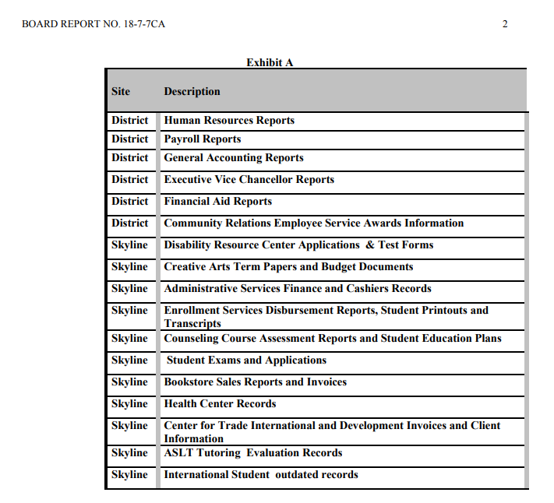

**Question 2:**

**Has there been a traffic study to assist with all the “new” members coming to the new Building 1 as well as to the proposed CSU?  As a Redwood City resident, I am very frustrated with the traffic as it is! I voted for this bond measure believing it was going to benefit “Cañada Students”, what percentage will remain academic and what percentage will for public use?**

**Question 3:**

**What do I need to do to get a 100,000 dollar pay raise over 5 years? Below is an example one of the Vice Chancellor pay from Transparent California for the past 6 years:**

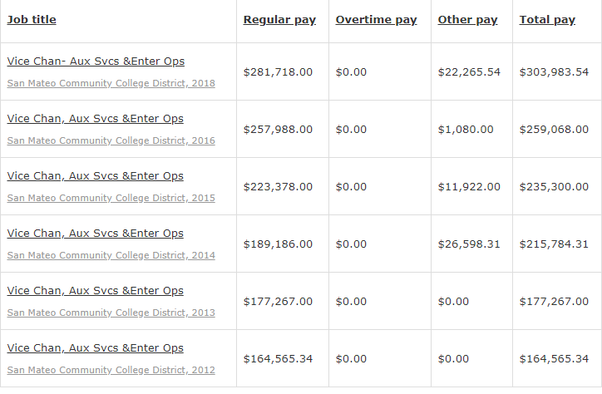

**Question 4:**

**The commitment from the Board was to implement the Promise Scholars Program at each of our colleges, a replication of the CUNY ASAP model. In the Spring of 2019 the Director of Promise Scholars Program was posted for Cañada, and then pulled. It was replaced with what is now posted as a Director of High School Transition and Dual Enrollment**.

**How does this job’s duties and responsibilities, with no mention of the Promise Program, impact all of the work that has been done over the past two years developing and implementing the Promise Program?**

**Question 5:**

KAD BUILDING 1 – QUESTIONS

Why is the KAD building space priority the space for Team EXOS “enterprise” operations instead of the Measure H Academic Building space for college classes?

What was EXOS’ role in designing the KAD Building, and why weren’t Cañada KAD academic professionals consulted or their concerns addressed other than documenting the concerns? If EXOS designed the building who approved Team EXOS requirements? Was there a cost involved for EXOS design services?

Did Team EXOS participate in the design of Cañada College KAD Building with Jose Nunez and Tom Bauer when the Cañada College KAD, academic experts were not consulted about classroom requirements in the huge workout area of the KAD Building?

What discussions have Tom Bauer, Jose Nunez, and Ron Galatolo had with Team EXOS concerning the construction of the Cañada College KAD Building; and have they been communicated to the Measure H Oversight Committee?

Have any financial commitments been made with Team EXOS in connection with the design of the Cañada College KAD Building? Where is a copy of the contractual agreement between Team EXOS and the San Mateo County Community College District?

What did Team EXOS under another business entity name that was acquired by them or its managers contribute to the Measure H ballot initiative?

How much is the District paying EXOS to “manage” the CSM SMAC facility?

Has a cost/benefit analysis and union impact analysis been done by the District, considering conflict/competitive issues in education services, janitorial services, clerical services, and facility usage conflicts for students taking classes and for non-profit community availability of the building?

Why is the District providing “free space” for the benefit of Team EXOS?

Are Independent Contractor laws being followed regarding Team EXOS employees who are duplicating jobs that are done simultaneously by faculty, janitorial staff, and classified staff?

How much does the District pay Team EXOS to manage the CSM San Mateo Athletic Club? (Tom Bauer was unable to give the Cañada College Planning and Budget Committee on October 16, 2019).

What are the projected costs of paying Team EXOS to manage the proposed new Cañada College SMAC facility?

Why have only 2 meetings of the Measure H Bond Oversight Committee been set this year – September 30, 2019 and December 5, 2019?

Why is all communication with the Measure H Bond Oversight Committee through Mitch Bailey? With no contact information available for the committee members how do community members can contact the Measure H Bond Oversight Committee since so few meetings have been scheduled.

Why is there no mention of any agreements between San Mateo County Community College District and Team EXOS in the reports to the Measure H Bond Oversight Committee?

Does the Measure H Bond Oversight Committee have all the information about the plan for 9,000 membership use of the Cañada College KAD Building? Has this plan been communicated to the Redwood City/Woodside community/voters?

Why have millions been spent for the roof design recreational area that could have been used for educational activities?

Why can’t students enrolled in Fitness Classes access the gym any hours it is opened?

Why are we providing fewer bleacher seats than in the old building?

Why don’t we have additional KAD storage space in the new building?

How can the public, community and college faculty, staff, and students access any agreements between the San Mateo County Community College District and Team EXOS?

What documents were destroyed in the Board Approval at the July 25, 2018 Board of Directors Meeting?

Since the Measure H Bond passed, how much money has been paid to Team EXOS?

Can a Management Firm provide the same educational classes without accreditation alongside the accredited courses offered by Cañada College, a public educational institution?

Are Team EXOS classes in direct competition with the classes that can be offered by Cañada College?

Why is a for-profit facility necessary when the college is now funded by property taxes, which rose 7.1% to $238.8 Billion.

Source:

<http://www.samceda.org/san-mateo-county-business-news/news/press-release-san-mateo-county%E2%80%99s-2019-20-property-assessment>

SAN MATEO COUNTY’S 2019-20 PROPERTY ASSESSMENT ROLL REACHES RECORD HIGH AFTER NINTH CONSECUTIVE YEAR OF GROWTH: ROLL VALUE INCREASES BY 7.1% TO $238.4 BILLION

**When can the SMCCD Board of Trustees address the Cañada College Faculty Resolutions?**

**SAN MATEO COUNTY’S 2019-20 PROPERTY ASSESSMENT ROLL REACHES RECORD HIGH AFTER NINTH CONSECUTIVE YEAR OF GROWTH: ROLL VALUE INCREASES BY 7.1% TO $238.4 BILLION**

Source: <http://www.samceda.org/san-mateo-county-business-news/news/press-release-san-mateo-county%E2%80%99s-2019-20-property-assessment>

BOARD MEETING DECEMBER 18, 2018 - DISCUSSION ABOUT THE BUILDING

**AUTHORIZATION TO AUGMENT THE DESIGN-BUILD CONTRACT FOR CAÑADA COLLEGE BUILDING 1N, NEW KINESIOLOGY AND WELLNESS/AQUATICS CENTER (18-12-105B**) It was moved by Trustee Nuris and seconded by Vice President Schwarz to approve the contract augmentation as presented. Trustee Holober asked if the project is covered by the District’s Project Labor Agreement. Mr. StrugarFritsch said it is. Trustee Holober said he recalls that at some point he voted against an earlier proposal with a cost of approximately $88 million because he believes in the need to be forthright with the voters of San Mateo County and this project, which absorbs a huge amount of the bond funds that voters approved, was not on the list of voter approved projects. He said that while he realizes that the District is perfectly within its rights to use generic language to the effect of “and other projects as we may choose,” he does not feel comfortable with not itemizing a large project that he believes was known about from the beginning. Trustee Holober said he is now in a dilemma because the work is going to be done and he wants it to be done right. He said the initial decision is in the past and he is pleased that the work will be done under the PLA. He said he will continue to urge his colleagues to staff the facilities that are for the public to the maximum degree with District employees rather than contracting out to a management company which may in turn contract out to a janitorial company. He said he will continue to press for looking very closely at what the Board can do to augment the number of jobs at the athletic club for District employees. Trustee Mandelkern said the interior uses of the building seem to have changed somewhat based on this proposal. He said he sees in the proposal information about an aquatic center, studios for dance and yoga, cycling, gymnasium, track, weight training and Enterprise locker rooms and facilities. He said he does not see much mention of lecture classrooms or faculty and staff offices. He asked what percentage of the building will be for classroom instructional use and faculty and staff office use. José Nuñez, Vice Chancellor of Facilities Planning, Maintenance and Operations, said the entire building is an academic building and part of the utilization will be the Enterprise function. He said there will be one 8 general lecture classroom and six or seven studios where all Kinesiology trainings will take place. Chancellor Galatolo said the basketball and volleyball courts are NCAA courts for use by existing teams. He said the building will be tripurpose, similar to the San Mateo Athletic Club: (1) students who take courses as part of their degree or for personal interest will have better facilities to use, (2) student athletes will have better facilities, with one room designated exclusively for them, and (3) with memberships, the District has taken what was a very expensive cost center and turned it into a revenue center, with profits put back into supporting domestic students and expanding courses, not only in physical education, but in the rest of the college as well. Chancellor Galatolo said he believes this project does a considerable amount to advance the interest of students. After this discussion, the motion carried, all members voting Aye.