Educational Master Planning Task Force
February 2, 2022
MEETING MINUTES
Task Force Members Present: David Eck, Roslind Young, Jeanne Stalker, Jenna French, Alicia Aguirre, Mary Ho, Wissem Bennani, Allison Hughes, Hyla Lacefield, Mira Rubio
PRIE: Karen Engel, Alex Claxton, Milena Angelova, Isaac Chukwudebe
Task Force Members Absent: Brittney Samora-Delgadillo, Leonor Cabrera, Krystal Martinez, Nimsi Garcia, Eddy Harris,

Task Force Members were welcomed by the Tri-Chairs of the Task Force (Eck, Young, Engel).
Tri Chairs presented the minutes of the previous meeting and members confirmed its accuracy (consensus).

David informed meeting participants of an agenda that included planning for the Community Forum on February 11, a PRIE presentation of more external scan data, and a final review of MVV feedback. He shared the polling results of challenging issues ranked according to priority.

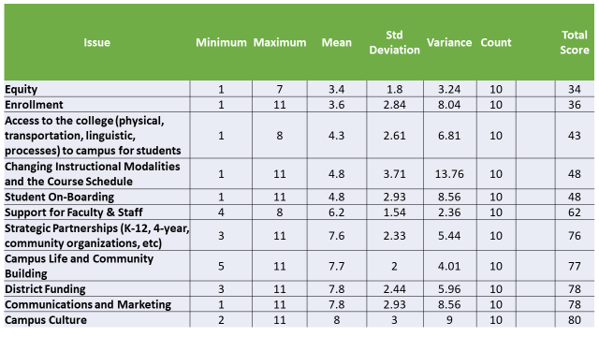

The Tri chairs described one of the goals of the Community Forum as a means of getting the college on the same page in terms of the most pressing problems facing the College. To the extent possible, the Task Force was asked to identify the five topics that would most benefit from community discussion and clarification.

Hyla stated that the college's problems were well known, so a focus on identifying solutions at the forum was ideal. Jeanne agreed with a focus on solutions and emphasized that many students still find the matriculation process confusing, despite the new Salesforce platform. Alicia noted the risk to the success of the EMP plan posed by a complex registration process. To address the issues with registration, Alicia proposed ideas such as greater staffing of the welcome center and proactive personnel.

The group determined that “access” was the overarching strategic issue.

David suggested that the Community Forum attendees be presented with draft statements related to each challenge/strategic issue to avoid having to start from scratch.

Dean Engel suggested a presentation of the challenges to the forum followed by break out groups focused on solutions. Roz noted the interconnected nature of the issues. Milena expressed the view that all issues are important, and that the forum's participants be allowed into breakout rooms to freely discuss subjects of interest. Finally, a planning team of Milena, David, Roz, and Dean Engel volunteered to conclude preparations for the town hall.

The PRIE team delivered a presentation of external scan data, including maps of student enrollment by service area, overlaid by US census data related to population, income and educational attainment levels. This analysis revealed that the College is not recruiting students proportionately from those communities in the College’s service area that might most needs us (those with lower income and lower levels of educational attainment). The maps revealed also that students live all over the region. However, proportionately more students in CAN’s service area enroll at CSM than vice versa.

Jeanne warned of the tendency of some feeder schools to encourage students to bypass Cañada. To address this, Dean Engel mentioned the College’s existing efforts to work more closely with high schools on dual enrollment. Hyla proposed that the College implement policies taking into consideration the demographics of the service area, especially the existence of persons who already have degrees. Milena suggested an analysis to understand what programs attract students from other colleges. Mary called for a review of data on enrollment by race to help advance the college's goal of being a Hispanic serving institution. Other contributions emphasized the need to establish a presence in targeted communities, improvements in messaging, and the use of multiple instruction modalities to expand student access.

The meeting concluded with the incorporation of anonymously obtained input for the MVV statements.

