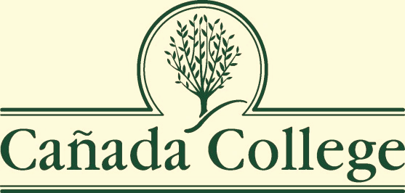

Strategic Enrollment Plan 2014-2017
Updated fall 2018
Extended to spring 2020

Prepared by the
Office of Planning, Research & Institutional Effectiveness
On behalf of the
2018 PBC Enrollment Task Force

Approved and adopted by the Planning & Budgeting Council
November 7, 2018

Table of Contents
Introduction 3
District Strategic Goals 3
College Mission, Vision and Values 4
College Strategic Goals 5
Process for Updating the Strategic Enrollment Plan to 2020 5
Key Changes in Enrollment since 2014-17 Plan 6
Updated Enrollment Trend Data (2013-18) 7
FTES, FTEF, Sections and Load at Cañada College (2013-18) 8
High School Graduates and Take Rates (2013-2018) 10
Concurrent High School Enrollment (2013-2018) 11
First-Time Student Enrollment (2013-2018) 11
Enrollment by Student Type (2013-2018) 12
Persistence (2012-2018) 13
Enrollment by Ethnicity (2012-2018) 13
Student Success Data (2017-18) 15
International Student Enrollment (2013-2018) 16
Distance Education Enrollment (2013 – 2018) 17
Impact of Building 1 Demolition on KAD Enrollments 21
Enrollment by Department fall 2018 21
New Student Enrollment Pipeline Data 22
Updated Enrollment Goals & Strategies from fall 2018 – spring 2018 23
Enrollment Trends Goals & Strategies for 2018-2020: 23
Community Strategies for 2018-2020: 23
Student Success Goals & Strategies for 2018-2020: 23
Student Demographic Goals & Strategies for 2018-2020: 24
Instructional Program Offerings & Labor Markets Goals & Strategies for 2018-2020: 24
New Student Enrollment Pipeline Goals & Strategies for 2018-2020: 24
Related Data, Plans and Resources 25
Historical Data Charts (from 2013-2017 SEP) 26

Introduction
The purpose of this Strategic Enrollment Plan (2014-2017), updated in fall 2018 for a period of 15 months (through spring 2020), for Cañada College is to:

- Establish Comprehensive Enrollment Goals – number, types of students, various modes of instructional delivery are needed to accomplish mission. Enrollment forecasting to determine campus wide needs for programs and course selection. Formal process to strengthen high school connections and collaborations in order to enhance dual enrollment, concurrent enrollment with an enhanced opportunity to predict, articulate and process these students’ needs. Better serve international student needs with continued outreach to enhance their student/college experience.

- Promote Institutional Success – access, transition, persistence, employment reporting, graduation and completion metrics through effective data driven strategic and financial planning. Develop new program curriculum for regional/local and student needs. Promotion of students’ voices and our alumni who have successfully transitioned. Greater development of an alumni network. Utilization of best practices and transferability of successful programs to other areas or new programs. Greater and more variable student life activities in order to strengthen college connectedness.

- Strengthen Internal and External Communications – strategic marketing, business and community outreach, community partner outreach, high school/adult school/early college outreach, promotion of programs and services offered in order to drive or increase enrollment, demonstrating student success, establish a career pathway to assist students in understanding career opportunities. Greater incorporation of advisory board views as a part of the campus decision making processes.

- Increase Campus Collaboration – among programs to accomplish mission, helping faculty, staff and administration incorporating student voices into institutional plans. Partnerships with instructional and student services collaborations that are efficient. Business process analysis that supports efficiency and equity for our students. Leveraging technology to increase participation and usability in order to incorporate greater and varied voices.

Source: AACRAO (2009) Applying Strategic Enrollment Management at the Community College. Washington DC.

The Strategic Enrollment Plan (SEP) was developed using the mission, vision, values, strategic directions and objectives from the Educational Master Plan 2017-2022 (EMP), as well as information from the College Integrated Plan. In addition, this Strategic Enrollment Plan (SEP) incorporates the goals set forth by the Board of Trustees for the San Mateo Community College District in 2015.

District Strategic Goals
- Develop and Strengthen Educational Offerings, Interventions, and Support Programs that Increase Student Access & Success
- Establish And Expand Relationships With School Districts, 4-year College Partners, And Community-based Organizations To Increase Higher Education Attainment In San Mateo County
- Increase Program Delivery Options, Including the Expanded Use of Instructional Technology, to Support Student Learning and Success
- Ensure Necessary Resources Are Available To Implement This Strategic Plan Through Sound Fiscal Planning And Management Of Allocations. Protect Community-supported Status And Undertake The Development Of Innovative Sources Of Revenue That Support Educational Programs Beyond That Which Is Available From Community And State Allocations.

College Mission, Vision and Values

Mission
Cañada College provides our community with a learning-centered environment, ensuring that all students have equitable opportunities to achieve their transfer, career/technical, and lifelong learning educational goals. The college cultivates in its students the ability to think critically and creatively, communicate effectively, reason quantitatively, and understand and appreciate different points of view within a diverse community.

Vision
Cañada College is committed to being a preeminent institution of learning, renowned for its quality of academic life, its diverse culture and practice of personal support and development, extraordinary student success, and its dynamic, innovative programs that prepare students for the university, the modern workplace, and the global community.

Values
- Transforming Lives
- High Academic Standards
- Diverse and Inclusive Environment
- Student Success in Achieving Educational Goals
- Community, Education, and Industry Partnerships
- Communication and Collaboration
- Engaging Student Life
- Accountability
- Sustainability
- Transparency

College Strategic Goals

The College updated its strategic goals in its 2017-2022 Education Master Plan:

Student Completion/Success
Provide educational and student services programs that highlight inclusivity, diversity, and equity in their mission to help students meet their unique educational goals and minimize logistical and financial barriers to success.

Community Connections
Build and strengthen collaborative relationships and partnerships that support the needs of, reflect, and enrich our diverse and vibrant local community.
Organizational Development

Focus institutional resources on the structures, processes, and practices that invest in a diverse student population and prioritize and promote equitable, inclusive, and transformative learning.

Process for Updating the Strategic Enrollment Plan to 2020

The Planning and Budgeting Council, at its meeting on September 5, 2018, appointed a new Enrollment Management Task Force with membership similar to that which developed the previous plan. It included:

VP of Instruction | Dr. Tammy Robinson | Academic Senate President | Hyla Lacefield
Dean of Counseling | Max Hartman | Professor | Paul Naas
Dean of PRIE | Dr. Karen Engel | Classified Senate President | Jeanne Stalker
 |  | Vice President of Student  Services (interim) | Dr. Char Perlas
Most of these Task Force members participated in a Districtwide Enrollment Management Summit with Gary Fretwell of Ruffalo Noel Levitz on September 11, 2018. At this Summit, the Task Force learned that the development of a strategic enrollment plan (SEP) and the structures that support it effectively can take 12-18 months. For this reason, the Task Force recommends to the Planning & Budgeting Council that the College update and extend its current SEP while it develops new structures that can support continuous, effectively, strategic enrollment management practices, and adopt a new SEP in spring 2020.
To inform its recommendations and update this Plan, the Task Force relied on data collected during the College’s Education Master Planning process here as well as by updating the data that was originally included for consideration in the 2014-17 SEP. That historical data can now be found at the end of this report.

Other college plans referenced reviewed to inform this plan update include:
- Educational Master Plan 2017-2022  - Cañada College Integrated Plan 2017-2019 | - SMCCD Strategic Plan 2015-2020  - Board of Trustees Goals 2015-2020

Key Changes in Enrollment since 2014-17 Plan

- The number of full time equivalent students (FTES) has continued to drop to its lowest level in 18 years.
- The number of full time equivalent faculty (FTEF) is at the lowest level in 18 years.

 | Highest Level (Year)* | Lowest Level (Year)* | 2018 Level*
FTES | 2,299 (2009) | 1,799 (2000) | 1,570
FTEF | 117 (2011) | 104 (2004) | 103
Number of Sections | 730 (2000) | 588 (2004) | 434
*Fall Terms only

- The total number of students graduating from public high schools in San Mateo County has remained relatively stable over the last 4-5 years. percentage of those public high school graduates who enroll in Cañada College at some point during the five years following graduation (Cañada’s “take rate”) has also remained relatively stable.
- Despite the drop in overall FTES of 17% between fall 2013 and fall 2018, the number of first-time students has only declined by 4% over the same time frame. A recent surge in fall 2018 is likely thanks to the College Promise Scholars program.
- In part thanks to the College Promise Scholars program and other outreach efforts, the number of first-time students enrolling full-time has increased dramatically (72%) since fall 2013. Even the number of continuing student enrolling in 12 or more units has increased steadily over time (47% since fall 2013)
- Black Non-Hispanic and Hispanic students are still under-represented in the successful student group as measured by overall course completion rates during the 2017-18 Academic Year.
- Enrollment in online and hybrid courses continues to climb dramatically, with corresponding high productivity rates. Success rates in distance education courses has, overall, kept pace with face-to-face classes – but there is high variability between courses and across sections that should be explored.
- The number of full time equivalent students (FTES) enrolled in the Kinesiology, Athletics, and Dance programs has fallen off sharply in recent years, perhaps due to the demolition of Building 1.
- The number of international students enrolled at Cañada as a home campus has seen declines in recent years, despite increases at the other SMCCD colleges during the same period. After reaching a peak of 159 during the 2016-17 academic year, the number of international students fell to 137 in 2017-18.
- Career Education program offerings have grown with a Marketing certificate and AS degree program newly approved by the State and active in the fall 2018 course schedule, an AD-T in Human Services, a 100% on-line paralegal degree program, a new, accelerated Business Online Academy. Under development: video game developer certificate; home staging certificate; and expanding Early Childhood Education’s (ECE) youth and afterschool services certificates as part of the region’s teacher preparation pipeline.

Updated Enrollment Trend Data (2013-18)

Historical enrollment data from the previous Strategic Enrollment Plan (SEP) can found at the end of this updated plan. The charts listed here are updated to reflect data from the 2013-2018 Academic Years with some elements updated to fall 2018.

Overall, Cañada’s enrollment of Full Time Equivalent Students (FTES) is at the lowest point in 18 years – 11% lower than its previous low point in 2001. The steady, year-over-year decline since the high point in enrollment during the Great Recession of 2009-2011, has continued for nearly a decade.

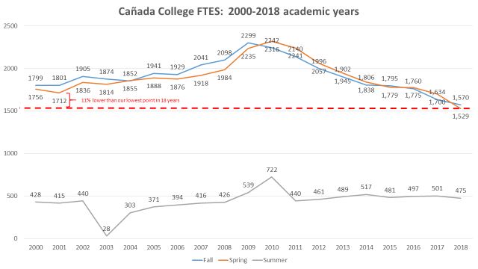

FTES, FTEF, Sections and Load at Cañada College (2013-18)

Over the last five years, the summer term seems to remain stable in terms of enrollment, while the fall and spring terms continue to decline.

Declining numbers of Full Time Equivalent Students are correlated with declines in the number of Full Time Equivalent Faculty, which are also at the lowest point in the last 18 years.

High School Graduates and Take Rates (2013-2018)
The total number of students graduating from public high schools in San Mateo County has remained relatively stable over the last 4-5 years.

The percentage of those public high school graduates who enroll in Cañada College at some point during the five years following graduation (Cañada’s “take rate”) has also remained relatively stable.

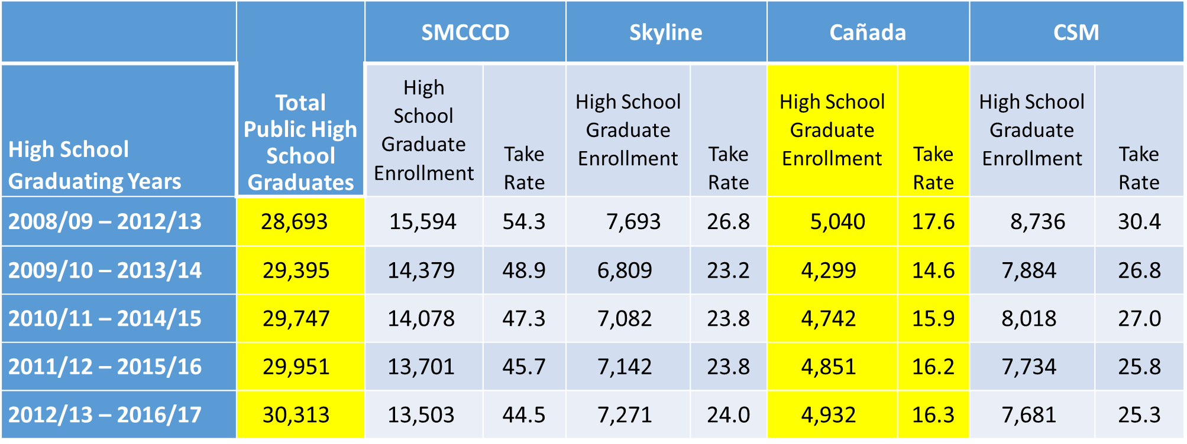

Concurrent High School Enrollment (2013-2018)

The number of concurrently enrolled High Schools students has fluctuated considerably year-to-year. Middle College High School Students make up approximately 16% (87 students in 2017-18) of the total concurrently enrolled high school students at Cañada.

First-Time Student Enrollment (2013-2018)
NEW DATA: Despite the drop in overall FTES of 17% between fall 2013 and fall 2018, the number of first-time students has only declined by 4% over the same time frame. A recent surge in fall 2018 is likely thanks to the College Promise Scholars program which recruited more than 300 additional first-time students to the campus in fall 2018. Prior to this program, the number of first-time students enrolling had been dropping since 2015.

Enrollment by Student Type (2013-2018)
NEW DATA: In part thanks to the College Promise Scholars program and other outreach efforts, the number of first-time students enrolling full-time has increased dramatically (72%) since fall 2013. Even the number of continuing students enrolling in 12 or more units has increased steadily over time (47% since fall 2013)

Type of Student, Fall 2018 | Credit Range
 | 0.5 - 5.9 | 6 - 8.9 | 9 - 11.9 | 12+ | TOTAL Students
Continuing Student | 970 | 813 | 601 | 1204 | 3588
Returning Student | 222 | 81 | 37 | 40 | 380
Returning Transfer Student | 135 | 82 | 33 | 34 | 284
First-Time Student | 189 | 68 | 99 | 393 | 749
Not Applicable, Currently K-12 | 266 | 62 | 122 | 11 | 461
First-Time Transfer Student | 164 | 78 | 47 | 93 | 382
TOTAL STUDENTS | 1946 | 1184 | 939 | 1779 | 5848

Enrollment trends by student type show the number of continuing students fairly stable across fall terms since 2013. The number of returning students (defined as students enrolling after stopping out for 3 or more semesters) and returning transfer students have declined however. Fall enrollment of returning students has dropped 37% between 2013 and 2018.

Student Type | Fall 2013 | Fall 2014 | Fall 2015 |  | Fall 2016 |  | Fall 2017 | Fall 2018
Continuing Student | 3607 | 3567 | 3636 | 3782 |  | 3587 |  | 3588
First-Time Student | 692 | 683 | 750 | 675 |  | 613 |  | 749
First-Time Transfer Student | 429 | 436 | 411 | 444 |  | 403 |  | 382
Not Applicable, Currently K-12 | 394 | 538 | 605 | 511 |  | 529 |  | 461
Returning Student | 598 | 497 | 426 | 390 |  | 368 |  | 380
Returning Transfer Student | 331 | 404 | 392 | 357 |  | 307 |  | 284
TOTAL | 6051 | 6125 | 6220 | 6159 |  | 5810 |  | 5848

Persistence (2012-2018)
NEW DATA: An enrollment metric not considered in the 2014-17 Strategic Enrollment Plan is that of persistence, the re-enrollment of students in the semester following their first semester. The percentage of first time students who re-enroll (or persist) from fall to spring varies considerably based on the number of units they take during their first semester.

 | FA '12 | FA '13 | FA '14 | FA '15 | FA '16 | FA '17
Full Time First Time Students (12+ units) | 89% | 86% | 87% | 87% | 89% | 83%
Part Time First Time Students (6 - 11.9 units) | 71% | 63% | 66% | 68% | 80% | 74%
Less Than Part Time First Time Students (0.1 - 5.9 units) |  | 54% | 51% | 55% | 54% | 57%

Enrollment by Ethnicity (2012-2018)
The ethnic and racial composition of Cañada students has not changed substantially over time. An increase in the percentage of students who identify themselves as Asian or of more than one racial group has correlated with decreases in the percentage of students identifying themselves as Hispanic/Latinx or White Non-Hispanic.
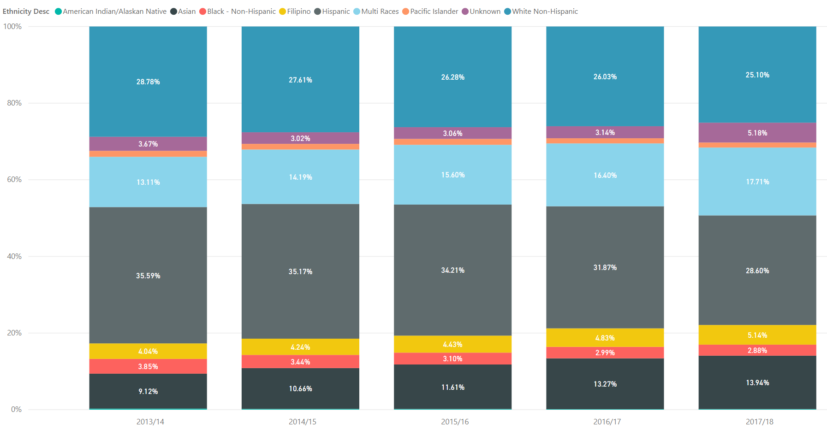

These trends have not been reflected in the enrollment trends of full time first time students.

Student Success Data (2017-18)

One of the significant goals of the 2014-2017 SEP was to increase the success of Cañada’s Black and Hispanic students. Course success rate data from the 2017-18 Academic Year reveals that Hispanic/Latinx and Black Non-Hispanic students are still under-represented in the successful student group.*

Course Success

Overall Course Success Rate: 72.4%
*Note: American Indian and Pacific Islander sub-populations are subject to a margin of error greater than the Percentage Point Gap between their success rates and that of all students.

International Student Enrollment (2013-2018)
The number of international students enrolled at Cañada as a home campus has seen declines in recent years, despite increases at the other SMCCD colleges during the same period. After reaching a peak of 159 during the 2016-17 academic year, the number of international students fell to 137 in 2017-18. Cañada’s international student population remains a fraction of that of its sister colleges (CSM: 776; Skyline: 273 in Fall 2018 – compared to 117 at Cañada).

REVISED: International Students are identified by home campus and by those who have an I-20 visa. Only students enrolled in credit courses are counted.

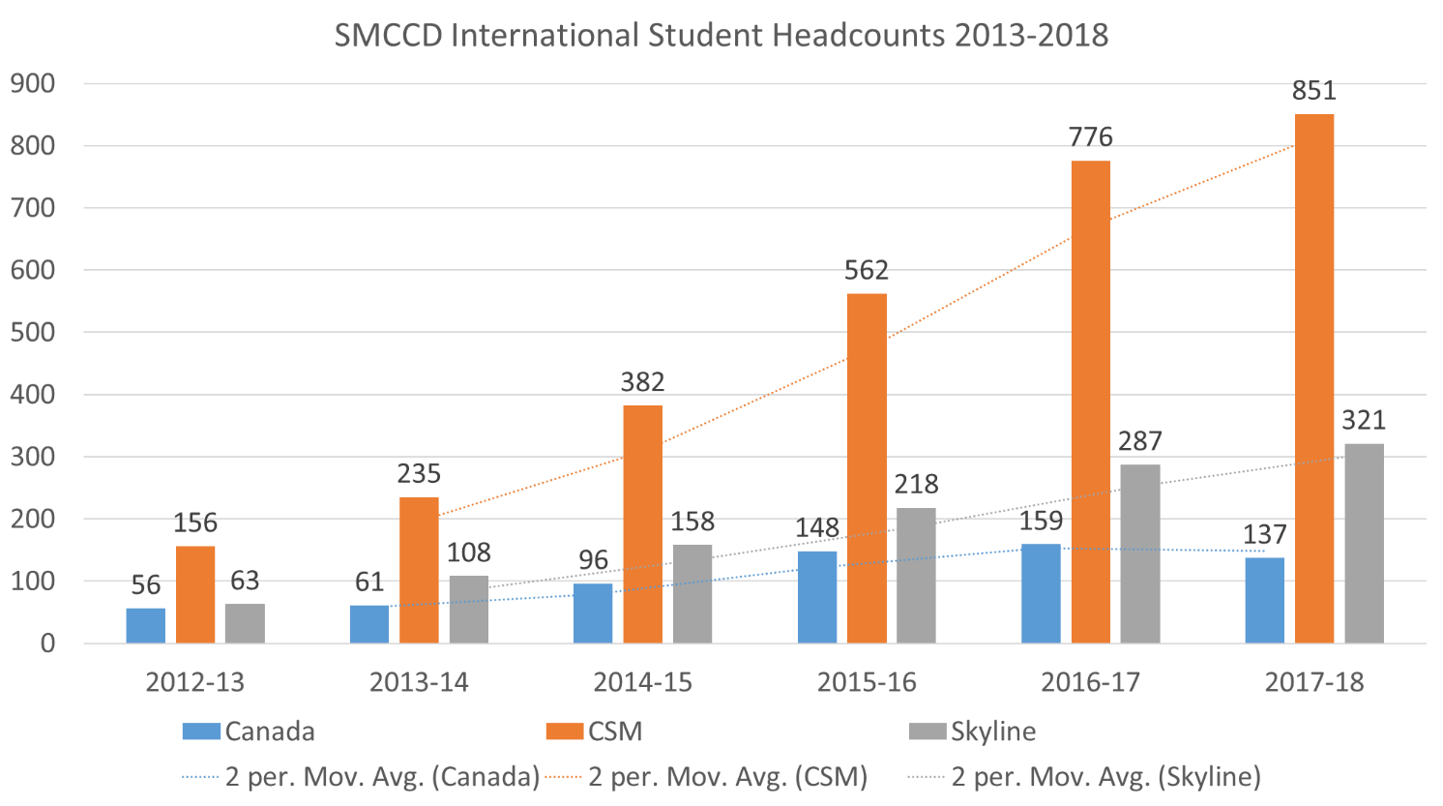

Distance Education Enrollment (2013 – 2018)
Enrollment in online and hybrid courses continues to climb dramatically, with corresponding high productivity rates. Success rates in distance education courses has, overall, kept pace with face-to-face classes – but there is high variability between courses and across sections that should be explored.

Impact of Building 1 Demolition on KAD Enrollments
NEW DATA: The impact of the demolition of Building 1 and related changes in the kinesiology, athletics, and dance programs should be considered.

Enrollment by Department fall 2018
When considering patterns of enrollment by academic discipline, it is interesting to note than nearly three quarters (73%) of all enrollments in the fall of 2018 are in 18 departments (see chart below). Nearly one in three enrollments (27%) are in the top three departments: mathematics, English, and biology. This trend may shift with the implementation of AB 705 in the decrease in basic skills enrollments.
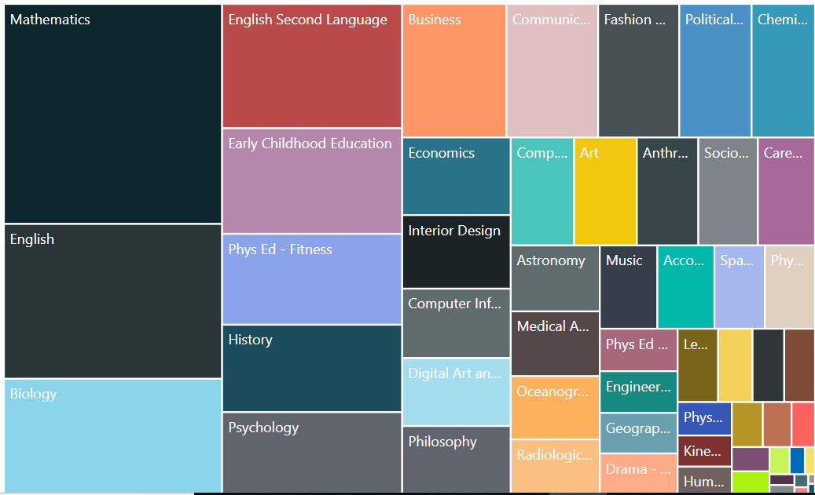

New Student Enrollment Pipeline Data
The Matriculation Pipeline data considered during the last Strategic Enrollment Plan process is being re-evaluated. As a placeholder, data from the Chancellor’s Office Data Mart is included here.

California Community Colleges Chancellor's Office
Student Success Services Summary Report
Report Run Date As Of : 11/2/2018 1:13:33 PM
 |  | Fall 2015 | Fall 2015 | Fall 2015 | Fall 2015
 |  | Directed | Directed | Exempted | Exempted
 |  | Service Received | Service Not Received | Service Received | Service Not Received
Canada |  | 6,934 | 10,156 | 2,746 | 16,698
 | Academic/Progress Probation Services | 172
 | Counseling/Advisement Services | 1,859 | 1,675 | 1,337 | 3,384
 | Education Plan Services | 1,244 | 2,290 | 915 | 3,806
 | Initial Assessment Services Placement | 149 | 3,105 | 311 | 4,690
 | Initial Orientation Services | 168 | 3,086 | 183 | 4,818
 | Other Services | 3,342
 |  | Fall 2016 | Fall 2016 | Fall 2016 | Fall 2016
 |  | Directed | Directed | Exempted | Exempted
 |  | Service Received | Service Not Received | Service Received | Service Not Received
Canada |  | 7,888 | 19,333 | 1,110 | 7,022
 | Academic/Progress Probation Services | 170
 | Counseling/Advisement Services | 2,400 | 3,730 | 577 | 1,321
 | Education Plan Services | 1,569 | 4,561 | 342 | 1,556
 | Initial Assessment Services Placement | 325 | 5,535 | 114 | 2,054
 | Initial Orientation Services | 353 | 5,507 | 77 | 2,091
 | Other Services | 3,071
 |  | Fall 2017 | Fall 2017 | Fall 2017 | Fall 2017
 |  | Directed | Directed | Exempted | Exempted
 |  | Service Received | Service Not Received | Service Received | Service Not Received
Canada |  | 7,609 | 18,598 | 1,018 | 6,556
 | Academic/Progress Probation Services | 214
 | Counseling/Advisement Services | 2,222 | 3,661 | 536 | 1,229
 | Education Plan Services | 1,541 | 4,342 | 362 | 1,403
 | Initial Assessment Services Placement | 297 | 5,329 | 69 | 1,953
 | Initial Orientation Services | 360 | 5,266 | 51 | 1,971

Updated Enrollment Goals & Strategies from fall 2018 – spring 2018

Enrollment Trends Goals & Strategies for 2018-2020:
In order to mitigate the negative enrollment trends that we are now experiencing, the College will:
- Review enrollment data regularly and set section- and program-specific enrollment/load targets.
- Regularly analyze course scheduling and delivery modes for completion and course optimization (to avoid class cancellations and conflicts).
- Establish criteria for course scheduling - this will be different for every Division.
- Improve the accuracy of Student Education Plans (SEP) and utilize that data to project more accurate course schedules.
- Group degree programs into interest areas or “meta majors.”
- Align support services with interest areas.
- Increase the percentage of current high school students enrolled at Cañada (see below for addition high school transition strategies).
- Increase the percentage of international students enrolling at Cañada College.
- Continue to increase the Distance Education course sections.
- Continue to increase late-start distance education and non-distance education offerings. Do this in the context of inquiry regarding the role of 8-week classes or other changes to the course schedule.
- Continue to expand the number of online certificate and/or degree programs.
- Look at program complete-ability.
  - Are all of our degree and certificate programs complete-able “on time.”
  - Examine the role of class cancellations and the need for students to take program courses at one of the other SMCCD campuses and whether or not students can complete their course of study within 150% of normal time.
  - Explore whether classes required for a degree or certificate are offered every year.

Community Strategies for 2018-2020:

- Maintain and develop additional career education pathways that lead to job placement.
- Incorporate Cañada’s proximity, course selection and affordability into our marketing materials.
- Promote our college as a community resource specifically tied to the enhancement of the cultural, intellectual and physical well-being of our local residents.

Student Success Goals & Strategies for 2018-2020:

- Increase the success of our Black and Hispanic/Latinx students.
- Increase the percentage of students who enroll in transfer level math, English and ESL and provide appropriate instructional supports based on multiple placement measures.
- In the context of the College Distance Education Plan, continue to monitor the success of online students. Disaggregate the student data and address the needs of disproportionately impacted groups of students.

Student Demographic Goals & Strategies for 2018-2020:
- Expand various high school engagement strategies: dual enrollment, summer programs, concurrent enrollment, and other early college credit opportunities for local high school students.
- Fully implement and scale College Promise Scholars program and all high school outreach efforts.
- Monitor overall high school completion rates in our service area and continue to increase by at least 5% each fall, the percentage of service area High School graduates enrolling at Cañada College.
- Conduct research to identify the percentage of high school graduates that directly enter four-year institutions, bypassing the community college, and the percentage that are not pursuing any form of higher education.
- Continue to support evening and weekend course offerings and the expansion of the College for Working Adults.
- Modify the current Priority Enrollment Program (PEP) to better serve incoming students.
- Expand cohorts via learning communities.

Instructional Program Offerings & Strategies for Career Education 2018-2020:
- Increase Career Education program offerings based on regional needs and labor market data.
- Enhance the College’s ability to help all students explore long-term career options.
- Integrate and expand support for job placement and career assistance for students.
- Establish tools and mechanisms for tracking employment outcomes for graduates.

New Student Enrollment Pipeline Goals & Strategies for 2018-2020:

Please note: as the Office of Student Services and the Office of Planning, Research, and Institutional Effectiveness work with District IT Services to determine the accuracy of application and matriculation data, new targets for the coming plan cycle are under development. One aspect of this issue pertains to the number of applications “hacked” and falsely submitted between 2015 and 2018.

Among the strategies under consideration for the College’s Guided Pathways efforts as well as its Quality Focus Essay, as part of its 2019 Institutional Self Evaluation Report and accreditation process, are:
- Streamline the application, registration and financial aid process by designing and implementing a new Customer Relationship Management (CRM) system with the District.
- Expand proactive registration
- Expand support for FAFSA completion
- Develop a First Year Experience program and development of bridge programs.

Related Data, Plans and Resources
- Education Master Plan 2017-2022 and related data: https://canadacollege.edu/emp/emp-data.php
- Program Review and program data: https://canadacollege.edu/programreview/datapackets.php
- 2017-19 Integrated Plan: Basic Skills Initiative, Student Equity, and Student Success and Support Program: https://canadacollege.edu/aces/docs/Canada%20Integrated%20Plan_BOT%20Report_11.21.17.pdf
- San Mateo Community College District Strategic Plan and related metrics: https://smccd.edu/strategicplan/
- Career Technical Education Outcomes Survey (CTEOS): https://cteos.santarosa.edu/cteos-survey-home

Historical Data Charts (from 2013-2017 SEP)

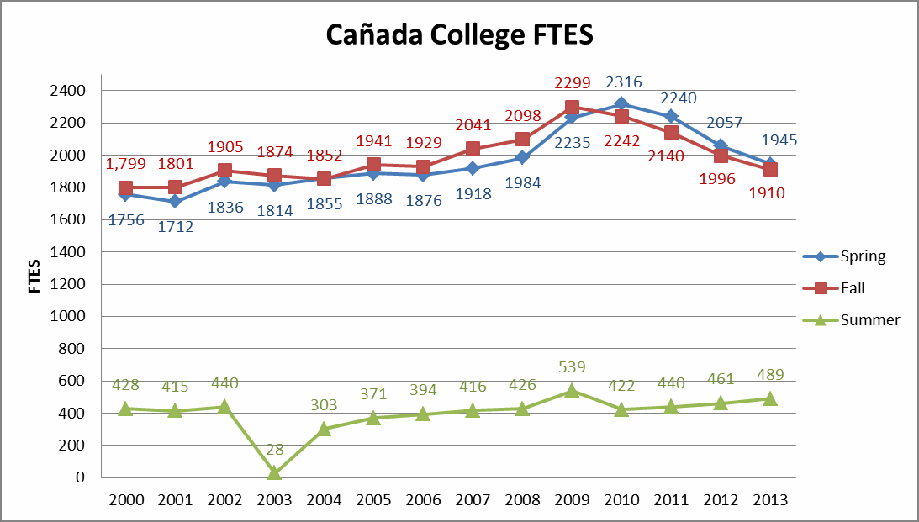

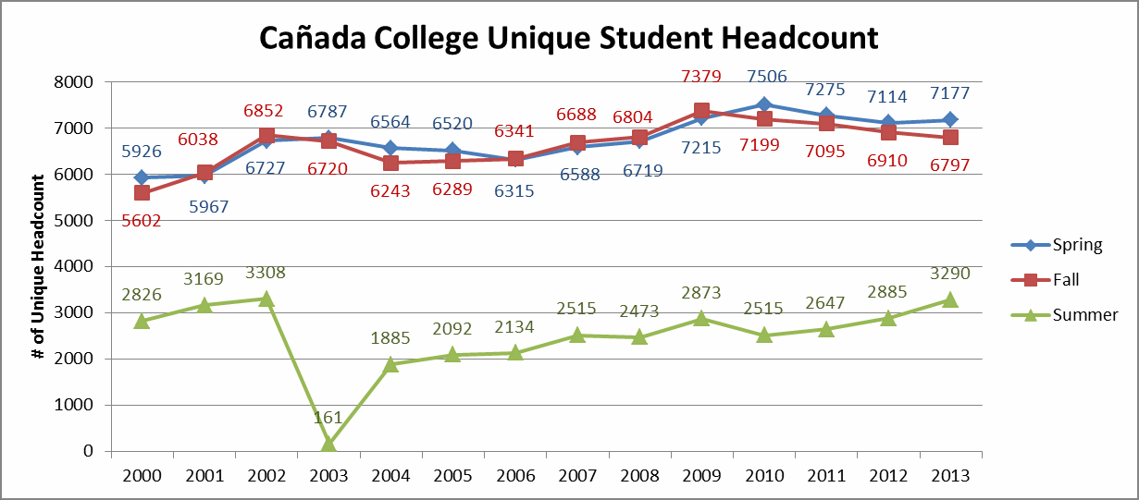

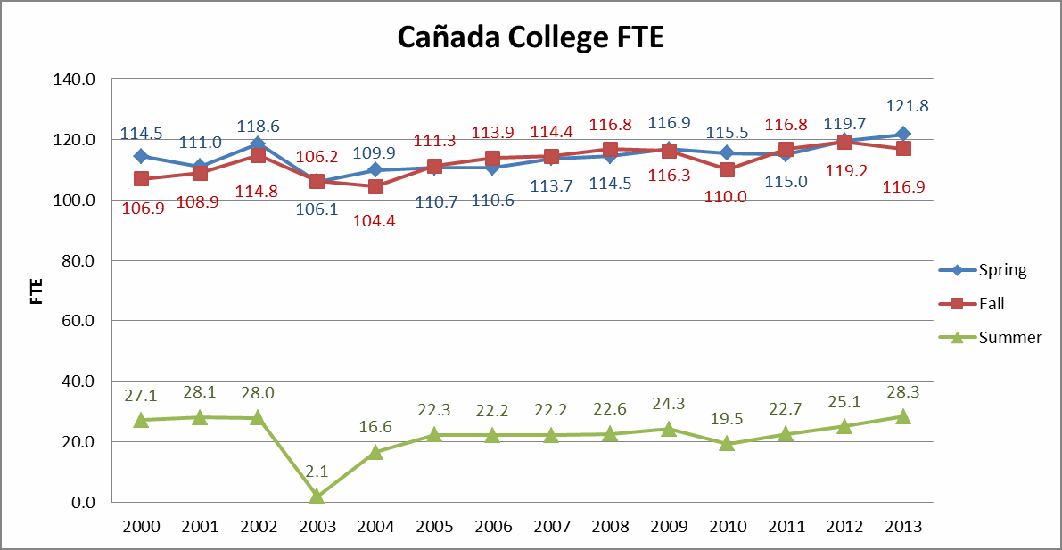
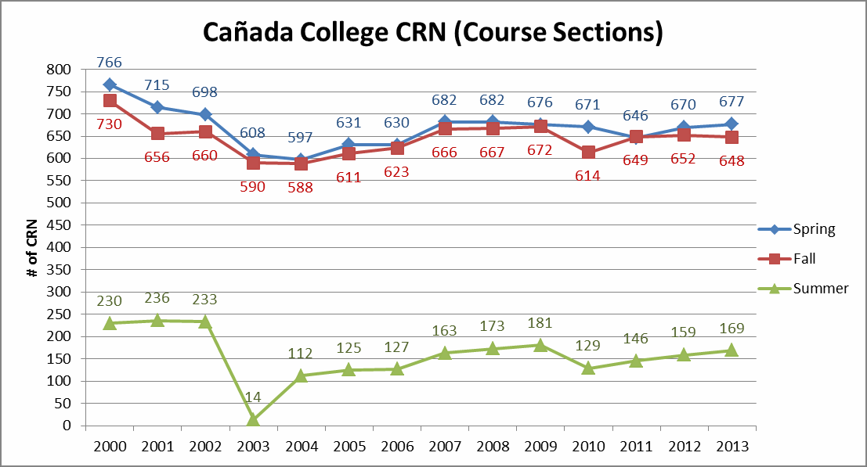

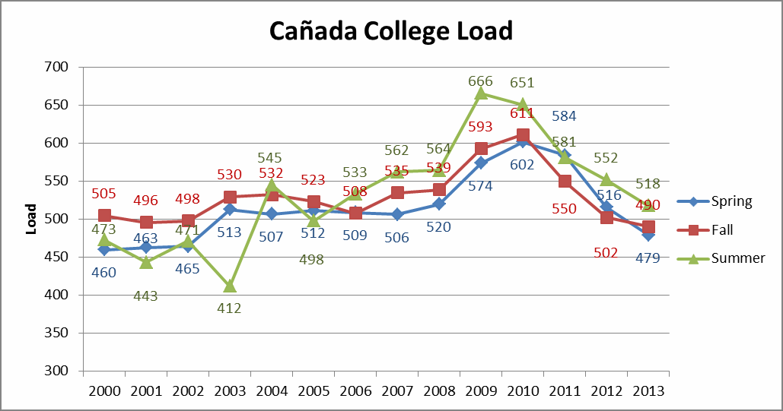
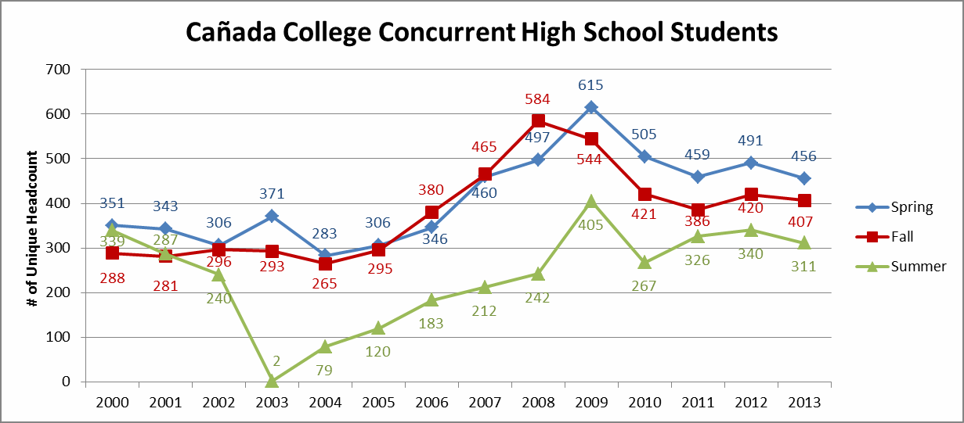

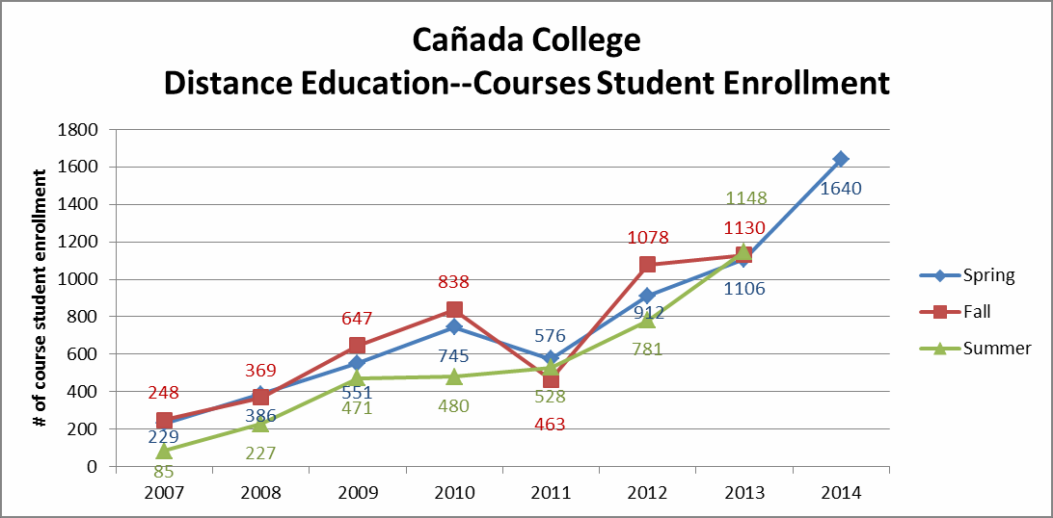
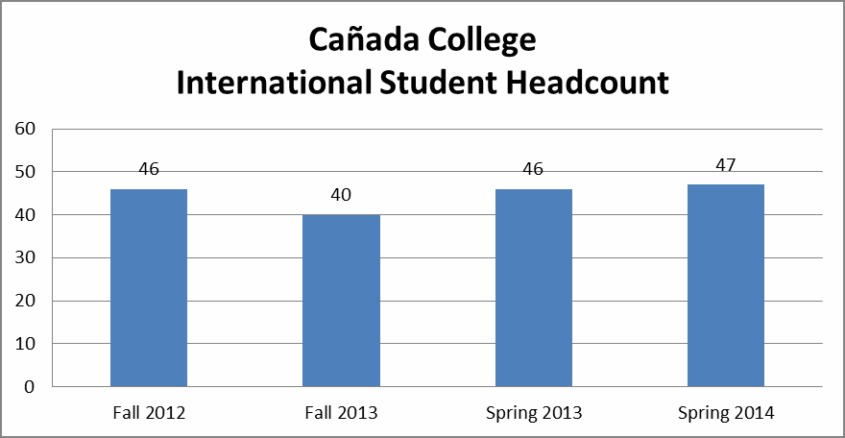
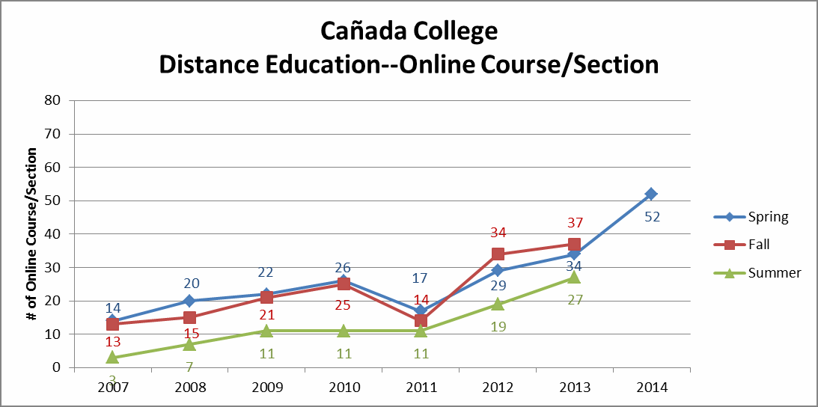
Summer 2013 and Fall 2013 District

Register Course 866
53%

No Matricuation District
Register Course 2692
56%
1630
Apply 4778
Matriculation
3148
Orientation
848

Orientation 848

Orientation 848
Orientation
Orientation
Orientation
Orientation
Assessment
810

Assessment 810
Assessment
Assessment
1163

Assessment 1163
Assessment
Assessment
Counseling
582
Counseling
Counseling
Counseling
659
Counseling
Counseling
968
Counseling
Register Courses 517

Register Courses 663

Register Courses 687

Register Courses 577

Register Courses 911

Register Courses 796

Register Courses 1826

