English as a Second Language
Comprehensive Program Review Data Packet
7A. Enrollment Trends
Use the data provided by PRIE to examine your enrollments by department or courses. Describe trends in headcount, FTES, and load. If applicable, describe any other enrollment data that is relevant to your program

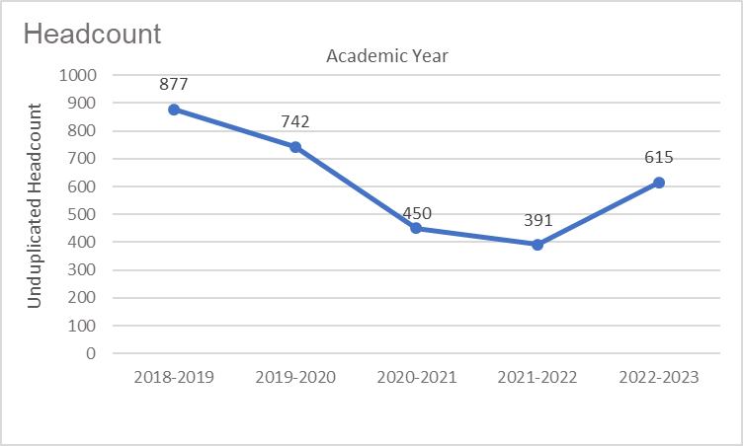
Headcount in English as a Second Language was down 29.9% in 2022-2023 (615 students) compared to 2018-2019 (877 students). Headcount declined steadily for four academic years then increased in the most recent academic year.

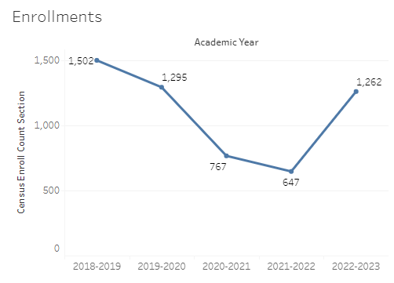
Enrollment in English as a Second Language was down 16% in 2022-2023 compared to five years ago in 2018-2019. English enrollment was at a five-year high in 2018-2019 with 1,502 enrollments and a five-year low of 647 enrollments in 2021-2022.

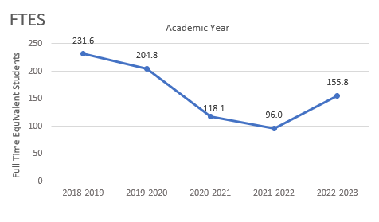
Full-time equivalent students (FTES) in English as a Second Language was down 32.7% in the most recent academic year (2022-2023) compared to five years ago (2018-2019), a decrease of 75.8 FTES.

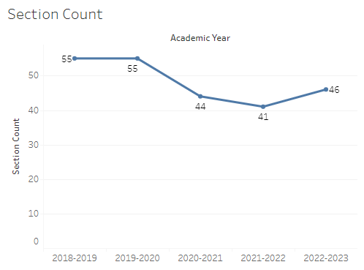
The number of sections offered in English as a Second Language remained at 55 sections for two academic years then dropped to 44 sections and 41 sections over the next two years. The section count increased to 46 sections in the most recent academic year, 2022-2023.

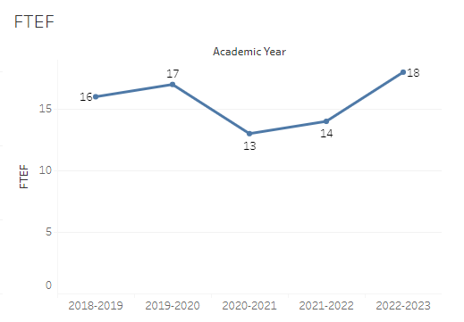
The number of full-time equivalent faculty (FTEF) in English as a Second Language (ESL) was 18 in the most recent academic year, two more FTEF than five years ago (2018-2019 = 16 FTEF). The count of FTEF in ESL dropped significantly for two academic years during 2020-2021 and 2021-2022 (13 and 14 FTEF, respectively), before reaching a five-year high in 2022-2023.

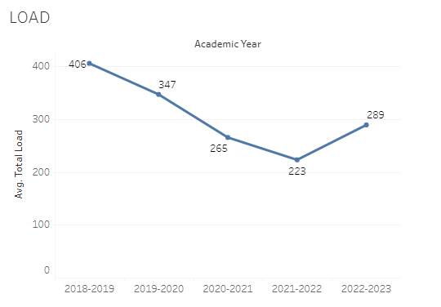
Load in English as a Second Language (ESL) dropped steadily for four academic years, then increased slightly in the most recent academic year. The maximum load in ESL over the last five academic years was 406 in 2018-2019 and the minimum was 223 in 2021-2022.

8A. Access & Completion
Describe the student completion and success rate in your courses and/or program using the data provided by PRIE. Look at your course offerings, in the last program review cycle was it possible for a student to complete your certificates or degrees while only completing courses at Cañada College? How can the college help you improve student completion and success? What changes could be made?

Note: See the Course Enrollment & Success Detail Report for additional course-level data. This report can be found on PRIE’s Data Dashboards & Packets page under the program name.

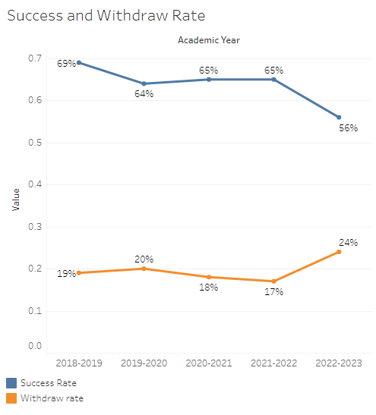
The overall success rate in English as a Second Language (ESL) started at 69% in 2018-2019 then held steady at roughly 65% for the next three academic years. The success rate in ESL dropped to 56% in the most recent academic year (2022-2023), 9 percentage points lower than the previous academic year. ESL withdraw rates started at 19% in 2018-2019 and fluctuated slightly the next three academic years. In 2022-2023 the withdraw rate in ESL was 24%, 7 percentage points higher than the previous academic year.
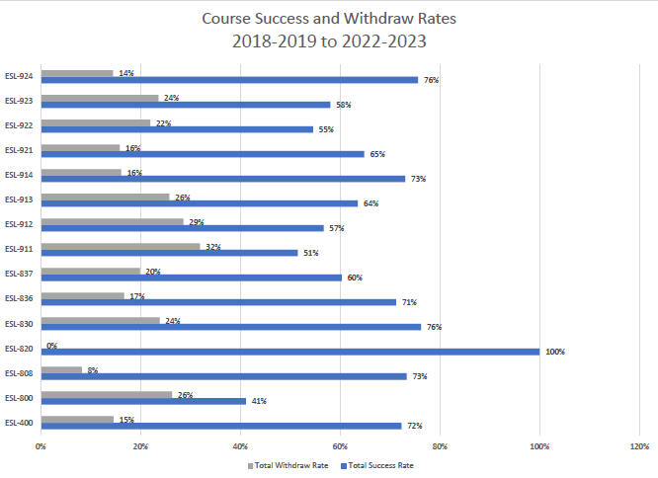
Course success rates in English as a Second Language (ESL) ranged from a minimum of 41% in ESL 800 to a maximum of 100% in ESL 820. If ESL 820 were excluded the max would have been 76% in ESL 830 and ESL 924. Withdraw rates in ESL ranged from a max of 32% in ESL 911 to a minimum of 8% in ESL 808 (this excludes ESL 820 with 0% withdraw rate).

8B. Student Equity
One of the goals of the College’s Student Equity plan is to close the performance gaps for disproportionately impacted students. Use the data provided by PRIE that indicates which groups are experiencing a disproportionate impact in your program. Which gaps are most important for improving outcomes in your program? How can the college help you address these gaps? What changes could be made?

The Equity and Disproportionate Impact (DI) dashboard was used to identify subgroups that may have been disproportionately impacted in English as a Second Language (ESL) in the most recent academic year (2022-2023). The three metrics used to examine potential disproportionate impact were enrollment rates (referred as access), success rates, and withdraw rates. The rate for each subgroup was compared to either the college-wide rate (access) or the overall program-level rate (success and withdraws). The difference between the two rates is known as the ‘gap’ and may be referred to as a performance gap or equity gap. Student subgroups that may have been disproportionately impacted in ESL appear below (see Table 1-3).
Access
Access is an indicator of what student subgroups are enrolling in courses, based on unique student counts. Enrollment data revealed five student subgroups were underrepresented in ESL classes compared to the college-wide population (see Table 1). For instance, the proportion of students age 18-22 enrolled in ESL was 24.3 percentage points lower than the same age group enrolled college-wide.
Table 1.
Student Subgroup | Gap
Not First Generation | -33.4
Age 18-22 | -24.3
First Generation | -20.3
White Non-Hispanic | -18.7
Not Low Income | -11.8

Success
Success is the rate at which different student subgroups pass courses and is based on enrollments. The success rate for different subgroups in ESL was compared to the overall success rate in ESL or overall success rate by course modality. The difference between the two rates (the gap) revealed nine subgroups may have been disproportionately impacted (see Table 2). For example, the success rate for students under age 18 was 31.1 percentage points lower than the overall success rate in ESL. The success rate for male students enrolled in synchronous ESL sections was 26.7 percentage points lower than the overall success rate for all synchronous ESL sections.

Table 2.
Student Subgroup | Gap
Age Under 18 | -31.1
Course Modality=Synchronous: Males | -26.7
Course Modality=Hybrid: Hispanic Males | -14.1
Hispanic Males | -13.6
Course Modality=Hybrid: Males | -11.7
Male | -11.7
First Generation | -9.0
Unit load - Less than part-time (less than 6 units) | -7.5
Not Low Income | -4.8

Withdraws
Withdraws is the rate at which a student withdraws from a course, with higher numbers being worse, as they indicate greater withdraw rates. The withdraw rates for subgroups in ESL was compared to the overall withdraw rate for the program. Three subpopulations in ESL had withdraw rates that were higher than the overall ESL withdraw rate, suggesting these groups may have been disproportionately impacted. One subgroup, Hispanic male students had withdraw rates six percentage points higher than the average rate for ESL.
Table 3.
Student Subgroup | Gap
Hispanic Males | +6.0
Males | +5.7
Not Low Income | +4.3

8C. Completion – Success Online
The college has a goal of improving success in online courses. Using the data provided by PRIE, what significant gaps do you see in success between online/hybrid and non-online courses? What changes could be made to reduce these gaps? If your program does not offer online/hybrid courses, please write “not applicable”.
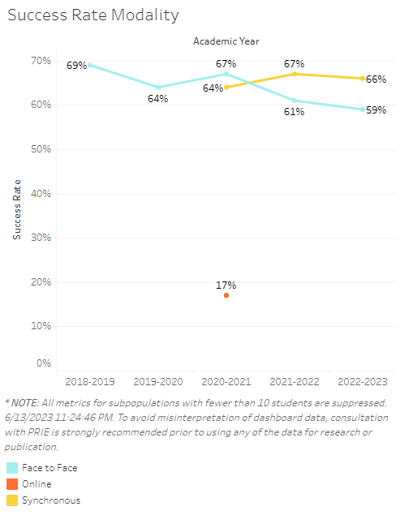
English as a Second Language (ESL) offered synchronous sections for the last three academic years, starting in 2020-2021. The first academic year synchronous sections were offered the success rate was three percentage points lower than the success rate for face-to-face sections. In the next two academic years the success rate for synchronous sections surpassed face-to-face sections by 6-7 percentage points.
The equity and disproportionate impact data presented in the previous section (see 8B. Student Equity) revealed male students enrolled in synchronous ESL sections had success rates 26.7 percentage points lower than the overall success rate for synchronous ESL sections.

Source: https://canadacollege.edu/prie/dashboards/disproportionate-impact.php

