Kinesiology, Athletics, and Dance
Comprehensive Program Review Data Packet
7A. Enrollment Trends
Use the data provided by PRIE to examine your enrollments by department or courses. Describe trends in headcount, FTES, and load. If applicable, describe any other enrollment data that is relevant to your program
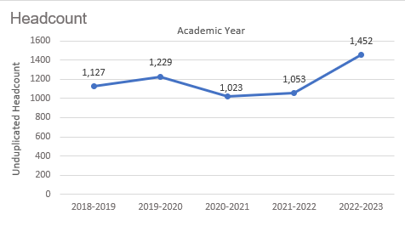
Headcount in Kinesiology, Athletics, and Dance was up 28.8% in 2022-2023 (1,452 students) compared to 2018-2019 (1,127 students).

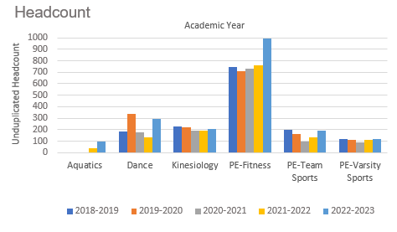
The majority of the headcount in Kinesiology, Athletics, and Dance was in Fitness classes.
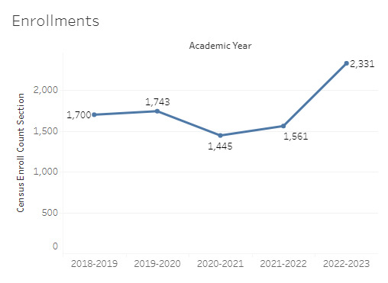
Enrollment in Kinesiology, Athletics, and Dance was up 37.1% in 2022-2023 compared to five years ago in 2018-2019. Enrollment in these programs reached a five-year high in 2022-2023 (2,331 enrollments) and a five-year low in 2020-2021 (1,445 enrollments).

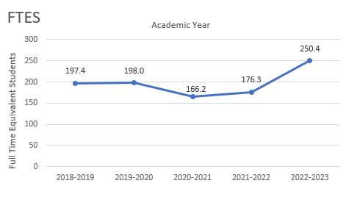
The number of full-time equivalent students (FTES) in Kinesiology, Athletics, and Dance was up 26.9% in the most recent academic year (2022-2023) compared to five years ago (2018-2019), an increase of 53 FTES.

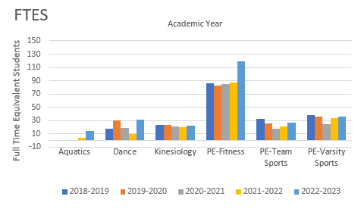
Similar to headcount, the majority of FTES in Kinesiology, Athletics, and Dance was in Fitness classes.

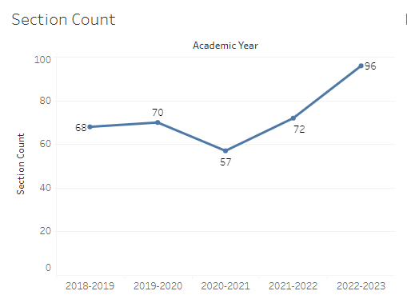
The number of sections offered in Kinesiology, Athletics, and Dance increased over the last five academic years, going from 68 sections in 2018-2019 to 96 sections in 2022-2023.

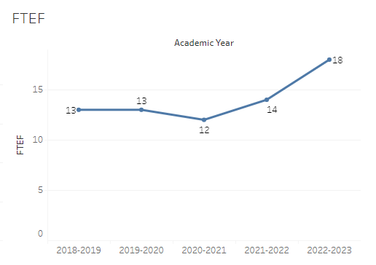
The number of full-time equivalent faculty (FTEF) in Kinesiology, Athletics, and Dance went from 13 in 2018-2019 down to 12 FTEF in 2020-2021, and up to 18 sections in 2022-2023.

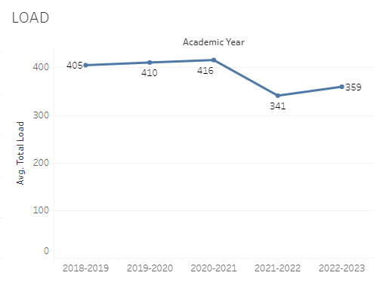
Load in Kinesiology, Athletics, and Dance stayed between 405 and 416 for three academic years before it dropped to 341 in 2021-2022. The load was 359 in the most recent academic year (2022-2023).

8A. Access & Completion
Describe the student completion and success rate in your courses and/or program using the data provided by PRIE. Look at your course offerings, in the last program review cycle was it possible for a student to complete your certificates or degrees while only completing courses at Cañada College? How can the college help you improve student completion and success? What changes could be made?

Note: See the Course Enrollment & Success Detail Report for additional course-level data. This report can be found on PRIE’s Data Dashboards & Packets page under the program name.

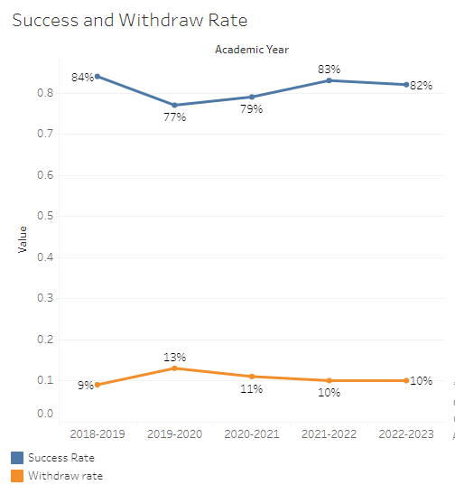
The overall success rates for Kinesiology, Athletics, and Dance stayed between 77% and 84% for the last five academic years. Withdraw rates for Kinesiology, Athletics, and Dance have been at 10-11% for the last three academic years.
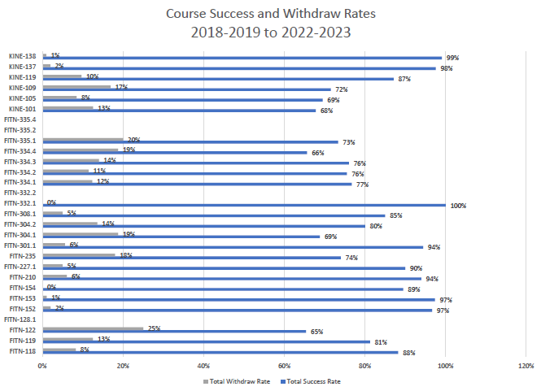

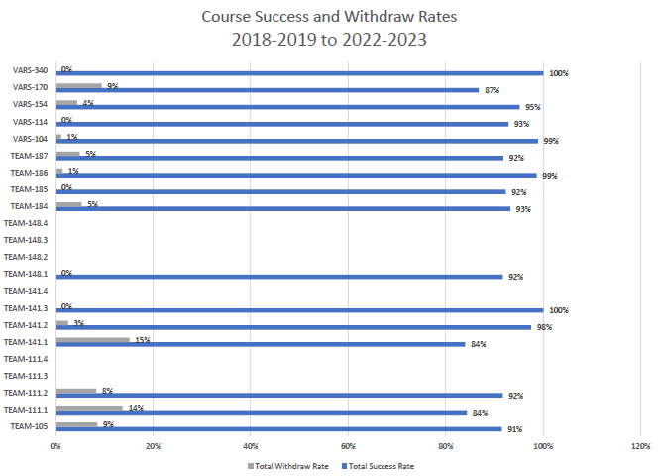

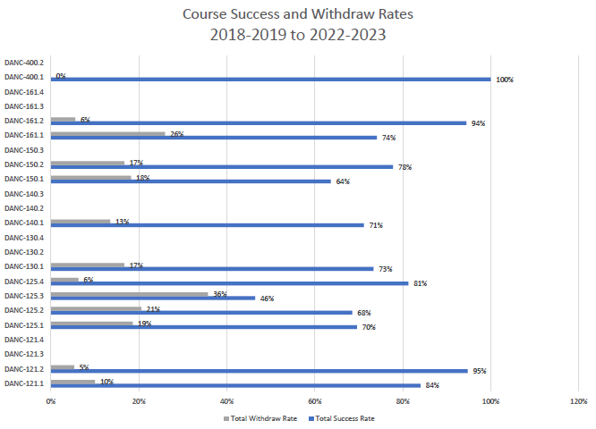

8B. Student Equity
One of the goals of the College’s Student Equity plan is to close the performance gaps for disproportionately impacted students. Use the data provided by PRIE that indicates which groups are experiencing a disproportionate impact in your program. Which gaps are most important for improving outcomes in your program? How can the college help you address these gaps? What changes could be made?

The Equity and Disproportionate Impact (DI) dashboard was used to identify subgroups that may have been disproportionately impacted in Kinesiology, Athletics, or Dance in the most recent academic year (2022-2023). The three metrics used to examine potential disproportionate impact were enrollment rates (referred as access), success rates, and withdraw rates. The rate for each subgroup was compared to either the college-wide rate (access) or the overall program-level rate (success and withdraws). The difference between the two rates is known as the ‘gap’ and may be referred to as a performance gap or equity gap. Student subgroups that may have been disproportionately impacted in Kinesiology, Athletics, or Dance appear below (see Table 1-3).
Access
Access is an indicator of what student subgroups are enrolling in courses, based on unique student counts. Enrollment data revealed four student subgroups were underrepresented in Kinesiology, Athletics, or Dance classes compared to the college-wide population (see Table 1). For instance, the proportion of students in Kinesiology, Athletics, and Dance with a unit load considered ‘less than part-time’ (fewer than 6 units) was 16.5 percentage points lower than the proportion of ‘less than part-time’ students enrolled college-wide. Female students were underrepresented in hybrid and face-to-face classes in Kinesiology, Athletics, and Dance compared to college-wide enrollment rates.
Table 1.
Student Subgroup | Gap
Unit load - Less than part-time (less than 6 units) | -16.5
Course modality: Hybrid - Females | -15.5
Course modality: Face-to-face – Females | -13.5
Not low income | -5.0

Success
Success is the rate at which different student subgroups pass courses and is based on enrollments. The success rate for different subgroups in Kinesiology, Athletics, or Dance was compared to the overall success rate in Kinesiology, Athletics, or Dance. The difference between the two rates (the gap) revealed fifteen subgroups may have been disproportionately impacted (see Table 2). For example, foster youth in Kinesiology, Athletics, and Dance had success rates 33 percentage points lower than the overall success rate in Kinesiology, Athletics, and Dance during the 2022-2023 academic year. Pacific Islanders and female Filipino students in online Kinesiology, Athletics, or Dance sections had success rates about 28 percentage points below the average success rate for online courses.
Table 2.
Student Subgroup | Gap
Foster Youth | -33.3
Pacific Islanders | -32.6
Course Modality: Online - Pacific Islander | -28.5
Course Modality: Online - Filipino Females | -28.2
Filipino Females | -24.1
Course Modality: Online – Hispanic Males | -10.6
Age 23 – 28 | -9.4
Disabled | -9.3
Low Income | -8.0
Hispanic Females | -6.8
Course Modality: Online – Hispanic | -5.3
Hispanic | -3.9
First Generation | -3.9
Unit Load: Less than Part-time (less than 6 units) | -3.8
Females | -3.2

Withdraws
Withdraws is the rate at which a student withdraws from a course, with higher numbers being worse, as they indicate greater withdraw rates. The withdraw rates for subgroups in Kinesiology, Athletics, or Dance were compared to the overall withdraw rate for the program. Four subgroups had withdraw rates that were significantly higher than the overall rate, suggesting these groups experienced disproportionate impact in Kinesiology, Athletics, and Dance. One subgroup, female Filipino students enrolled in online Kinesiology, Athletics, and Dance sections, had withdraw rates 21.6 percentage points higher than the average rate for online Kinesiology, Athletics, and Dance sections.
Table 3.
Student Subgroup | Gap
Course Modality: Online - Filipino Females | +21.6
Filipino Females | +18.2
Age 23-28 | +6.9
Low Income | +4.6

8C. Completion – Success Online
The college has a goal of improving success in online courses. Using the data provided by PRIE, what significant gaps do you see in success between online/hybrid and non-online courses? What changes could be made to reduce these gaps? If your program does not offer online/hybrid courses, please write “not applicable”.
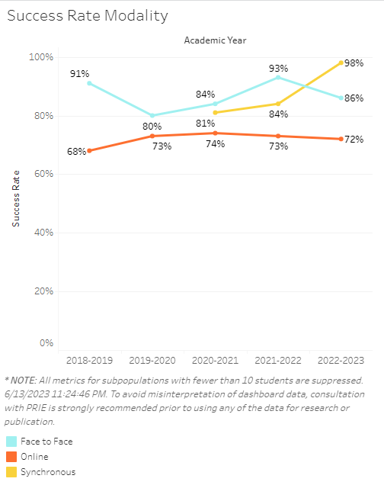
Success rates in online sections in Kinesiology, Athletics, and Dance were 7-23 percentage points lower than success rates for face-to-face sections. Success rates for synchronous sections were between online and face-to-face rates for two academic years, then surpassed the other course modalities in the most recent academic year (2022-2023).

Source: https://canadacollege.edu/prie/dashboards/disproportionate-impact.php

