Learning Center
Comprehensive Program Review Data Packet
7A. Enrollment Trends
Use the data provided by PRIE to examine your enrollments by department or courses. Describe trends in headcount, FTES, and load. If applicable, describe any other enrollment data that is relevant to your program
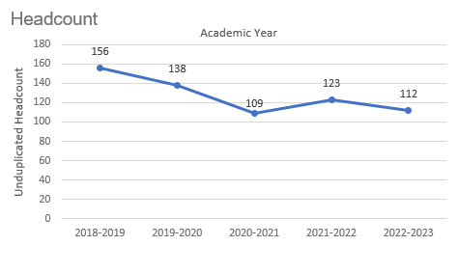
Headcount in Learning Center courses was down 28.2% in 2022-2023 (112 students) compared to 2018-2019 (156 students). Headcount declined steadily for three academic years then increased slightly for one year before decreasing again in the most recent academic year.

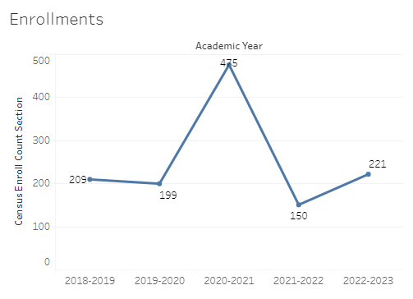
Enrollment in Learning Center courses was up 5.7% in 2022-2023 compared to five years ago in 2018-2019. Learning Center enrollments spiked to 475 for one academic year in 2020-2021.

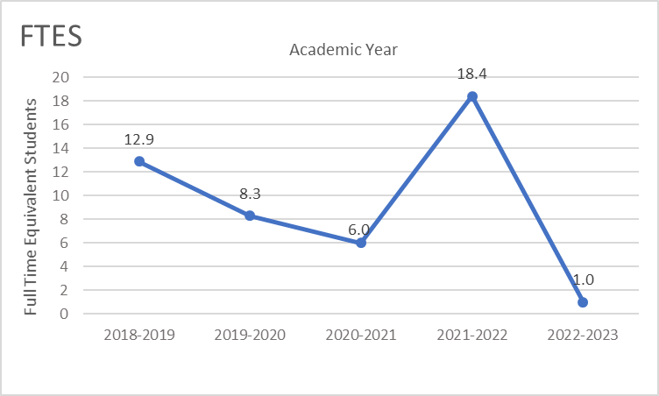
Full-time equivalent students (FTES) in the Learning Center was down 92.3% in the most recent academic year (2022-2023) compared to five years ago (2018-2019), a decrease of 11.9 FTES.

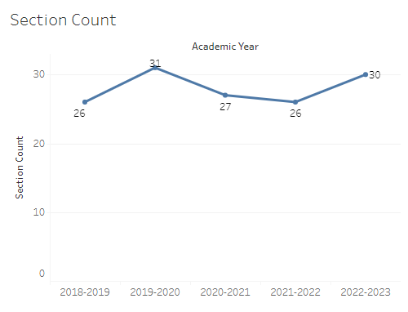
The Learning Center offered four more sections in the most recent academic year compared to five years ago (30 and 26 sections, respectively).

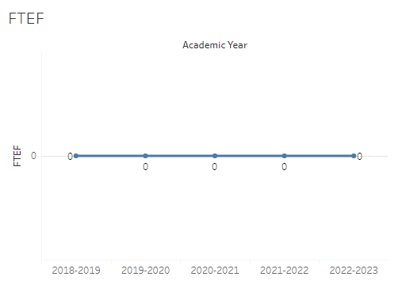
The number of full-time equivalent faculty (FTEF) in the Learning Center was zero for the last five academic years.

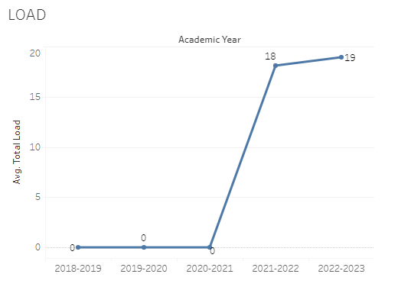
Load in the Learning Center was zero for three academic years then 18-19 for the next two years.

8A. Access & Completion
Describe the student completion and success rate in your courses and/or program using the data provided by PRIE. Look at your course offerings, in the last program review cycle was it possible for a student to complete your certificates or degrees while only completing courses at Cañada College? How can the college help you improve student completion and success? What changes could be made?

Note: See the Course Enrollment & Success Detail Report for additional course-level data. This report can be found on PRIE’s Data Dashboards & Packets page under the program name.

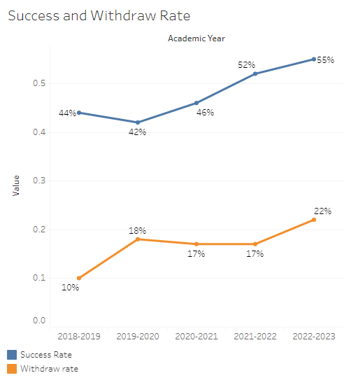
The overall success rate in Learning Center courses increased from 44% in 2018-2019 to 55% in 2022-2023. Withdraw rates in Learning Center courses also increased from 10% in 2018-2019 to 22% in 2022-2023. While a greater proportion of students in Learning Center courses were successful in the most recent academic year compared to the previous four years, a greater proportion also withdrew from the Learning Center courses in 2022-2023 (a five-year high).
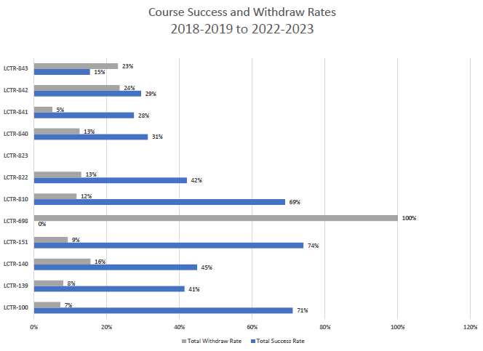
Course success rates in Learning Center courses ranged from a minimum of 15% in LCTR 843 to a maximum of 74% in LCTR 151. Withdraw rates in Learning Center courses ranged from a max of 24% in LCTR 842 (LCTR 698 was excluded) to a minimum of 5% in LCTR 841.

8B. Student Equity
One of the goals of the College’s Student Equity plan is to close the performance gaps for disproportionately impacted students. Use the data provided by PRIE that indicates which groups are experiencing a disproportionate impact in your program. Which gaps are most important for improving outcomes in your program? How can the college help you address these gaps? What changes could be made?

The Equity and Disproportionate Impact (DI) dashboard was used to identify subgroups that may have been disproportionately impacted in Learning Center courses in the most recent academic year (2022-2023). The three metrics used to examine potential disproportionate impact were enrollment rates (referred as access), success rates, and withdraw rates. The rate for each subgroup was compared to either the college-wide rate (access) or the overall program-level rate (success and withdraws). The difference between the two rates is known as the ‘gap’ and may be referred to as a performance gap or equity gap. Student subgroups that may have been disproportionately impacted in Learning Center courses appear below (see Table 1-3).
Access
Access is an indicator of what student subgroups are enrolling in courses, based on unique student counts. Enrollment data revealed one student subgroup was underrepresented in Learning Center classes compared to the college-wide population (see Table 1). The proportion of students in Learning Center courses with a total unit load considered ‘less than part-time’ (fewer than 6 units) was 14 percentage points lower than the proportion of ‘less than part-time’ students enrolled college-wide.
Table 1.
Student Subgroup | Gap
Unit Load: Less than part-time (less than 6 units) | -14.0

Success
Success is the rate at which different student subgroups pass courses and is based on enrollments. The success rate for different subgroups in Learning Center courses was compared to the overall success rate in the Learning Center. The difference between the two rates (the gap) revealed two subgroups may have been disproportionately impacted (see Table 2). The success rate for students age 23 – 28 was 37 percentage points lower than the overall success rate in Learning Center courses during the 2022-2023 academic year. The success rate for part-time students (students enrolled in 6 to 11.9 units) was 22.9 percentage points lower than the overall success rate in Learning Center courses in 2022-2023.

Table 2.
Student Subgroup | Gap
Age: 23 - 28 | -37.0
Unit Load: Part-Time (6 to 11.9 units) | -22.9

Withdraws
Withdraws is the rate at which a student withdraws from a course, with higher numbers being worse, as they indicate greater withdraw rates. The withdraw rates for subgroups in Learning Center courses were compared to the overall withdraw rate for the program. One subgroup had withdraw rates that were significantly higher than the overall rate, suggesting this group may have been disproportionately impacted in Learning Center courses. Learning Center students taking a part-time unit load (6 – 11.9 units) had withdraw rates 22.9 percentage points higher than the average withdraw rate.
Table 3.
Student Subgroup | Gap
Unit Load: Part-Time (6 to 11.9 units) | +22.9

8C. Completion – Success Online
The college has a goal of improving success in online courses. Using the data provided by PRIE, what significant gaps do you see in success between online/hybrid and non-online courses? What changes could be made to reduce these gaps? If your program does not offer online/hybrid courses, please write “not applicable”.
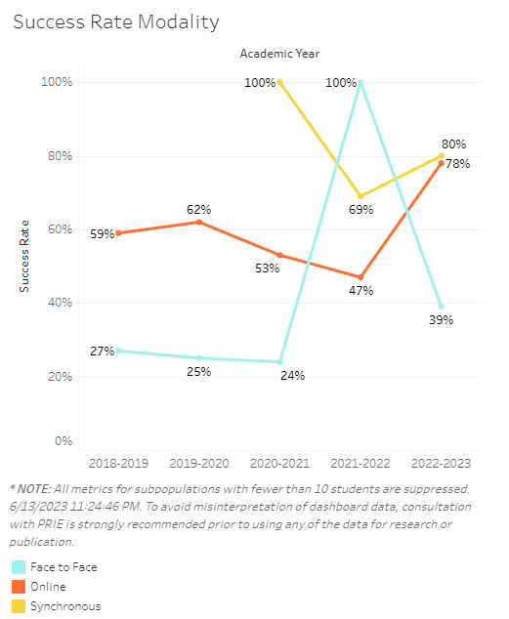
Students enrolled in online Learning Center sections tend to have higher success rates than students enrolled in face-to-face sections. Students in synchronous sections have higher success rates than those in online and face-to-face sections for two of the last three academic years.

Source: https://canadacollege.edu/prie/dashboards/disproportionate-impact.php

