Medical Assisting
Comprehensive Program Review Data Packet
7A. Enrollment Trends
Use the data provided by PRIE to examine your enrollments by department or courses. Describe trends in headcount, FTES, and load. If applicable, describe any other enrollment data that is relevant to your program
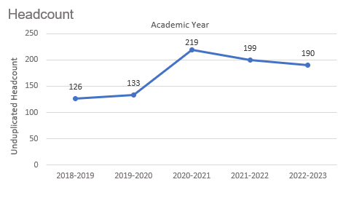
Headcount in Medical Assisting was up 50.8% in 2022-2023 (190 students) compared to 2018-2019 (126 students). Headcount peaked in 2020-2021 with 219 students.

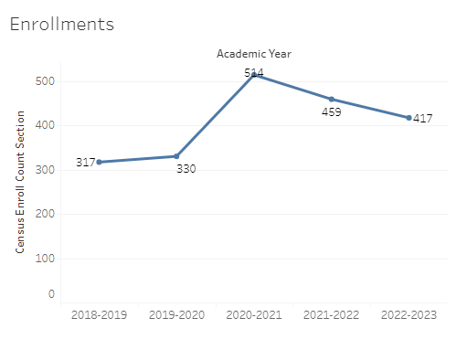
Enrollment in Medical Assisting was up 31.5% in 2022-2023 compared to five years ago in 2018-2019. The number of enrollments reached a five-year high in 2020-2021 with 514 enrollments and a five-year low of 317 enrollments in 2018-2019.

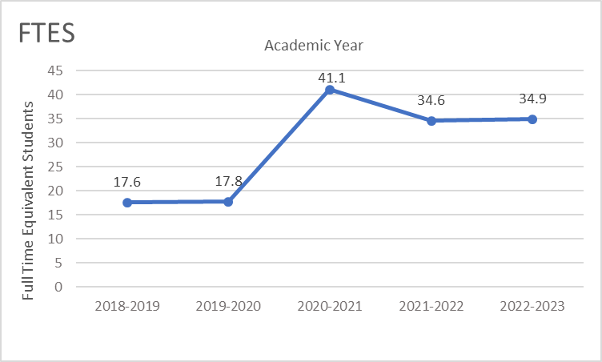
Full-time equivalent students (FTES) in Medical Assisting was up 98.3% in the most recent academic year (2022-2023) compared to five years ago (2018-2019), an increase of 17.3 FTES.

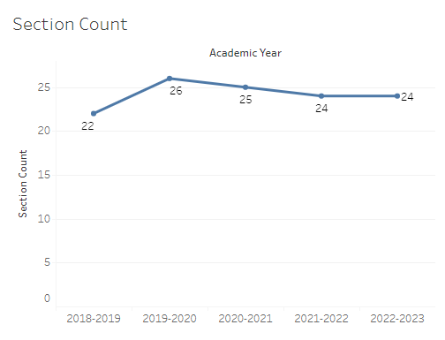
The number of sections in Medical Assisting went from 22 sections in 2018-2019 to 24 sections in 2022-2023, with a high of 26 sections in 2019-2020.

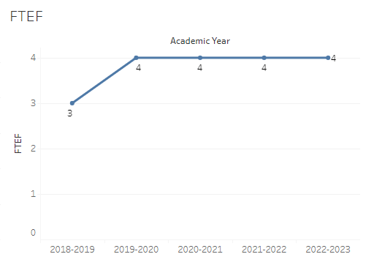
The number of full-time equivalent faculty (FTEF) in Medical Assisting went from 3 in 2018-2019 to 4 for the next four academic years.

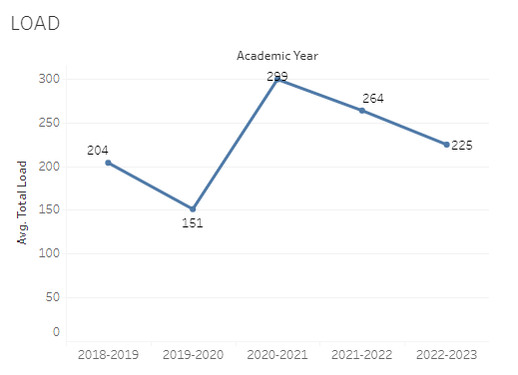
Load in Medical Assisting fluctuated over the last five academic years, with a five-year max of 299 in 2020-2021 and a five-year low of 151 in 2019-2020. Load for the most recent academic year was 225.

8A. Access & Completion
Describe the student completion and success rate in your courses and/or program using the data provided by PRIE. Look at your course offerings, in the last program review cycle was it possible for a student to complete your certificates or degrees while only completing courses at Cañada College? How can the college help you improve student completion and success? What changes could be made?

Note: See the Course Enrollment & Success Detail Report for additional course-level data. This report can be found on PRIE’s Data Dashboards & Packets page under the program name.

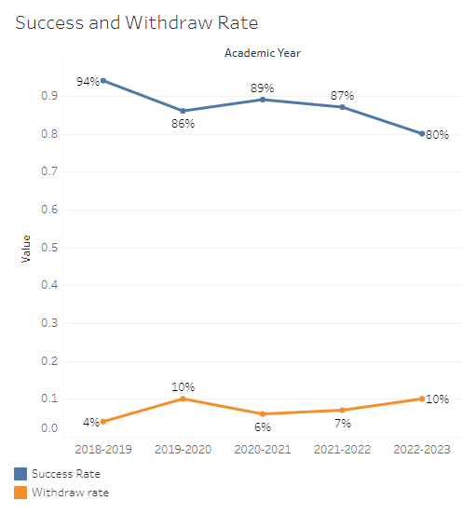
The overall success rate in Medical Assisting decreased from 94% in 2018-2019 to 80% in 2022-2023. Withdraw rates fluctuated between a high of 10% (2022-2023) and a low of 4% (2018-2019).
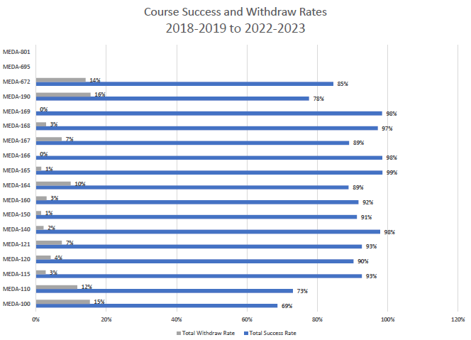
Course success rates in Medical Assisting ranged from a minimum of 69% in MEDA 100 to a maximum of 99% in MEDA 165. Course withdraw rates in Medical Assisting ranged from a max of 16% in MEDA 190 to a minimum of 0% in MEDA 166 and MEDA 169.

8B. Student Equity
One of the goals of the College’s Student Equity plan is to close the performance gaps for disproportionately impacted students. Use the data provided by PRIE that indicates which groups are experiencing a disproportionate impact in your program. Which gaps are most important for improving outcomes in your program? How can the college help you address these gaps? What changes could be made?

The Equity and Disproportionate Impact (DI) dashboard was used to identify subgroups that may have been disproportionately impacted in Medical Assisting in the most recent academic year (2022-2023). The three metrics used to examine potential disproportionate impact were enrollment rates (referred as access), success rates, and withdraw rates. The rate for each subgroup was compared to either the college-wide rate (access) or the overall program-level rate (success and withdraws). The difference between the two rates is known as the ‘gap’ and may be referred to as a performance gap or equity gap. Student subgroups that may have been disproportionately impacted in Medical Assisting appear below (see Table 1-3).
Access
Access is an indicator of what student subgroups are enrolling in courses, based on unique student counts. Enrollment data revealed five student subgroups were underrepresented in Medical Assisting classes compared to the college-wide population (see Table 1). For example, the proportion of male students in Medical Assisting (and in synchronous MEDA sections) is 29.5 percentage points lower than the proportion of male students enrolled college-wide.
Table 1.
Student Subgroup | Gap
Males | -29.5
Course Modality Synchronous: Males | -29.5
Unit Load - Less than part-time (less than 6 units) | -29.5
Not First Generation | -17.8
Not Low Income | -16.4

Success
Success is the rate at which different student subgroups pass courses and is based on enrollments. The success rate for different subgroups in Medical Assisting was compared to the overall success rate in Medical Assisting. The difference between the two rates (the gap) revealed six subgroups may have been disproportionately impacted (see Table 2). For example, the success rate for white non-Hispanic students enrolled in synchronous Medical Assisting sections was 16.5 percentage points lower than the overall success rate in synchronous Medical Assisting sections during the 2022-2023 academic year.

Table 2.
Student Subgroup | Gap
Course Modality Synchronous: White Non-Hispanic Females | -16.6
Course Modality Synchronous: White Non-Hispanic | -16.5
White Non-Hispanic | -15.8
White Non-Hispanic Females | -15.6
Age 18 - 22 | -9.3
Unit load – Full-time (12 or more units) | -9.3

Withdraws
Withdraws is the rate at which a student withdraws from a course, with higher numbers being worse, as they indicate greater withdraw rates. The withdraw rates for subgroups in Medical Assisting was compared to the overall withdraw rate for the program No disproportionate impact was found for withdraws in Medical Assisting.

8C. Completion – Success Online
The college has a goal of improving success in online courses. Using the data provided by PRIE, what significant gaps do you see in success between online/hybrid and non-online courses? What changes could be made to reduce these gaps? If your program does not offer online/hybrid courses, please write “not applicable”.
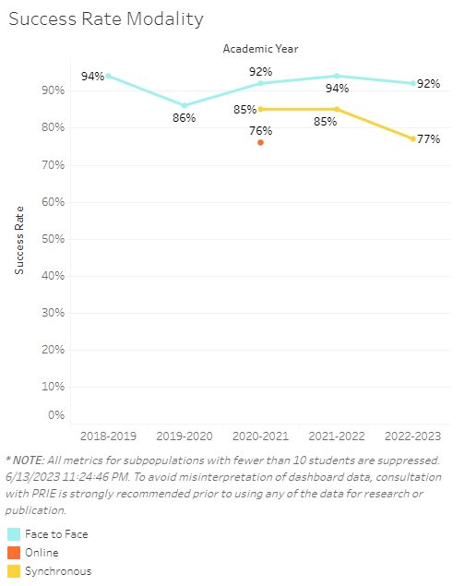
Synchronous sections in Medical Assisting were first offered in 2020-2021. For the last three academic years, success rates in synchronous sections were 7–15 percentage points lower than success rates for face-to-face sections.

Source: https://canadacollege.edu/prie/dashboards/disproportionate-impact.php

