Spanish
Comprehensive Program Review Data Packet
7A. Enrollment Trends
Use the data provided by PRIE to examine your enrollments by department or courses. Describe trends in headcount, FTES, and load. If applicable, describe any other enrollment data that is relevant to your program
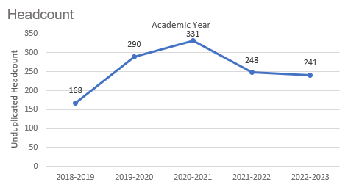
Headcount in Spanish was up 43.5% in 2022-2023 (241 students) compared to 2018-2019 (168 students). Headcount increased steadily for two academic years then decreased for the next two academic years.

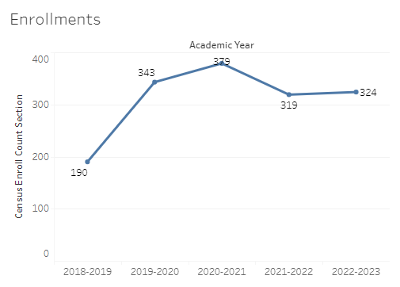
Enrollment in Spanish was up 70.5% in 2022-2023 compared to five years ago in 2018-2019. Spanish enrollment reached a five-year high in 2020-2021 with 379 enrollments and a five-year low of 190 enrollments in 2018-2019.

Full-time equivalent students (FTES) in Spanish was up 38% in the most recent academic year (2022-2023) compared to five years ago (2018-2019), an increase of 8.4 FTES.

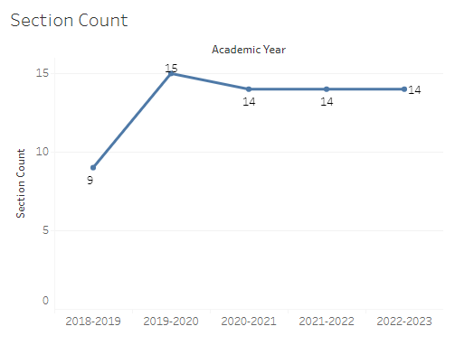
The number of sections offered in Spanish increased from 9 sections in 2018-2019 to 15 sections the following academic year. Then the section count remained at 14 for the next three academic years (2020-2021 through 2022-2023).

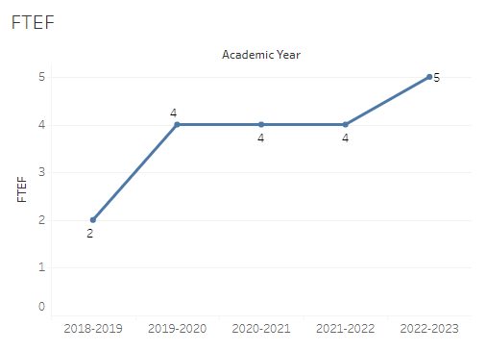
The number of full-time equivalent faculty (FTEF) in Spanish went from 2 in 2018-2019 to 4 FTEF for the next three academic years, then increased to 5 FTEF in 2022-2023.

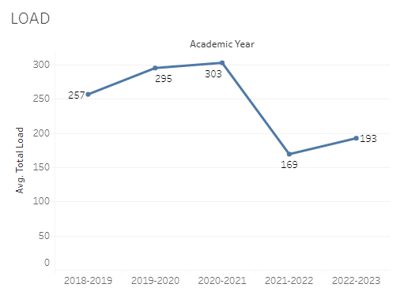
Load in Spanish fluctuated over the last five academic years with a sharp decline in 2021-2022. The highest load in Spanish occurred in 2020-2021 with 303 and the lowest load was the following academic year in 2021-2022 at 169.

8A. Access & Completion
Describe the student completion and success rate in your courses and/or program using the data provided by PRIE. Look at your course offerings, in the last program review cycle was it possible for a student to complete your certificates or degrees while only completing courses at Cañada College? How can the college help you improve student completion and success? What changes could be made?

Note: See the Course Enrollment & Success Detail Report for additional course-level data. This report can be found on PRIE’s Data Dashboards & Packets page under the program name.

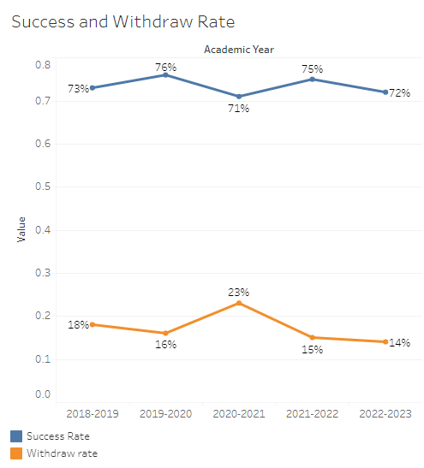
The overall success rate in Spanish was between 71% and 76% over the last five academic years. Overall withdraw rates peaked at 23% in 2020-2021 and reached a five-year low in the most recent academic year at 14% (2022-2023).
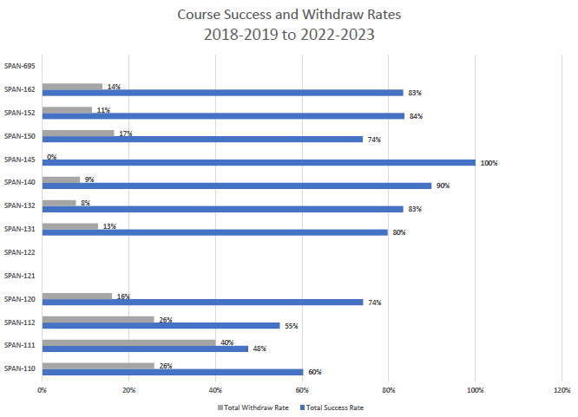
Course success rates in Spanish ranged from a minimum of 48% in SPAN 111 to a maximum of 100% in SPAN 145. Withdraw rates in Spanish ranged from a max of 40% in SPAN 111 to a minimum of 8% in SPAN 132 (SPAN 145 was excluded).
8B. Student Equity
One of the goals of the College’s Student Equity plan is to close the performance gaps for disproportionately impacted students. Use the data provided by PRIE that indicates which groups are experiencing a disproportionate impact in your program. Which gaps are most important for improving outcomes in your program? How can the college help you address these gaps? What changes could be made?

The Equity and Disproportionate Impact (DI) dashboard was used to identify subgroups that may have been disproportionately impacted in Spanish in the most recent academic year (2022-2023). The three metrics used to examine potential disproportionate impact were enrollment rates (referred as access), success rates, and withdraw rates. The rate for each subgroup was compared to either the college-wide rate (access) or the overall program-level rate (success and withdraws). The difference between the two rates is known as the ‘gap’ and may be referred to as a performance gap or equity gap. Student subgroups that may have been disproportionately impacted in Spanish appear below (see Table 1-3).
Access
Access is an indicator of what student subgroups are enrolling in courses, based on unique student counts. Enrollment data revealed one student subgroup was underrepresented in Spanish compared to the college-wide population (see Table 1). The proportion of students age 18 – 22 enrolled in Spanish during 2022-2023 academic year was 16.4 percentage points lower than the proportion of students in the same age group enrolled college-wide.
Table 1.
Student Subgroup | Gap
Age 18 - 22 | -16.4

Success
Success is the rate at which different student subgroups pass courses and is based on enrollments. The success rate for different subgroups in Spanish was compared to the overall success rate in Spanish. The difference between the two rates (the gap) revealed two subgroups may have been disproportionately impacted (see Table 2). The success rate for Asian male students was 38.6 percentage points lower than the overall success rate in Spanish during the 2022-2023 academic year. The success rate for male students enrolled in synchronous Spanish sections was 23 percentage points lower than the overall success rate for synchronous Spanish sections.
Table 2.
Student Subgroup | Gap
Asian Males | -38.6
Course Modality: Synchronous - Males | -23.0
Withdraws
Withdraws is the rate at which a student withdraws from a course, with higher numbers being worse, as they indicate greater withdraw rates. The withdraw rates for subgroups in Spanish was compared to the overall withdraw rate for the program. No disproportionate impact was found for withdraws in Spanish.

8C. Completion – Success Online
The college has a goal of improving success in online courses. Using the data provided by PRIE, what significant gaps do you see in success between online/hybrid and non-online courses? What changes could be made to reduce these gaps? If your program does not offer online/hybrid courses, please write “not applicable”.
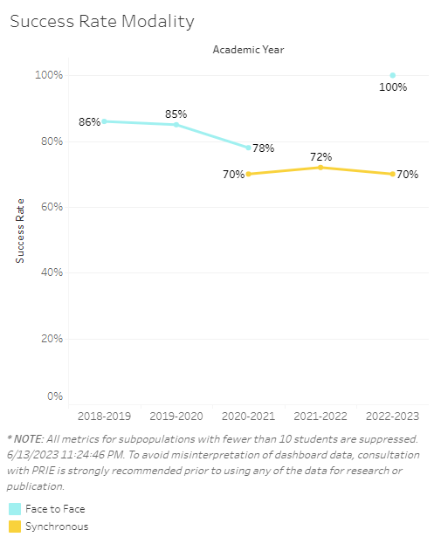
The overall success rates for synchronous Spanish sections were 6-16 percentage points lower than the success rates for face-to-face Spanish sections.

Source: https://canadacollege.edu/prie/dashboards/disproportionate-impact.php

