Safety Committee
Agenda
Thursday, January 28, 2021
11:00 am – 12:00 pm
ZOOM Meeting

- Agenda/Minutes (5 minutes)

- Report/Updates
  - Public Safety (5 minutes)
  - Facilities (5 minutes)
  - Emergency Preparedness Office (5 minutes)

- Reporting On Safety Concerns (15 minutes)
OPEN DISCUSSION:

- Committee Membership (15 minutes)
ACTION REQUIRED: Finalize Membership
FEEDBACK RECEIVED:
  - Representative from Health Center
  - Director of DRC and PCC
  - Student Life Representative
  - ITS member
  - Division Member and/or Faculty Representative
  - Public Safety Representative
  - Facilities Representative
  - PIO
  - Building Capt./ Building Manager
  - All Vice Presidents
  - President

  - EOC Staffing Organization chart which will need to be covered by Safety Committee Members:
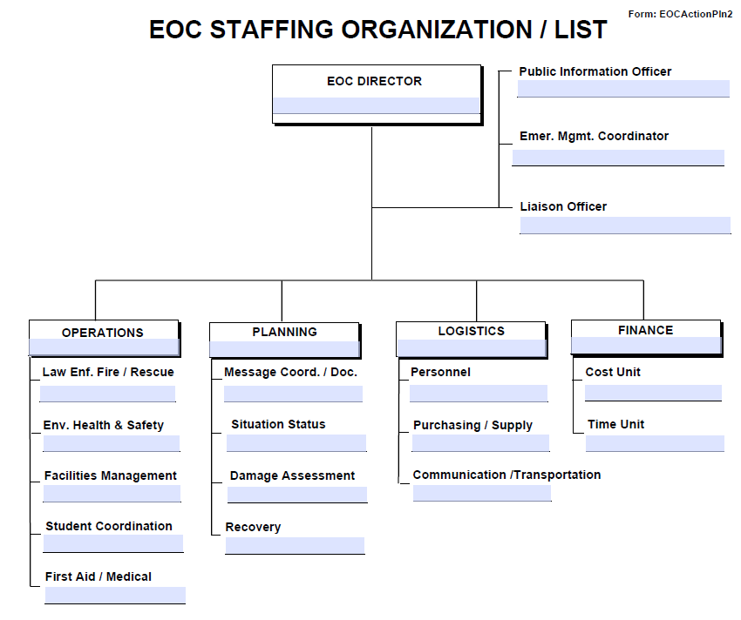

- Establishing Work Group/Teams (5 minutes)
ACTION REQUIRED: Need 2 to 3 volunteers for each work group.

    - Building Safety Infrastructure. [Building safety and training.] (Membership: Alex)
    - Chemical Safety and Hygiene. [Chemical safety on campus.] (Membership: Karen, Roz, Graciano)
    - Identifying and addressing safety concerns. (Membership: )
    - Injury/Illness Incidents. [HR/Student and Health Services/ Behavioral Intervention Team. Better understanding of health and safety regarding employee and student trends on campus.] (Membership: Max)
    - Title 9. (Membership: Michiko, Max, Adrian ) (VPSS Perez to review and make recommendations.)
    - EOC Implementation. (Membership: Mary Chries)

- Roundtable/Adjourn (5 minutes)

Future Topics:
- Finalize Committee Membership
- Establish Work Groups and Identify Volunteer Leads
    - Building Safety Infrastructure [Building safety and training.]
    - Chemical Safety and Hygiene [Chemical safety on campus.]
    - Injury/Illness Incidents: (HR/Student and Health Services/ Behavioral Intervention Team (Dean Hartman) [Better understand health and safe of employee and student trends on campus.

