Individual College Cost
Focused on Math 222/225/225+ 1st & Math 200 2nd

Requirement | Description | Price Per Unit | # Units/Faculty | Total Cost
Professional  Development | Building Thinking Classroom PD #1 in October 2023 Flex | $15000 | 1 speaker cost | $15000
Professional  Development | Building Thinking Classroom PD #2 in March/April 2024 Flex  (paid for by one sister college) | $15000 | 1 speaker cost | $15000
Professional  Development | Building Thinking Classroom PD #3 in August 2024 Flex  (paid for by other sister college) | $15000 | 1 speaker cost | $15000
Professional  Development | SLAM CoP Special Rate | $100 | 3 Semesters or 27 hours * 8 faculty | $21600
Professional  Development | B-STEM CoP Special Rate | $100 | 3 Semesters or 27 hours * 8 faculty | $21600
Professional  Development | Books | $40 | 8 faculty | $320
Professional  Development | Coordination (including collaboration with sister-college counterparts) | $20000 | 3 Semesters @ 20% FTE | $60000
Concurrent  Support | Level 2 Embedded Part-Time Instructional Aide #1 (cover salaries for existing employees of STEM/Learning Centers) | $35000 | 3 Semester @ 10 hours per week | $35000
Concurrent  Support | Level 2 Embedded Part-Time Instructional Aide #2 (cover salaries for existing employees of STEM/Learning Centers) | $35000 | 3 Semesters @ 10 hours per week | $35000
 |  |  | Total Cost | $188520

BTC Infographic #1
Specific, Coherent, A-Z Comprehensive, Research-Based, Content-Agnostic, Scalable, Math-Focused

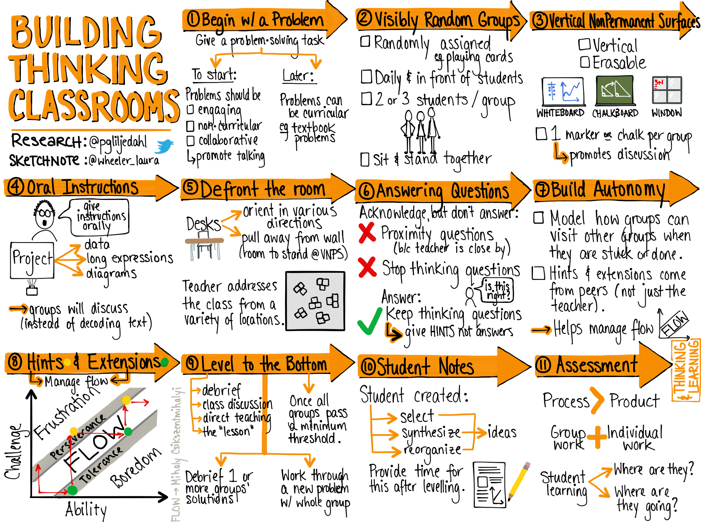

BTC Infographic #2
Specific, Coherent, A-Z Comprehensive, Research-Based, Content-Agnostic, Scalable, Math-Focused
