2016 Institutional Learning Outcomes (ILO) Assessment
Graduation Survey (Spring 2016)

Prepared for:
Planning & Budgeting Council

Prepared by:
PRIE

September 2016
Cañada College 4200 Farm Hill Blvd. Redwood City, CA 94061
Table of Contents
ILO Assessment for 2015-16 3
Background Explanation 3
Executive Summary 4
ILO 1: Critical Thinking 5
ILO 2: Creativity 6
ILO 3: Communication 7
ILO 4: Community 8
ILO 5: Quantitative Reasoning 9
Disaggregat Data 10
ILO Results, Spring 2016 10
Recommendations 19

ILO Assessment for 2015-16

Background Explanation
The College’s Institutional Learning Outcomes (ILOs) identify the knowledge, skills, abilities and attitudes that will characterize students who successfully complete a program of study. Consequently, the College surveys its prospective graduates requesting them to perform a self-assessment of their achievement of the ILOs. Although these surveys do not directly assess student performance of ILOs, in essence, the self-assessments serve as an indicator of institutional effectiveness. Survey results from students who do not apply for graduation serve as a point of comparison since they are less likely to have completed their program of study.
The College conducted a Graduation Survey May 2016. We emailed to 917 students who applied for graduation for summer 2014, fall 2015, spring 2016, and summer 2016, as well as those who claimed to transfer to 4-year universities. There were 124 students who completed the survey and the return rate was about 14%.
The College’s ILOs include:
- Critical Thinking
Select, evaluate, and use information to investigate a point of view, support a conclusion, or engage in problem solving.
- Creativity
Produce, combine, or synthesize ideas in creative ways within or across disciplines.
- Communication
Use language to effectively convey an idea or a set of facts, including the accurate use of source material and evidence according to institutional and discipline standards.
- Community
Understand and interpret various points of view that emerge from a diverse world of peoples and cultures.
- Quantitative Reasoning
Represent complex data in various mathematical forms (e.g., equations, graphs, diagrams, tables, and words) and analyze these data to draw appropriate conclusions.

Executive Summary
Overall, students rated their level of achievement from high to low on these 5 ILOs:
- ILO 4 Community (3.61)
- ILO 1 Critical Thinking (3.59)
- ILO 3 Communication (3.51)
- ILO 2 Creativity (3.51)
- ILO 5 Quantitative Reasoning (3.45)

Of participate note, the strongest responses in all ILOs items obtained by the following statements.
  - I can work effectively with diverse groups of people to accomplish a task or solve a problem. (ILO 4)
  - I can identify the contributions of people from of a different economic, social, racial or ethnic background than my own. (ILO 4)
  - I can analyze the basic elements of an argument, idea, or theory. (ILO 1)

While this result does not signify true weakness or failure, it does indicate there is opportunity for improvement.
The weakest responses were obtained by the following statements:
- I can use equations to analyze and solve problems. (ILO 5)
- I can critically analyze whether data, presented in graphs, tables or diagrams, support appropriate conclusions. (ILO5)
  - I can draw from a variety of sources and inspirations to create unique, imaginative or innovative ideas or works. (ILO2)

In terms of disaggregate data,
- Male seem slightly rated higher than female of the desired institutional learning outcomes (not statistical significant).
- In terms of ethnicity and age group, there is no specific patterns observed.

ILO 1: Critical Thinking
Select, evaluate, and use information to investigate a point of view, support a conclusion, or engage in problem solving.
Mean Score
Graduate  2014 | Graduate  2015 |  |  | Graduate 2016
N=244 |  | N=162 | N=124
3.34 |  | 3.52 | 3.59
Average of items from Table 1
1=Strongly Disagree, 2=Disagree, 3=Agree, 4=Strongly Agree
Table 1. Mean Score
ILO I: Critical Thinking-related questions | Graduate  2014  N=244 | Graduate  2015  N=162 | Graduate 2016  N=124
1. Through my educational experience at Cañada College, I can apply theories or concepts to solving practical problems. | 3.34 | 3.50 | 3.59
2. Through my educational experience at Cañada College, I can analyze the basic elements of an argument, idea, or theory. | 3.31 | 3.51 | 3.60
3. Through my educational experience at Cañada College, I can select, evaluate, and use information to support a conclusion. | 3.38 | 3.55 | 3.58

ILO 2: Creativity
Produce, combine, or synthesize ideas in creative ways within or across disciplines.
Mean Score
Graduate  2014 | Graduate  2015 |  |  |  |  | Graduate 2016
N=244 |  | N=162 |  |  | N=124
3.33 |  |  | 3.48 | 3.51
Average of items from Table 2
1=Strongly Disagree, 2=Disagree, 3=Agree, 4=Strongly Agree
Table 2
ILO 2: Creativity-related questions | Graduate  2014  N=244 | Graduate  2015  N=162 | Graduate 2016  N=124
4. Through my educational experience at Cañada College, I can draw from a variety of sources and inspirations to create unique, imaginative or innovative ideas or works. | 3.30 | 3.46 | 3.47
5. Through my educational experience at Cañada College, I can identify and evaluate multiple approaches to solving problems. | 3.31 | 3.46 | 3.52
6. Through my educational experience at Cañada College, I can apply the knowledge or skills that I acquired in one discipline to work that I do in another discipline. | 3.39 | 3.53 | 3.54

ILO 3: Communication
Use language to effectively convey an idea or a set of facts, including the accurate use of source material and evidence according to institutional and discipline standards.
Mean Score
Graduate  2014 | Graduate  2015 |  |  |  |  | Graduate 2016
N=244 |  | N=162 |  | N=124
3.37 |  |  | 3.48 |  | 3.51
Average of items from Table 3
1=Strongly Disagree, 2=Disagree, 3=Agree, 4=Strongly Agree
Table 3
ILO 3: Communication-related questions | Graduate  2014  N=244 |  | Graduate  2015  N=162 |  | Graduate 2016  N=124
7. Through my educational experience at Cañada College, I can speak clearly and effectively to convey an idea or set of facts. | 3.31 | 3.48 |  | 3.48
8. Through my educational experience at Cañada College, I can write clearly and effectively to convey an idea or set of facts. | 3.35 | 3.51 |  | 3.51
9. Through my educational experience at Cañada College, I can find and evaluate sources of information and cite sources appropriately according to institutional and discipline standards. | 3.40 | 3.45 |  | 3.52
10. Through my educational experience at Cañada College, I can integrate ideas or information from a variety of sources into a document or report. | 3.41 | 3.50 |  | 3.54

ILO 4: Community
Understand and interpret various points of view that emerge from a diverse world of peoples and cultures.
Mean Score
Graduate  2014 | Graduate  2015 |  |  |  |  | Graduate 2016
N=244 |  | N=162 |  |  | N=124
3.44 |  |  | 3.52 | 3.61

Average of items from Table 4
1=Strongly Disagree, 2=Disagree, 3=Agree, 4=Strongly Agree
Table 4
ILO 4: Community-related questions | Graduate  2014  N=244 |  | Graduate  2015  N=162 |  | Graduate 2016  N=124
11. Through my educational experience at Cañada College, I can understand the perspective of people who hold religious beliefs, political opinions, or personal values that substantially differ from my own. | 3.43 | 3.47 |  | 3.60
12. Through my educational experience at Cañada College, I can work effectively with diverse groups of people to accomplish a task or solve a problem. | 3.44 | 3.54 |  | 3.62
13. Through my educational experience at Cañada College, I can identify the contributions of people from of a different economic, social, racial or ethnic background than my own. | 3.46 | 3.54 |  | 3.62

ILO 5: Quantitative Reasoning
Represent complex data in various mathematical forms (e.g., equations, graphs, diagrams, tables, and words) and analyze these data to draw appropriate conclusions.
Mean Score
Graduate  2014 | Graduate  2015 |  |  | Graduate 2016
N=244 |  | N=162 | N=124
3.31 | 3.42 |  |  | 3.45

Average of items from Table 4
1=Strongly Disagree, 2=Disagree, 3=Agree, 4=Strongly Agree
Table 4
ILO 5: Quantitative-related questions | Graduate  2014  N=244 | Graduate  2015  N=162 | Graduate 2016  N=124
14. Through my educational experience at Cañada College, I can use equations to analyze and solve problems. | 3.32 | 3.38 | 3.37
15. Through my educational experience at Cañada College, I can make judgments and draw conclusions from data presented in graphs, tables, or diagrams. | 3.31 | 3.46 | 3.52
16. Through my educational experience at Cañada College, I can critically analyze whether data, presented in graphs, tables or diagrams, support appropriate conclusions. | 3.29 | 3.41 | 3.46

Disaggregat Data

ILO Results, Spring 2016

Total (n=124)
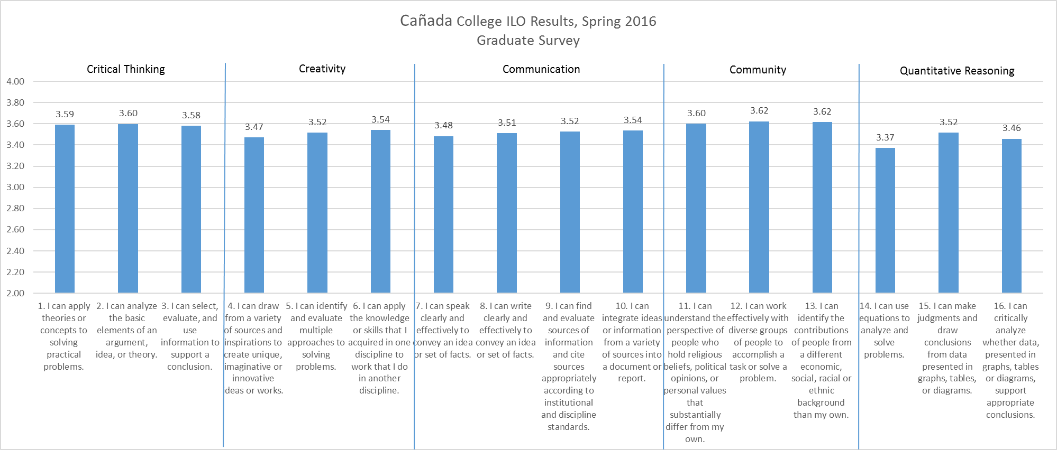

Gender

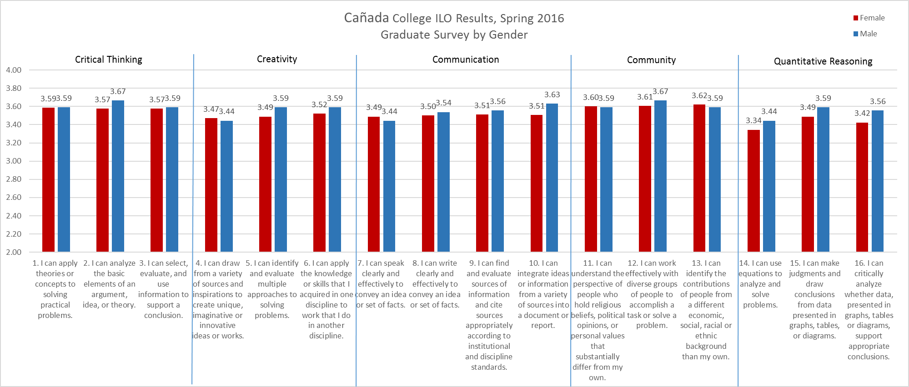
 | Female | Male | Total
Survey | 94 (74%) | 27 (26%) | 124 (100%)
College | 60% | 40% | 11,374 (Academic Year)

No statistical significant.

ETHNICITY

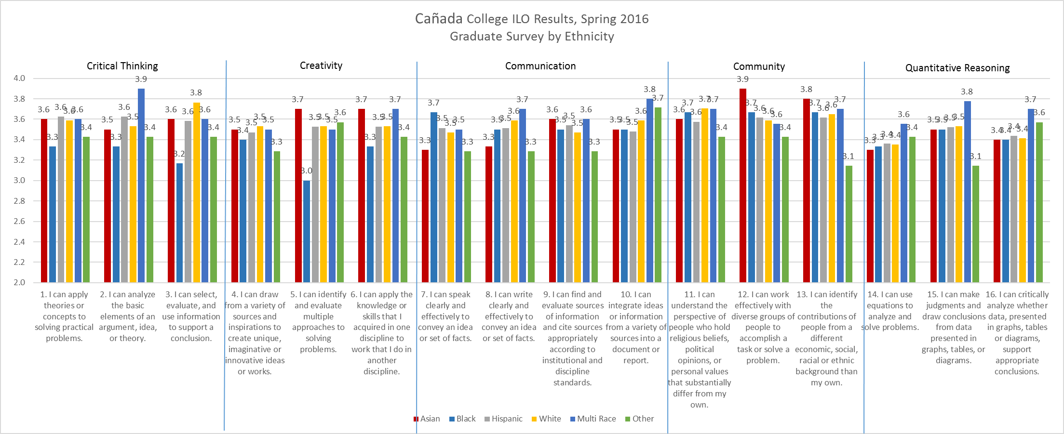

 | Asian | Black | Hispanic | White | Multi-Race | Other | Total
Survey | 10 (8%) | 6 (4%) | 72 (59%) | 17 (14%) | 10 (8%) | 7 (6%) | 124 (100%)
College | 14% | 3% | 40% | 24% | 18% |  | 11,374 (Academic Year)

Age Group
<20 years old=5; Age 20-22=30; Age 23-25=26; Age 26-30=23; Age 31-35=12; Age 41-50=13; Age 51-60=4; Total=124

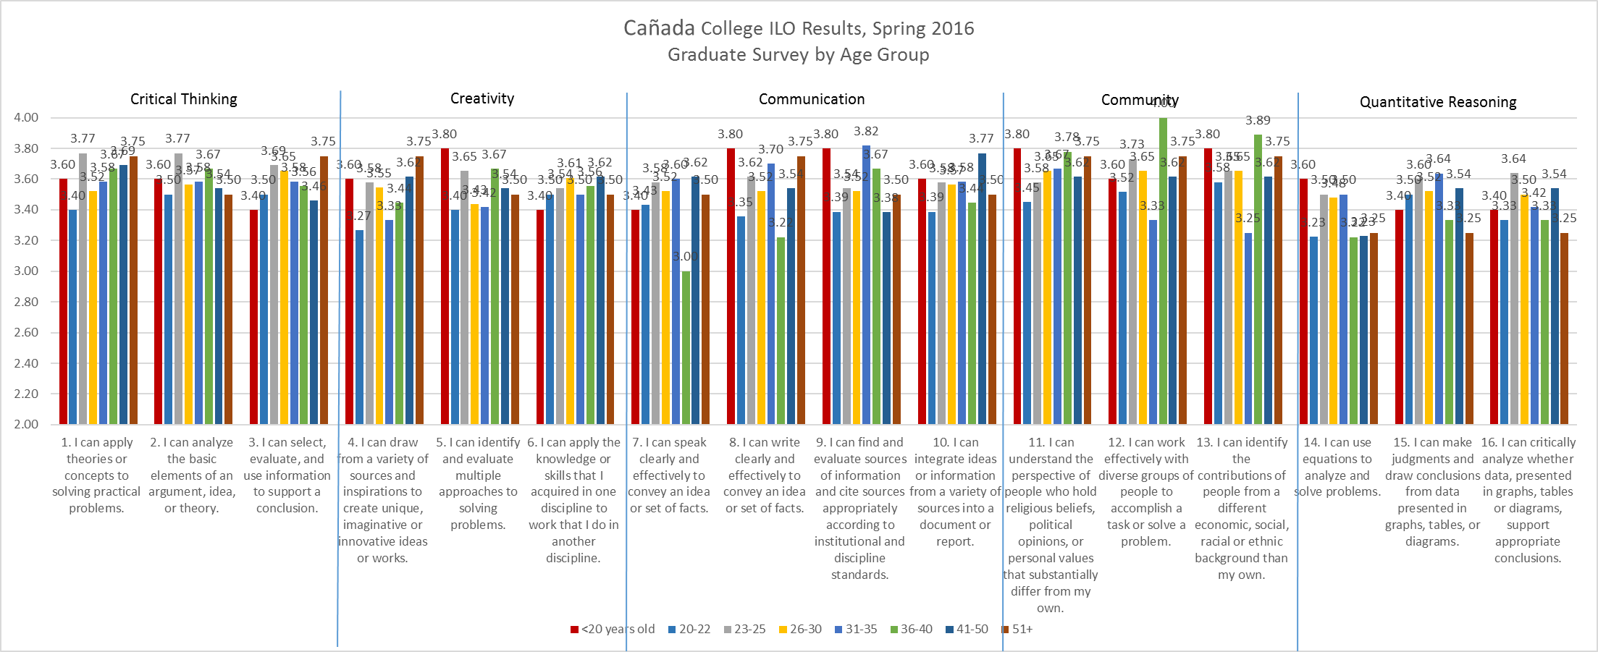

My Ethnicity is: |  | N |  |  |  | Mean
 |  | 1 Female |  | 2 Male | Total | 1 Female | 2 Male | Total
1. I can apply theories or concepts to solving practical problems. | 1 Asian |  | 4 | 6 | 10 | 3.50 | 3.67 | 3.60
 | 2 Black |  | 6 |  | 6 | 3.33 |  | 3.33
 | 3 Hispanic |  | 58 | 14 | 72 | 3.62 | 3.64 | 3.63
 | 4 White |  | 13 | 4 | 17 | 3.54 | 3.75 | 3.59
 | 5 Multi Race |  | 7 | 2 | 9 | 3.57 | 3.50 | 3.56
 | 6 Other |  | 6 | 1 | 7 | 3.67 | 2.00 | 3.43
 | Total |  | 94 | 27 | 121 | 3.59 | 3.59 | 3.59
2. I can analyze the basic elements of an argument, idea, or theory. | 1 Asian |  | 4 | 6 | 10 | 3.50 | 3.67 | 3.60
 | 2 Black |  | 6 |  | 6 | 3.17 |  | 3.17
 | 3 Hispanic |  | 58 | 14 | 72 | 3.60 | 3.50 | 3.58
 | 4 White |  | 13 | 4 | 17 | 3.69 | 4.00 | 3.76
 | 5 Multi Race |  | 7 | 2 | 9 | 3.57 | 3.50 | 3.56
 | 6 Other |  | 6 | 1 | 7 | 3.50 | 3.00 | 3.43
 | Total |  | 94 | 27 | 121 | 3.57 | 3.59 | 3.58
3. I can select, evaluate, and use information to support a conclusion. | 1 Asian |  | 4 | 6 | 10 | 3.25 | 3.67 | 3.50
 | 2 Black |  | 6 |  | 6 | 3.33 |  | 3.33
 | 3 Hispanic |  | 58 | 14 | 72 | 3.64 | 3.57 | 3.63
 | 4 White |  | 13 | 4 | 17 | 3.38 | 4.00 | 3.53
 | 5 Multi Race |  | 7 | 2 | 9 | 3.86 | 4.00 | 3.89
 | 6 Other |  | 6 | 1 | 7 | 3.50 | 3.00 | 3.43
 | Total |  | 94 | 27 | 121 | 3.57 | 3.67 | 3.60

My Ethnicity is: |  | N |  |  |  | Mean
 |  | 1 Female |  | 2 Male | Total | 1 Female | 2 Male | Total
4. I can draw from a variety of sources and inspirations to create unique, imaginative or innovative ideas or works. | 1 Asian |  | 4 | 6 | 10 | 3.50 | 3.50 | 3.50
 | 2 Black |  | 5 |  | 5 | 3.40 |  | 3.40
 | 3 Hispanic |  | 58 | 14 | 72 | 3.50 | 3.36 | 3.47
 | 4 White |  | 13 | 4 | 17 | 3.46 | 3.75 | 3.53
 | 5 Multi Race |  | 7 | 2 | 9 | 3.43 | 3.50 | 3.44
 | 6 Other |  | 6 | 1 | 7 | 3.33 | 3.00 | 3.29
 | Total |  | 93 | 27 | 120 | 3.47 | 3.44 | 3.47
5. I can identify and evaluate multiple approaches to solving problems. | 1 Asian |  | 4 | 6 | 10 | 3.50 | 3.83 | 3.70
 | 2 Black |  | 6 |  | 6 | 3.00 |  | 3.00
 | 3 Hispanic |  | 58 | 14 | 72 | 3.52 | 3.57 | 3.53
 | 4 White |  | 13 | 4 | 17 | 3.46 | 3.75 | 3.53
 | 5 Multi Race |  | 7 | 2 | 9 | 3.43 | 3.50 | 3.44
 | 6 Other |  | 6 | 1 | 7 | 3.83 | 2.00 | 3.57
 | Total |  | 94 | 27 | 121 | 3.49 | 3.59 | 3.51
6. I can apply the knowledge or skills that I acquired in one discipline to work that I do in another discipline. | 1 Asian |  | 4 | 6 | 10 | 3.75 | 3.67 | 3.70
 | 2 Black |  | 6 |  | 6 | 3.33 |  | 3.33
 | 3 Hispanic |  | 58 | 14 | 72 | 3.53 | 3.50 | 3.53
 | 4 White |  | 13 | 4 | 17 | 3.46 | 3.75 | 3.53
 | 5 Multi Race |  | 7 | 2 | 9 | 3.57 | 4.00 | 3.67
 | 6 Other |  | 6 | 1 | 7 | 3.50 | 3.00 | 3.43
 | Total |  | 94 | 27 | 121 | 3.52 | 3.59 | 3.54

My Ethnicity is: |  | N |  |  |  |  |  | Mean
 |  | 1 Female |  | 2 Male |  | Total |  | 1 Female |  | 2 Male |  | Total
7. I can speak clearly and effectively to convey an idea or set of facts. | 1 Asian | 4 | 6 |  | 10 |  | 3.50 |  | 3.17 |  | 3.30
 | 2 Black | 6 |  |  | 6 |  | 3.67 |  |  |  | 3.67
 | 3 Hispanic | 56 | 14 |  | 70 |  | 3.52 |  | 3.50 |  | 3.51
 | 4 White | 13 | 4 |  | 17 |  | 3.46 |  | 3.50 |  | 3.47
 | 5 Multi Race | 7 | 2 |  | 9 |  | 3.29 |  | 4.00 |  | 3.44
 | 6 Other | 6 | 1 |  | 7 |  | 3.33 |  | 3.00 |  | 3.29
 | Total | 92 | 27 |  | 119 |  | 3.49 |  | 3.44 |  | 3.48
8. I can write clearly and effectively to convey an idea or set of facts. | 1 Asian | 4 | 5 |  | 9 |  | 3.50 |  | 3.20 |  | 3.33
 | 2 Black | 6 |  |  | 6 |  | 3.50 |  |  |  | 3.50
 | 3 Hispanic | 58 | 14 |  | 72 |  | 3.52 |  | 3.50 |  | 3.51
 | 4 White | 13 | 4 |  | 17 |  | 3.46 |  | 4.00 |  | 3.59
 | 5 Multi Race | 7 | 2 |  | 9 |  | 3.57 |  | 4.00 |  | 3.67
 | 6 Other | 6 | 1 |  | 7 |  | 3.33 |  | 3.00 |  | 3.29
 | Total | 94 | 26 |  | 120 |  | 3.50 |  | 3.54 |  | 3.51
9. I can find and evaluate sources of information and cite sources appropriately according to institutional and discipline standards. | 1 Asian | 4 | 6 |  | 10 |  | 3.25 |  | 3.83 |  | 3.60
 | 2 Black | 6 |  |  | 6 |  | 3.50 |  |  |  | 3.50
 | 3 Hispanic | 58 | 14 |  | 72 |  | 3.57 |  | 3.43 |  | 3.54
 | 4 White | 13 | 4 |  | 17 |  | 3.46 |  | 3.50 |  | 3.47
 | 5 Multi Race | 7 | 2 |  | 9 |  | 3.43 |  | 4.00 |  | 3.56
 | 6 Other | 6 | 1 |  | 7 |  | 3.33 |  | 3.00 |  | 3.29
 | Total | 94 | 27 |  | 121 |  | 3.51 |  | 3.56 |  | 3.52
10. I can integrate ideas or information from a variety of sources into a document or report. | 1 Asian | 4 | 6 |  | 10 |  | 3.25 |  | 3.67 |  | 3.50
 | 2 Black | 6 |  |  | 6 |  | 3.50 |  |  |  | 3.50
 | 3 Hispanic | 59 | 14 |  | 73 |  | 3.46 |  | 3.57 |  | 3.48
 | 4 White | 13 | 4 |  | 17 |  | 3.54 |  | 3.75 |  | 3.59
 | 5 Multi Race | 7 | 2 |  | 9 |  | 3.71 |  | 4.00 |  | 3.78
 | 6 Other | 6 | 1 |  | 7 |  | 3.83 |  | 3.00 |  | 3.71
 | Total | 95 | 27 |  | 122 |  | 3.51 |  | 3.63 |  | 3.53

My Ethnicity is: |  | N |  |  |  | Mean
 |  | 1 Female | 2 Male | Total | 1 Female |  | 2 Male | Total
11. I can understand the perspective of people who hold religious beliefs, political opinions, or personal values that substantially differ from my own. | 1 Asian | 4 | 6 | 10 | 3.50 |  | 3.67 | 3.60
 | 2 Black | 6 |  | 6 | 3.67 |  |  | 3.67
 | 3 Hispanic | 59 | 14 | 73 | 3.58 |  | 3.57 | 3.58
 | 4 White | 13 | 4 | 17 | 3.69 |  | 3.75 | 3.71
 | 5 Multi Race | 7 | 2 | 9 | 3.57 |  | 4.00 | 3.67
 | 6 Other | 6 | 1 | 7 | 3.67 |  | 2.00 | 3.43
 | Total | 95 | 27 | 122 | 3.60 |  | 3.59 | 3.60
12. I can work effectively with diverse groups of people to accomplish a task or solve a problem. | 1 Asian | 4 | 6 | 10 | 4.00 |  | 3.83 | 3.90
 | 2 Black | 6 |  | 6 | 3.67 |  |  | 3.67
 | 3 Hispanic | 59 | 14 | 73 | 3.63 |  | 3.57 | 3.62
 | 4 White | 13 | 4 | 17 | 3.54 |  | 3.75 | 3.59
 | 5 Multi Race | 6 | 2 | 8 | 3.33 |  | 4.00 | 3.50
 | 6 Other | 6 | 1 | 7 | 3.50 |  | 3.00 | 3.43
 | Total | 94 | 27 | 121 | 3.61 |  | 3.67 | 3.62
13. I can identify the contributions of people from a different economic, social, racial or ethnic background than my own. | 1 Asian | 4 | 6 | 10 | 4.00 |  | 3.67 | 3.80
 | 2 Black | 6 |  | 6 | 3.67 |  |  | 3.67
 | 3 Hispanic | 59 | 14 | 73 | 3.63 |  | 3.57 | 3.62
 | 4 White | 13 | 4 | 17 | 3.62 |  | 3.75 | 3.65
 | 5 Multi Race | 7 | 2 | 9 | 3.57 |  | 4.00 | 3.67
 | 6 Other | 6 | 1 | 7 | 3.33 |  | 2.00 | 3.14
 | Total | 95 | 27 | 122 | 3.62 |  | 3.59 | 3.61

My Ethnicity is: |  | N |  |  | Mean
 |  | 1 Female | 2 Male | Total | 1 Female | 2 Male | Total
14. I can use equations to analyze and solve problems. | 1 Asian | 4 | 6 | 10 | 3.25 | 3.33 | 3.30
14. I can use equations to analyze and solve problems. | 2 Black | 6 |  | 6 | 3.33 |  | 3.33
14. I can use equations to analyze and solve problems. | 3 Hispanic | 58 | 14 | 72 | 3.34 | 3.43 | 3.36
14. I can use equations to analyze and solve problems. | 4 White | 13 | 4 | 17 | 3.23 | 3.75 | 3.35
14. I can use equations to analyze and solve problems. | 5 Multi Race | 6 | 2 | 8 | 3.50 | 3.50 | 3.50
14. I can use equations to analyze and solve problems. | 6 Other | 6 | 1 | 7 | 3.50 | 3.00 | 3.43
14. I can use equations to analyze and solve problems. | Total | 93 | 27 | 120 | 3.34 | 3.44 | 3.37
15. I can make judgments and draw conclusions from data presented in graphs, tables, or diagrams. | 1 Asian | 4 | 6 | 10 | 3.50 | 3.50 | 3.50
 | 2 Black | 6 |  | 6 | 3.50 |  | 3.50
 | 3 Hispanic | 57 | 14 | 71 | 3.49 | 3.64 | 3.52
 | 4 White | 13 | 4 | 17 | 3.46 | 3.75 | 3.53
 | 5 Multi Race | 6 | 2 | 8 | 3.67 | 4.00 | 3.75
 | 6 Other | 6 | 1 | 7 | 3.33 | 2.00 | 3.14
 | Total | 92 | 27 | 119 | 3.49 | 3.59 | 3.51
16. I can critically analyze whether data, presented in graphs, tables or diagrams, support appropriate conclusions. | 1 Asian | 4 | 6 | 10 | 3.50 | 3.33 | 3.40
 | 2 Black | 5 |  | 5 | 3.40 |  | 3.40
 | 3 Hispanic | 57 | 14 | 71 | 3.40 | 3.57 | 3.44
 | 4 White | 13 | 4 | 17 | 3.31 | 3.75 | 3.41
 | 5 Multi Race | 7 | 2 | 9 | 3.57 | 4.00 | 3.67
 | 6 Other | 6 | 1 | 7 | 3.67 | 3.00 | 3.57
 | Total | 92 | 27 | 119 | 3.42 | 3.56 | 3.45

Recommendations
- Continue using these assessment tools in order to determine if the patterns we are observing persist over time.
- Ask ACES (Academic Committee for Equity and Success) to provide IPC, SSPC, APC with relevant information to facilitate discussion of the significance of these assessment results from an equity and success perspective.

