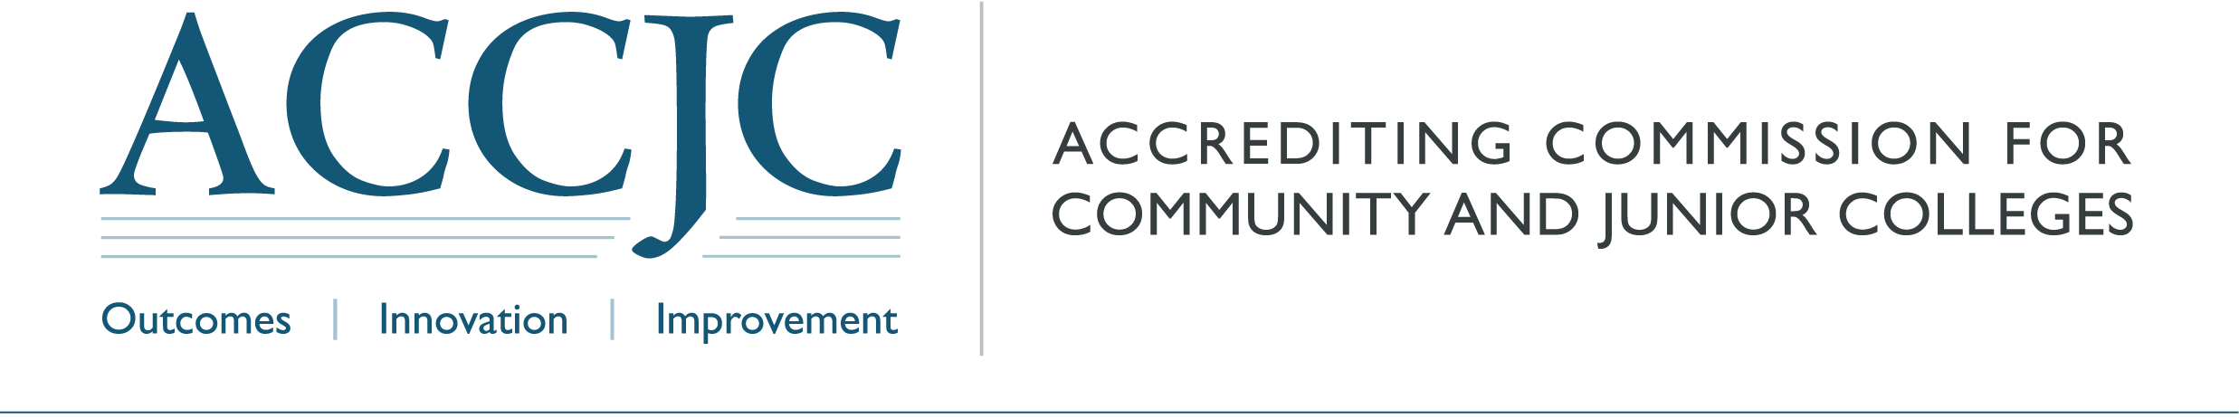
 | Date: | January 29, 2024
 | To: | Accreditation Liaison Officers of ACCJC Member Institutions
 | From: | Kevin Bontenbal, Vice President
 | Subject: | Distance Education Approval
ACCJC has recently updated its Policy on Substantive Change and Substantive Change Manual and has clarified distance education approval requirements as seen in the U.S. Department of Education’s Letter on Accreditation and Eligibility Requirements for Distance Education.

If your institution has received initial approval from ACCJC to offer programs in the distance education modality, you can continue offering those programs in this modality. However, please notify us within 30 days, through our Substantive Change Inquiry Form, of any new or existing programs where 50 percent or more of the total program (including General Education courses) will be offered via distance education.

Additionally, if one or both of the following apply, you must receive additional Substantive Change approval from ACCJC:
- 50 percent or more of your total student population is enrolled in at least one course offered through distance education, or
- 50 percent or more of all your institution’s courses are offered via distance education.

To receive approval, please submit the Substantive Change Inquiry Form by March 1, 2024. Please choose “Distance Education Approval” as the type of change and indicate which circumstance applies. We will follow up within five days with the approval application for you to complete. According to our updated policy and as indicated in the manual, this type of change will require review and approval by ACCJC senior staff (Administrative Approval). There is no fee for substantive changes eligible for Administrative Approval.

If you have any questions, please reach out to me at kbontenbal@accjc.org or Elizabeth Dutton at edutton@accjc.org.

