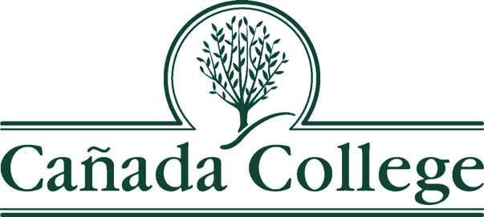

Agenda for Administrative Planning Council

Friday, September 20, 2019
11:00 A.M. – 11:55 A.M.
Building 8, Room 110

AGENDA ITEM | FACILITATOR | TIME
1. Agenda/Minutes | Graciano Mendoza | 5 min
2. APC Bylaws –Final Version | Graciano Mendoza | 5 min
3. Accreditation Update  -Prep  -Meetings/Schedule  -Events | Karen Engel | 20 min
4. Program Planning and Resource Request Process for  FY 2020-21. | Karen Engel and Graciano Mendoza | 20 min
5. Future Meeting Dates:  -October 1, 2019  -November 22, 2019  -January 24, 2020  -March 27, 2020  -May 22, 2020  -July 24, 2020 | Graciano | 5 min

Next Meeting: October 1st, 2019. The meeting will be held from 11:00am to 11:55am at B8-119.

Standard Calendar items

- Accreditation related review and recommendation (Fall)
- Evaluation of the Participatory Governance Process and Action Plan (Spring)
- Evaluation of Program Review and program review process (Spring)
- Dialogue of SAO (Service Area Outcome) (Spring)
- Evaluation/update of resource requests (Spring)

