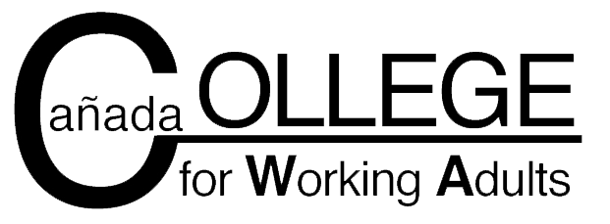

Statement of Commitment

The College for Working Adults gives working adults the opportunity to earn three Associate in Arts degrees in three years while attending class nights and weekends. CWA students may complete one or more of the following degrees:

- AA-T in Psychology
- AA in Interdisciplinary Studies with an Emphasis in Social and Behavioral Sciences
- AA in Interdisciplinary Studies with an Emphasis in Arts and Humanities
- AA in Economics

While enrolled in the College for Working Adults, I commit to the following:
- I will take the courses listed in the CWA curriculum plan.
- I understand that any course taken outside the program requires prior approval from the CWA Counselor/Project Director/Faculty Coordinator.
- I will pay my student fees in full each semester. I understand that I will be dropped from my classes if I do not meet the payment deadline for student fees.
- I will meet in-person or via telephone with the CWA counselor each semester to update my Student Education Plan.
- I will notify the CWA Counselor/Project Director/Faculty Coordinator if I want to drop or withdraw from a course.
- I will organize my work and personal obligations around my class schedule to allow adequate time to attend all class meetings.
- I understand that three (3) absences in a Thursday class or two (2) absences in a Saturday class are considered “excessive absence” and may result in the instructor dropping me from the class.
- I will fulfill the requirements outlined in the syllabus for each course.
My initials above confirms that I have read and agree to the program requirements listed. Failure to comply with these requirements may result in dismissal from the CWA program.

___________________________________
Student Signature

____________________________________ _____________________
Student Name (printed) Date

