Cañada College
Intern Scan Summary
Fall 2021

As part of Cañada’s educational master planning process in 2021-22, the Office of Planning, Research & Institutional Effectiveness conducted a scan of all of the salient internal institutional metrics, including all of those included in the College Scorecard (Institution Set Standards). The Scan included an analysis of all aspects of the student journey: student access, matriculation, course success, completion, and program of study completion. Wherever possible, the data was disaggregated to enable a deeper understanding of inequity and bias in student outcomes.
The Scan also included a more nuanced analysis of the different types of journeys students experience at Cañada, and an effort to understand the challenges experiences by part-time students in particular. The impact of the pandemic on student preferences for instructional modalities as well as some of the main reasons students stopped out during the pandemic were also considered. A more in-depth analysis of the College course schedule and its possible impact on student momentum is also presented.
The COVID-19 pandemic impacted many of the internal metrics on which basis Cañada measures its ability to effectively serve students as they seek to achieve their educational goals. In most cases, the pandemic exacerbated pre-existing trends, such as the decline in full-time equivalent students (FTES) as well as the decline in the percentage of students enrolled at Cañada who are seeking a degree or certificate from Cañada.
This document highlights some of the most salient findings of the Internal Scan.

Enrollment

- For over the last 10 years, Cañada has experienced a decline in enrollment. The COVID-19 pandemic exacerbated this trend. Most pronounced is the decline in Full Time Equivalent Students (FTES). Possible contributing factors include: (1) an increase in the number of Skyline and CSM students taking a course at Cañada (swirl); (2) students taking fewer units, on average, during the pandemic; and (3) Cañada discontinuing the use of TBA hours in its schedule in 2014.
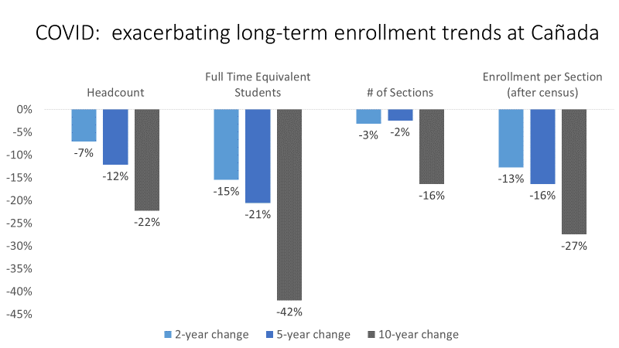
- Cañada’s share of Full Time Equivalent Students is declining faster than those shares at Skyline and College of San Mateo, which impacts the funding allocated to Cañada from the District.
- Prior to the pandemic, Cañada had the lowest % of Full Time Equivalent Students (FTES) of 41 comparable community colleges in California, including its sister colleges:
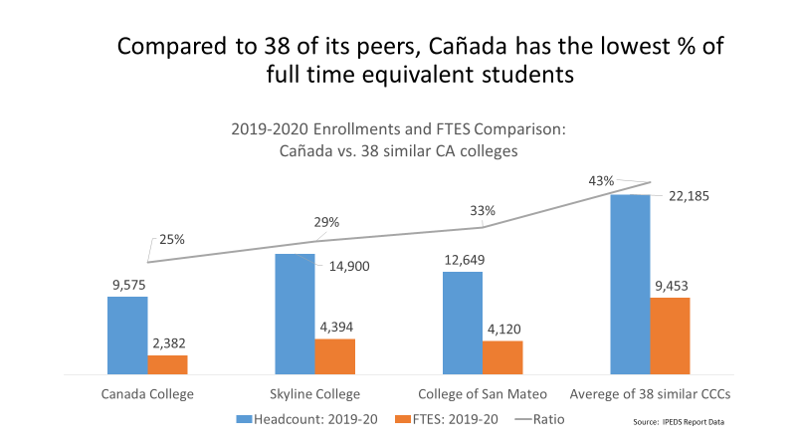

- During the pandemic, Cañada is seeing a decline in the % of its enrolled students who are seeking a degree or certificate from Cañada (as opposed to Skyline or CSM):
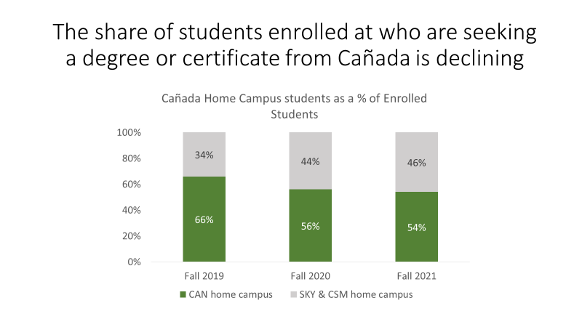

Enrollment Management

- During the COVID-19 pandemic, about 10% of continuing students stopped out (between Fall 2019 and Fall 2021). The College also experienced an overall decline in the number of first-time students (down 12% between Fall 2019 and Fall 2021).
- When surveyed in spring 2021, stopped out students across the District reported that the top two reasons they stopped out included: (1) Needing to prioritize employment; and (2) Not preferring to enroll in online classes.
- The two most important things the San Mateo Colleges could do to support the return to college of stopped out students in the future included: (1) more scheduling options (help getting courses they want when they want them); and (2) financial support.
- Cañada offers the vast majority of course sections between the hours of 9 a.m. and 12 noon, Monday-Thursday. As a result, many courses are offered at the same time and students frequently must choose and cannot take all of the classes at Cañada that they might need.
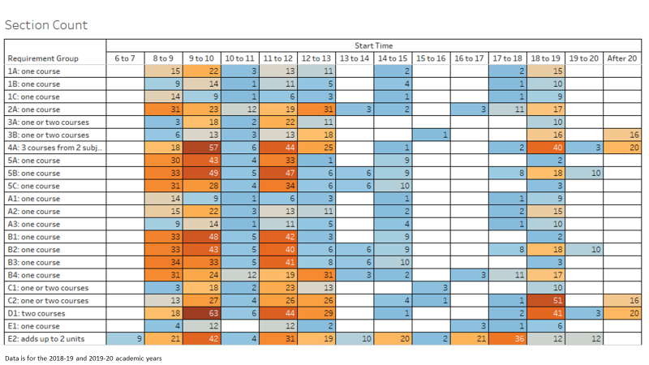
- The impact of scheduling classes on a Monday-Wednesday block, rather than a Monday-Wednesday-Friday block, results in more course conflicts:
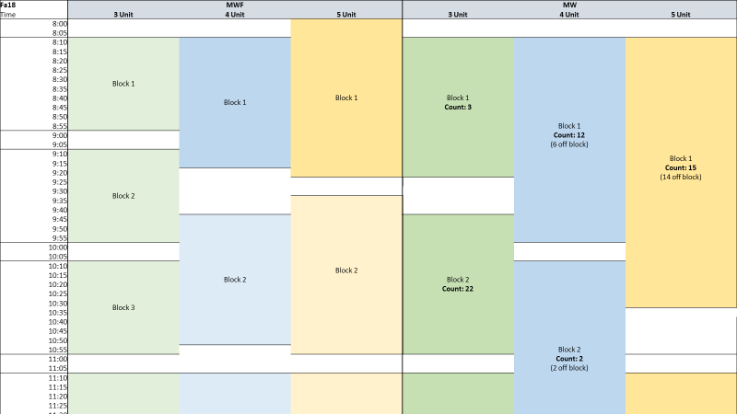

- Now that students have more opportunities to take classes online at Skyline and CSM, Cañada is seeing a smaller share of its home campus students take both core and selective courses at Cañada:
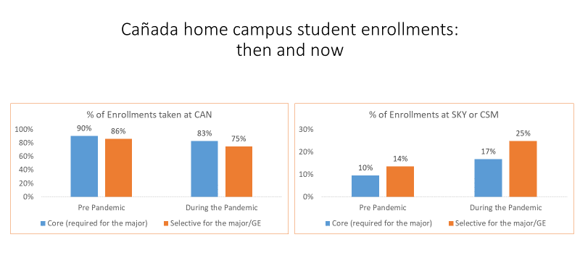

Access

- When US Census data on income and educational attainment are compared to the proportion of the County population and the percentage of students enrolling in the San Mateo CCD Colleges, several communities in the Cañada service area are underserved, including parts of Redwood City, North Fair Oaks, Belle Haven, and East Palo Alto:

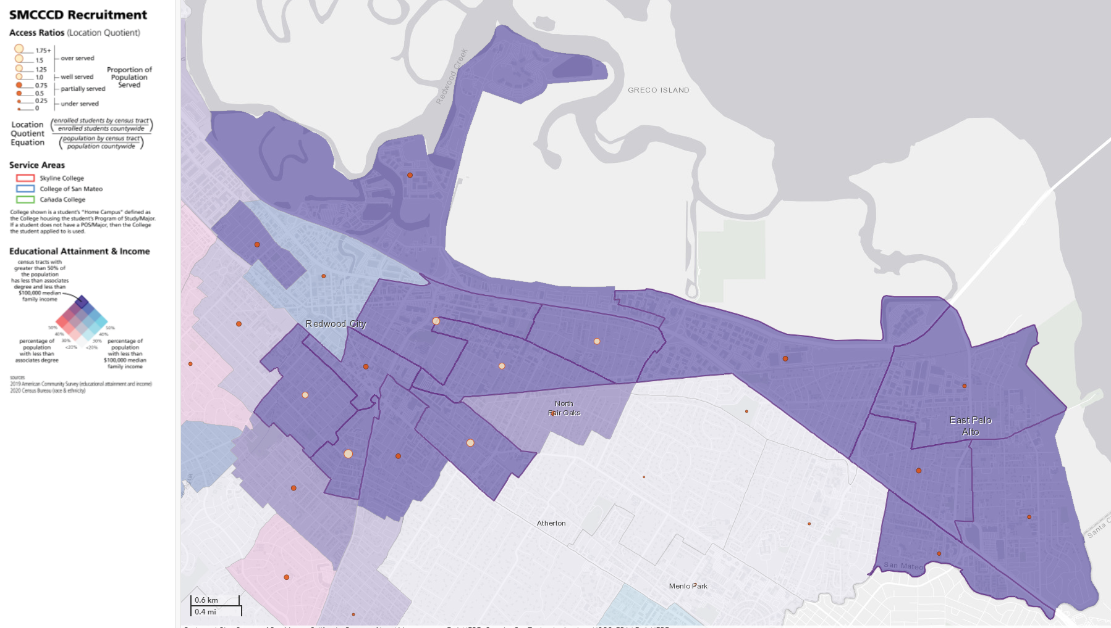

- Overall, the number of students enrolling in a course at Cañada during the same or subsequent year of applying to Cañada has declined since 2016-17:
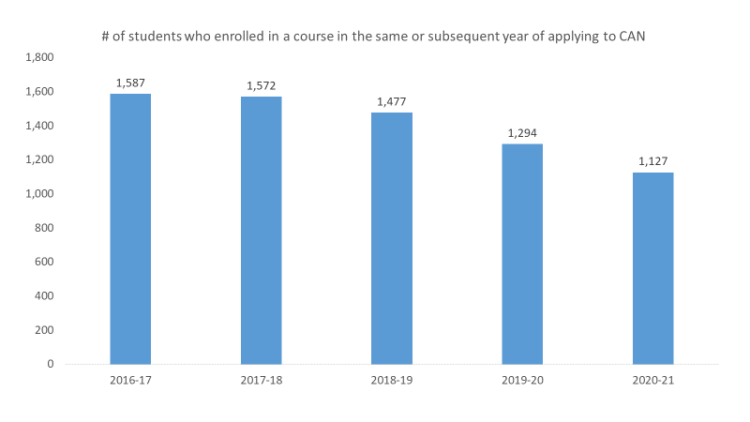
- The percentage of enrolled students who are low income and accessing financial aid has also declined over the last five years:
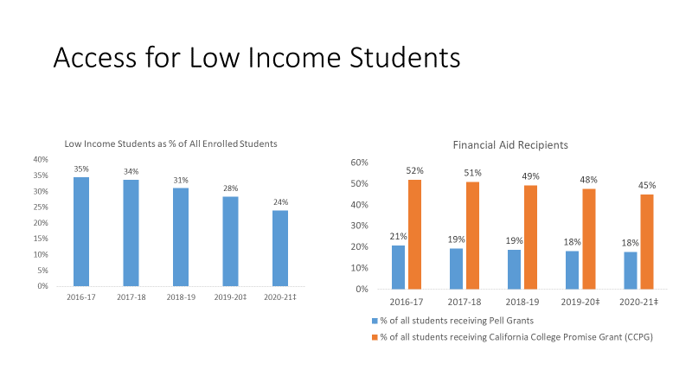
- Cañada home campus students (those seeking a degree or certificate from Cañada) are more likely to be low income, slightly older, female and Hispanic, than Skyline and CSM home campus students.
- During the pandemic years, some student populations were more negatively impacted in terms of their access of the college than others, with the greatest declines occurring among low income, Black, Indigenous Persons of Color (BIPOC) students. ESL students, first generation students and disabled students were also saw severe declines in their enrollments at Cañada during the pandemic.
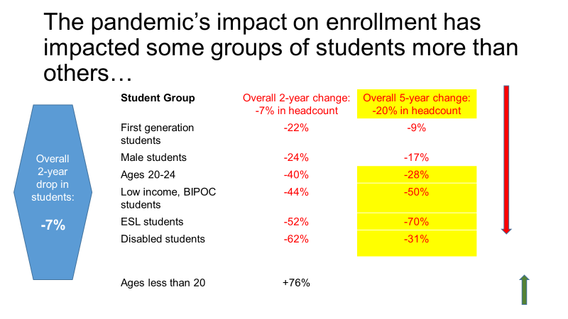

Student Momentum

- BIPOC students continue to be negatively disproportionately impacted in terms of their course success rates at Cañada.
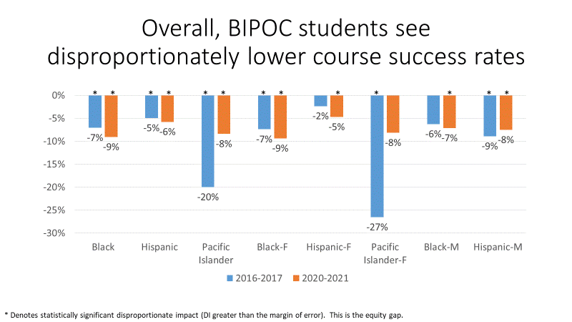
- This trend is more pronounced in online courses, even as the College is improving its overall online course success rate.
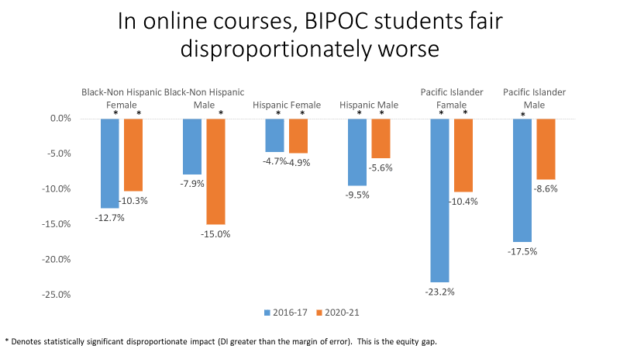

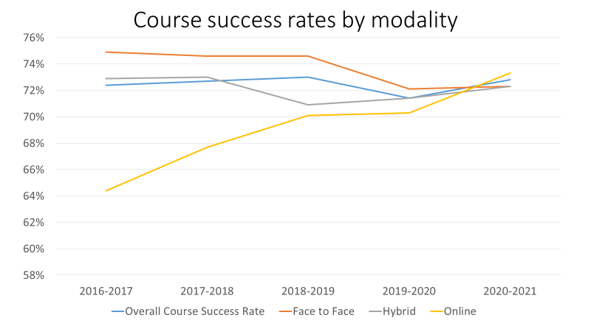
- Cañada’s implementation of AB 705 is yielding significant gains for students and is closing access and throughput gaps in transfer-level English and Math.
- While overall persistence rates are improving, Black non-Hispanic students continue to persist at disproportionately lower rates.
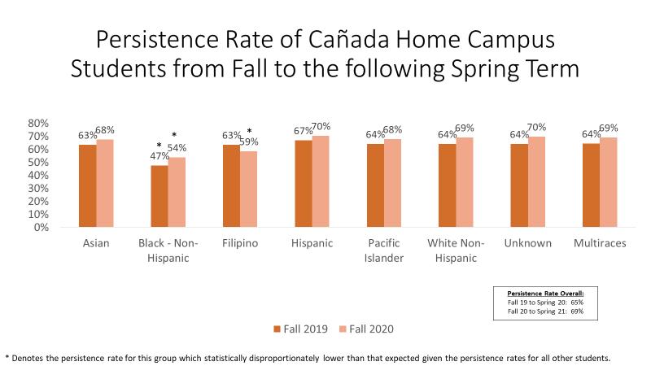
- Special Programs help with persistence and, to some degree, with course success.

Different Types of Student Journeys

- Students enrolling at Cañada (primary campus) can have very different experiences at the College. An analysis of a Fall 2016 first-time cohort found three distinct types of journeys in terms of the rate of unit accumulation: Rapid (32%); Steady (12%) and Low (56%).
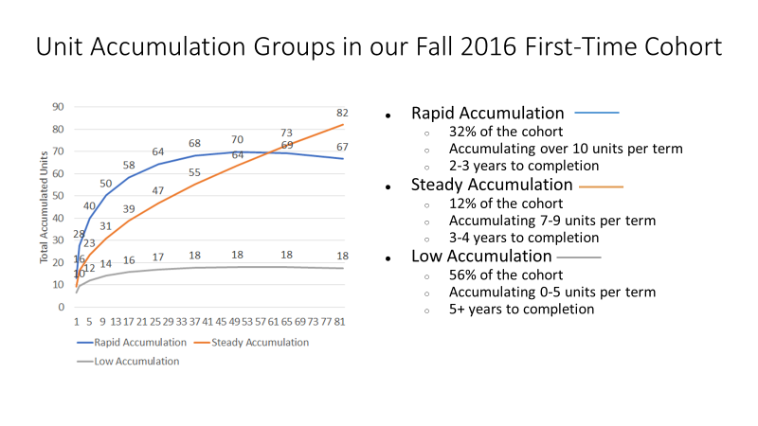
- Latinx students at Cañada are disproportionately more likely to be in the Low Accumulation group and less likely to be degree, certificate or transfer seeking than their Asian American, Native American, Pacific Islander, White and Black and multiracial peers.
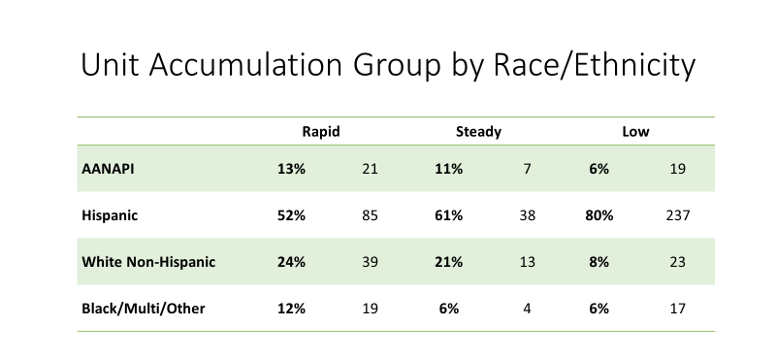

Unit Accumulation

- The majority of Cañada’s primary campus students (78% in Fall 2021) are attending part-time – less than 12 units per term. This trend was exacerbated during the COVID-19 pandemic.
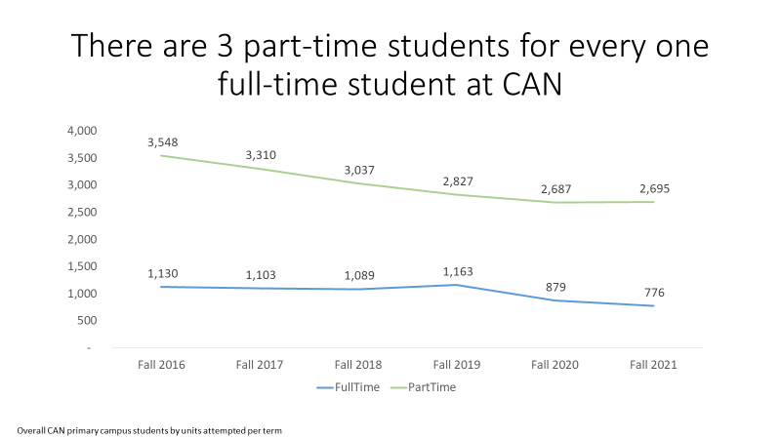
- The majority of Cañada students enrolled at Cañada during the Spring of 2021 (65%) worked for pay during the term. 29% of them reported working full time while taking classes. Part-time students are far more likely to be working, especially working full time:
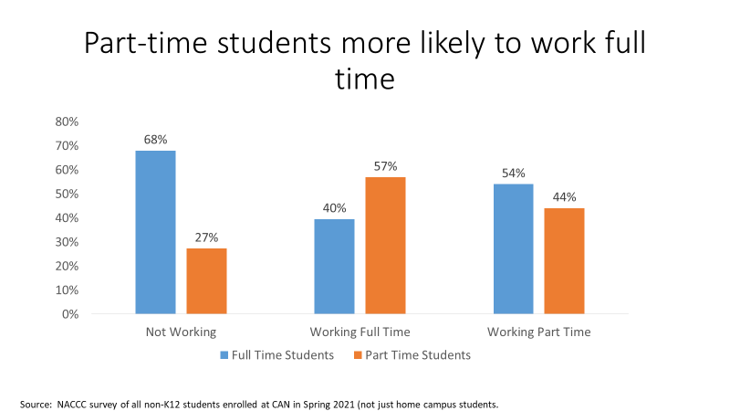

Student Completion

- Cañada is not fulfilling its mission of “ensuring that all students have equitable opportunities to achieve their transfer, career education, and lifelong learning educational goals.” During the 2020-21 academic year, 60% of Cañada home campus students indicated a goal of attaining a 2-year degree. In a typical cohort, only 2% of them will earn it in 2 years.
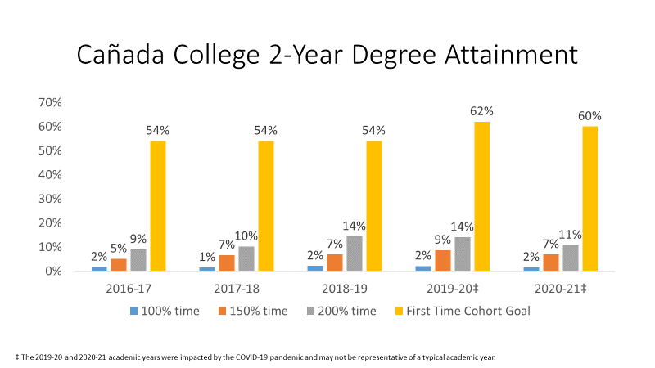
- During the 2020-21 academic year, 65% of Cañada home campus students indicated an educational goal of transferring to a 4-year college or university. As of 2020-21, 9% of Cañada home campus transfer-seeking students transfer after 2 years and only 24% do so after 4 years:
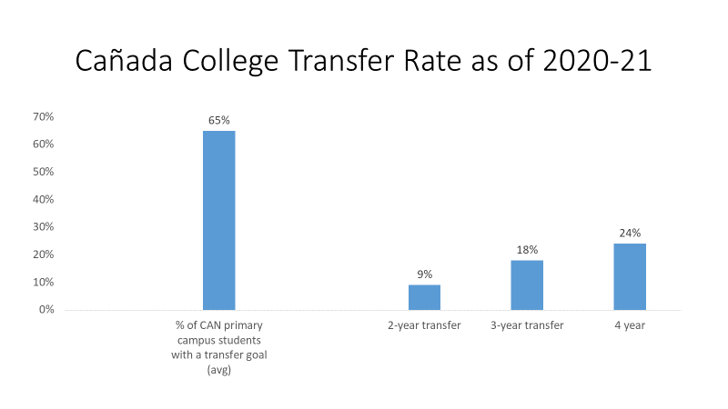

- Hispanic, low income and first-generation college students are less likely to transfer than we would expect.
- Among Cañada’s Career Technical Education (CTE) degree and/or certificate earners, approximately three quarters report working in an occupation that is close or very close to their field of study at Cañada within a year of leaving the College.

