Semester | Course | Title | Units
FALL – Semester 1
 | Engl 100 | Reading & Composition | 3
 | Hist 201 | US History through 1877 | 3
 | Mus 202 | Music Appreciation | 3
 | Fitn 304.1 | Walking Fitness | 1
 |  | Total Units | 10
SPRING - Semester 2
 | Plsc 310 | Cal State & Local Gov’t | 3
 | Eng 110 | Comp, Lit, & Critical Thinking | 3
 | Comm 110 | Public Speaking | 3
 | Fitn 304.2 | Walking Fitness | 1
 |  | Total Units | 10
SUMMER
 | Lib 100 | Intro to Information Research | 1
 | Soc 100 | Introduction to Sociology | 3
 |  | Total Units | 4
FALL - Semester 3
 | Elective | Elective | 3
 | Psych 100 | General Psychology | 3
 | Lit 441 | Film Study | 3
 | Crer 110 (Honors) | Transfer Essentials & Planning | 1
 |  | Total Units | 10
SPRING - Semester 4
 | Math 190 | Path to Statistics (NT)* | 6
 | Bio 130 | Human Biology | 3
 | Bio 132 | Human Biology Lab | 1
 |  | Total Units | 10
SUMMER
 | Hist 104 | World History I | 3
 | Ocen 100 | Oceanography | 3
 |  | Total Units | 6
FALL - Semester 5
 | Drama 140 | Introduction to Theater | 3
 | Psych 200 | Developmental Psychology | 3
 | Math 200 | Elem. Probability & Statistics | 4
 |  | Total Units | 10
SPRING - Semester 6
 | Hist 100 | Western Civilization | 3
 | Psych 205 | Social Science Research Method | 3
 |  | Total Units | 6
 |  | 66 Total Units  (6 Not Transferrable units) | 60 Total

Classes for Fall 2014
Begin August 21st
For information and an application go to:
www.canadacollege.edu/CWA

Questions please contact: Jeri Eznekier
CanadaCWA@smccd.edu
or call (650) 306-3304



Come to Open House! Check our website for time & location

Course Registration Guaranteed every semester!

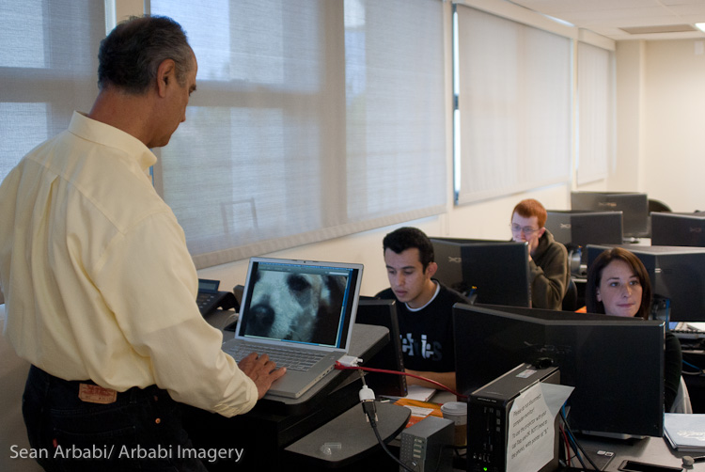
Cañada College
4200 Farm Hill Boulevard
Redwood City, CA 94061
Phone: 650-306-3100

This program is funded through the
San Mateo County
Measure G Parcel Tax Initiative.
College for Working Adults
Honors Program
The Cañada College Honors Transfer Program (CCHTP) is designed to support highly motivated students as they pursue their educational goals of graduation and transfers. CCHTP is a member of the UCLA Honors Transfer Alliance Program (TAP) and the Honors Transfer Council of California HTCC. College for Working Adults students can now participate in CCHTP. Ask about participation when you apply.
As a working adult, you know how challenging it can be to juggle family, work, hobbies and your personal life. As a working adult, you know what you want. You want a program that works with your schedule, your career goals, and your life. As a working adult, CWA can help you get what you want. You can complete an Associate in Arts degree in Interdisciplinary Studies with an emphasis in Social and Behavior Sciences in just three years in this innovative program designed just for you.

.

College for Working Adults
Our Mission
Earn a degree while working full time…
Attend classes only on Thursday evening and every other Saturday!

Sample Program

Attend Classes on Thursday Evening
and every other Saturday

STEPS TO APPLY!
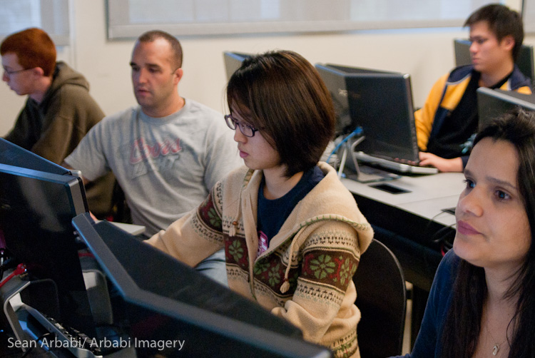
Questions: Contact Jeri Eznekier
CanadaCWA@smccd.edu
or call 650 306-3304
Building 9, Room 132
Once you have applied to the college and have your G number, follow the four simple steps below to enroll in the College for Working Adults program.
Complete the College for Working Adults Application. The application is available on our website: www.canadacollege.edu/cwa
Once you are accepted into the program, you will be contacted to make an appointment with our CWA counselor to:
- Complete your individual Student Ed Plan.
- Complete all necessary registration forms.
- Sign up for one of our Mandatory Student CWA Orientations.

Forward your completed application to:

canadacwa@smccd.edu
or fax to (650) 381-3512
or drop it off on campus:
Building 9, Rm. 132

Contact Jeri Eznekier to confirm your application has been received and is complete.

Step 3
Step 1
Step 4
Step 2
- Follow a predetermined plan of classes, eliminating guesswork about degree and transfer requirements.
- Enjoy priority enrollment in CWA classes to guarantee you can earn your degree in three years. We do all the registration for you!
- Meet on the same days and the same times throughout the entire program.
- Enroll in classes that are fully transferable to public and private colleges and universities.
- Participate in classes that are integrated to help link and reinforce learning.
- Meet one-on-one with our CWA designated counselor throughout to the program to ensure you are on the right track and in the right classes every semester.
- Be a member of a community. The College for Working Adults is designed in a cohort format - meaning that you will start and complete the program with other CWA students - students just like you.
- Earn AA three degrees that allows you to transfer into a wide variety of 4-year degree programs. DEGREES: Arts and Humanities, Social and Behavior Sciences, Psychology.

Transfer courses you have already completed and join a current cohort!
Complete a degree in all of the following disciplines:
*AA Degree in Psychology
*AA Degree Interdisciplinary Studies: Social & Behavioral Sciences
*AA Degree Interdisciplinary Studies: Arts and Humanities

As a COLLEGE FOR WORKING ADULTS student you will:

