Over 70% of our graduates transfer to a four-year college or university. Join one of them who are now attending one of the four-year institutions below:

- University of California – Berkeley
- Notre Dame de Namur
- Cal State East Bay
- San Francisco State University
- Menlo College
- Humbolt State University
- Palo Alto University


Course |  | Course Title | Trans  Units
Recommended Semester 1
ENGL | 847 | Accelerated Academic Reading & Writing  (ENGL 100 prerequisite- if needed ) | Non- Trans
ENGL | 100 | Reading and Composition * | 3
Recommended Semester 2
ENGL | 110 | Composition, Literature, Critical Thinking * | 3
Recommended Semester 3
MATH JAM |  | Math placement determined (See counselor)
MATH | 190 | Path to Statistics * | Non- Trans
BIO | 130 | Human Biology | 3
BIO | 132 | Human Biology Lab | 1
COMM | 110 | Public Speaking | 3
CRER | 110 | Transfer Essentials and Planning (Honors)* | 1
DRAM | 140 | Introduction to Theater | 3
ECON | 100 | Principles of Macroeconomics * | 3
ECON | 102 | Principles of Microeconomics * | 3
FITN | 304.1 | Walking Fitness I | 1
FITN | 304.2 | Walking Fitness II | 1
HIST | 101 | History of Western Civilization II | 3
HIST | 201 | US History through 1877 | 3
LIBR | 100 | Introduction to Information Research | 1
LIT | 441 | Film Study | 3
MATH | 200 | Elementary Probability and Statistics* | 4
MUS | 240 | Music of the Americas | 3
OCEN | 100 | Oceanography | 3
PLSC | 210 | American Politics | 3
PLSC | 310 | California State and Local Government | 3
PSYC | 100 | General Psychology | 3
PSYC | 200 | Developmental Psychology* | 3
PSYC | 205 | Social Science Research Methods* | 3
SOC | 100 | Introduction to Sociology | 3
 |  | Total Transferable Units | 63
*Requires prerequisite

CWA Courses Offered

Attend Classes Thursday Evening
and every other Saturday

Classes for Spring 2016
Begin January 21st
For information or to apply online go to:
www.canadacollege.edu/CWA

Questions please email: CanadaCWA@smccd.edu
or call (650) 306-3310



I always was afraid of everything that had to do with registering for school, buying books, charting my own academic course, etc. (fear of failure I guess!) so if it wasn't for CWA, I wouldn't be in school. I love having this opportunity so thanks, thanks, thanks!!
Karen Turner
Immaculate Heart of Mary School, Belmont, CA
Wow, I thought it would never happen, but I am a student. It’s great and I am excited to pursue this new and wonderful opportunity….Thanks again for helping me along the way. ☺

Shaina Denner, HS Office Supervisor
Santa Clara County Health & Hospital System

…when I started the (CWA) program, I was committed, but it’s hard work and your resolve is continually tested. Now, I’m graduating in May with two degrees!

Siosiua “C2” Vea, Administrative Services Specialist
JobTrain, Menlo Park

See what students are saying about
the College for Working Adults!
College for Working Adults
Honors Program

The Cañada College Honors Transfer Program (CCHTP) is designed to support highly motivated students as they pursue their educational goals of graduation and transfers. CCHTP is a member of the UCLA Honors Transfer Alliance Program (TAP) and the Honors Transfer Council of California HTCC. College for Working Adults students can now participate in CCHTP. Ask about participation when you apply.
Course Registration Guaranteed every semester!

Come to an Information Forum! Check our website for time & location.
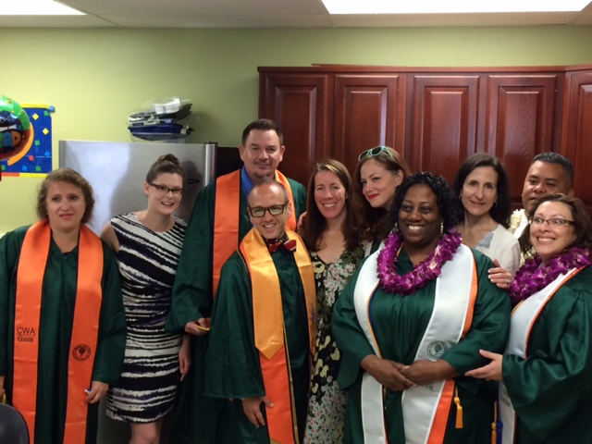

Earn a degree while working full time…
Attend classes only on Thursday evening and every other Saturday!
STEPS TO APPLY!
Complete a degree in one or three of the following disciplines
Transfer courses you have already completed and join a current cohort!

Questions? Contact us at:

CanadaCWA@smccd.edu
or call 650 306-3310
Building 13, Room 106
- Follow a predetermined plan of classes, eliminating guesswork about degree and transfer requirements.
- Enjoy priority enrollment in CWA classes to guarantee you can earn your degree in three years.
We do all the registration for you!
- Meet on the same days and the same times throughout the entire program.
- Enroll in classes that are fully transferable to public and private colleges and universities.
- Participate in classes that are integrated to help link and reinforce learning.
- Connect with our CWA designated counselor throughout the program to ensure you are on the right track and in the right classes every semester.
- Join one of our six learning communities. The College for Working Adults is designed in a cohort format - meaning that you will start and complete the program with other CWA students - students just like you.
- Earn 1, 2, or 3 degrees that allow you to transfer into a wide variety of 4-year degree programs. DEGREES: (1) Psychology, (2) Interdisciplinary Studies: Social & Behavioral Sciences,
(3) Interdisciplinary Studies: Arts & Humanities, (4) Economics.

As a COLLEGE FOR WORKING ADULTS student you will:
- AA Degree in Psychology
- AA Degree Interdisciplinary Studies: Social & Behavioral Sciences
- AA Degree Interdisciplinary Studies: Arts & Humanities
- AA Degree Economics
Once you have applied to Cañada College and have your G number, follow the four simple steps below to enroll in the College for Working Adults program.
Complete the College for Working Adults Application. The application is available on our website: www.canadacollege.edu/cwa/apply
Once you are accepted into the program, you will be contacted to make an appointment with our CWA counselor to:
- Complete your individual Student Ed Plan.
- Complete all necessary registration forms.
- Sign up for one of our Mandatory Student CWA Orientations.

Forward your completed application to:

canadacwa@smccd.edu
or fax to (650) 381-3512
or drop it off on campus:
Building 13, Rm. 106

Email or call to confirm your application has been received and is complete.

Step 3
Step 1
Step 4
Step 2

