Integrated Planning and Budgeting
To effectively integrate its planning, budgeting, and evaluation cycle each year, the College follows this Integrated Planning and Budgeting Calendar. Conceptually, the cycle looks like this:

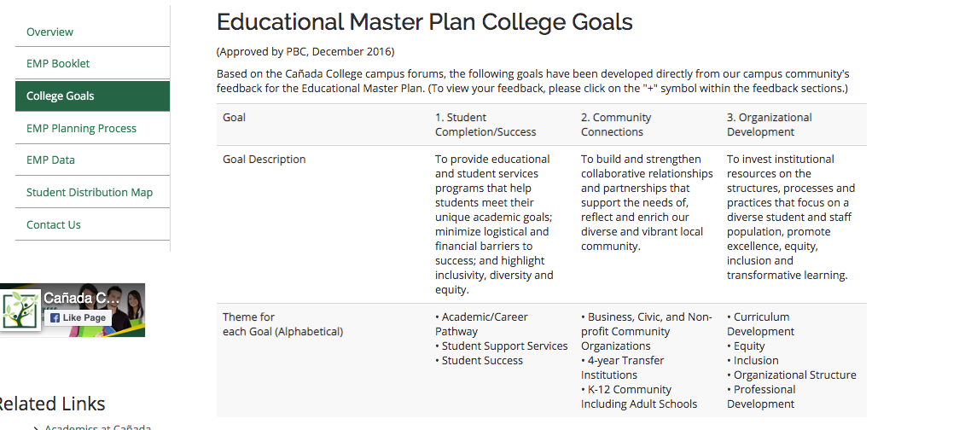
- Sets forth the activities to be implemented in one year to support the achievement of the five-year goals articulated in the Education Master Plan, which are in support of achieving the College Mission.
- Is a synthesis of objectives, strategic initiatives, and activities of other college plans, grant deliverables, and recent mandates from the State Chancellor’s Office.

