Compendium of Committees
Participatory Governance Manual
Originally approved by PBC on February 6, 2019
Updated by PBC on September 24, 2021
Updated by PBC: May 17, 2023

Cañada Participatory Governance Structure

Overview
Participatory governance is defined as a collaborative effort of administration, faculty, staff, and students for the purpose of providing high quality college programs and services. All members of the campus community are invited to participate in planning for the future and in developing policies, regulations, and recommendations under which the College is governed and administered (see California Education Code (70901(b)(1)(E)). This Compendium of Committees describes the relationship of various college committees to each other, as well as the roles, responsibilities, and membership of each.
Organizational Structure
The primary stakeholder groups at Cañada College are:
- Academic Senate
- Associated Students of Cañada College (ASCC)
- Classified Senate/CSEA
Representatives from each of these stakeholder groups come together with college administrators to collaborate in the following participatory governance groups:
- Planning & Budgeting Council (PBC)
- Instructional Planning Council (IPC)
- Student Services Planning Council (SSPC)
- Equity & Antiracism Planning Council (EAPC)

Participatory Governance Groups Defined
In addition to the primary college stakeholder groups and participatory governance Planning Councils, the College has a number of college-wide planning committees. Their role was updated by the Planning and Budgeting Council on April 15, 2020. The definition and role of each participatory governance group, as distinct from operational groups, is laid out in the PBC-approved chart below:
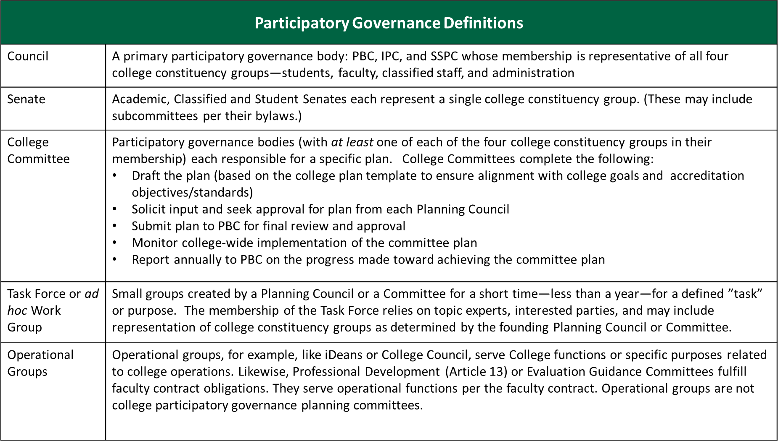

College Committees
As participatory governance bodies, college-wide planning committees should have at least one member from each of the four college constituency groups. Each committee is responsible for a specific plan and for monitoring the effective implementation of college strategic initiatives in their issue area that are identified in the Education Master Plan and the Strategic Enrollment Management Plan. College Committees complete the following:

- Draft the plan (based on the college plan template to ensure alignment with college goals and accreditation objectives/standards)
- Solicit input and seek approval for plan from each Planning Council
- Submit plan to PBC for final review and approval
- Monitor college-wide implementation of the committee plan
- Report annually to PBC on the progress made toward achieving the committee plan

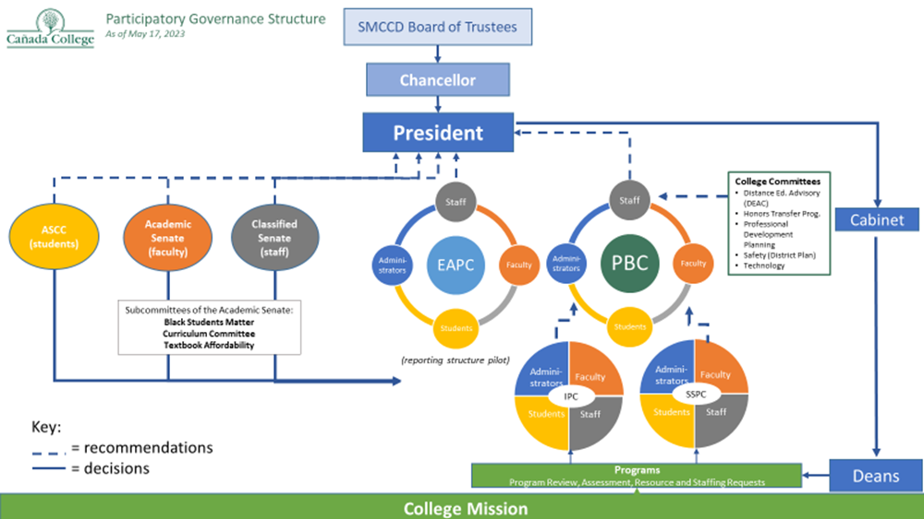
As of May 2023, the campus-wide planning committees include:
- Distance Education Advisory Committee (DEAC)
- Honors Transfer Program Committee
- Professional Development Planning Committee
- Safety Committee
- Technology Committee

Stakeholder Group, Planning Council, and Related Committee Roles and Responsibilities
Stakeholder Group | Roles & Responsibilities | Membership
Academic Senate | The Academic Senate provides for the effective participation of faculty in participatory governance and assumes primary responsibility for making recommendations to the college administration and district in the areas of curriculum and academic and professional standards. These areas are referred to as 10+1 which are identified in California state legislation AB 1725 amended Education Code Title 5, Section 53200 to identify the 10+1 "academic and professional matters".  Academic Senate Bylaws | All faculty are members.  Officers:  - President  - Vice President  - Secretary  - Treasurer  Senators: Subcommittee Reps for Curriculum Committee and Professional Development Committee  Senators: One Representative for each Division and one Adjunct Representative
Classified Senate | It is the mission of the Cañada College Classified Senate to work with the administration, faculty, and students in the interest of enriching the educational and social environment of the College, in accordance with the College's mission and strategic goals.  We are the primary governing body for classified professionals at Cañada College. Our members are from various areas, full time or part time employment, and actively participate in all college-wide discussion, excluding collective bargaining matters. We represent CSEA, AFSCME, and non-represented classified employees which includes supervisors and management. Our constitution, by-laws, and statement of ethics help us to fairly represent all our constituents.  Classified Senate Bylaws | All classified staff are members. Leadership includes:  - President  - Vice President  - Secretary  - Treasurer  - Co-Activities Coordinators  - Photographer
Associated Students of Cañada College (ASCC) | The Associated Students of Cañada College (ASCC) is the student government at Cañada College.  The ASCC are elected and appointed student representatives who organize and promote campus wide programs, protect student rights, and represent the student voice on campus committees.  ASCC Constitution | Leadership includes:  - President  - Vice President  - Commissioner of Finances  - Commissioner of Publicity  - Commissioner of Activities  - Commissioner of Public Record (2)  - Commissioner of Design and Marketing  - Senator at Large: Science & Technology  - Senator at Large: Humanities and Social Sciences  - Senators (2)

Planning Council | Roles & Responsibilities | Membership
Planning & Budgeting Council (PBC) | PBC reviews College and District policies and develops procedures to implement policy; provides accreditation oversight; establishes ad hoc work groups and subcommittees to address college planning needs and priorities.  The PBC’s purpose is to provide recommendations directly to the college president on matters pertaining to institutional priorities, policies, procedures, planning and budget development. As such, this body has the responsibility to provide concrete decisions and rulings on behalf of the College. Of the planning councils, PBC is the ultimate recommending body to the President. PBC recommendations include the following: 1) Strategic planning issues (i.e., accreditation and campus plans), 2) Budgeting issues (prioritizing Fund 1 resource requests and serving as the focus of information sharing about other funds and expenditures). Meetings are always open to the entire campus community.  The PBC serves as the College’s Accreditation Oversight Committee with particular focus on ensuring that the College meets all of the requirements and standards set by the Accrediting Commission for Community and Junior Colleges (ACCJC).  PBC Bylaws. | PBC Members (updated May 1, 2019):  - Academic Senate President or Vice President (co-chair)  - Classified Senate President or Vice President (co-chair)  - IPC and SSPC Representatives  - Faculty Representatives - one from each of the Instructional Divisions, one from Student Services, and one at-large representative at the Academic Senate’s discretion. Note: one of these faculty members could be an adjunct faculty, if possible.  - Classified Representatives – the number of classified staff representatives should match the total number of faculty representatives including one at-large representative chosen at the Classified Senate’s discretion. As much as possible, representation should be balanced across divisions and major college functions  - Two (2) ASCC Representatives  - 6 Classified Representatives (including one at-large)  - Dean of Planning, Research and Institutional Effectiveness  - College Business Officer or VPA  - Director of Marketing and Public Information  - Dean (appointed by the President)  - Vice President of Instruction  - Vice President of Student Services  - Vice President of Administrative Services  - College President – no voting rights  PBC membership page
Instructional Planning Council (IPC) | The IPC is advisory to the PBC on a range of issues related to instruction:  1. Development of a calendar for program review, staffing, equipment and facilities needs as they pertain to instruction.  2. Development of an evaluation process for the program review cycle.  3. Recommendations about policies and procedures as they relate to instruction.  4. Recommendations about prioritization of resources as they relate to Strategic Goals regarding instruction and review of Instructional Strategic Goals yearly.  5. Evaluation of proposals for new instructional programs and instructional program discontinuance.  6. Support of accreditation review process and self-study.  7. Completion of a yearly review of the mission statement and roles of this Planning Council.  Instructional Planning Council Bylaws – revised April 2023 | Membership: 17 voting members  - Co-Chairs: VPI and one faculty member (from list below)  - 9 Faculty – appointed by Academic Senate:  - Curriculum Committee Chair  - Instructional Assessment Coordinator  - Honors Transfer Program Coordinator  - Faculty Equity Coordinator  - Counselor  - Librarian (chosen by dept. and approved by Senate)  - 3 Faculty Members-at-large (faculty at-large positions will be used to balance membership – adjunct, career education, division representation, etc.)  - 2 Classified Staff Members-at-large – recommended by Classified Senate and appointed by CSEA  - Instructional Technologist  - 2 Students – approved by the ASCC  - 1 Instructional Dean  - Dean of Planning, Research and Institutional Effectiveness  - Vice President of Instruction
Student Services Planning Council (SSPC) | The SSPC oversees the implementation of a comprehensive process for planning and assessing student services based on program review, the effective integration of student learning outcomes into program activities and services, and alignment with the college’s mission and strategic goals.  The Student Services Planning Council is advisory to the College Planning and Budgeting Council. The roles of the SSPC include:  1. Develop, implement, and evaluate a Student Services planning cycle (including staffing, equipment, facilities and budgetary needs)  2. Integrate Student Services Division Plans  3. Make recommendations about policies and procedures related to student services  4. Make recommendations to College Planning and Budgeting Council regarding prioritization of resources advancing the Strategic Goals regarding Student Services  5. Meet at least once a year with the Instructional Program Planning Council as part of the hiring process.  6. Evaluate proposals for adding, modifying, and discontinuing student services programs  7. Develop ongoing communication strategy with Instructional Planning Council by designating a Student Services Planning Council member(s) to report to IPC on SSPC matters and to report back to SSPC on IPC matters  8. Form subcommittees, work groups and task forces as needed  SSPC Bylaws | Membership Composition – 25 voting members  Co-Chairs: Vice President, Student Services and One SSPC Member Admissions & Records Representative  Career Center Representative  Classified Members (2)  College Recruiter  Dean of Counseling  Dean of Enrollment Services  Dream Center Representative  EOPS/CARE/CalWORKs Representative  Faculty Members (2):  - Counseling Faculty  - Instructional Faculty  Financial Aid Representative  International Student Representative  Post-Secondary Success Representative  Promise Scholars Program Representative  SparkPoint Representative  Student Representatives (up to 2 voting members) – (e.g., ASCC, Peer Mentor, Outreach Ambassador)  Student Life and Leadership Development Representative  TRIO Programs Representative  Transfer Center Representative  Veterans Services Representative  Vice President of Student Services  Welcome Center Representative  Wellness Center Representative  Advisory  Dean of Planning, Research and Institutional Effectiveness  Learning Center Representative  Library Representative  Puente Representative
Administrative Planning Council (APC) – suspended by PBC on April 7, 2021 | APC, in collaboration and communication with SSPC and IPC, oversees the implementation of a comprehensive process for planning and assessing administrative services [instruction/student services] based on program review, the effective integration of student learning outcomes into program activities and services, and alignment with the college’s mission and strategic goals.  Develops, implements, and evaluates an Administrative Program Plan cycle (including staffing) and makes recommendations about policy.  APC Bylaws. | Membership:  - College President  - VPI  - VPSS  - VPA  - Faculty member  - Classified Staff member  - Dean of PRIE  - Director of Marketing, Communications, and Public Relations  - PRIE Research Analyst  - Executive Assistant to the President  - Executive Assistant to VPI  - Executive Assistant to VPSS  - College Business Officer
Equity & Antiracism Planning Council  Reporting structure in pilot per Oct 19, 2022 PBC minutes. Bylaws adopted by PBC and College President in December, 2022. | The mission of the Equity and Antiracism Planning Council is to disrupt and dismantle systemic racism and White supremacy for our college community in pursuit of equity, antiracism, justice and liberation.  EAPC reports to the College President annually on the progress of the College Equity and Antiracism 3-year Plan (inclusive of the Student Equity and Achievement Program Plan). The Council provides information on this evaluation to the Planning and Budget Council regularly, at least once per academic year.  The EAPC uses a framework that centers equity, antiracism, and the pursuit of liberation to:  - Critically examine larger systems of oppression  - Audit and interrogate our campus’ racist culture and inequities, and  - Engage Cañada personnel and students in antiracist systems changing  In an effort to achieve the Council mission/purpose, the EAPC will:  Goal # 1: Review and revise college policies and practices.  Goal # 2: Facilitate training for students, faculty, staff, and administration.  Goal # 3: Develop and implement collegewide programming related to equity and antiracism.  The EAPC responsibilities include: strategic planning, priority-setting, participatory governance, program development and support, addressing systemic barriers, policy review, innovation and inquiry, campus climate, professional development.  EAPC Bylaws | EAPC shall have 18 members as identified below:  3 Cochairs: 1 Faculty member, 1 Administrator (or Director of Equity), 1 Staff member  5 Faculty shall represent each of the below:  - English/Math  - ESL  - Counseling  - Faculty representative at large  - Faculty representative at large  6 Classified Staff Representatives  1 Administrator such as Vice President of Instruction and Dean of ASLT  1 Representative of PRIE (Office of Planning, Research, and Institutional Effectiveness)  2 members of ASCC (Associated Students of Cañada College) including at minimum one student  Staff and faculty members should represent different student services and equity-oriented programs, and committees supporting as many of the following communities as possible: Antiracism groups and groups addressing Anti-Black racism; Asian American and Native American Pacific Islander (AANAPI) student; Black students, ESL students; Foster youth; First generation students including; Immigrant and undocumented students; Latinx students (categorized as “Hispanic”); LGBTQ+ students; Students with disabilities; Students of Color; Veterans; and Additional communities that are disproportionately impacted or have been marginalized. Priority shall be given to members representing programs addressing the EAPC mission and goals and SEAP (Program Examples for Reference) .

Related Committee | Roles & Responsibilities | Membership
Academic Committee for Equity and Success (ACES) – suspended as of December 7, 2022, replaced by the Equity & Antiracism Council | The Academic Committee for Equity & Success (ACES) addresses student equity and success, particularly in courses below transfer level and for disproportionately impacted student groups, by supporting equity related programs and initiatives. | - Student representative (ASCC)  - English Faculty  - Math Faculty  - ESL Faculty  - Science Faculty  - Business Faculty  - Social Science Faculty  - Library Faculty  - EOPS/Calworks Representative  - Learning Support Center Representative  - Basic Skills Counselor  - Counselor  - Disabilities Resource Center Representative  - Veterans Representative  - Promise Representative  - Dreams Taskforce representative  - Basic Skills Retention Specialist  - Student Services Representative  - Classified Representative  - 20. Dean of Planning, Research & Institutional Effectiveness
Curriculum Committee  A sub-committee of the academic senate | Curriculum Committee is a subcommittee of Academic Senate. According to Article VI, section 6 of the Academic Senate Bylaws:  - The primary function of the Curriculum Committee shall be to coordinate and monitor Cañada’s curricular offerings so that they shall uphold the California Education Code, be consistent among the divisions and colleges of the District, be understandable to our students and staff, articulate with high schools and four- year institutions, and support the goals and objectives of the San Mateo County Community College District and Cañada College.  - The Curriculum Committee shall make recommendations to the Academic Senate about general instruction policies and standards, and degree and certification requirements. The Curriculum Committee shall also deliberate over the initiation and modification of programs and courses. To do this, the Curriculum Committee shall seek input from those campus and committee individuals who are affected by curricular decisions, and whose input is needed by the Curriculum Committee to make informed decisions. The Committee shall request the Office of the President of Cañada College to provide such information as is necessary for its deliberations and actions.  - All standing subcommittees of the Curriculum Committee shall have a written charter and guidelines. In addition, these subcommittees shall present, at minimum, annual reports to the Curriculum Committee.  Committee Bylaws and all other information about the Curriculum Committee are presented in detail in the Curriculum Handbook. | The Curriculum Committee is composed of the following voting members, who serve a term of two years. Ideally, members should not serve more than two terms in a row; however, they may do so as needed due to staffing limitations.  - A chairperson, appointed by the Academic Senate Governing Council, with the option of reappointment, by the agreement of the Curriculum Committee and the Academic Senate Governing Council  - Two faculty members from each instructional division, and two faculty members from Student Services  - One Transfer Center Program Supervisor  - One Degree Audit Program Services Coordinator  - One student representative appointed by the Associated Students of Cañada College  - Articulation Officer  - Curriculum and Instructional Systems Specialist  - Vice President of Instruction
Distance Education Advisory Committee (DEAC) | The Distance Education Advisory Committee (DEAC) strengthens Cañada’s distance education program and advises the campus on distance education courses and policies. The committee is under the umbrella of CIETL and reports to the Vice President of Instruction. Members of the Committee also serve on the college Technology Committee.  Bylaws updated by PBC May 17, 2023 | - Dean of ASLT –co-chair  - Faculty DE Coordinator – co chair appointed by Academic Senate/IPC  - Faculty OER/ZTC Representative appointed by Academic Senate/IPC  - 5 faculty representing their Divisions and approved by Academic Senate: (KAD, HSS, BDW, ST, Counseling)  - Instructional Technologist (by position)  - Alternate Media Instructional Aide (DRC Representative) (by position)  - Tutor Coordinator (Learning Center Rep) – appointed by Classified Senate  - SSPC Representative – appointed by Classified Senate  - Student Representative – appointed by ASCC
Honors Transfer Program Committee | Established in 2009, the primary purpose of Cañada College's Honors Transfer Program (CCHTP) is to serve students whose educational goal is to transfer to a 4-year institution and complete a bachelor’s degree. The program is designed for students interested in participating in challenging, academically rigorous experiences through classes and seminars, and is meant to better prepare them for university work. All honors courses are open to the entire student population and are not limited to students who are members of HTP. The College is a member of the UCLA Honors Transfer Alliance Program (TAP) and the Honors Transfer Council of California HTCC.  General oversight of the HTP is provided by the Honors Transfer Program Advisory Committee, which meets at least twice per semester. | Membership:  - Co-Chair: HTP Program Counselor  - Co- Chair: HTP Program Coordinator  - Minimum of 7-9 faculty members who are teaching in the HTP, with representatives from the academic divisions and counseling (appointments approved by the Academic Senate Governing Council)  - Vice President of Instruction  - Transfer Center Director  - Articulation Officer  - 1 Student, appointed by the PTK leadership
Professional Development Planning Committee | The intention of the Cañada Professional Learning Framework is to provide the foundation for a comprehensive professional learning program that meets the college’s needs through supporting existing campus-wide professional learning opportunities and creating a path for further campus-wide professional efforts.  Bylaws need to be created. | Membership as of May, 2023:  - Dean of ASLT – co-chair  - 3 Faculty confirmed by Academic Senate  - Flex Day Coordinator (co-chair – appointed by IPC)  - 2 faculty representatives (one from Counseling)  - 2 Classified Staff (appointed by Classified Senate)  - 2 Associated Students of Cañada College (ASCC) representatives  - 1 administrator appointed by the College President
Safety Committee | Safety Committee  The Cañada College Safety Committee is a college-wide operational group that promotes a healthful and safe environment for staff and students, educating and training personnel in safe work practices, while at the same time serving as the College’s Emergency Operations Center (EOC).  Safety Committee Bylaws | Membership:  - VPAS  - VPSS  - VPI  - Instructional Dean  - Public Safety Sergeant  - Faculty Representative (1)  - Classified Representative (2)  - Student Representative (1)  - College Business Officer  - Public Information Officer  - Health Services Director  - Superintendent of Custodians and Grounds Ops  - Groundskeeper  - Student Life and Leadership Manager
Environmental Sustainability Committee – Sustainability planning is organized at the District – On April 5, 2023, PBC suspended this Committee as a college committee
Technology Committee | The Technology Committee is advisory to the Instructional Planning Council on a range of issues related to technology. These advisory tasks include:  - Develop the two-year Technology Plan that (a) summarizes the work the committee has accomplished, (b) sets forth the goals and objectives for the coming two years, (c) aligns with college and district plans, goals and objectives, (d) integrates into institutional planning at all levels, and (e) provides direction for the College’s technology vision.  - Prepare annual progress reports on the committee’s work on the goals and objectives set forth in the Technology Plan and on the committee’s work in the following areas.  - Assess & Evaluate  - Technology usage and needs annually with assistance from the Office of Planning, Research and Institutional Effectiveness;  - Technology resource requests by participating in the Planning and Budgeting Council’s annual resource request prioritization meeting.  - Develop Procedures and Policies for  - Educational technology and online instruction in consultation with the Accreditation Liaison Officer, Disability Resource Center (DRC) and Vice President of Instruction regarding compliance with external mandates, including specifications articulated by Title 5, the Accrediting Commission for Community and Junior Colleges (ACCJC), and Section 508 of the Federal Rehabilitation Act;  - Minimum campus technological standards in collaboration with Information Technology Services (ITS);  - Make Recommendations for  - The implementation of centralized online student support services;  - The appropriate use of educational technology, in particular the use of proprietary applications (e.g. textbook publisher’s online resources) that support teaching and learning;  - Technology needs and policies for the Instructional Planning Council (IPC) and the Planning and Budgeting Council (PBC);  - Review & Approve annual campus technology inventory, replacement cycle and replacement criteria drafted in collaboration with Information Technology Services (ITS);  - Collaborate with the Professional Learning Committee to determine campus professional development needs related to technology.  - Consult with Academic Senate when committee work may impact academic and professional matters that fall within the 10 + 1 area.  - Consult, advise, and collaborate with, as appropriate, other college and district colleagues concerned with the effective use of technology.  - Continuously improve the Technology Committee structure, mission, plan, goals and objectives in order to adapt to the changing technology needs for instruction, student services, and business operations.  The Technology Committee advocates for the college community to have secure, accessible, and reliable technology that improves and supports learning, instruction, communication, and operations. The Technology Committee reports to the Planning & Budgeting Council (PBC). Committee members are also required to report committee recommendations to constituent divisions and governing councils (including Academic Senate, Classified Senate, Instructional Planning Council (IPC), and Student Services Planning Council (SSPC).  Responsibilities  The Technology Committee is advisory to the Planning & Budgeting Council on a range of issues related to technology. These advisory tasks include:  - Develop the three-year Technology Plan that sets forth the goals and objectives for the coming three years and aligns with college and district plans, goals and objectives.  - Prepare an annual summary of the committee’s work progress based on goals and objectives set forth in the Technology Plan.  - Assess and evaluate:  - Technology usage and needs (annually) with assistance from the Office of Planning, Research, and Institutional Effectiveness (PRIE).  - Technology resource requests by providing input and guidance on requested  resources when needed.  - Develop procedures and policies for educational technology and online instruction in consultation with Vice President of Instruction, and both college and district DEAC. Establish compliance with external mandates, including specifications articulated by Title 5, the Accrediting Commission for Community and Junior Colleges (ACCJC), and Section 508 of the Federal Rehabilitation Act.  - Minimum campus technological standards in collaboration with Information Technology Services (ITS).  - Make recommendations for:  - The implementation of centralized online student support services.  - The appropriate use of educational technology, in particular the proprietary applications that are used college-wide and impact students, faculty, and staff.  - Equitable access to necessary technology for faculty, staff, and students.  - Support and review the annual Technology Refresh Process collaboration with Information Technology Services (ITS) and the Vice President of Administrative Services.  - Collaborate with the Professional Development Planning Committee to determine campus professional development needs related to technology.  - Consult with the Academic Senate when committee work may impact academic and professional matters that fall within the 10 + 1 area.  - Consult, advise, and collaborate with other college and district colleagues concerned with the effective use of technology.  - Continuously improve the Technology Committee structure, mission, plan, goals and objectives in order to adapt to the changing technology needs for instruction, student services, and business operations.  Draft updated bylaws for PBC review on May 17, 2023 | Membership Representing (appointed by)  - Dean of Academic Support & Learning Technologies (Tri-Chair & Voting Member) Instructional Planning Council  - Vice President of Instruction (Voting Member) Administrative Planning Council  - Vice President of Student Services (Voting Member) Planning & Budgeting Council  - Administrator Guided Pathways  - Vice President of Administrative Services (Resource Member) Budget Office  - At-large classified staff Classified Senate  - Instructional Technologist (Tri-Chair & Voting Member) Classified Senate  - Library Support Specialist (Resource Member) Library  - Instructional Aide II (Resource Member) Learning Center  - Project Director, TriO Upward Bound (Voting Member) Student Services Planning Council  - Online Education Coordinator, Faculty (Tri-Chair & Voting Member) Academic Senate & Distance Education Advisory Committee  - Faculty (Voting Member) Academic Senate  - Faculty (Resource Member) Division  - Faculty (Resource Member) Division  - Faculty (Resource Member) Division  - Faculty (Resource Member) Division  - CIETL Coordinator, Faculty (Resource Member) Professional Learning Committee  - Senator at large for STEM (Voting Member) Associated Students  - Senator Associated Students  - District ITS Staff (by position)  - Director of Information Technology Support Services (Voting Member) District ITS  - IT Technician III (Voting Member) notification to CSEA/Classified Senate Local ITS  Technology Committee Membership proposed as of May 17, 2023  - Dean of Academic Support and Learning Technologies (Tri-Chair, by position)  - Faculty Online Education Coordinator (Tri-Chair, by position)  - Instructional Technologist (Tri-Chair, by position)  - Technology-focused Faculty Member (academic senate)  - District ITS representative  - Local ITS representative  - Student Services Representative, Classified (SSPC Rep)  - Associated Students of Cañada College representative  - Vice President of Administrative Services (by position)  Resource Members should include at a minimum:  - Technology-focused Faculty Representatives from each non-represented division  - Disability Resource Center Representative  - Professional Development Planning Committee Representative  - Guided Pathways Advisory Committee Representative  - Library Representative  - Learning Center Representative  - DEAC Representative  - Vice President of Instruction  - Vice President of Student Services

