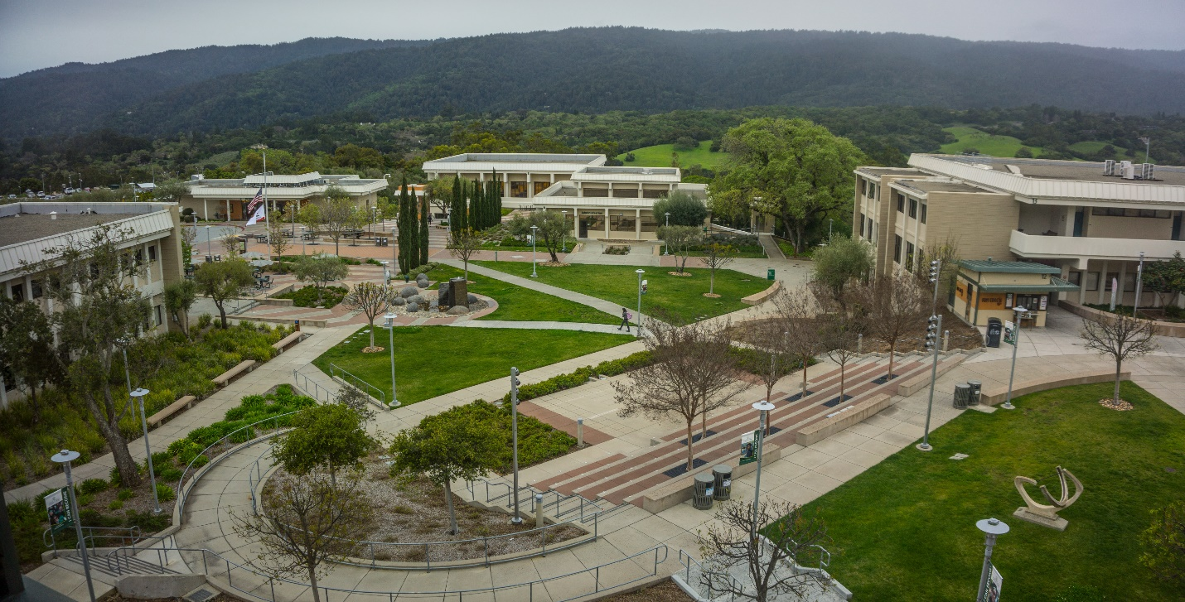



Campus Climate Survey Results

Spring 2019

Introduction
In the spring of 2019, 127 Cañada College faculty, staff and administrators responded to the Campus Climate Survey. This represents a response rate of approximately 42%. The perspectives identified by this Survey and summarized here will inform the College’s 2019-20 strategic planning and priorities.
Thank you for taking time to complete it!

Question 1: What is your current employment classification?

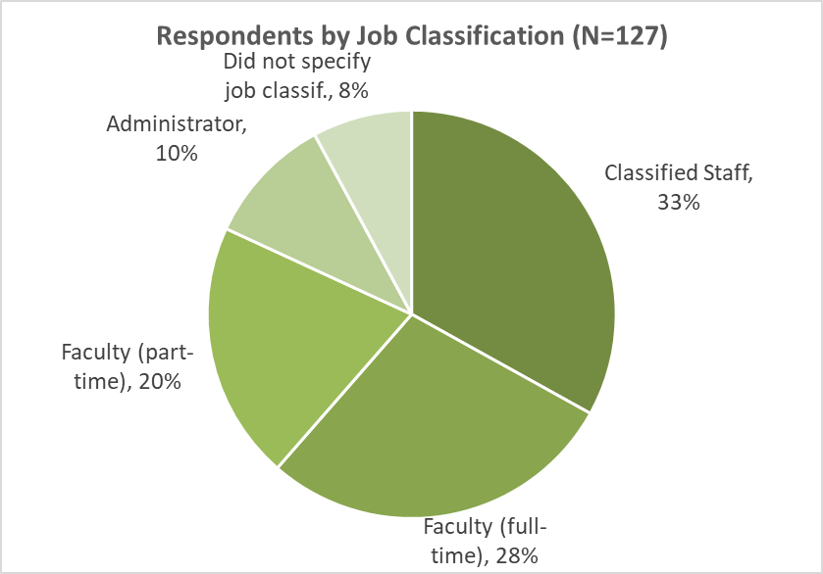
Question 2: Please indicate how long you have worked at Cañada College

Aggregated Responses to Statements 3-21:
Each of the statements listed below asked respondents to choose a Likert-type response (right). In the chart below, a Likert Scale is developed using the numeric value of each response tallied with all of the other responses to that statement and an average response value is calculated. Higher average response values indicate more responses were in agreement with each statement. Lower average response values indicate more responses were in disagreement.
Statement | Average Response on 1-5 Likert Scale
I support the mission of Cañada College. | 4.52
I regularly acknowledge my co-workers for a job well done. | 4.30
I am proud to be part of Cañada College. | 4.23
My supervisor recognizes and values the diversity that exists in our department. | 3.92
I feel Cañada College is a good place to work. | 3.83
I access available opportunities for training and growth. | 3.75
I am comfortable communicating within my department in an open and honest manner. | 3.71
I am satisfied with my current position. | 3.69
I can see myself working at Cañada College in 5 years. | 3.68
I am comfortable and safe bringing forward concerns to my supervisor. | 3.68
I am aware of the roles and activities of the Planning and Budgeting Council and other participatory governance committees. | 3.63
I am given enough flexibility to be innovative and perform my job well. | 3.63
I feel connected to the College. | 3.56
I know who represents me on the Planning and Budgeting Council and other participatory governance committees. | 3.53
I am given support to fulfill the educational needs of the students. | 3.50
I receive adequate recognition from my department for a job well done. | 3.47
Overall, there is a climate of mutual respect among my colleagues here at the College. | 3.40
The College encourages innovation and the exchange of ideas. | 3.37
I receive appropriate (adequate) training to do my job well. | 3.35
Diverse perspectives are valued at the College. | 3.29
The College offers campus-wide activities that promote a sense of community. | 3.19
In the chart on the next page, the percentage of responses in each of the Likert Scale categories is given for each statement.

Responses to Statements 3-21 by Job Classification:

Open Response Themes
The recurring themes identified in the responses to the open-ended questions are summarized below.
If there was one thing you could change about Cañada College, what would it be?
- More effective communication generally about what is going on on-campus, and between departments and across divisions especially.
- The name of the College.
- Greater financial support for part-time faculty to participate in campus activities such as SLO, Curriculum Committee, program review, participatory governance bodies.
- College leadership to solicit opinions and recommendations more broadly prior to making decisions, especially about hiring, new initiatives, space allocations, and funding.
- Provide more opportunities for faculty and staff to collaborate and connect with one another across departments and divisions.
- Foster a greater sense of community via fun or engaging events for the campus to come together, to celebrate and connect with one another across departments and divisions.
- Less turnover in college administration.
- Better enforcement of Academic Integrity policy to address student cheating.
- Ensure all full-time faculty are sharing the burden of committee work, hiring committees, and other college-wide obligations that are in the AFT contract.

What is the one thing you would not change about the College?
- The students
- The location, view, and natural beauty of the campus
- The dedication everyone has to student success
- The close-knit sense of community/family and value placed on collegiality
- The size of the College and that it is a safe and inviting place where people care about each other
- The name of the College
- The accessibility of administrators

Do you have suggestions to support a positive, productive campus climate?
- More opportunities for the community to come together, like the Fiesta Days.
- Consistent, ongoing messaging about key college-wide work and initiatives.
- Emphasizing a culture of mutual respect, even with those who hold a different view.
- Clearer communication at the Division and College level about how and why decisions are made.
- A culture of open, clear, respectful dialogue about new initiatives and proposed changes so everyone understands and has had a chance to weigh in
- More emphasis on the program review presentations – including student services and administration – to help provide a better sense of what everyone is doing
- Continued improvement, simplification and transparency of college processes
- Emphasize the importance of work-life balance
- Support for part-timers, including compensation for participating and engaging in the life of the campus
- More opportunities to work together across departments – team building opportunities
- Regular (twice per semester) all-college or “town hall” meetings that everyone is required to attend
- Greater diversity in hiring, especially among faculty
- Less online instruction – ensure students always have access to face-to-face sections
- Greater transparency of participatory governance processes and decision-making

