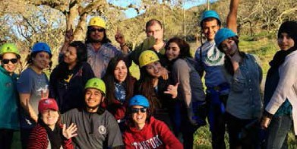

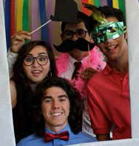


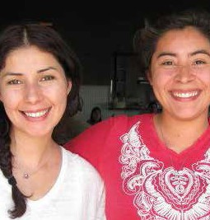

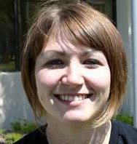
Cañada College
2012-2017

Strategic Plan
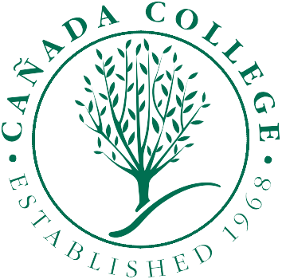
Progress Report for 2015-2016

Table of Contents
Campus-Wide Strategic Plan At-A-Glance 3
Progress Report 2015-2016 6
Strategic Plan Details Information on Annual Initiatives and Accomplishments 6

Campus-Wide Strategic Plan At-A-Glance
Plan | Student Learning | Sustainability | Completion
Educational Master Plan | 1.1 Assess SLOs, PLOs,  ILOs; discuss and make needed changes (100%) | 4.1 Create Sustainability  and social justice interest groups (100%)  - Integrate  sustainability into  Curriculum (75%, defer)  - Improve awareness on campus (100%) | 2.3 Improve orientation (100%)  2.9 Increase degrees and certificates through use of DegreeWorks (100%)  2.12 Monitor student success through review of benchmark and goal data (100%)
Distance Education Plan | 4. Increase student  awareness, retention and success (100%) |  | 1. Broaden DE course  Offerings (100%)  3.3 Routinely assess performance of on-line students (100%)
Student Equity Plan |  |  | - Revise Student Equity Plan (100%)
Technology Plan | - Provide staff  development on technology (100%)  - Evaluate and upgrade infrastructure (100%)
Basic Skills Plan | - Initiate use of e-portfolios for student work (100%)
Sustainability Plan |  | - Develop a sustainability plan. (100%)
Facilities Master Plan  Priorities (page 2.17) | - Increase the number of large classrooms in order to support current program demand and improve utilization of facilities (25%)  - Address the program needs for Science, Technology, Engineering, and Math (STEM), Allied Health, and Workforce (25%)  - Modernize/renovate existing facilities to better support Performing and Creative Arts (100%)  - Increase the College’s ability to support transfer programs in Kinesiology, Personal and Professional Fitness Training, and Dance (25%) | - Incorporate site-relevant energy efficiency, sustainability, and renewable energy projects to reduce operational costs and raise awareness in the community about sustainability (100%) | - Develop the campus environment to support student success. Create spaces, both indoor and outdoor, to facilitate informal interaction between students, faculty, and staff. Place student support services in easily identifiable and accessible locations (25%)

Plan | Pathways | Community | Completion
Educational Master Plan | - Assess and implement flexible scheduling (100%)  - Create and implement professional development plan (100%)  - Promote higher education pathways for middle school and high school students (100%)  - Improve assessment and placement process (100%)  - Identify clear pathways  for basic skills, career- tech, gen ed & majors  & honors (75%, defer)  - Implement financial  literacy and FAFSA campaigns (100%) | - Establish campus community outreach advisory committee (100%)  - Create President’s Circle (100%)  4.2 Expand international program (100%) | 2.6 Establish intentional counseling process to increase completion (100%)  - Enhance transfer services and outreach (100%)  - Review benchmark and goal data (100%)
Distance Education Plan |  |  | 2. Develop community of  DE faculty (75%, defer)  4. Increase student awareness, retention and success (100%)
Student Equity Plan | 1.2a Establish an Access/Success Equity Task Force to identify the barriers of access and success for black students. (100%) | 1. 1Maintain HSI status by continuing outreach efforts that support access for Hispanic students. (100%) | 4.1 Increase the completion rates of Hispanic, male, black and Filipino students. (100%)
Technology Plan | 2. Evaluate and upgrade  Infrastructure (100%) |  | 6. Assure adaptive and  assistive technology is available (100%)
Basic Skills Plan | - Identify improved pathways such as acceleration, Jams (100%) |  | - Direct students to math & English during first semester (100%)
Facilities Master Plan  Priorities (page 2.17) | - Increase the number of large classrooms in order to support current program demand and improve utilization of facilities (25%) |  | - Develop the campus environment to support student success. Create spaces, both indoor and outdoor, to facilitate informal interaction between students, faculty, and staff. Place student support services in easily identifiable and accessible locations (25%)

Plan | Student Engagement | Mentorships/Internships | Completion
Educational Master Plan | 1.4 Create and implement student engagement plan. (100%)  2.7 Implement BSI effective practices (100%) | 2.8 Create opportunities for faculty-student and student-student mentoring (100%)  2.10 Expand Career Center  Activities (100%)  - Integrate service learning and internships into curriculum (25%, defer)  - Enhance off-site learning opportunities (100%) | 2.12 Review benchmark and goal data (100%)
Distance Education Plan |  |  | 3.3 Routinely assess  performance of on-line students (100%)
Student Equity Plan | 5.1 Basic Skills: Increase  the completion rates of black students; Consider UMOJA program. (100%) |  | 4.1 Increase the  completion rates of Hispanic, male, black and Filipino students (100%)
Technology Plan | - Evaluate and upgrade infrastructure (100%)
Basic Skills Plan |  | 5.1 Look into the possibility  of learning communities for black students. (100%)
Facilities Master Plan Priorities  (page 2.17) | - Address the program needs for Science, Technology, Engineering, and Math (STEM), Allied Health, and Workforce (25%)

Progress Report 2015-2016

Strategic Plan Details Information on Annual Initiatives and Accomplishments
The detailed goals, objectives, and accomplishments from the various plans that relate to our annual initiatives are described as follows.

Facilities Master Plan Priority: Increase the number of large classrooms in order to support current program demand and improve utilization of facilities
- 25% accomplished— Facilities Master Plan Priority: Increase the number of large classrooms in order to support current program demand and improve utilization of facilities. 25% accomplished - This goal remained in the planning/discussion phase as a result of the district changing contracting methods for design-build entities. The new science building (B23) will increase the number of large general lecture classrooms.

Facilities Master Plan Priority: Address the program needs for Science, Technology, Engineering, and Math (STEM), Allied Health, and Workforce Development – related programs and provide for the projected expansions of these programs
- 25% accomplished— Facilities Mater Plan Priority: Address the program needs for Science, Technology, Engineering, and Math (STEM), Allied Health, and Workforce Development - related programs and provide for the projected expansions of these programs. 25% accomplished—This goal remains in the planning/discussion phase as the college and district work towards implementation of the Measure H facilities bond that was approved by voters in November 2014.

Educational Master Plan Global and Sustainable Objective 4.3: Work collaboratively with the Academic Senate and the Curriculum Committee to integrate sustainability into the curriculum by developing new courses and increasing the number of courses with a sustainability component.
- 100% accomplished—please see EMP 4.3 Progress Report 2015-2016.

Educational Master Plan Completion Objective 2.4: Improve entry by identifying clear student pathways for basic skills, career/technical, general transfer, specific majors, honors, and courses/programs.
- 75% accomplished—please see EMP 2.4 Progress Report 2015-2016. Defer to the new EMP.

Facilities Master Plan Priorities: Increase the College’s ability to support transfer programs in Kinesiology, Personal and Professional Fitness Training, and Dance
- 25% accomplished— Building 1 Kinesiology and Wellness Building demolition and new construction project

Distance Education Plan Goal 2: Develop a community of well-trained DE faculty members.
- 75% accomplished—please see DE Plan Progress Report 2015-2016.

Educational Master Plan Completion Objective 2.7: Improve progress by implementing effective practices for instruction included in the Basic Skills Initiative Effective Practices document.
- 100% accomplished—please see EMP 2.7 Progress Report 2015-2016.

Facilities Master Plan Priority: Develop the campus environment to support student success. Create spaces, both indoor and outdoor, to facilitate informal interaction between students, faculty, and staff. Place student support services in easily identifiable and accessible locations.
- 25% accomplished— Menlo Park Center Smart Classroom upgrades $0 01/03/2016 Planning/Discussion (25%) Medium Building 9 program efficiency and reconfiguration project $0 01/03/2016 Planning/Discussion (25%) High Create spaces in the Math/Science/Engineering Building new construction project.

Educational Master Plan Completion Objective 2.10: Improve completion by expanding the Career Center and having it closely linked with instructional programs.
- 100% accomplished—please see EMP 2.10 Progress Report 2015-2016.

Educational Master Plan Community Connections Objective 3.3: Integrate Service Learning and Internship opportunities for students into academic and student life.
- 25% accomplished—please see EMP 3.3 Progress Report 2015-2016. Defer to the new EMP.

