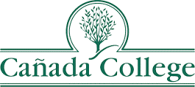

Reimaging Student Access to Career Opportunities
Work Group
Agenda
October 26, 2023 11:00 – 12:30 p.m.
Room 8-119 or on Zoom: https://smccd.zoom.us/j/83237831638

- Welcome and Introductions
- Purpose of the Work Group (refresher)
- Review of our discussion last year – does our “Vision” look accurate?
- Report Outs from the following folks who had follow-up items:
  - Chris and Bob to work together to see how we might standardize the process for getting students on the job board (College Central)
  - Bob, Rance (and Chris?) to explore other ways we can message students about career opportunities so we can both refine and scale the WBL/career messages students get (Canvas, Job Board, emails, other?)
  - Work Group to create a more comprehensive list of Industry Associations, Chambers, employer groups with which we should be connecting (and consider identify which of us will take the lead with different groups to share the load)
  - KE and others to research other colleges who are doing this well, such as
    - Mendocino College
- Discuss our Draft Recommendations to PBC/President Lopez to be presented December 6, 2023
- Next steps for the Work Group

