Astronomy
Comprehensive Program Review Questionnaire Data
7A. Enrollment Trends
Use the data provided by PRIE to examine your enrollments by department or courses. Describe trends in headcount, and load. If applicable, describe any other enrollment data that is relevant to your program

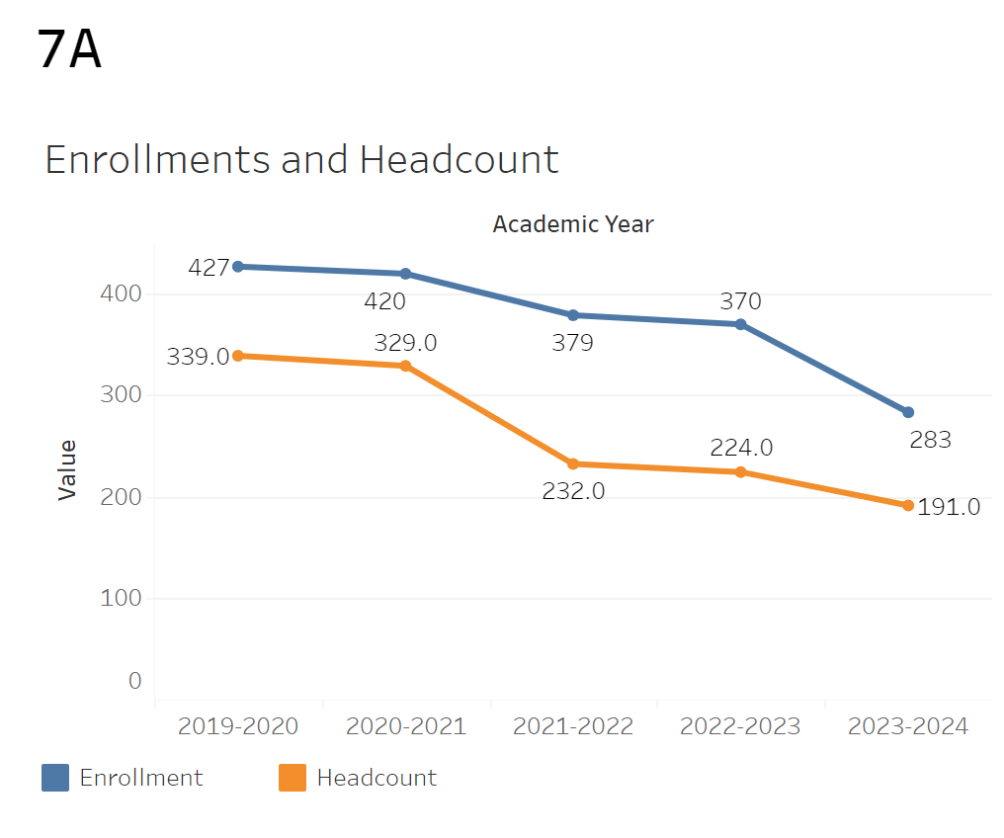
Enrollments have been trending downwards since 2019-2020 to 2023-2024. There was an especially notable decline in enrollments in the 2023-2024 academic year.
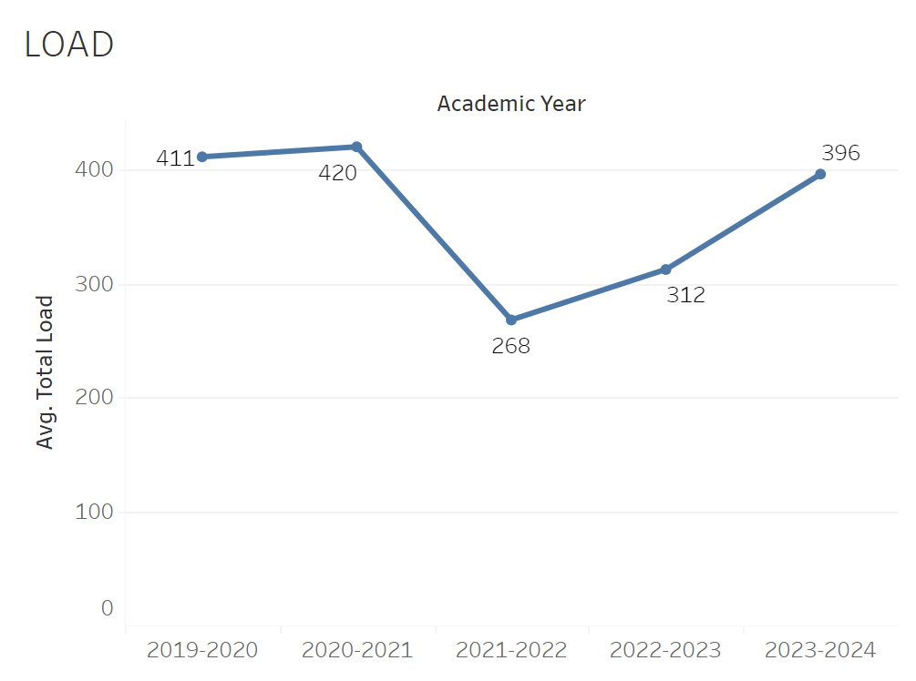
The overall Load had a steep decline between the academic years of 2020-2021 and 2021-2022 going from 420 to 268. It then gradually recovered between 2021-2022 and 2023-2024 though not back to the peak of 420.

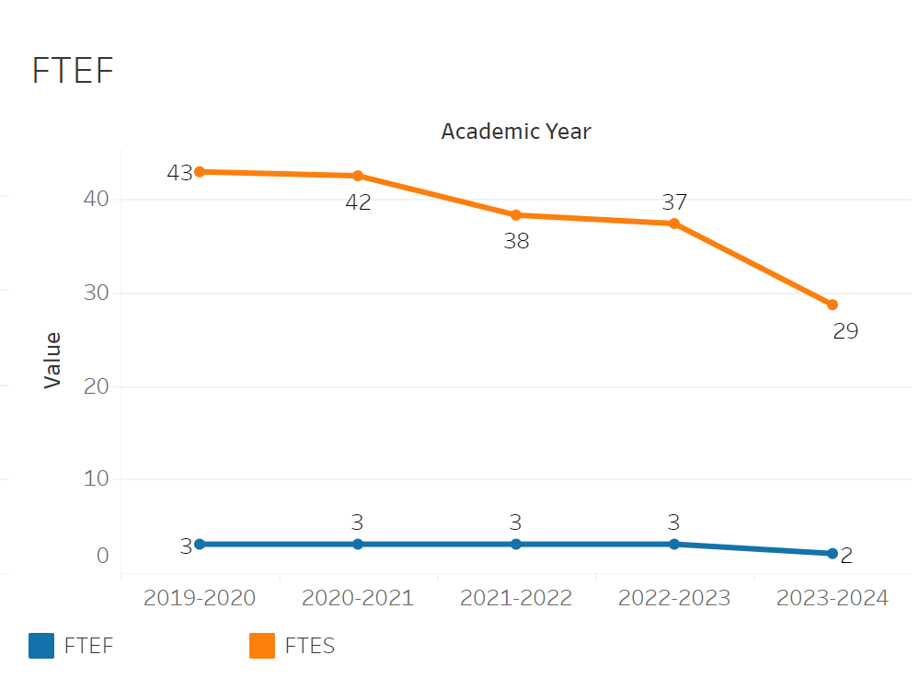
The overall FTEF had not changed at all from its peak until it declined from 3 to 2 in 2023-2024. FTES has followed the enrollment trend consistently going down every year. It started at 43 in 2019-2020 and went down to 29 in 2023-2024.

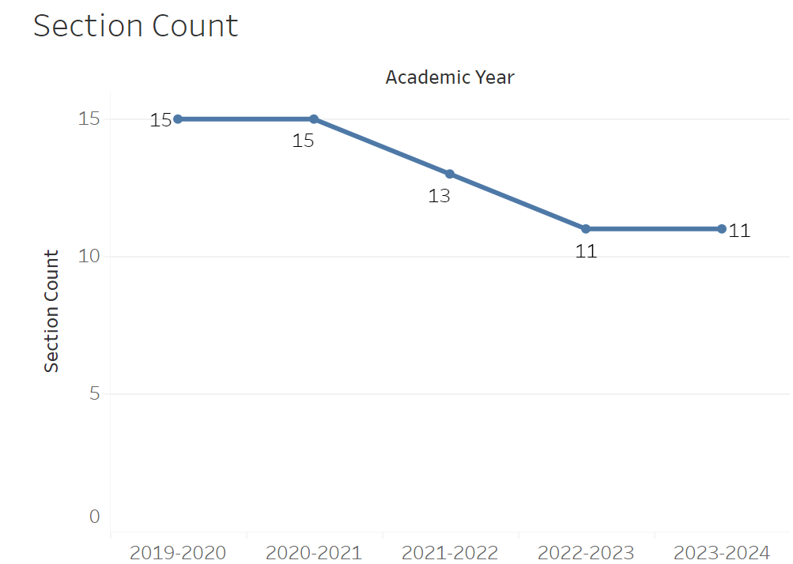

The overall section count for Astronomy has followed the general decline trend with enrollments. It went from 15 to 11 between 2019-2020 and 2022-2023. There was no decline in section count despite the enrollment decline in 2023-2024.

8A. Access & Completion
Describe the student completion and success rate in your courses and/or program using the data provided by PRIE. Look at your course offerings, in the last program review cycle was it possible for a student to complete your certificates or degrees while only completing courses at Cañada College? How can the college help you improve student completion and success? What changes could be made?

Note: See the Course Enrollment & Success Detail Report for additional course-level data. This report can be found on PRIE’s Data Dashboards & Packets page under the program name.
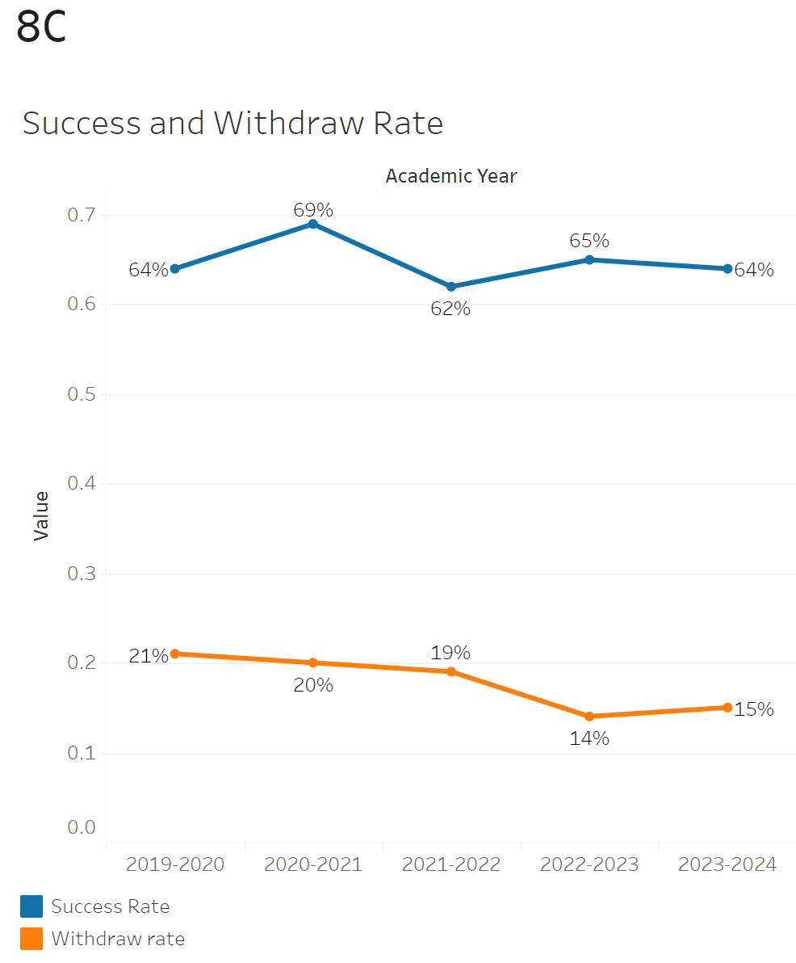
The overall Success rate has remained relatively stable with no major inclines or declines. The only notable incline was from 64% to 69% between 2019-2020 and 2020-2021 which then fell back to the usual range of around 64%. The Withdrawal rate has been on a slight decline over the academic years going from 21% in 2019-2020 to 15% in 2023-2024.

The maximum withdrawal rate was in Astronomy 101 at 21% while the minimum was at 14% in Astronomy 100. The maximum success rate was 69% for astronomy 100 and the minimum was 65% for Astronomy 101.

8B. Student Equity
One of the goals of the College’s Student Equity plan is to close the performance gaps for disproportionately impacted students. Use the data provided by PRIE that indicates which groups are experiencing a disproportionate impact in your program. Which gaps are most important for improving outcomes in your program? How can the college help you address these gaps? What changes could be made?
OVERALL EQUITY

The Equity and Disproportionate Impact (DI) dashboard was used to identify subgroups that may have been disproportionately impacted in Astronomy in the most recent academic year (2023-2024). The three metrics used to examine potential disproportionate impact were enrollment rates (referred as access), success rates, and withdraw rates. The rate for each subgroup was compared to either the college-wide rate (access) or the overall program-level rate (success and withdraws). The difference between the two rates is known as the ‘gap’ and may be referred to as a performance gap or equity gap. Student subgroups that may have been disproportionately impacted in Astronomy appear below (see Table 1-2).

Access
Access is an indicator of what student subgroups are enrolling in courses, based on unique student counts. Enrollment data revealed three student subgroups were underrepresented in Astronomy classes compared to the college-wide population (see Table 1). For instance, female students are underrepresented in Astronomy. The proportion of female students in Astronomy across all course modalities was 11 percentage points lower than the proportion of female students enrolled college-wide.
Table 1.
SubGroup | Gap
Female | -11%
Not Low Income | -8%
Less than Part Time | -15%

Success
Success is the rate at which different student subgroups pass courses and is based on enrollments. The success rate for different subgroups in Astronomy was compared to the overall success rate in Astronomy. The difference between the two rates (the gap) revealed five subgroups may have been disproportionately impacted (see Table 2). For example, the success rate for Hispanic students in Astronomy was 10 percentage points lower than the overall success rate in Astronomy during the 2023-2024 academic year.
Table 2.
SubGroup | Gap | Gap Type
Hispanic | -10% | Success

EQUITY BY INSTRUCTIONAL MODALITY
Success
Success is the rate at which different student subgroups pass courses and is based on enrollments. The success rate for different subgroups in Astronomy was compared to the overall success rate in Astronomy. The difference between the two rates (the gap) revealed three subgroups may have been disproportionately impacted (see Table 1). For example, the success rate for Low Income students in face to face classes for Astronomy was 16 points lower than the overall success rate in Astronomy during the 2023-2024 academic year.
Table 1.
SubGroup | ONLINE | FACE TO FACE | HYBRID | SYNC
Low Income |  | -16%
Hispanic | -13%
Hispanic - Male | -22%

8C. Completion – Success Online
The college has a goal of improving success in online courses. Using the data provided by PRIE, what significant gaps do you see in success between online/hybrid and non-online courses? What changes could be made to reduce these gaps? If your program does not offer online/hybrid courses, please write “not applicable”.
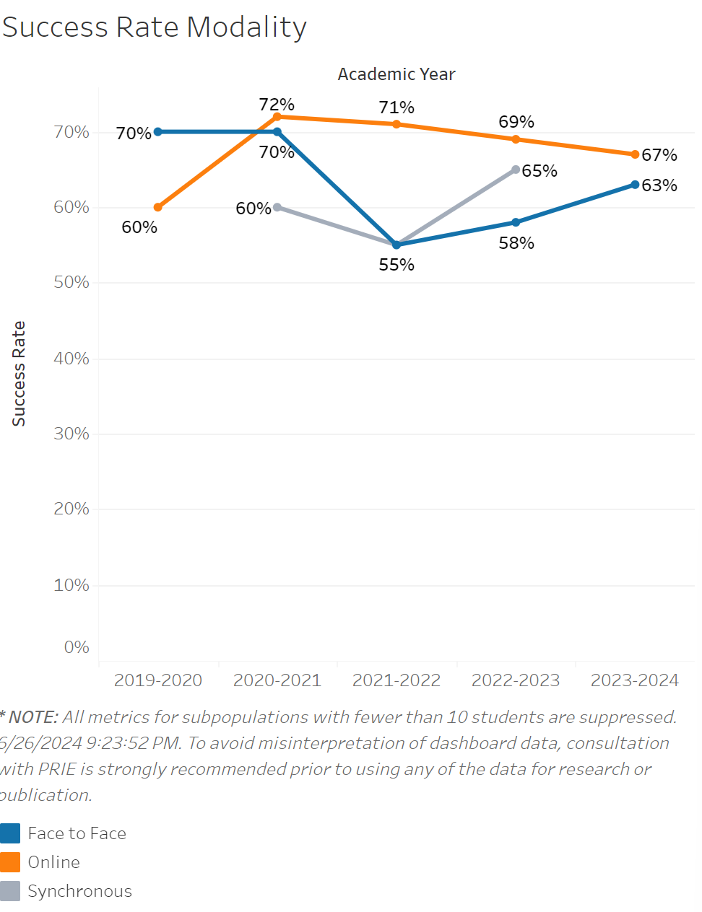
The overall rate of fully online classes sharply increased from 2019-2020 to 2020-2021 and then slowly declined between then and 2023-2024. However, it didn’t go back to its low of 60%. In person classes did the exact opposite of the online class modality. There isn’t enough data on Synchronous classes to draw any conclusions.

Source: https://canadacollege.edu/prie/dashboards/disproportionate-impact.php

