Biology, Biological Sciences, and Health Sciences (combined)
Comprehensive Program Review Questionnaire Data
Please Note: This data provides information for all of the biological sciences and biology disciplines together. For more data by discipline or program of study, please see the PRIE Data Dashboard and packet for Biological and Health Sciences.
—---------------------

7A. Enrollment Trends
Use the data provided by PRIE to examine your enrollments by department or courses. Describe trends in headcount, FTES, and load. If applicable, describe any other enrollment data that is relevant to your program

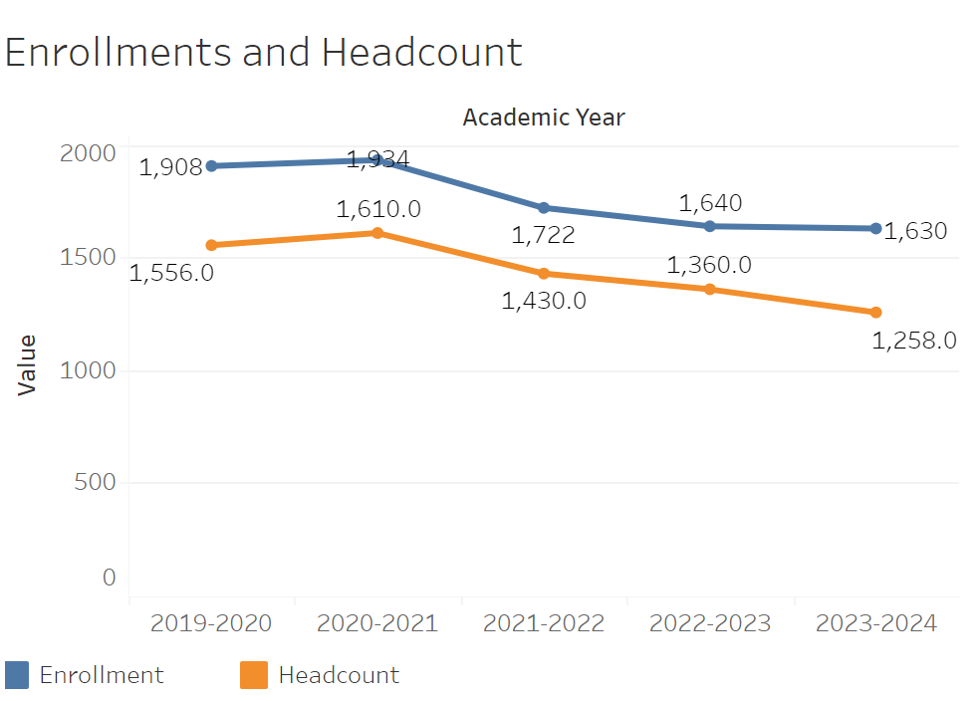

Enrollment and headcount trends are very close in line with one another and follow the same trend with the exception of 2023-2024. Enrollment has declined from 1,934 to 1,640 between 2020-2021 and 2022-2023 and then flatlined for the most part in 2023-2024. Headcount declined from 1,610 to 1,258 in 2023-2024.

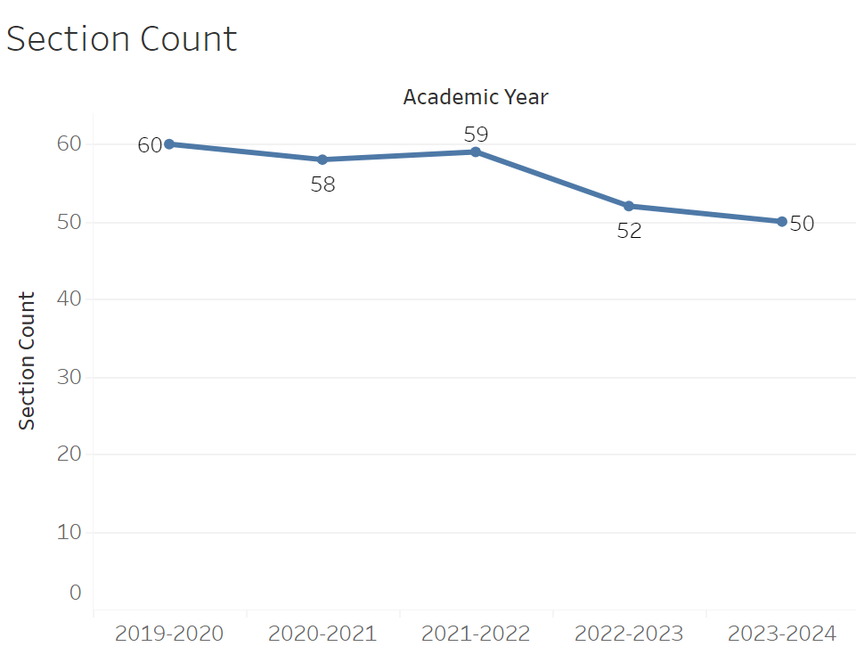
Section count has steadily declined from 60 to 50 between 2019-2020 and 2023-2024. Every year it declined with the exception of 2021-2022 where it increased briefly from 58 to 59.

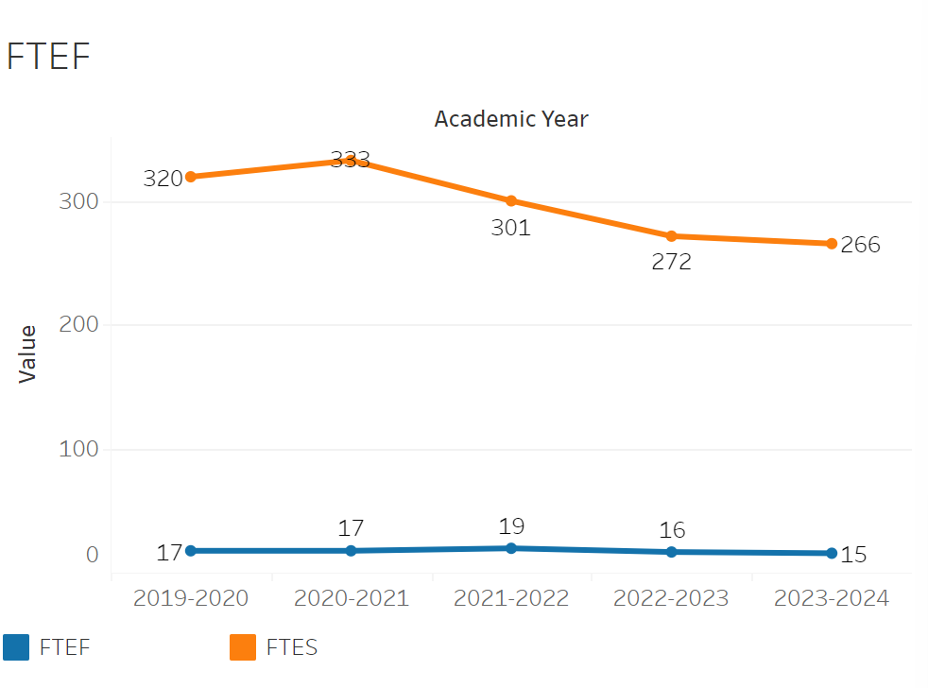
FTEF was at 17 between 2019-2020 and 2020-2021 and then briefly increased to 19 in 2021-2022. It then declined to 15 by 2023-20224. FTES rose from 320 to 333 between 2019-2020 and 2020-2021. After that point it steadily declined to 265 between then and 2023-2024.

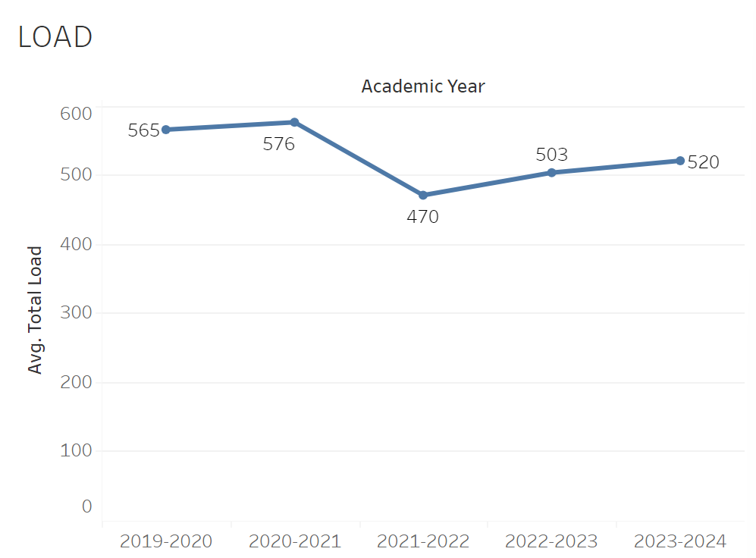
Load was at a peak of 576 in 2020-2021 and then declined steeply to 470 in 2021-2022. It then slowly recovered to 520 by 2023-2024, though not quite back to its peak.

8A. Access & Completion
Describe the student completion and success rate in your courses and/or program using the data provided by PRIE. Look at your course offerings, in the last program review cycle was it possible for a student to complete your certificates or degrees while only completing courses at Cañada College? How can the college help you improve student completion and success? What changes could be made?

Note: See the Course Enrollment & Success Detail Report for additional course-level data. This report can be found on PRIE’s Data Dashboards & Packets page under the program name.

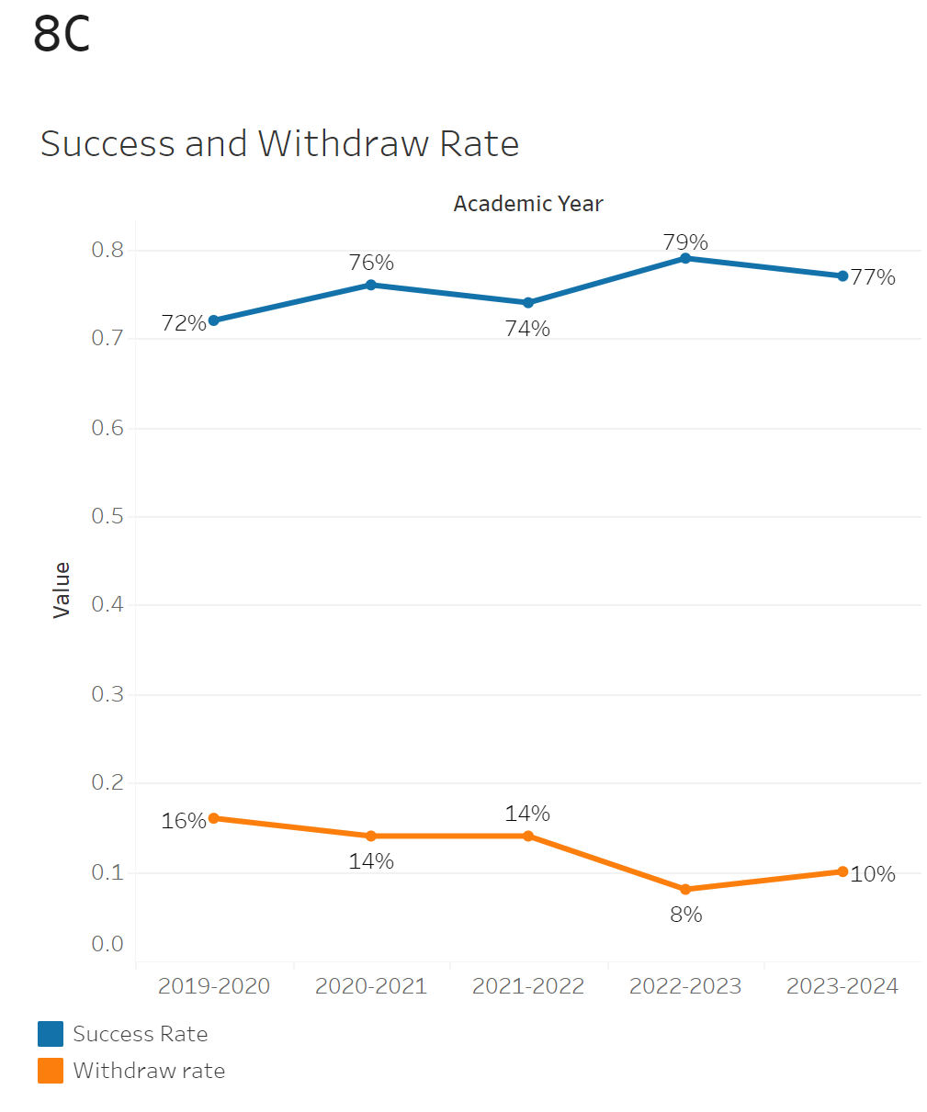
The overall success rate has been on an incline for Biology with some intermittent drops. Between 2019-2020 and 2023-2024 the success rate has increased by 5%. Withdrawals were mostly flat but declined from 14% to 8% between the 2021-2022 and 2022-2023 academic years. It has since remained at 10%.

The withdrawal rate for biology had a minimum of 0% in BIOL-695 and a maximum withdrawal rate of 31% in BIOL-133. The maximum success rate was 100% in BIOL-695 and the minimum was 50% in BIOL-1333.
8B. Student Equity
One of the goals of the College’s Student Equity plan is to close the performance gaps for disproportionately impacted students. Use the data provided by PRIE that indicates which groups are experiencing a disproportionate impact in your program. Which gaps are most important for improving outcomes in your program? How can the college help you address these gaps? What changes could be made?

OVERALL EQUITY

The Equity and Disproportionate Impact (DI) dashboard was used to identify subgroups that may have been disproportionately impacted in Biology in the most recent academic year (2023-2024). The three metrics used to examine potential disproportionate impact were enrollment rates (referred as access), success rates, and withdraw rates. The rate for each subgroup was compared to either the college-wide rate (access) or the overall program-level rate (success and withdraws). The difference between the two rates is known as the ‘gap’ and may be referred to as a performance gap or equity gap. Student subgroups that may have been disproportionately impacted in Biology appear below (see Table 1-3).
Access
Access is an indicator of what student subgroups are enrolling in courses, based on unique student counts. Enrollment data revealed four student subgroups were underrepresented in Biology classes compared to the college-wide population (see Table 1). For instance, male students are underrepresented in Biology. The proportion of male students in Biology across all course modalities was 6 percentage points lower than the proportion of male students enrolled college-wide.

Table 1.
SubGroup | Gap
Male | -6%
Not First Generation | -6%
Not Low Income | -7%
Less than Part-Time | -20%

Success
Success is the rate at which different student subgroups pass courses and is based on enrollments. The success rate for different subgroups in Biology was compared to the overall success rate in Biology. The difference between the two rates (the gap) revealed nine subgroups may have been disproportionately impacted (see Table 2). For example, the success rate for Black – Non-Hispanic students in Biology was 27 percentage points lower than the overall success rate in Biology during the 2023-2024 academic year.

Table 2.
SubGroup | Gap
Black- Non-Hispanic | -27%
Hispanic | -7%
Pacific Islander | -19%
Black- Non-Hispanic - Female | -21%
Black- Non-Hispanic- Male | -45%
Hispanic - Female | -5%
Hispanic - Unreported | -11%
First Generation | -4%
Low Income | -7%

Withdraws
Withdraws is the rate at which a student withdraws from a course, with higher numbers being worse, as they indicate greater withdrawal rates. The withdrawal rates for subgroups in Biology was compared to the overall withdrawal rate for the program. Two subgroups had withdrawal rates that were significantly higher than the overall rate, suggesting these groups experienced disproportionate impact in Biology. Black – Non-Hispanic students were disproportionately impacted in Biology during the 2023-2024 academic year. Black – Non-Hispanic students had withdrawal rates 18 percentage points higher than the average withdrawal rate for Biology.
Table 3.
SubGroup | Gap
Black- Non-Hispanic | 18%
50 - 59 | 24%

EQUITY BY INSTRUCTIONAL MODALITY
Success
Success is the rate at which different student subgroups pass courses and is based on enrollments. The success rate for different subgroups in Biology was compared to the overall success rate in Biology. The difference between the two rates (the gap) revealed ten subgroups may have been disproportionately impacted (see Table 1). For example, the success rate for Hispanic students in hybrid classes for Biology was 6 points lower than the overall success rate in Biology during the 2023-2024 academic year.
Table 1.
SubGroup | ONLINE | FACE TO FACE | HYBRID | SYNC
Unreported Gender |  | -29%
Hispanic |  | -7%
Hispanic - Male |  | -13%
23-28 |  | -6%
Black - Non-Hispanic |  |  | -26%
Hispanic |  |  | -6%
Black - Non-Hispanic | -38%
Pacific Islander | -34%
Black - Non-Hispanic -Female | -32%
Low Income | -12%

8C. Completion – Success Online
The college has a goal of improving success in online courses. Using the data provided by PRIE, what significant gaps do you see in success between online/hybrid and non-online courses? What changes could be made to reduce these gaps? If your program does not offer online/hybrid courses, please write “not applicable”.
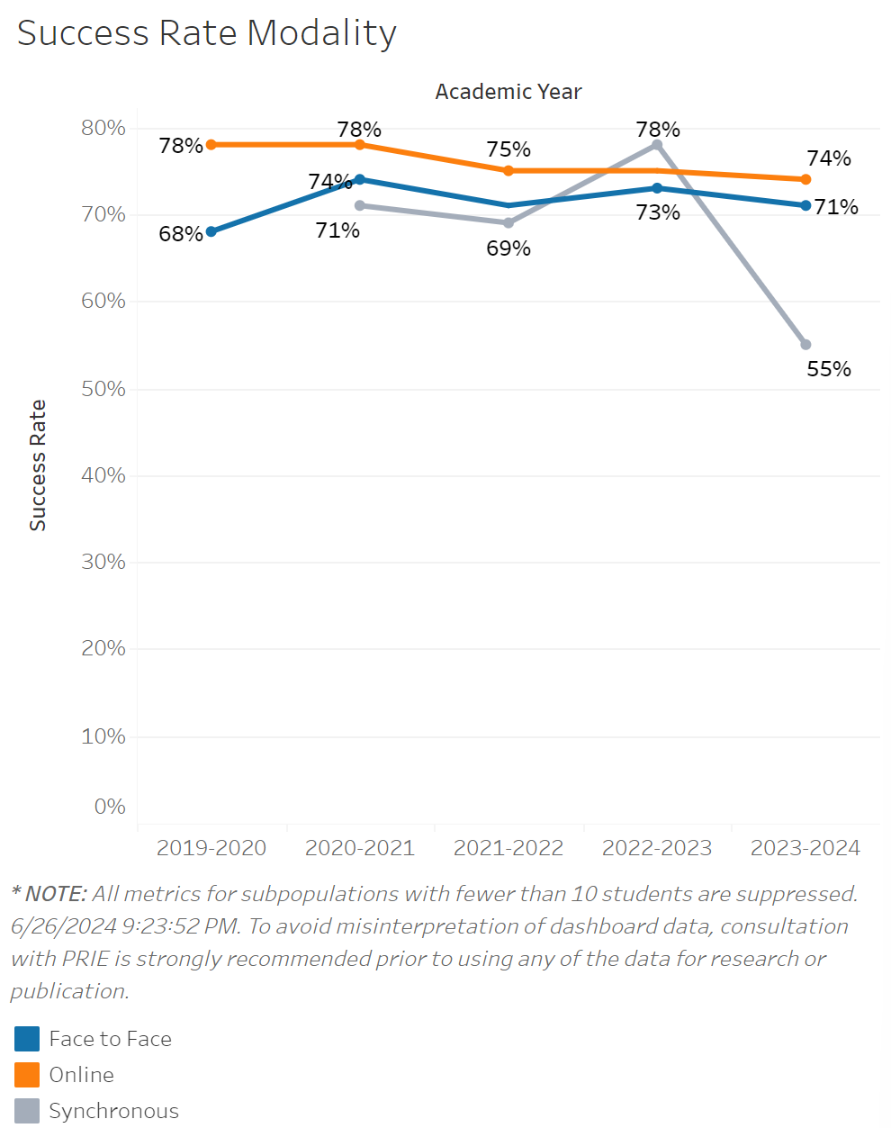

Success for face to face classes has been on a slight decline for online classes going from 78% to 74% between 2019-2020 and 2023-2024. Success for face to face classes have consistently been lower than online classes though not by a large margin aside from 2019-2020. After the incline from 68% to 74% between 2019-2020 and 2020-2021 Success remained relatively flat for face to face classes before dipping down to 69% in 2023-2024. The success rate for synchronous classes was quite inconsistent jumping from 69% in 2021-2022 to 78% in 2022-2023. It then dropped all the way down to 50% in 2023-2024.

Source: https://canadacollege.edu/prie/dashboards/disproportionate-impact.php

