Chemistry
Comprehensive Program Review Questionnaire Data
7A. Enrollment Trends
Use the data provided by PRIE to examine your enrollments by department or courses. Describe trends in headcount, FTES, and load. If applicable, describe any other enrollment data that is relevant to your program

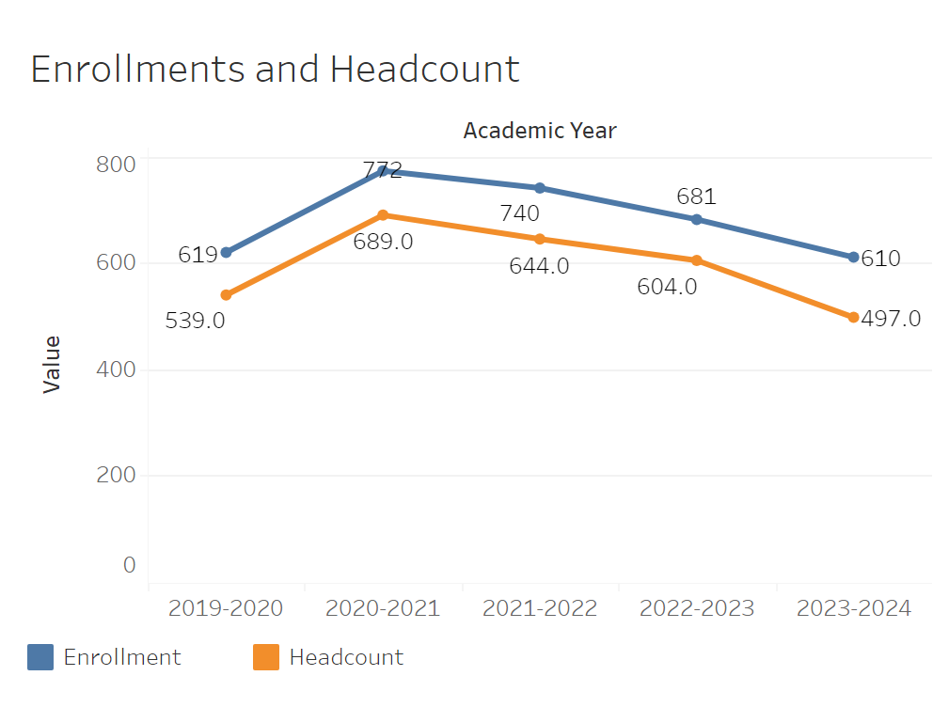
Between 2019-2020 and 2020-2021 overall enrollment increased from 619 to 772 for Chemistry. After 2020-2021, enrollment slowly declined until it reached 610 in 2023-2024. Headcount followed much the same trend.
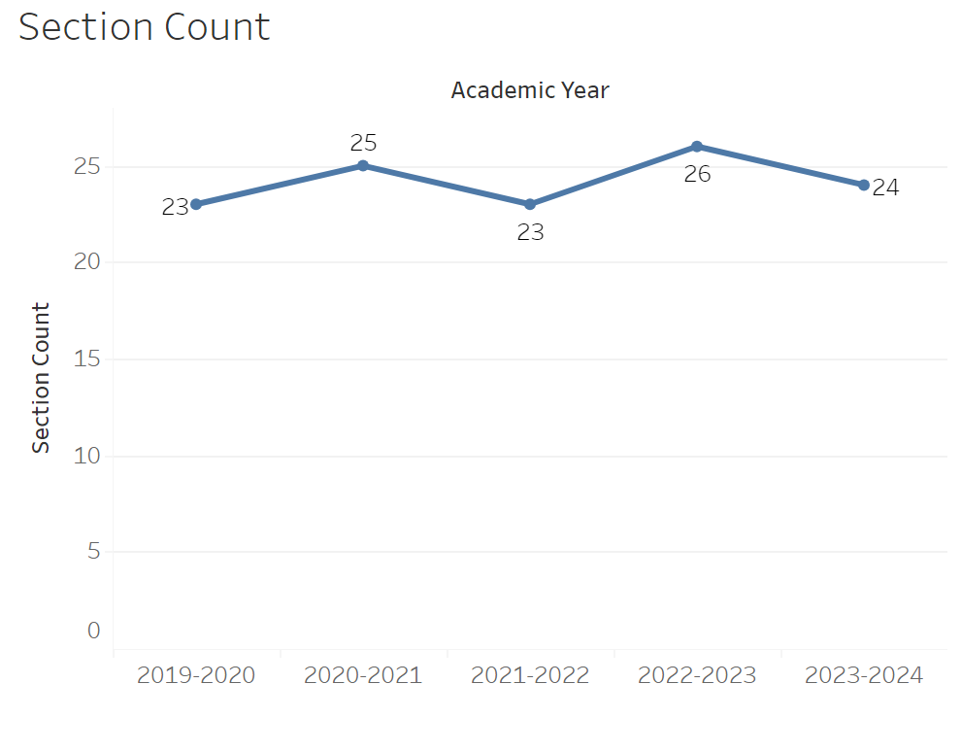
Section count has remained relatively flat, only fluctuating 23-26 year to year with no particular pattern.

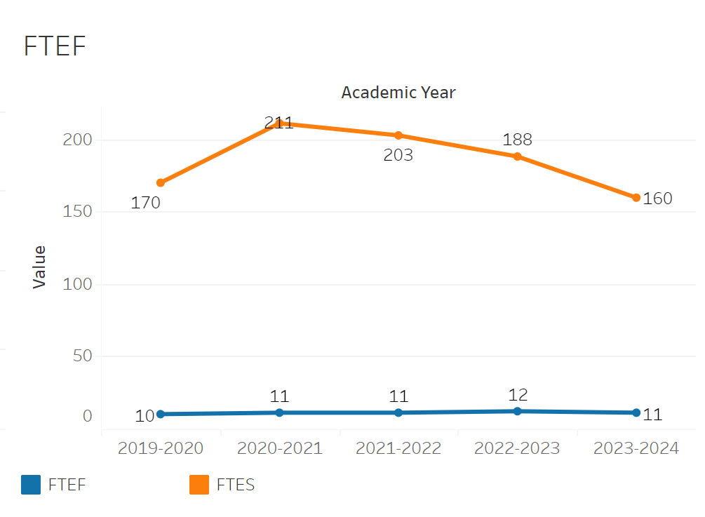
FTEF increased from 10 to 11 between 2019-2020 and 2020-2021. It then remained flat with the exception of 2022-2023 where it briefly went up to 12. FTES increased from 170 to 211 between 2019-2020 and 2020-2021. It then declined to 160 by 2023-2024.

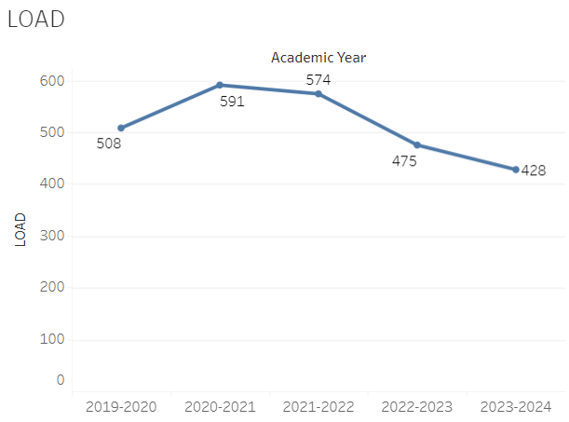
Load for Chemistry increased from 508 - 591 between 2019-2020 and 2020-2021. It then slowly declined during the pandemic from that peak between the 2020-2021 and 2023-2024 academic years down to 428.

8A. Access & Completion
Describe the student completion and success rate in your courses and/or program using the data provided by PRIE. Look at your course offerings, in the last program review cycle was it possible for a student to complete your certificates or degrees while only completing courses at Cañada College? How can the college help you improve student completion and success? What changes could be made?

Note: See the Course Enrollment & Success Detail Report for additional course-level data. This report can be found on PRIE’s Data Dashboards & Packets page under the program name.

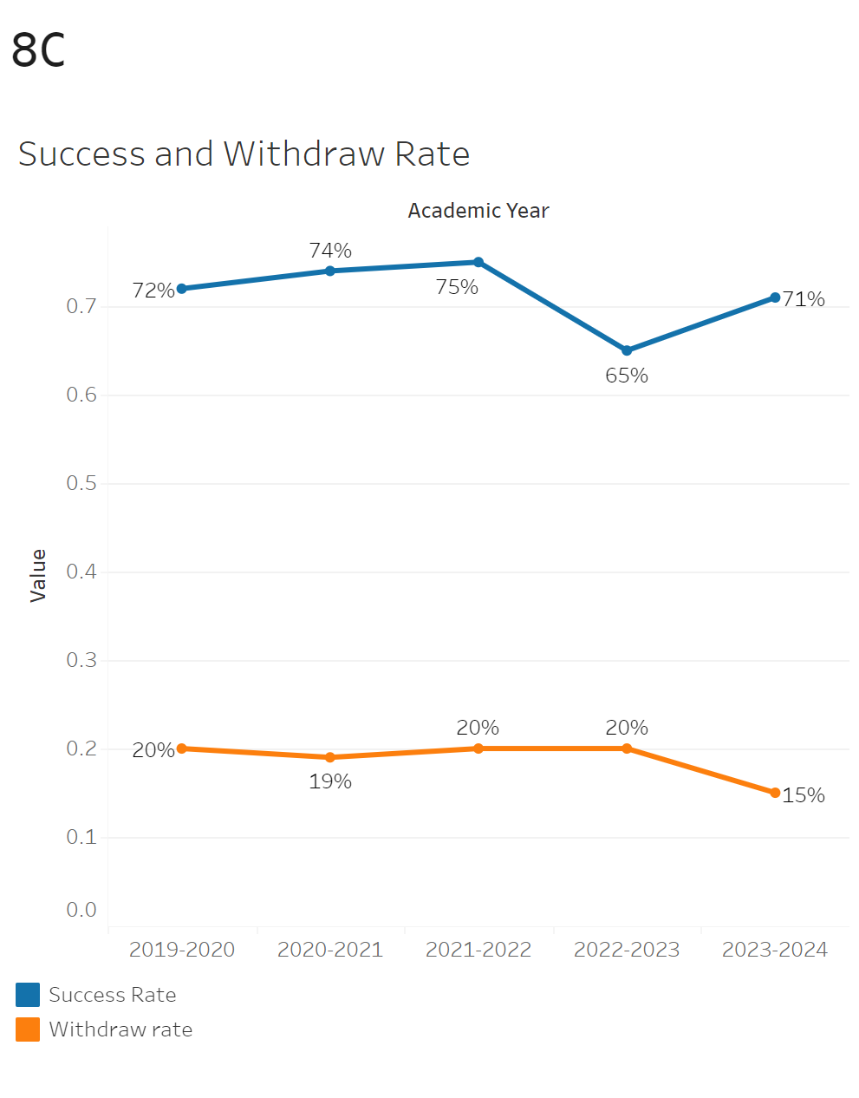
Success rates were relatively flat hovering around 72-75% between 2019-2020 and 2021-2022. The rates then declined to 65% in 2022-2023. Afterwards it recovered to 70% in 2023-2024. Withdrawals were flat at 20% between 2019-2020 to 2022-2023 aside from a 1% decline in 2020-2021. They then dipped to 16% in 2023-2024.

Chem 192 had the largest withdraw rate of 25% while Chem 232 had the smallest withdraw rate of 2%. Chem 192 also had the smallest success rate of 58% while Chem 232 had the largest success rate of 95%.
8B. Student Equity
One of the goals of the College’s Student Equity plan is to close the performance gaps for disproportionately impacted students. Use the data provided by PRIE that indicates which groups are experiencing a disproportionate impact in your program. Which gaps are most important for improving outcomes in your program? How can the college help you address these gaps? What changes could be made?

OVERALL EQUITY

The Equity and Disproportionate Impact (DI) dashboard was used to identify subgroups that may have been disproportionately impacted in Chemistry in the most recent academic year (2022-2023). The three metrics used to examine potential disproportionate impact were enrollment rates (referred as access), success rates, and withdrawal rates. The rate for each subgroup was compared to either the college-wide rate (access) or the overall program-level rate (success and withdrawals). The difference between the two rates is known as the ‘gap’ and may be referred to as a performance gap or equity gap. Student subgroups that may have been disproportionately impacted in Chemistry appear below (see Table 1-3).
Access
Access is an indicator of what student subgroups are enrolling in courses, based on unique student counts. Enrollment data revealed one student subgroup was underrepresented in Chemistry classes compared to the college-wide population (see Table 1). For instance, Less than Part-Time students are underrepresented in Chemistry. The proportion of less than Part-Time students in Chemistry across all course modalities was 24 percentage points lower than the proportion of Less than Part-Time students enrolled college-wide.
Table 1.
SubGroup | Gap
Less than Part-Time | -24%

Success
Success is the rate at which different student subgroups pass courses and is based on enrollments. The success rate for different subgroups in Chemistry was compared to the overall success rate in Chemistry. The difference between the two rates (the gap) revealed five subgroups may have been disproportionately impacted (see Table 2). For example, the success rate for Hispanic students in Chemistry was 12 percentage points lower than the overall success rate in Chemistry during the 2023-2024 academic year.
Table 2.
SubGroup | Gap
Hispanic | -12%
Hispanic - Female | -17%
40-49 | -30%
First Generation | -9%
Low Income | -10%

Withdraws
Withdraws is the rate at which a student withdraws from a course, with higher numbers being worse, as they indicate greater withdrawal rates. The withdrawal rates for subgroups in Chemistry was compared to the overall withdrawal rate for the program. One subgroup had withdrawal rates that were higher than the overall rate, suggesting this group experienced disproportionate impact in Chemistry. Hispanic students were disproportionately impacted in Chemistry during the 2023-2024 academic year. Hispanic students had withdrawal rates 6 percentage points higher than the average withdrawal rate for Chemistry.
Table 3.
SubGroup | Gap
Hispanic | 6%
Hispanic - Female | 10%
40-49 | 30%
First Generation | 7%

EQUITY BY INSTRUCTIONAL MODALITY
Success
Success is the rate at which different student subgroups pass courses and is based on enrollments. The success rate for different subgroups in Chemistry was compared to the overall success rate in Chemistry. The difference between the two rates (the gap) revealed five subgroups may have been disproportionately impacted (see Table 1). For example, the success rate for Hispanic students in hybrid classes for Chemistry was 14 points lower than the overall success rate in Chemistry during the 2023-2024 academic year.
Table 1.
SubGroup | ONLINE | FACE TO FACE | HYBRID | SYNC
Hispanic |  |  | -14%
Hispanic - Female |  |  | -18%
First Generation |  |  | -11%
Hispanic | -32%
Multiraces - Female |  | -36%

Withdraws
Withdraws is the rate at which a student withdraws from a course, with higher numbers being worse, as they indicate greater withdrawal rates. The withdrawal rates for subgroups in Chemistry was compared to the overall withdrawal rate for the program. Two subgroups had withdrawal rates that were higher than the overall rate, suggesting these groups experienced disproportionate impact in Chemistry. Hispanic students were disproportionately impacted in Chemistry during the 2023-2024 academic year. For example, Hispanic students in Hybrid classes had withdrawal rates 9 percentage points higher than the average withdrawal rate for Chemistry.
Table 2.
SubGroup | ONLINE | FACE TO FACE | HYBRID | SYNC
First Generation |  |  | 19%
Hispanic |  |  | 9%

8C. Completion – Success Online
The college has a goal of improving success in online courses. Using the data provided by PRIE, what significant gaps do you see in success between online/hybrid and non-online courses? What changes could be made to reduce these gaps? If your program does not offer online/hybrid courses, please write “not applicable”.

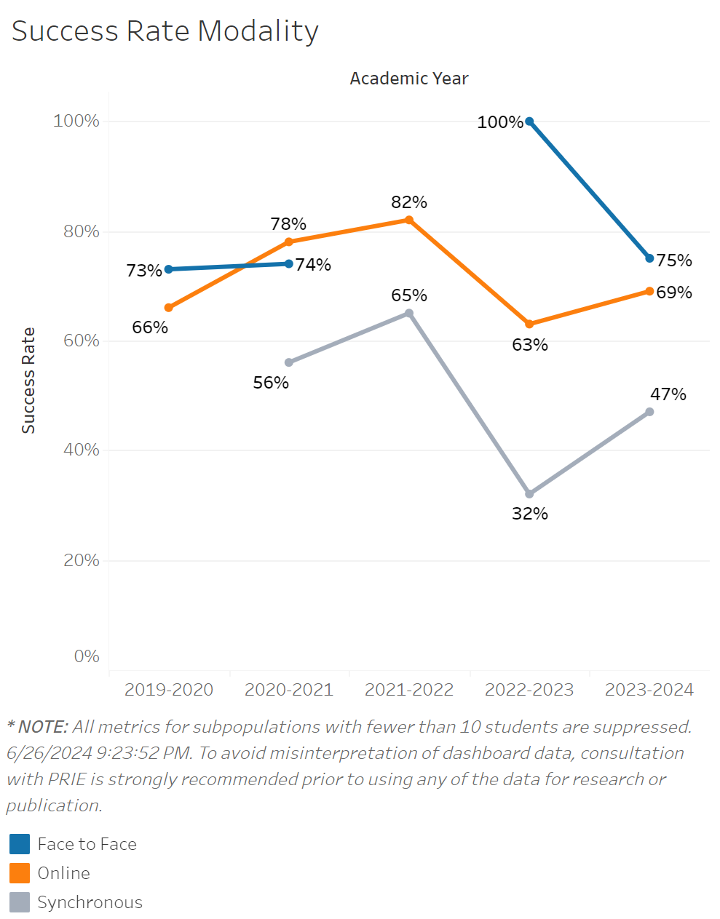

Success rates for Online classes in Chemistry increased from 66% to 82% between 2019-2020 and 2021-2022. They then fell to 63% in 2022-2023 and only recovered slightly to 69% in 2023-2024. Face to face class success rates primarily stayed between 73% and 74% with an anomaly of a 100% success rate in 2022-2023. Synchronous class success rates peaked in 2021-2022 at 65% and then dropped significantly to 32% in the 2022-2023 academic year. The success rate bounced back slightly in 2023-2024 to 44%.

Source: https://canadacollege.edu/prie/dashboards/disproportionate-impact.php

