Computer Science
Comprehensive Program Review Questionnaire Data
7A. Enrollment Trends
Use the data provided by PRIE to examine your enrollments by department or courses. Describe trends in headcount, FTES, and load. If applicable, describe any other enrollment data that is relevant to your program
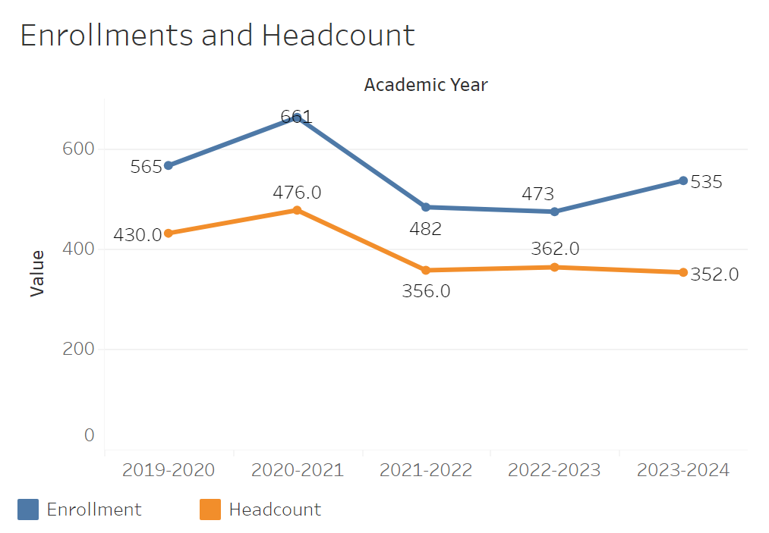
Enrollments rose from 565 to 661 between 2019-2020 and 2020-2021. It then sharply declined to 482 in 2020-2021. It has since slowly recovered to 535 in 2023-2024. Headcount has followed the same trend aside from having that recovery in 2023-2024.

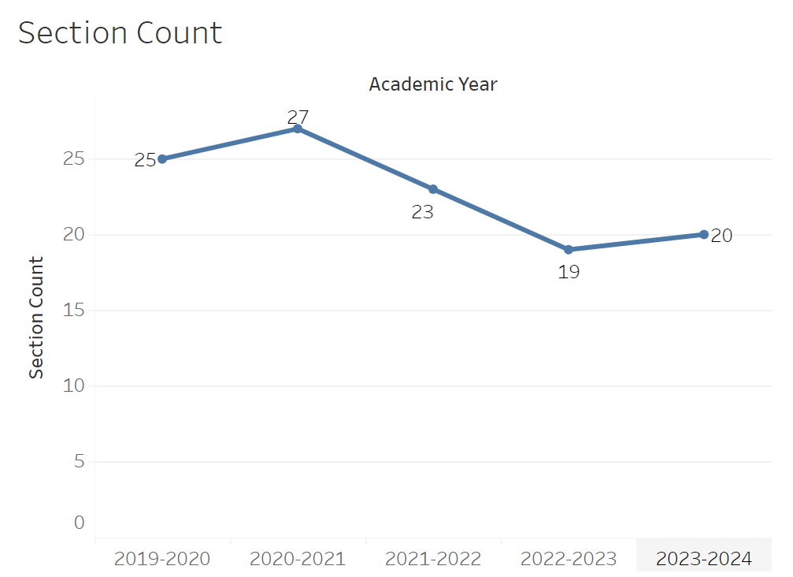
Section count peaked at 27 in 2020-2021. It then sharply declined to 19 between then and 2022-2023. It then went up slightly to 20 in 2023-2024. This puts it very roughly in line with the enrollment trend.
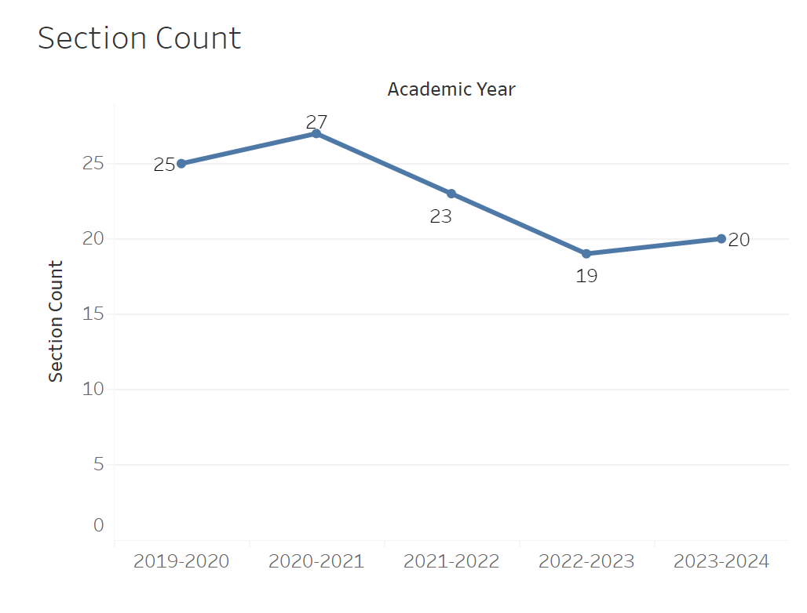
Section count went up to 27 in 2020-2021 from 25 in 2019-2020. It then fell to 19 between then and 2022-2023. Finally it rose up to 20 in 2023-2024 putting it roughly in line with the enrollment trend.
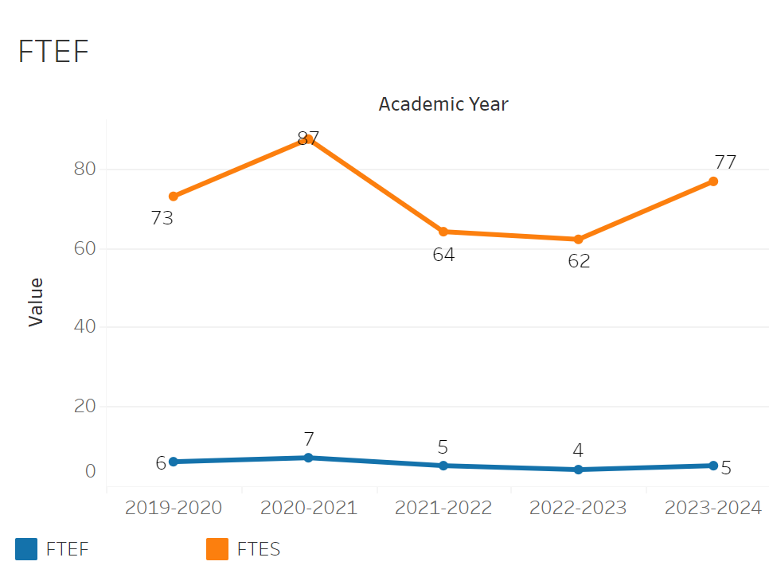
FTEF is roughly in line with the enrollment trend. FTEF rose from 6 to 7 between 2019-2020 and 2020-2021 and then fell thereafter until it reached 4 in 2022-2023. There was a brief recovery to 5 in 2023-2024. FTES went from 73 to 87 between 2019-2020 and 2020-2021. FTES then declined to 62 by 2022-2023. It recovered partially to 76.79 in 2023-2024, but not back to its peak.

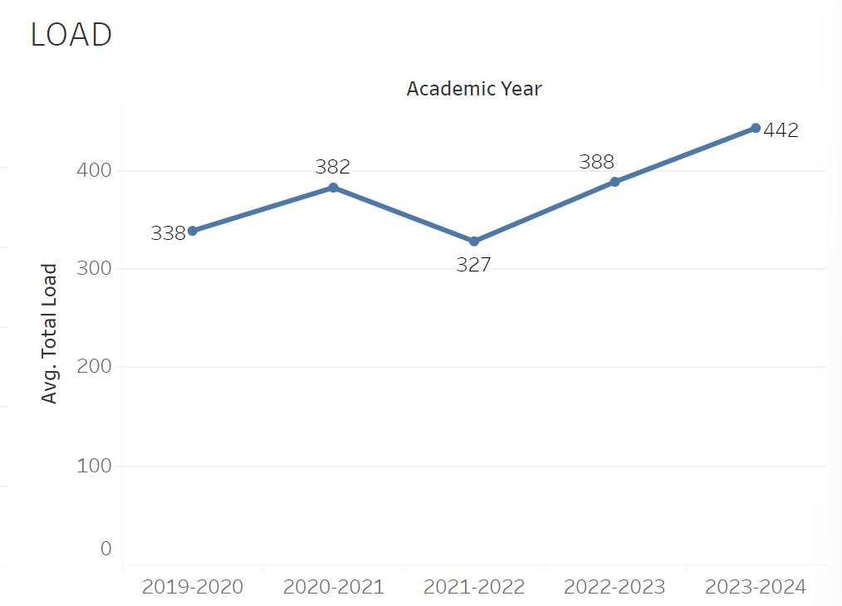
Load didn’t have any notable trends between 2019-2020 and 2021-2022 other than rising to 382 in 2020-2021. However, between 2021-2022 and 2023-2024 load rose from 327 to 442.
8A. Access & Completion
Describe the student completion and success rate in your courses and/or program using the data provided by PRIE. Look at your course offerings, in the last program review cycle was it possible for a student to complete your certificates or degrees while only completing courses at Cañada College? How can the college help you improve student completion and success? What changes could be made?

Note: See the Course Enrollment & Success Detail Report for additional course-level data. This report can be found on PRIE’s Data Dashboards & Packets page under the program name.
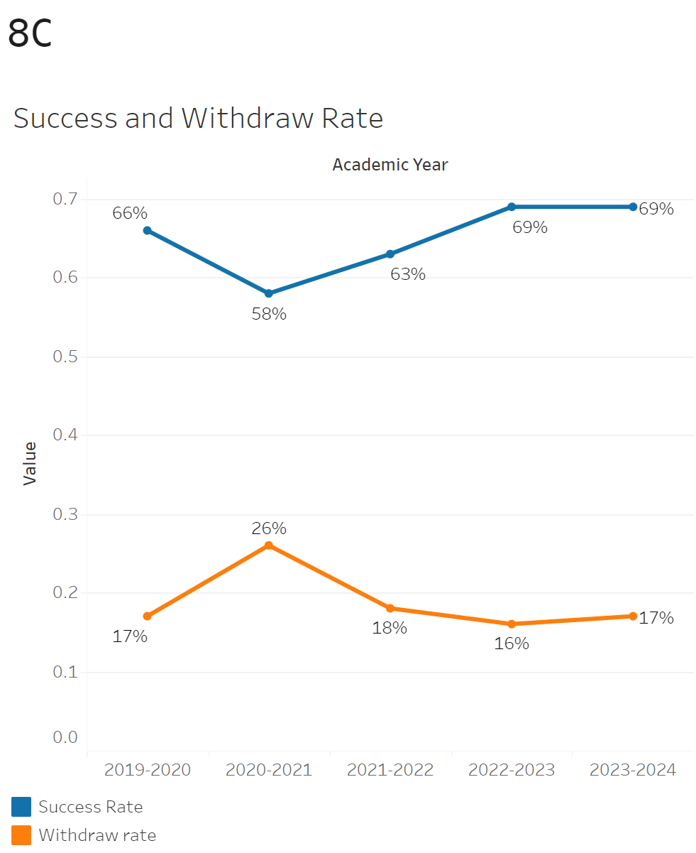
Success rates fell from 66 to 58% in 2020-2021. Between 2020-2021 and 2022-2023 success rates began to climb up past their initial peak of 66% to 69%. They then fell to 67% in 2023-2024. Withdrawal rates were relatively flat, only fluctuating between 16-18%. However, there was a notable peak of 26% in 2020-2021.

The withdraw rate ranged from a maximum of 33% in CIS-321 to a minimum of 6% in CIS-262. The maximum success rate was 87% in CIS 262 and the minimum success rate was 37% in CIS-295.
8B. Student Equity
One of the goals of the College’s Student Equity plan is to close the performance gaps for disproportionately impacted students. Use the data provided by PRIE that indicates which groups are experiencing a disproportionate impact in your program. Which gaps are most important for improving outcomes in your program? How can the college help you address these gaps? What changes could be made?

OVERALL EQUITY

The Equity and Disproportionate Impact (DI) dashboard was used to identify subgroups that may have been disproportionately impacted in Computer Science in the most recent academic year (2023-2024). The three metrics used to examine potential disproportionate impact were enrollment rates (referred as access), success rates, and withdraw rates. The rate for each subgroup was compared to either the college-wide rate (access) or the overall program-level rate (success and withdraws). The difference between the two rates is known as the ‘gap’ and may be referred to as a performance gap or equity gap. Student subgroups that may have been disproportionately impacted in Computer Science appear below (see Table 1-3).
Access
Access is an indicator of what student subgroups are enrolling in courses, based on unique student counts. Enrollment data revealed two student subgroups were underrepresented in Computer Science classes compared to the college-wide population (see Table 1). For instance, female students are underrepresented in Computer Science. The proportion of female students in Computer Science across all course modalities was 33 percentage points lower than the proportion of female students enrolled college-wide.
Table 1.
SubGroup | Gap
Female | -33%
Less than Part-Time | -19%

Success
Success is the rate at which different student subgroups pass courses and is based on enrollments. The success rate for different subgroups in Computer Science was compared to the overall success rate in Computer Science. The difference between the two rates (the gap) revealed five subgroups may have been disproportionately impacted (see Table 2). For example, the success rate for Hispanic students in Computer Science was 12 percentage points lower than the overall success rate in Computer Science during the 2023-2024 academic year.
Table 2.
SubGroup | Gap
Hispanic | -12%
Hispanic - Male | -14%
23-28 | -14%
29-39 | -18%
Disabled | -20%

Withdraws
Withdraws is the rate at which a student withdraws from a course, with higher numbers being worse, as they indicate greater withdrawal rates. The withdrawal rates for subgroups in Computer Science was compared to the overall withdrawal rate for the program. One subgroup had withdrawal rates that were significantly higher than the overall rate, suggesting this group experienced disproportionate impact in Computer Science. Aged 40-49 students and were disproportionately impacted in Computer Science during the 2023-2024 academic year. Aged 40-49 students had withdrawal rates 27 percentage points higher than the average withdrawal rate for Computer Science.

Table 3.
SubGroup | Gap
40-49 | 27%

EQUITY BY INSTRUCTIONAL MODALITY
Success
Success is the rate at which different student subgroups pass courses and is based on enrollments. The success rate for different subgroups in Computer Science was compared to the overall success rate in Computer Science. The difference between the two rates (the gap) revealed eight subgroups may have been disproportionately impacted (see Table 1). For example, the success rate for Hispanic students in online classes for Computer Science was 17 points lower than the overall success rate in Computer Science during the 2023-2024 academic year.

SubGroup | ONLINE | FACE TO FACE | HYBRID | SYNC
Hispanic |  | -10%
23-28 |  | -17%
Hispanic | -17%
Hispanic - Male | -20%
29-39 | -21%
Disabled | -35%
First Generation | -11%
Full-Time | -13%

8C. Completion – Success Online
The college has a goal of improving success in online courses. Using the data provided by PRIE, what significant gaps do you see in success between online/hybrid and non-online courses? What changes could be made to reduce these gaps? If your program does not offer online/hybrid courses, please write “not applicable”.
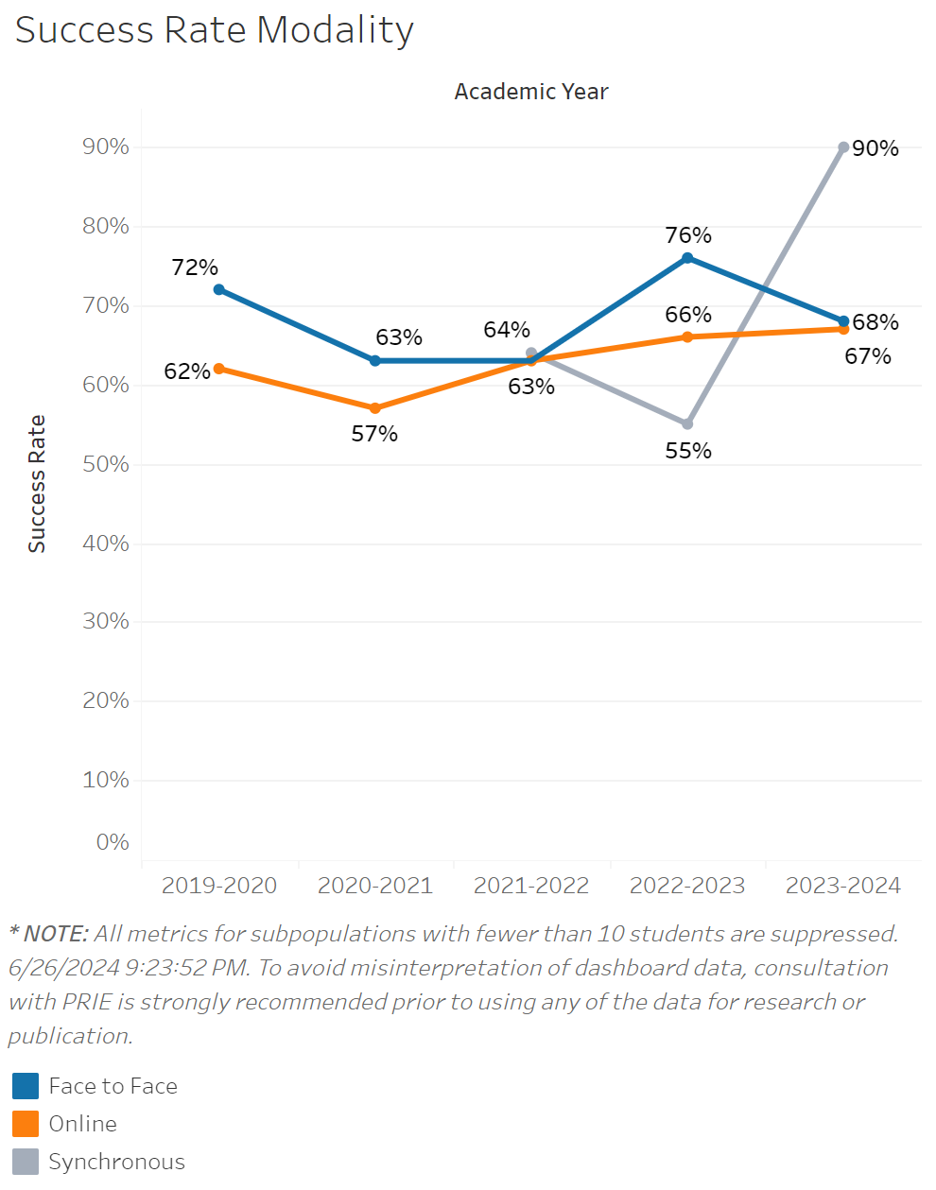
The success rate for in person classes appears to have no consistent trend for Computer Science. However, the success rate fluctuates between 63% to 76%. Success rates for online classes were consistently below the rates for in person classes. That was until it hit a consistent uprise past 2020-2021 from 57% to 67% in 2023-2024 where it exceeded in person classes by 2 %. There is limited data for Synchronous classes, but it appears that success rates dipped from 63% to 55% from 2021-20222 to 2022-2023 and then jumped significantly to 90% in 2023-2024

Source: https://canadacollege.edu/prie/dashboards/disproportionate-impact.php

