Digital Art & Animation and Multimedia Art (combined)
Comprehensive Program Review Questionnaire Data
Please Note: Additional data on course level outcomes and program of study is available under on the PRIE Data Dashboard website under Digital Art and Animation
7A. Enrollment Trends
Use the data provided by PRIE to examine your enrollments by department or courses. Describe trends in headcount, FTES, and load. If applicable, describe any other enrollment data that is relevant to your program
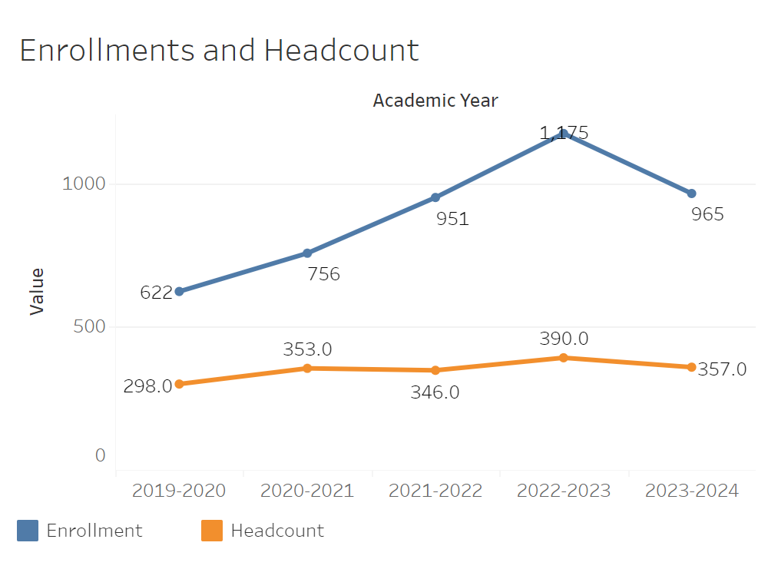
Overall enrollments in Digital Art & Animation consistently went up year over year going from 622 in 2019-2020 to 1,175 by 2022-2023. The only exception to this sharp trend up in enrollment is the drop in 2023-2024 to 965. Headcount has remained relatively flat in the middle to upper three hundreds all five years.

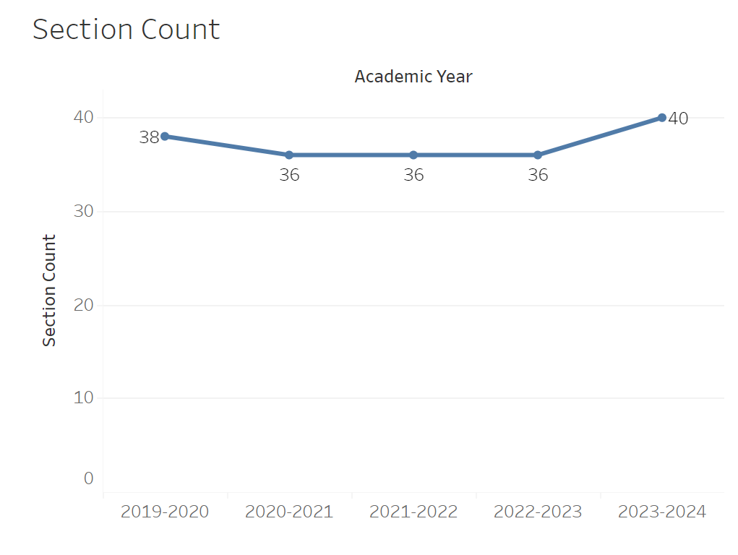
Section count has remained mostly flat at 36 all five years. The only noteworthy change is going from 36 to 40 in 2023-2024 from the year prior.
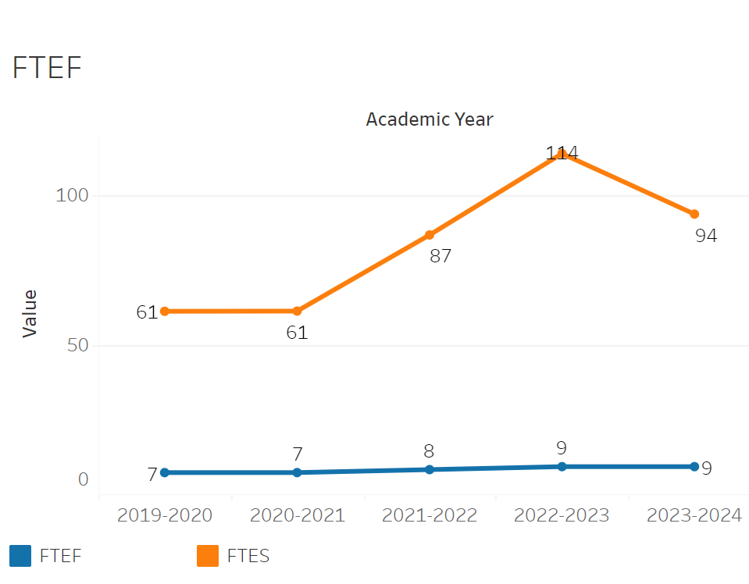
FTEF increased from 7 to 9 between 2020-2021 and 2022-2023. Otherwise it has remained flat. FTEF very roughly followed the enrollment trend. FTES has also generally followed the enrollment trend. FTES had a substantial increase from 61.3 in 2020-2021 to 114.2 in 2022-2023. It then declined to 93.8 in 2023-22024.
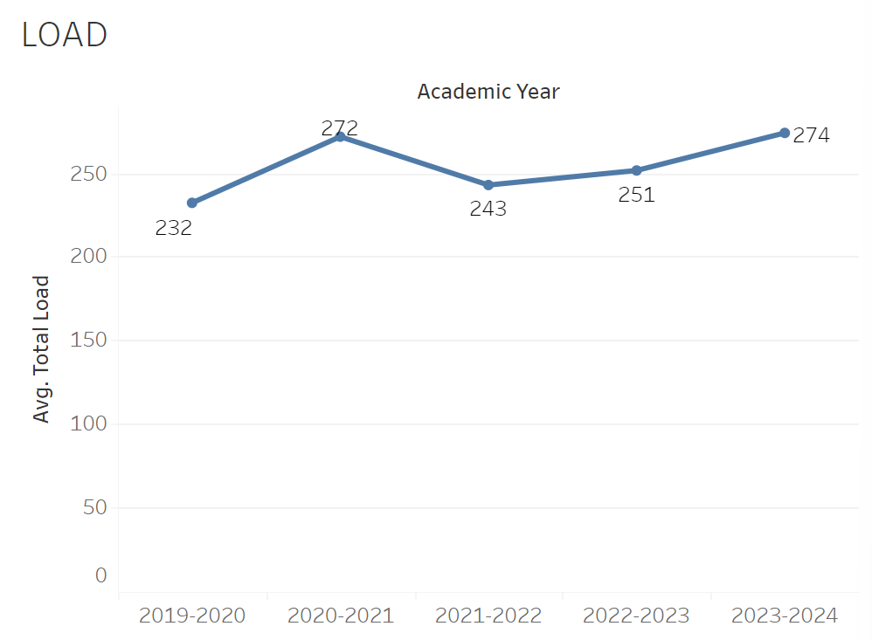
Load has increased consistently with the exception of 2021-2022 going from 272 the year prior to 243. Load went from 232 in 2019-2020 to 274 in 2023-2024.

8A. Access & Completion
Describe the student completion and success rate in your courses and/or program using the data provided by PRIE. Look at your course offerings, in the last program review cycle was it possible for a student to complete your certificates or degrees while only completing courses at Cañada College? How can the college help you improve student completion and success? What changes could be made?

Note: See the Course Enrollment & Success Detail Report for additional course-level data. This report can be found on PRIE’s Data Dashboards & Packets page under the program name.

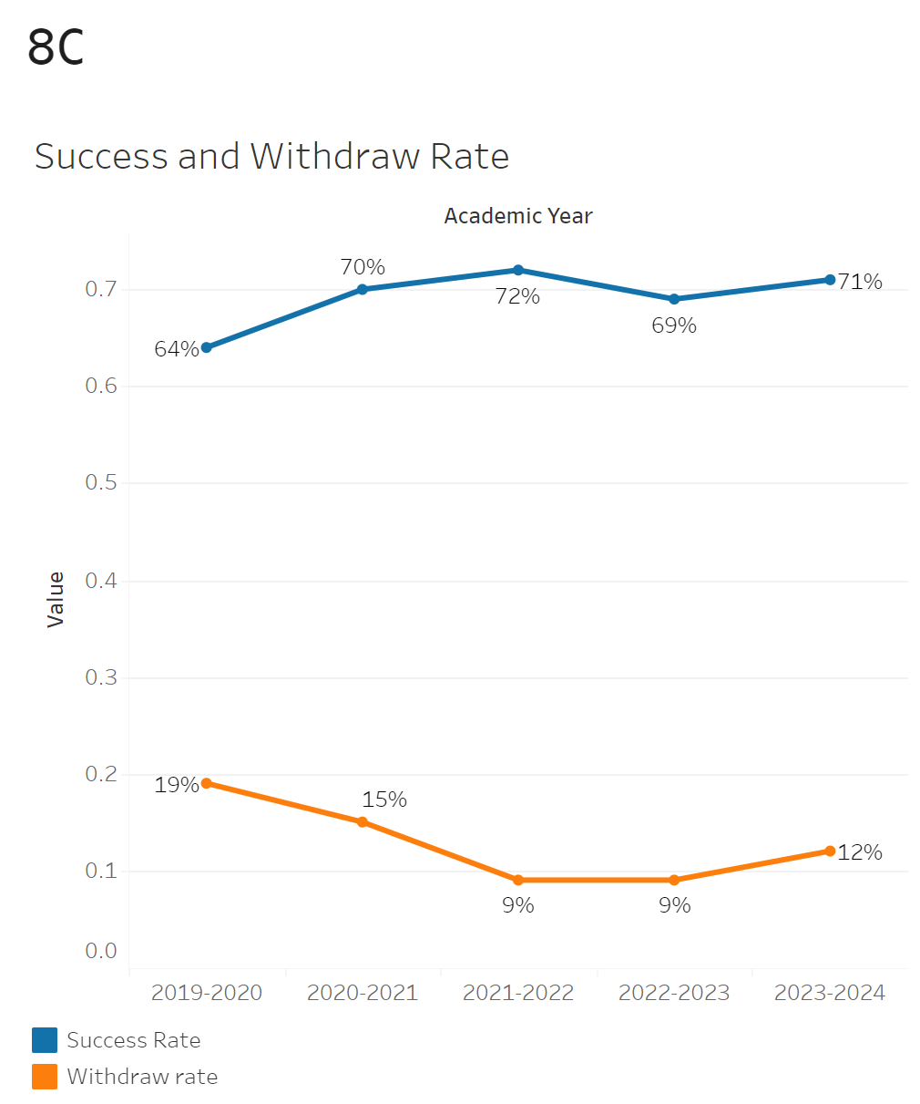
The overall success rate rose from 64% in 2019-2020 to 72% in 2021-2022. Success rates then declined to 69% in 2022-2023 and stayed there in the 2023-2024 academic year.

Digital Art & Animation had the smallest withdrawal rate of 0% in MART-680CL and MART-451 with a maximum withdrawal rate of 25% in MART-441. MART-680CL and MART-451 had a maximum success rate of 100% while MART 432 had a minimum success rate of 43%.

8B. Student Equity
One of the goals of the College’s Student Equity plan is to close the performance gaps for disproportionately impacted students. Use the data provided by PRIE that indicates which groups are experiencing a disproportionate impact in your program. Which gaps are most important for improving outcomes in your program? How can the college help you address these gaps? What changes could be made?

OVERALL EQUITY

The Equity and Disproportionate Impact (DI) dashboard was used to identify subgroups that may have been disproportionately impacted in Digital Art & Animation in the most recent academic year (2023-2024). The three metrics used to examine potential disproportionate impact were enrollment rates (referred as access), success rates, and withdraw rates. The rate for each subgroup was compared to either the college-wide rate (access) or the overall program-level rate (success and withdraws). The difference between the two rates is known as the ‘gap’ and may be referred to as a performance gap or equity gap. Student subgroups that may have been disproportionately impacted in Digital Art & Animation appear below (see Table 1-2).
Access
Access is an indicator of what student subgroups are enrolling in courses, based on unique student counts. Enrollment data revealed three student subgroups were underrepresented in Digital Art & Animation classes compared to the college-wide population (see Table 1). For instance, female students are underrepresented in Digital Art & Animation. The proportion of female students in Digital Art & Animation across all course modalities was 16 percentage points lower than the proportion of female students enrolled college-wide.
Table 1.
SubGroup | Gap
Female | -16%
Not disabled | -7%
Less than Part-Time | -21%

Success
Success is the rate at which different student subgroups pass courses and is based on enrollments. The success rate for different subgroups in Digital Art & Animation was compared to the overall success rate in Digital Art & Animation. The difference between the two rates (the gap) revealed dix subgroups may have been disproportionately impacted (see Table 2). For example, the success rate for Hispanic male students in Digital Art & Animation was 8 percentage points lower than the overall success rate in Digital Art & Animation during the 2023-2024 academic year.
Table 2.
SubGroup | Gap
Male | -5%
Black - Non-Hispanic | -16%
Hispanic - Male | -8%
Under 18 | -15%
Low Income | -9%
Less than Part-Time | -8%

EQUITY BY INSTRUCTIONAL MODALITY
Success
Success is the rate at which different student subgroups pass courses and is based on enrollments. The success rate for different subgroups in Digital Art & Animation was compared to the overall success rate in Digital Art & Animation. The difference between the two rates (the gap) revealed three subgroups may have been disproportionately impacted (see Table 1). For example, the success rate for under 18 students in face to face classes for Digital Art & Animation was 12 points lower than the overall success rate in Digital Art & Animation during the 2023-2024 academic year.

SubGroup | ONLINE | FACE TO FACE | HYBRID | SYNC
Under 18 |  | -23%
Less than Part-Time |  | -9%
23-28 | -16%

8C. Completion – Success Online
The college has a goal of improving success in online courses. Using the data provided by PRIE, what significant gaps do you see in success between online/hybrid and non-online courses? What changes could be made to reduce these gaps? If your program does not offer online/hybrid courses, please write “not applicable”.

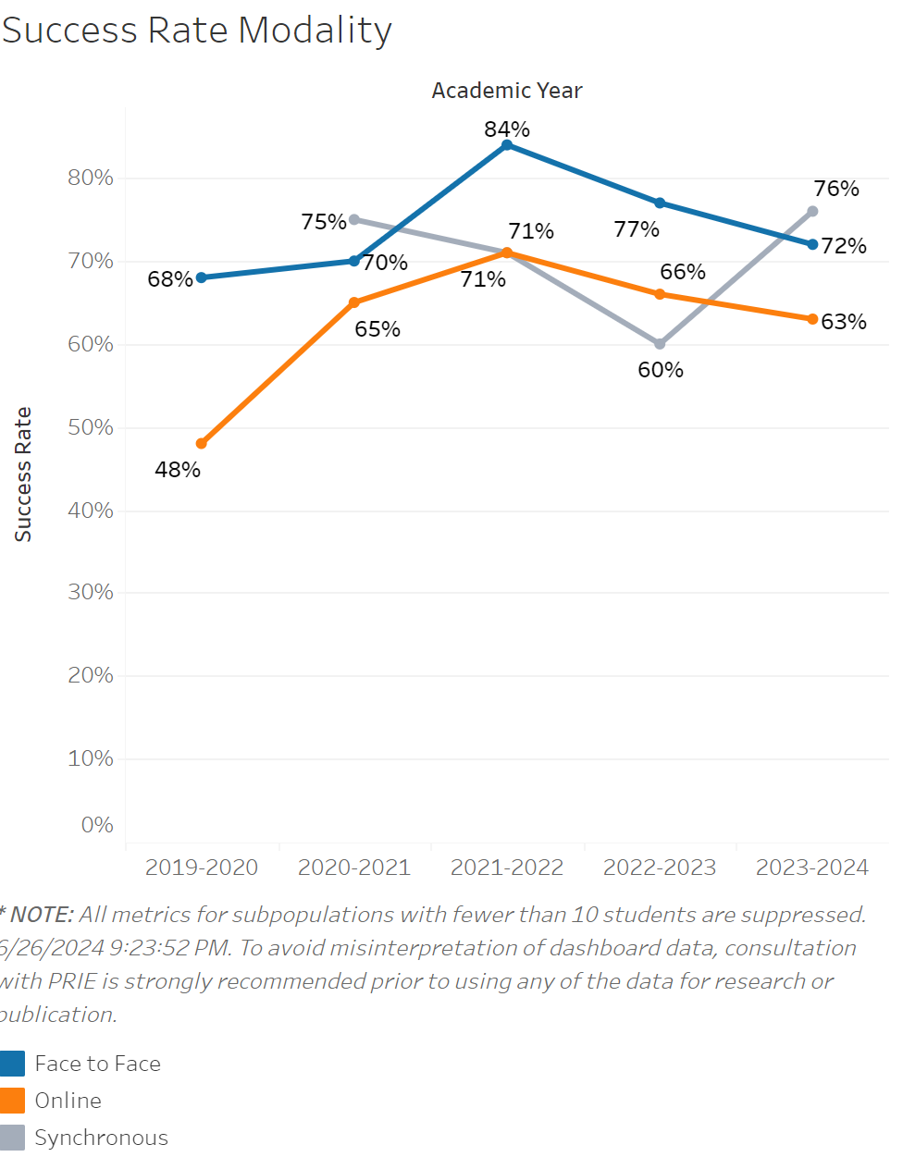

Success rates for in person classes were consistently higher all five years recorded than online classes. Success rates for in person classes rose from 68% to 84% between 2019-2020 and 2021-2022. They then dipped back to the low of 68% by 2023-2024. Online class success rates increased significantly between 2019-2020 to 2021-2022 going from 48% to 71%. However, much like in person classes, they dipped down consistently until 2023-2024. In this case the success rate was 63% versus 68% for in person classes. Success rates for synchronous classes started at 75% in 2020-2021, dipped to 60% by 2022-2023 and then rose to an all time high of 78% in 2023-2024.

Source: https://canadacollege.edu/prie/dashboards/disproportionate-impact.php

