EARTH SCIENCES: This document contains data to help inform the comprehensive program review questionnaire responses for all of the academic disciplines included in the Department: Environmental Sciences, Geography, Geology, Oceanography and Meteorology
This data is also found on the PRIE Data Dashboard website and additional, more detailed information about course level outcomes, program of study, graduates, and labor markets can be found under the Earth Sciences tab on this website.

Environmental Science
Comprehensive Program Review Data Packet
7A. Enrollment Trends
Use the data provided by PRIE to examine your enrollments by department or courses. Describe trends in headcount, FTES, and load. If applicable, describe any other enrollment data that is relevant to your program

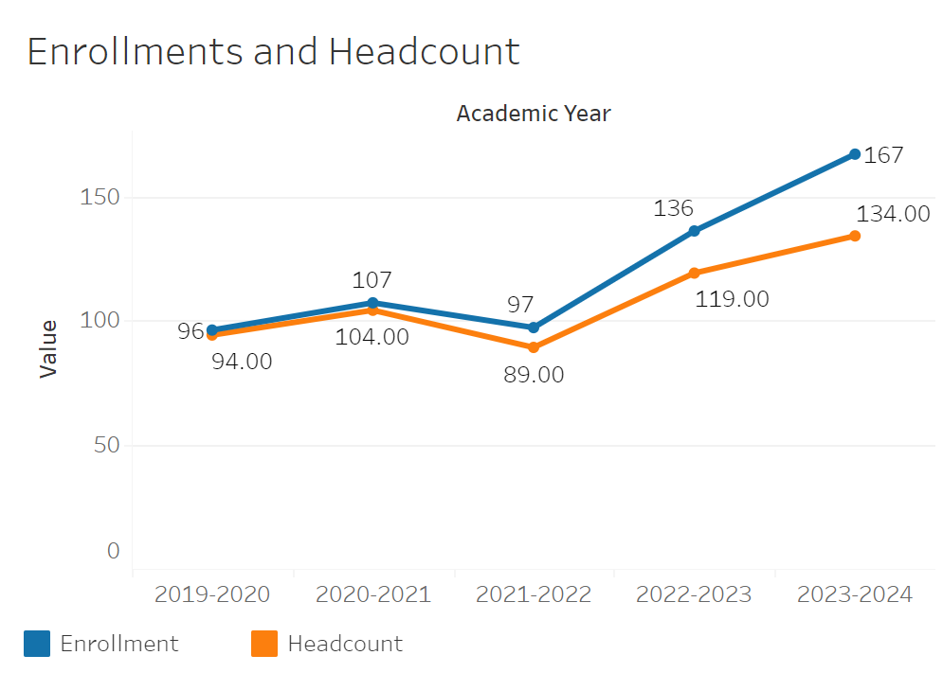
Overall enrollments in Environmental Science gradually grew from 96 to 167 between 2019-2020 and 2023-2024. The only year where enrollments dipped was in 2021-2022 where it went down from 107 the year prior to 97, but it quickly picked back up thereafter. Headcount remained very close to enrollments between 2019-2020 and 2021-2022. In 2022-2023 it started to diverge more until it reached a difference of -33 relative to enrollments.

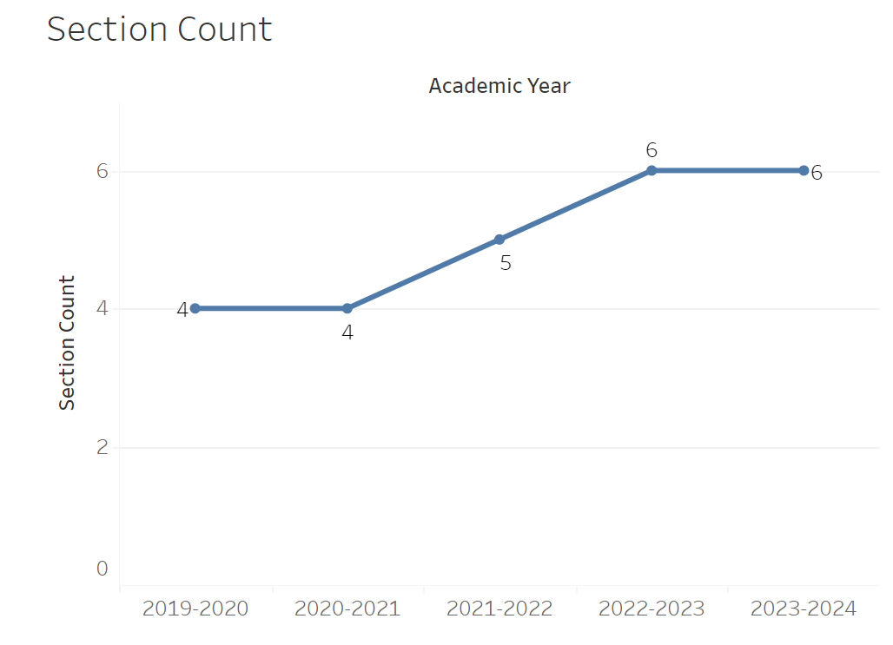
Section count rose from 4 in 2020-2021 to 6 by 2022-2023. Otherwise it has remained flat.

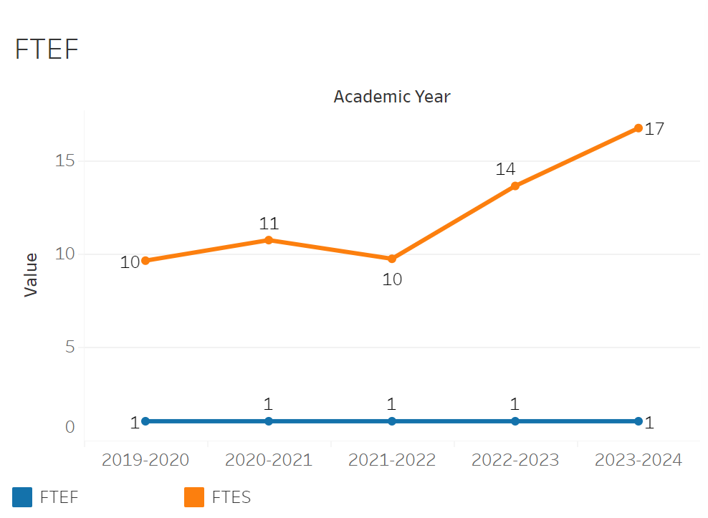
FTEF has remained completely flat at 1 all years recorded. FTES has grown gradually with it picking up significant pace in 2022-2023 where it rose from 10 to 14. It finally reached 17 in 2023-2024.

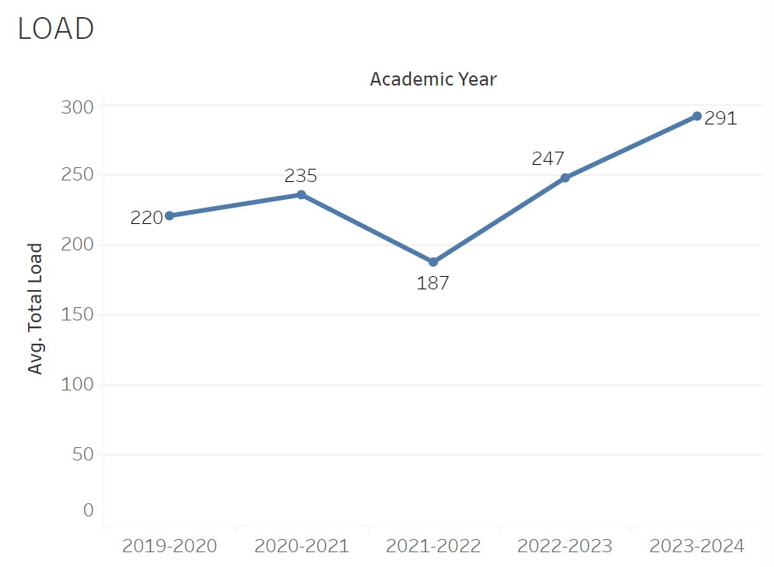
Load has roughly followed a similar trend to enrollment and FTES, declining from 235 to 187 between 2020-2021 and 2021-2022 then inclining to 291 by 2023-2024.

8A. Access & Completion
Describe the student completion and success rate in your courses and/or program using the data provided by PRIE. Look at your course offerings, in the last program review cycle was it possible for a student to complete your certificates or degrees while only completing courses at Cañada College? How can the college help you improve student completion and success? What changes could be made?

Note: See the Course Enrollment & Success Detail Report for additional course-level data. This report can be found on PRIE’s Data Dashboards & Packets page under the program name.

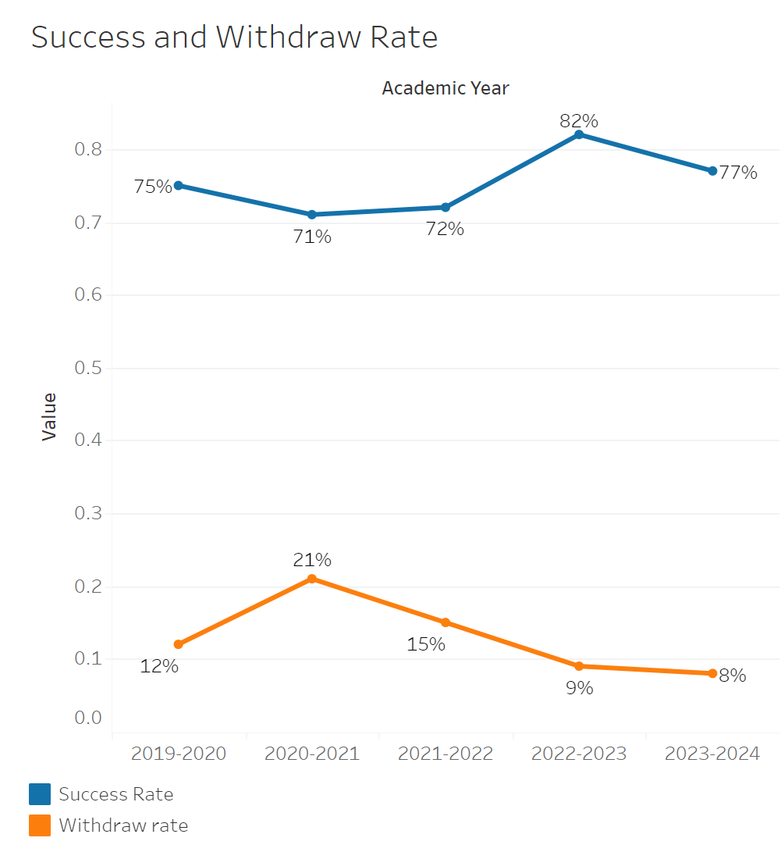
Success rates fell from 75% to 72% between 2019-2020 and 2021-2022. They then recovered and rose to 82% in 2022-2023. Success rates then fell to 77%. Withdraw rates rose from 12% to 21% between 2019-2020 and 2020-2021 from 12% to 21%. They then declined thereafter until bottoming out at 8% by 2023-2024.

Envs-115 had the highest withdraw rate of 16% and the lowest success rate of 72%. ENVS-101 had the lowest withdraw rate and the highest success rate meanwhile.
8B. Student Equity
One of the goals of the College’s Student Equity plan is to close the performance gaps for disproportionately impacted students. Use the data provided by PRIE that indicates which groups are experiencing a disproportionate impact in your program. Which gaps are most important for improving outcomes in your program? How can the college help you address these gaps? What changes could be made?

OVERALL EQUITY

The Equity and Disproportionate Impact (DI) dashboard was used to identify subgroups that may have been disproportionately impacted in Environmental Science in the most recent academic year (2023-2024). The three metrics used to examine potential disproportionate impact were enrollment rates (referred as access), success rates, and withdraw rates. The rate for each subgroup was compared to either the college-wide rate (access) or the overall program-level rate (success and withdraws). The difference between the two rates is known as the ‘gap’ and may be referred to as a performance gap or equity gap. Student subgroups that may have been disproportionately impacted in Environmental Science appear below (see Table 1).

Access
Access is an indicator of what student subgroups are enrolling in courses, based on unique student counts. Enrollment data revealed one student subgroup was underrepresented in Environmental Science classes compared to the college-wide population (see Table 1). Less than Part-Time Students are underrepresented in Environmental Science. The proportion of Less than Part-Time students in Environmental Science across all course modalities was 45 percentage points lower than the proportion of Less than Part-Time students enrolled college-wide.

Table 1.
SubGroup | Gap | Gap Type
Less than Part-Time | -45% | Access

8C. Completion – Success Online
The college has a goal of improving success in online courses. Using the data provided by PRIE, what significant gaps do you see in success between online/hybrid and non-online courses? What changes could be made to reduce these gaps? If your program does not offer online/hybrid courses, please write “not applicable”.

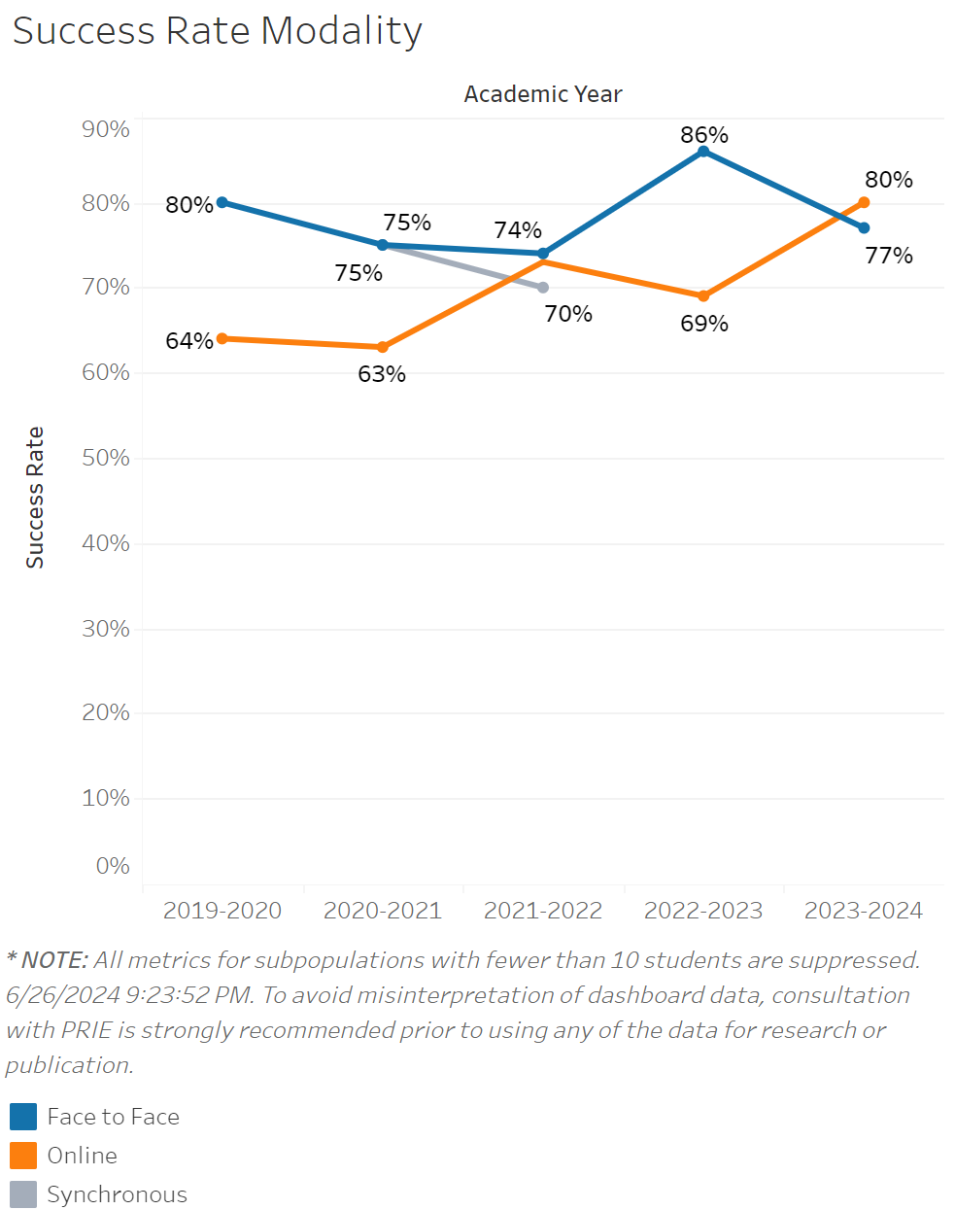
Success rates for in person classes have constantly remained higher than online classes with the exception of 2023-2024. The in person success rate dropped from 80% to 74% between 2019-2020 and 2021-2022. They then increased to 86% after that point in 2022-2023 and fell to 80% by 2023-2024. Success rates for online classes rose from 63% to 73% between 2020-2021 getting close to the success rate for in person classes. Finally online class success rates overtook in person classes by 2023-2024.

Geology
Comprehensive Program Review Questionnaire Data
7A. Enrollment Trends
Use the data provided by PRIE to examine your enrollments by department or courses. Describe trends in headcount, FTES, and load. If applicable, describe any other enrollment data that is relevant to your program
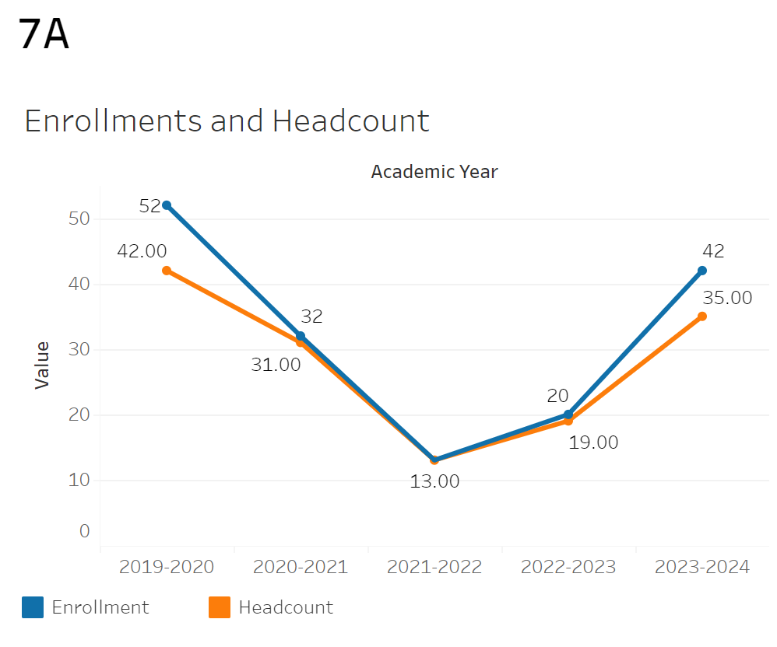
Enrollment fell from 52 to 13 between 2019-2020 and 2021-2022. Between then and 2023-2024 it recovered up to 42. Headcount followed almost the exact same trend with very little notable deviation from the enrollment trend.
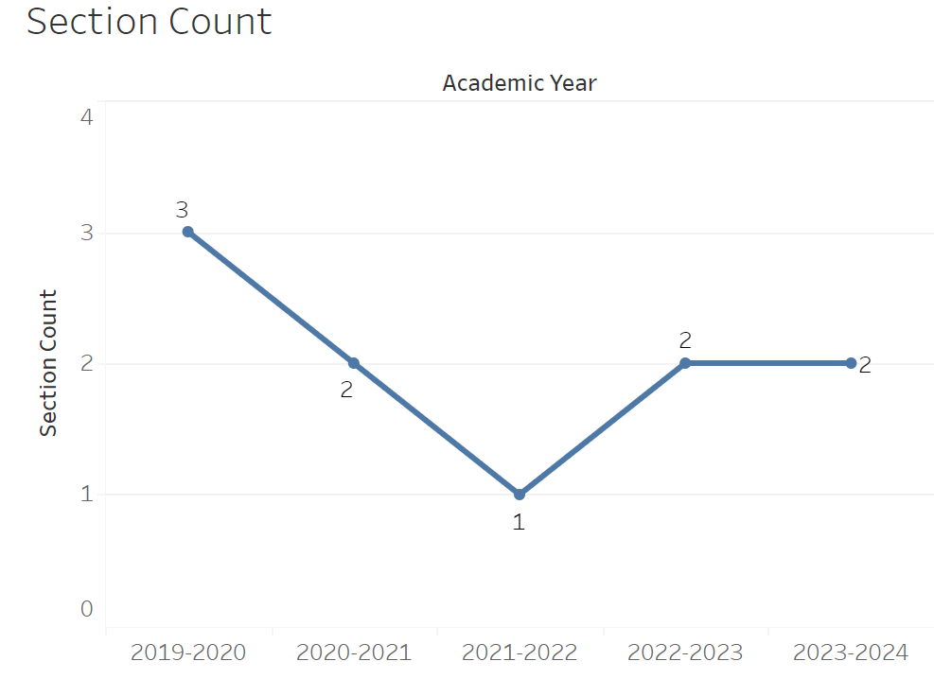
Section Count went from 3 to 1 between 2019-2020 and 2021-2022. It then recovered to 2 in 2022-2023 in 2022-2023 and remained that way in 2023-2024.

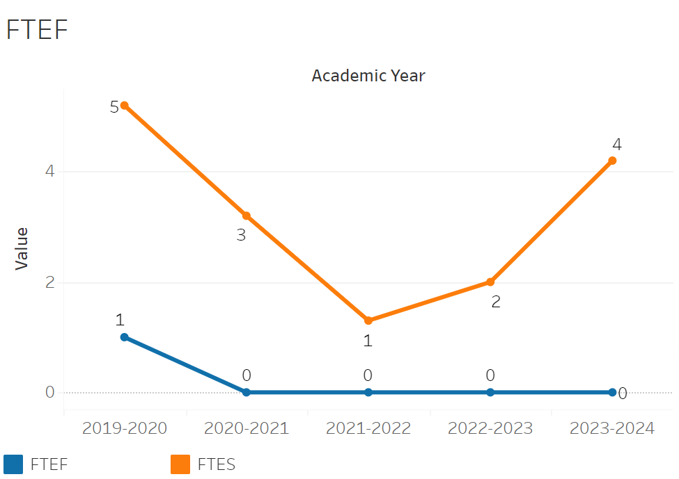
FTEF went from 1 to 0 between 2019-2020 and 2020-2021. It then remained at 0 thereafter. FTES declined from 5 to 1 between 2019-2020 and 2021-2022. It then climbed back up to 4 by 2023-2024. This roughly follows the enrollment trend.

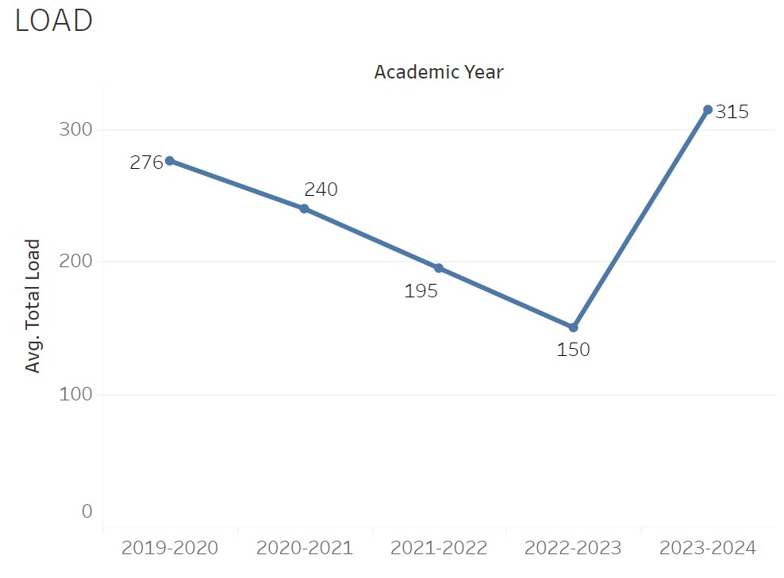
Load had a steady decline from 276 to 150 between 2019-2020 and 2022-2023. It then sharply increased to 315 in 2023-2024.

8A. Access & Completion
Describe the student completion and success rate in your courses and/or program using the data provided by PRIE. Look at your course offerings, in the last program review cycle was it possible for a student to complete your certificates or degrees while only completing courses at Cañada College? How can the college help you improve student completion and success? What changes could be made?

Note: See the Course Enrollment & Success Detail Report for additional course-level data. This report can be found on PRIE’s Data Dashboards & Packets page under the program name.

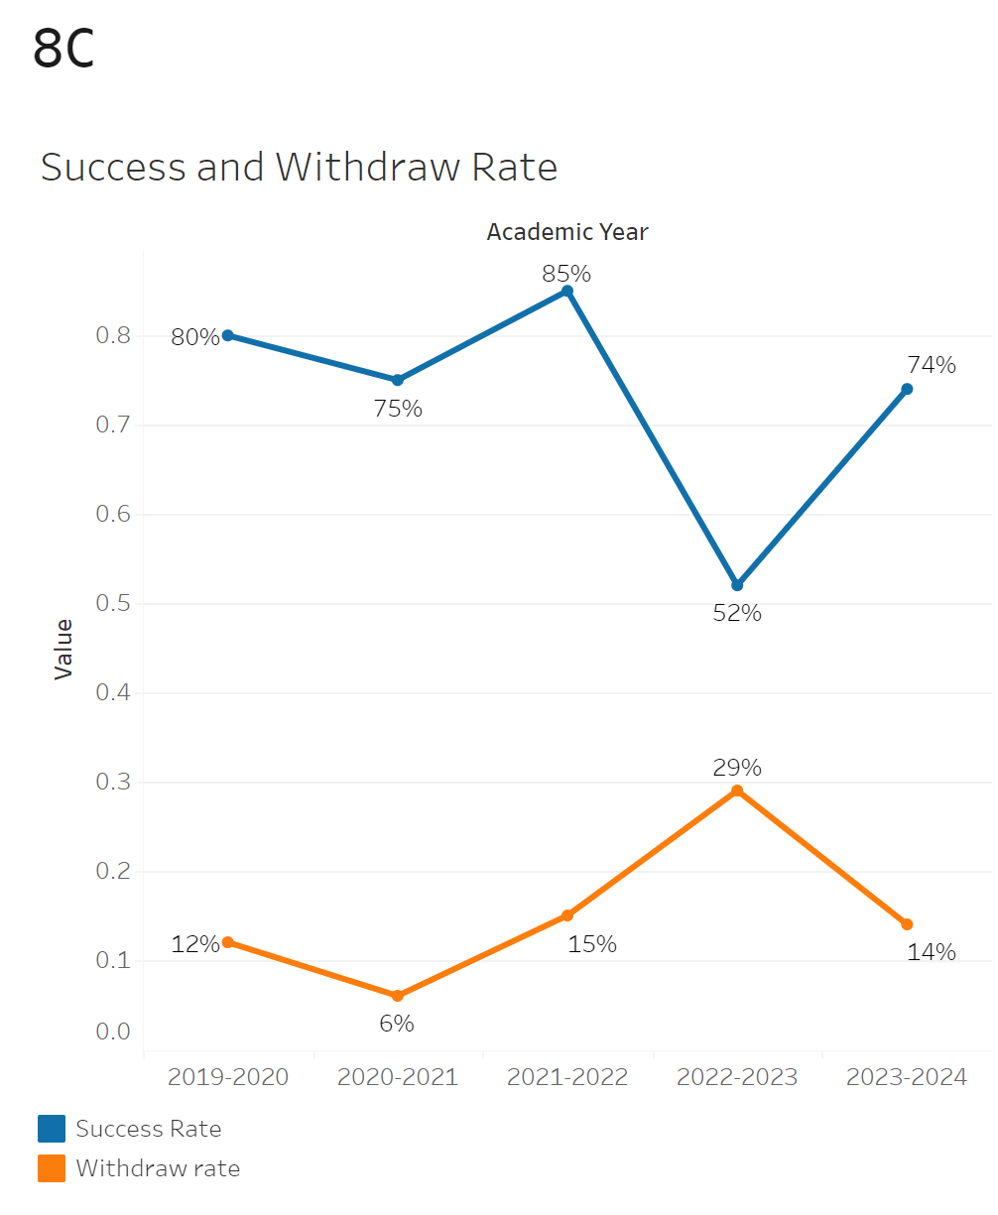
The overall success and withdraw rate has fluctuated quite a lot possibly due to the low student population. The most notable change in the success rate was a sharp decline in success rates going from 85% in 2021-2022 to 52% in 2022-2023. It then inclined to 74% in 2023-2024. Withdraw rates followed a similar trend going from 15% to 29% between 2021-2022 and 2022-2023. It then fell to 14% in 2023-2024.

GEOL-101 had the lowest withdraw rate of 0% and the highest success rate of 85%. Geology 100 had the lowest success rate of 73% and the highest withdraw rate of 16%.

8B. Student Equity
One of the goals of the College’s Student Equity plan is to close the performance gaps for disproportionately impacted students. Use the data provided by PRIE that indicates which groups are experiencing a disproportionate impact in your program. Which gaps are most important for improving outcomes in your program? How can the college help you address these gaps? What changes could be made?
OVERALL EQUITY

The Equity and Disproportionate Impact (DI) dashboard was used to identify subgroups that may have been disproportionately impacted in Geology in the most recent academic year (2023-2024). The three metrics used to examine potential disproportionate impact were enrollment rates (referred as access), success rates, and withdraw rates. The rate for each subgroup was compared to either the college-wide rate (access) or the overall program-level rate (success and withdraws). The difference between the two rates is known as the ‘gap’ and may be referred to as a performance gap or equity gap. Student subgroups that may have been disproportionately impacted in Geology appear below (see Table 1).
Access
Access is an indicator of what student subgroups are enrolling in courses, based on unique student counts. Enrollment data revealed one student subgroup was underrepresented in Geology classes compared to the college-wide population (see Table 1). Less than Part-Time students are underrepresented in Geology. The proportion of Less than Part-Time students in Geology across all course modalities was 34 percentage points lower than the proportion of Less than Part-Time students enrolled college-wide.
Table 1.
SubGroup | Gap | Gap Type
Less than Part-Time | -34% | Access

Success

While no statistically significant disproportionate outcomes were noted for Geology, there are still discrepancies in outcomes between student subgroups which can be seen in the PRIE Equity & Disproportionate Impact Dashboard.

Withdraws

While no statistically significant disproportionate withdraw rates were noted for Geology, there are still discrepancies in outcomes between student subgroups which can be seen in the PRIE Equity & Disproportionate Impact Dashboard.

8C. Completion – Success Online
The college has a goal of improving success in online courses. Using the data provided by PRIE, what significant gaps do you see in success between online/hybrid and non-online courses? What changes could be made to reduce these gaps? If your program does not offer online/hybrid courses, please write “not applicable”.

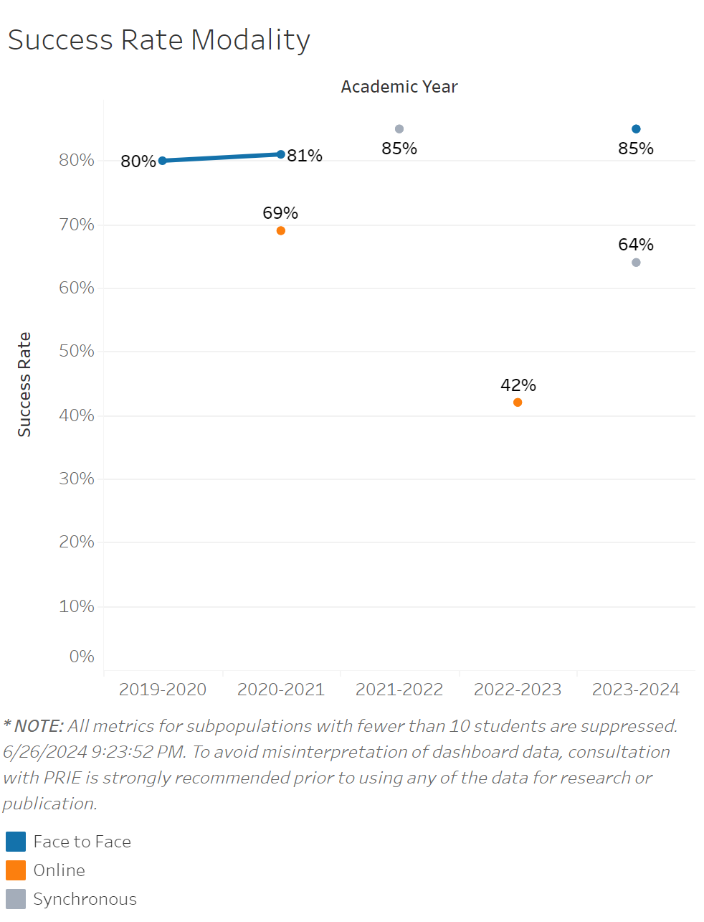
The success by modality rates are too scattered to draw conclusions.

Geography
Comprehensive Program Review Questionnaire Data
7A. Enrollment Trends
Use the data provided by PRIE to examine your enrollments by department or courses. Describe trends in headcount, FTES, and load. If applicable, describe any other enrollment data that is relevant to your program

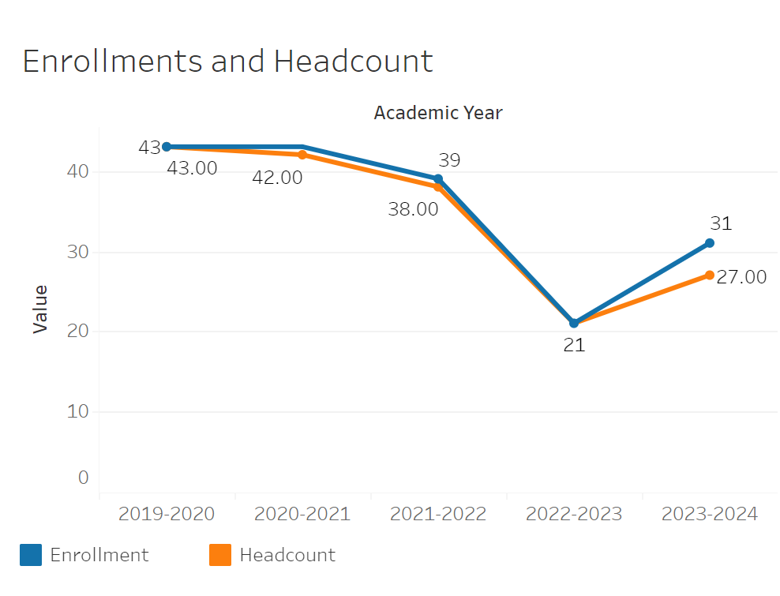
Enrollment was relatively flat between 2019-2020 to 2021-2022 only declining from 43 to 39. However, in 2022-2023 there was a significant dip to 21 and a small recovery to 31 by 2023-2024. Headcount was incredibly close to enrollments making the difference negligible.
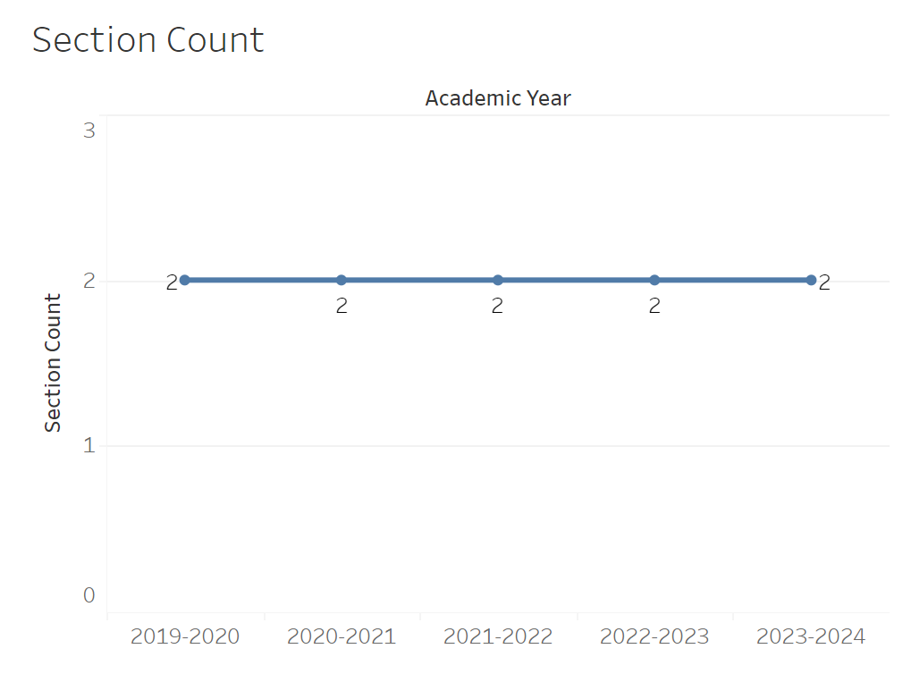
Section count has remained flat at 2 between 2019-2020 and 20023-2024.

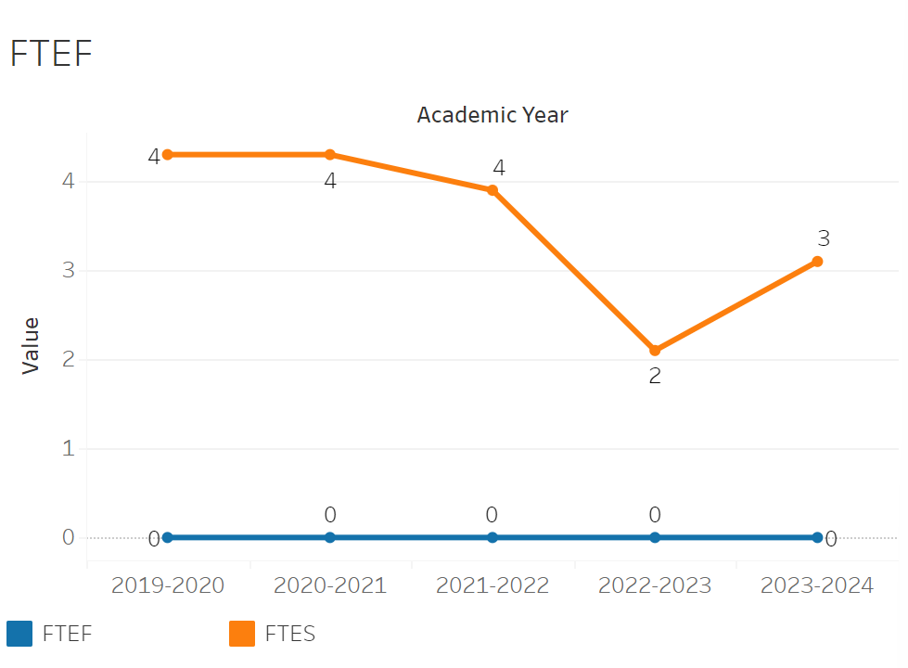
FTEF has remained completely flat at 0 overall. FTES fell from 4 to 2 by 2022-2023 and then recovered to 3.

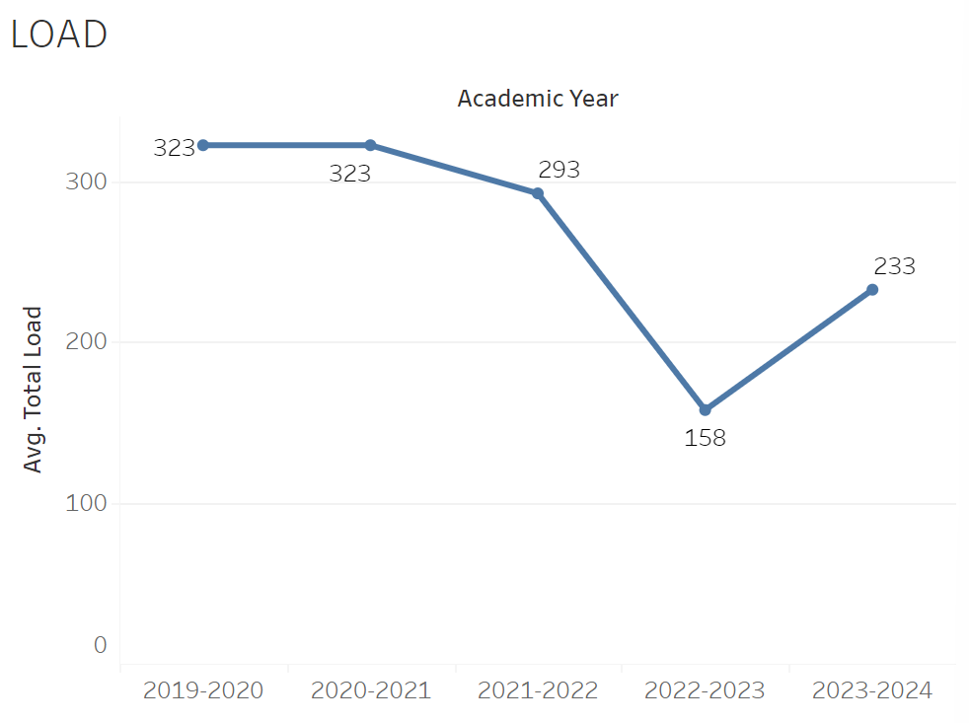
Load was relatively flat between 2019-2021-2022 going from 323 to 293. There was a significant decline to 158 however by 2022-2023. Then in 2023-2024 it rose to 233 putting it roughly in line with the enrollment trend.

8A. Access & Completion
Describe the student completion and success rate in your courses and/or program using the data provided by PRIE. Look at your course offerings, in the last program review cycle was it possible for a student to complete your certificates or degrees while only completing courses at Cañada College? How can the college help you improve student completion and success? What changes could be made?

Note: See the Course Enrollment & Success Detail Report for additional course-level data. This report can be found on PRIE’s Data Dashboards & Packets page under the program name.

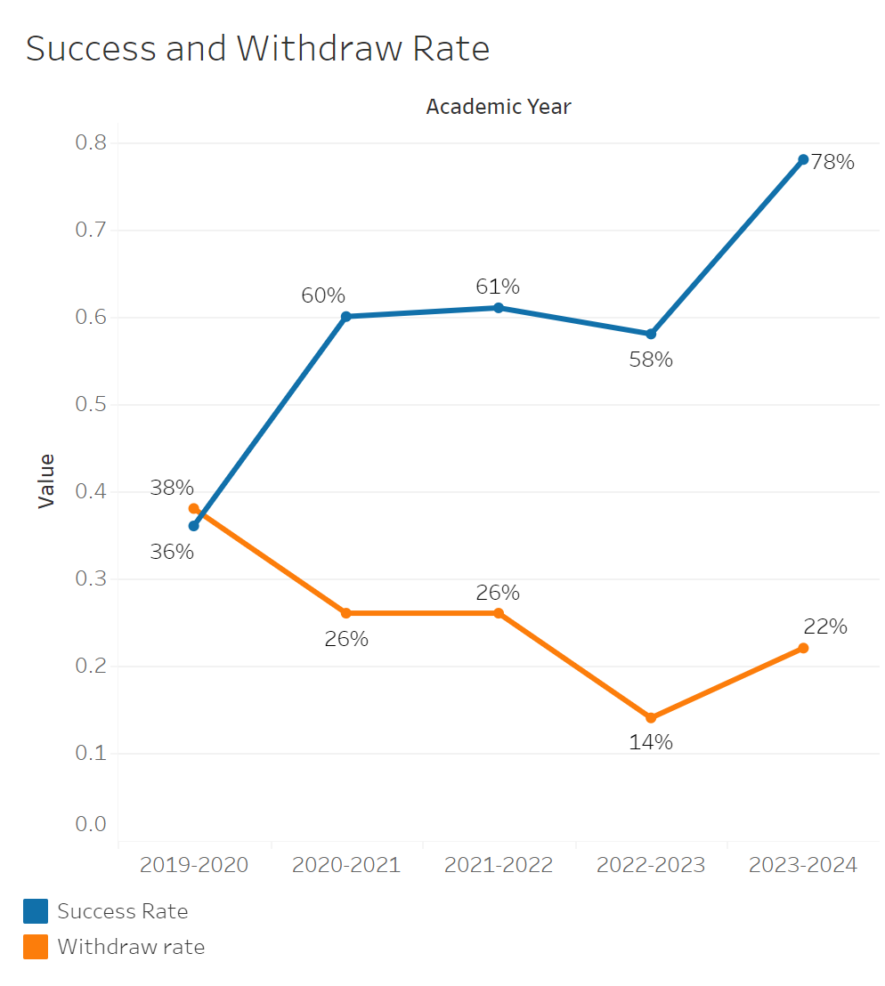
Success rates rose from 36% to 60% between 2019-2020 and 2020-2021. They then remained flat between then and 2022-2023. Finally there was a significant increase in 2023-2024 to 78%. Between 2019-2020 and 2022-2023 there was a significant decline in withdraw rates from 38% to 14%. However, there was a notable increase to 22% in 2023-2024.

GEOG-100 had a withdraw rate of 27% and a total success rate of 58%.

8B. Student Equity
One of the goals of the College’s Student Equity plan is to close the performance gaps for disproportionately impacted students. Use the data provided by PRIE that indicates which groups are experiencing a disproportionate impact in your program. Which gaps are most important for improving outcomes in your program? How can the college help you address these gaps? What changes could be made?
OVERALL EQUITY

No DI available for Geography

8C. Completion – Success Online
The college has a goal of improving success in online courses. Using the data provided by PRIE, what significant gaps do you see in success between online/hybrid and non-online courses? What changes could be made to reduce these gaps? If your program does not offer online/hybrid courses, please write “not applicable”.

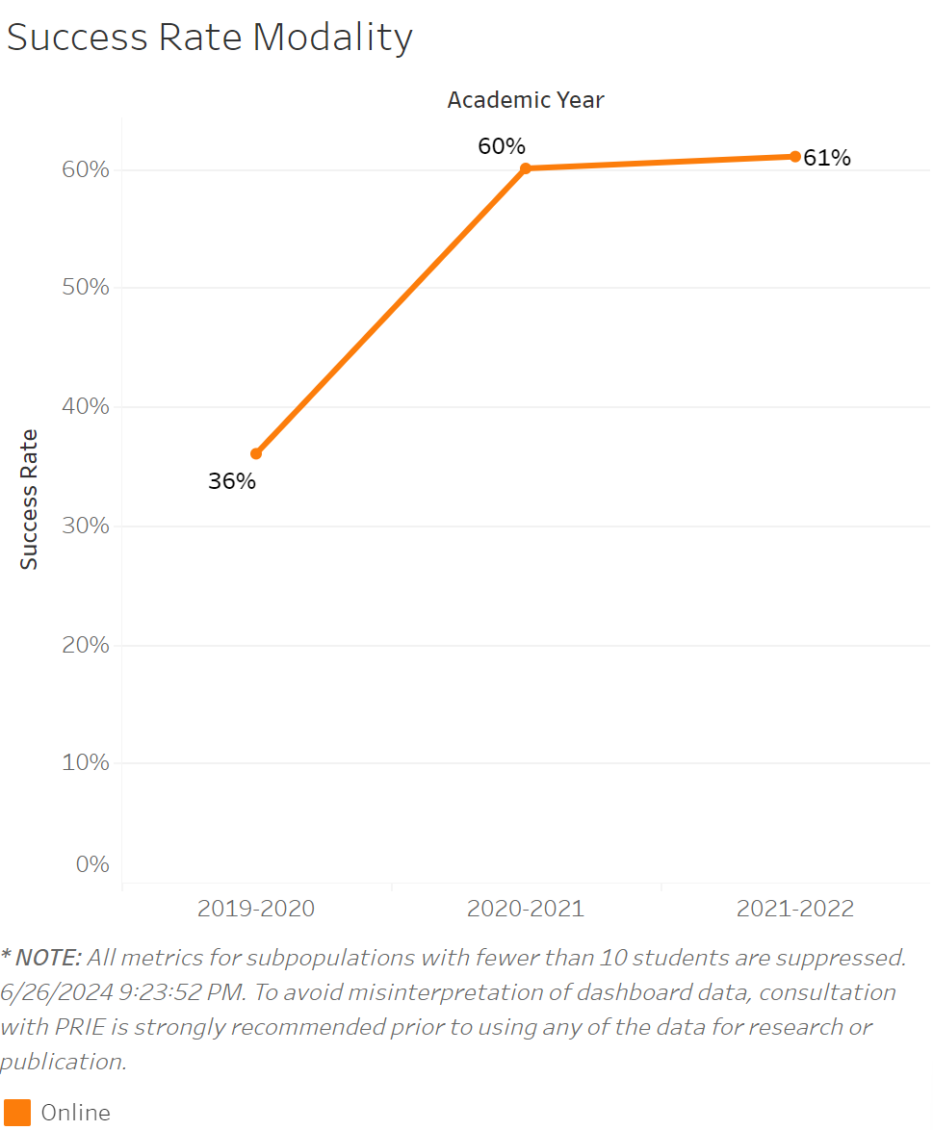
This is just a repeat of the success and withdraws chart given that there are only online classes available.

Meteorology
Comprehensive Program Review Data Packet
7A. Enrollment Trends
Use the data provided by PRIE to examine your enrollments by department or courses. Describe trends in headcount, FTES, and load. If applicable, describe any other enrollment data that is relevant to your program

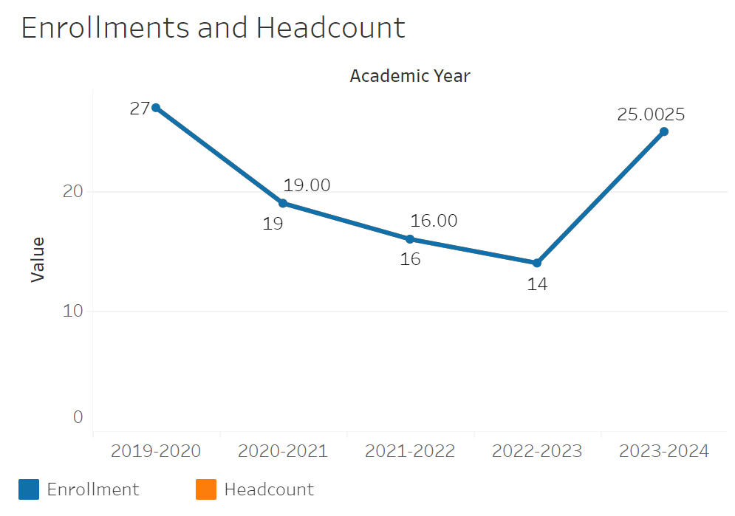
Enrollments declined from 27 to 14 between 2019-2020 and 2022-2023. They then increased to 25 by 2023-2024. No data appears to be available for headcount in regards to Meteorology.

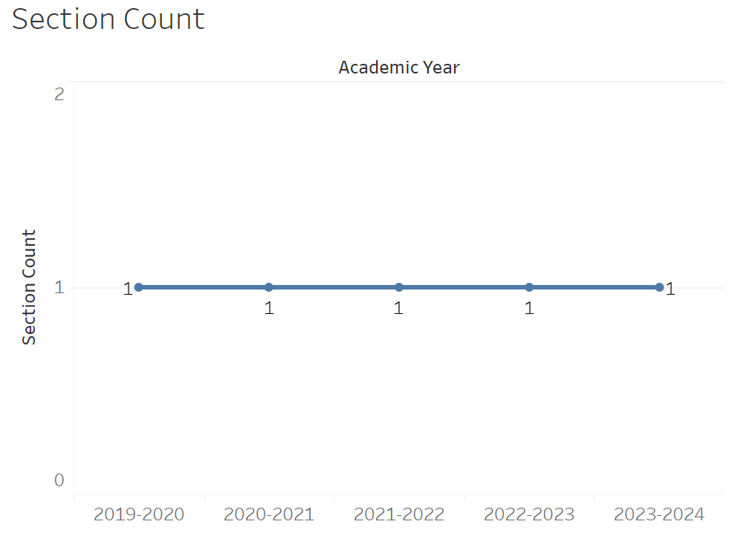
Section count has remained at 1 all academic years recorded.

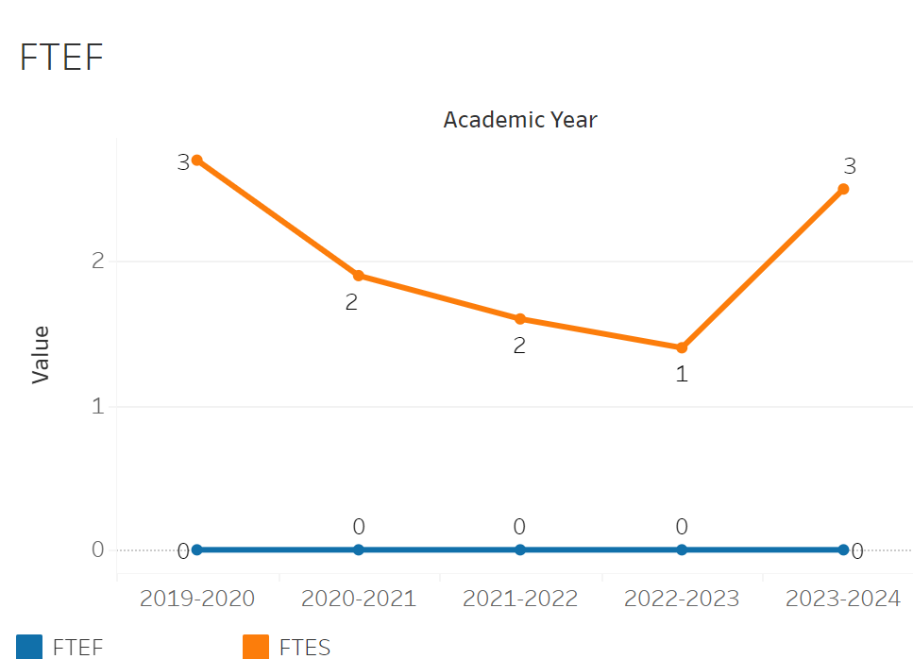
FTEF has remained flat at 0 from 2019-2020 to 2023-2024. FTES fell from 3 to 1 between 2019-2020 and 2022-2023. In 2023-2024 it rose back to 3.

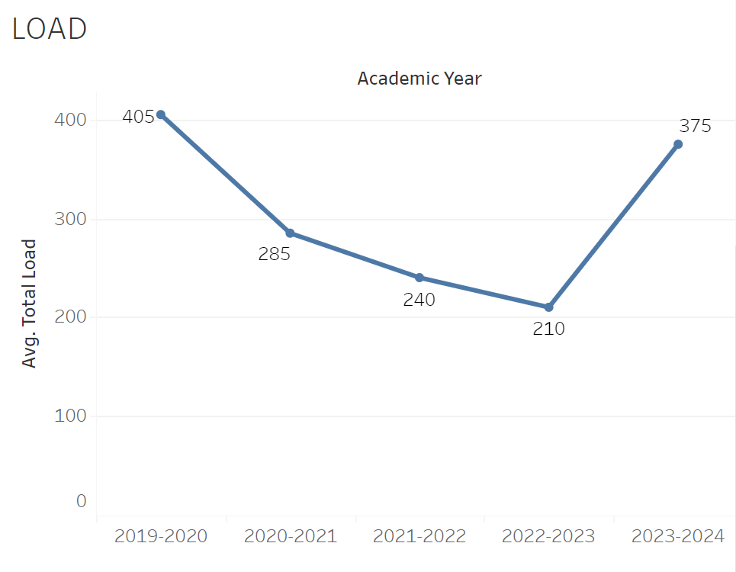
Load declined from 405 to 210 between 2019-2020 and 2022-2023. It then increased to 375 in 2023-2024.

8A. Access & Completion
Describe the student completion and success rate in your courses and/or program using the data provided by PRIE. Look at your course offerings, in the last program review cycle was it possible for a student to complete your certificates or degrees while only completing courses at Cañada College? How can the college help you improve student completion and success? What changes could be made?

Note: See the Course Enrollment & Success Detail Report for additional course-level data. This report can be found on PRIE’s Data Dashboards & Packets page under the program name.

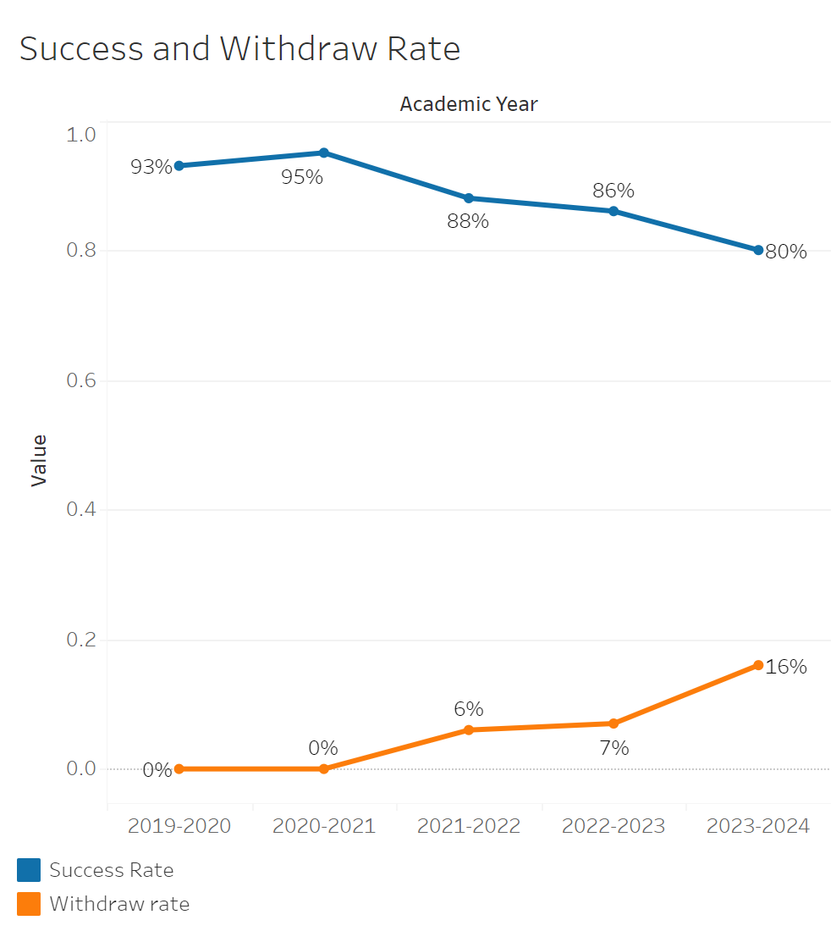
Success rates fell from 93% in 2019-2020 to 80% by 2023-2024. Withdraw rates went from 0% in 2019-2020 to 16% by 2023-2024.

The withdrawal rate for METE-100 was 6% while the success rate was 88%.

8B. Student Equity
One of the goals of the College’s Student Equity plan is to close the performance gaps for disproportionately impacted students. Use the data provided by PRIE that indicates which groups are experiencing a disproportionate impact in your program. Which gaps are most important for improving outcomes in your program? How can the college help you address these gaps? What changes could be made?
OVERALL EQUITY

No DI available for Meteorology.

8C. Completion – Success Online
The college has a goal of improving success in online courses. Using the data provided by PRIE, what significant gaps do you see in success between online/hybrid and non-online courses? What changes could be made to reduce these gaps? If your program does not offer online/hybrid courses, please write “not applicable”.

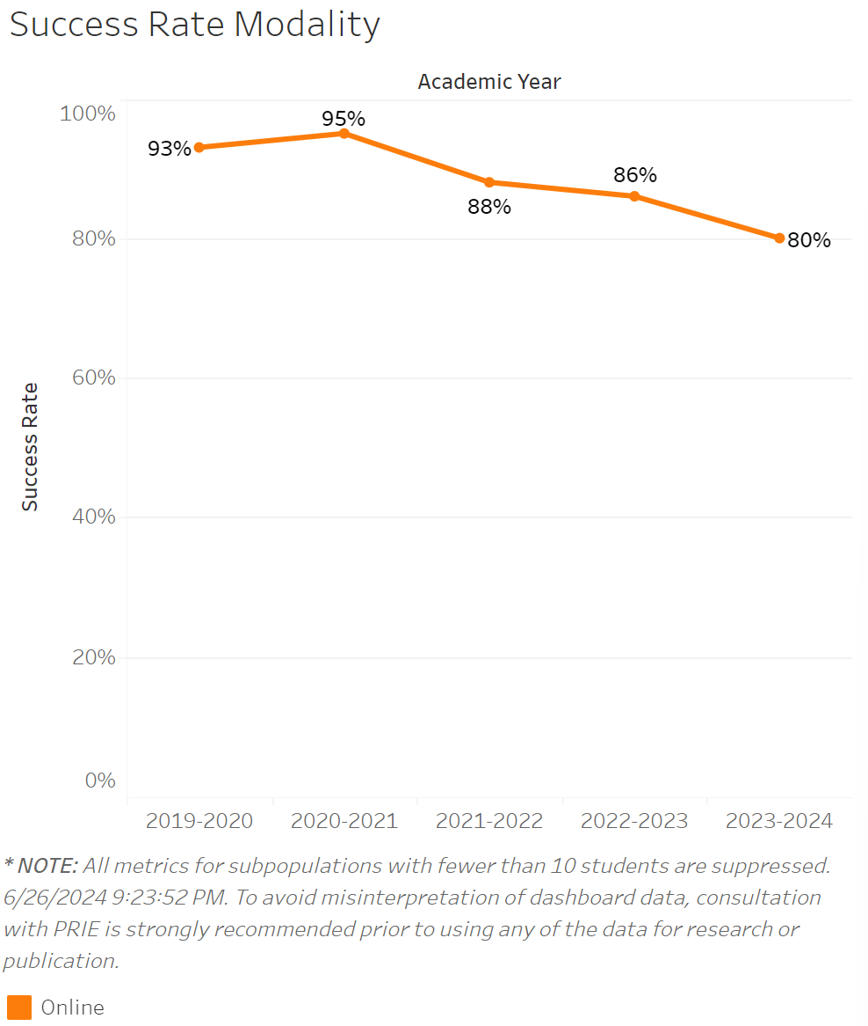
Given that the only modality offered is online, it is the same exact success rate as the success and withdraws chart.

Oceanography
Comprehensive Program Review Questionnaire
7A. Enrollment Trends
Use the data provided by PRIE to examine your enrollments by department or courses. Describe trends in headcount, FTES, and load. If applicable, describe any other enrollment data that is relevant to your program

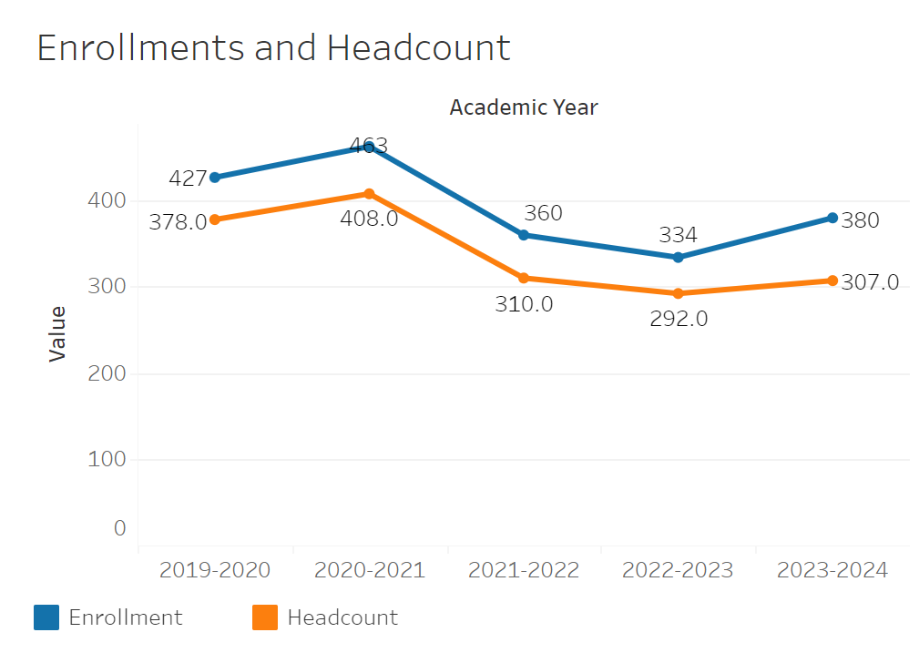
Overall enrollments for Oceanography rose to 463 from 427 between 2019-2020 and 2020-2021. They then declined to 334 by 2022-2023 and then recovered to 380 in 2023-2024. Headcount has largely followed the same trend with a small but relatively consistent drop of 50 from the enrollments.

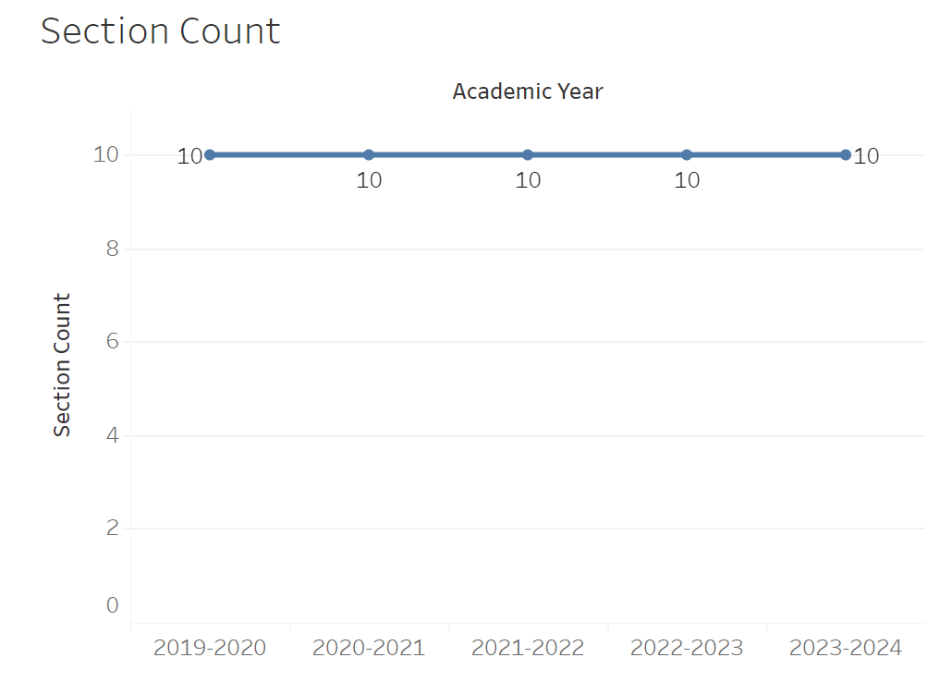
Section count has remained constantly level at 10 between all years recorded.

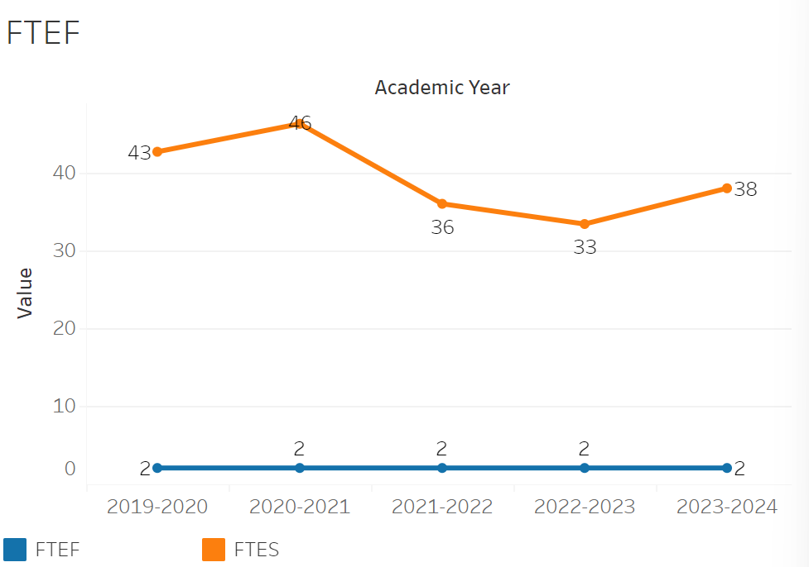
FTEF has remained constant at 2 all years recorded. FTES on the other hand, has roughly followed the enrollment and headcount trend. FTES rose from 43 to 46 between 2019-2020 and 2020-2021. It then fell to 33 in 2022-2023. By 2023-2024 it had recovered to 38.

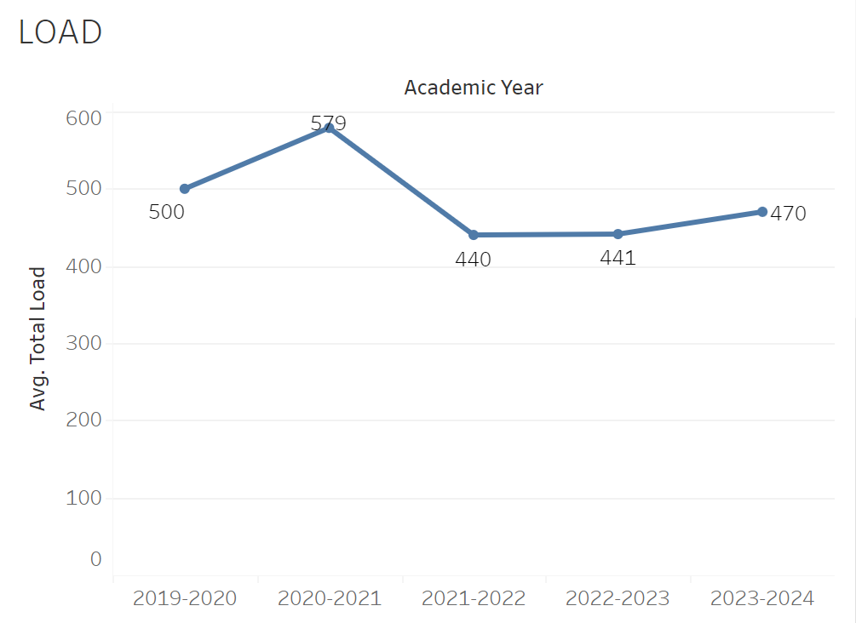
Load moved up from 500 to 579 between 2019-2020 and 2020-2021. It then dropped to 440 by 2021-2022. Load then recovered slightly to 470 by 2023-2024.

8A. Access & Completion
Describe the student completion and success rate in your courses and/or program using the data provided by PRIE. Look at your course offerings, in the last program review cycle was it possible for a student to complete your certificates or degrees while only completing courses at Cañada College? How can the college help you improve student completion and success? What changes could be made?

Note: See the Course Enrollment & Success Detail Report for additional course-level data. This report can be found on PRIE’s Data Dashboards & Packets page under the program name.

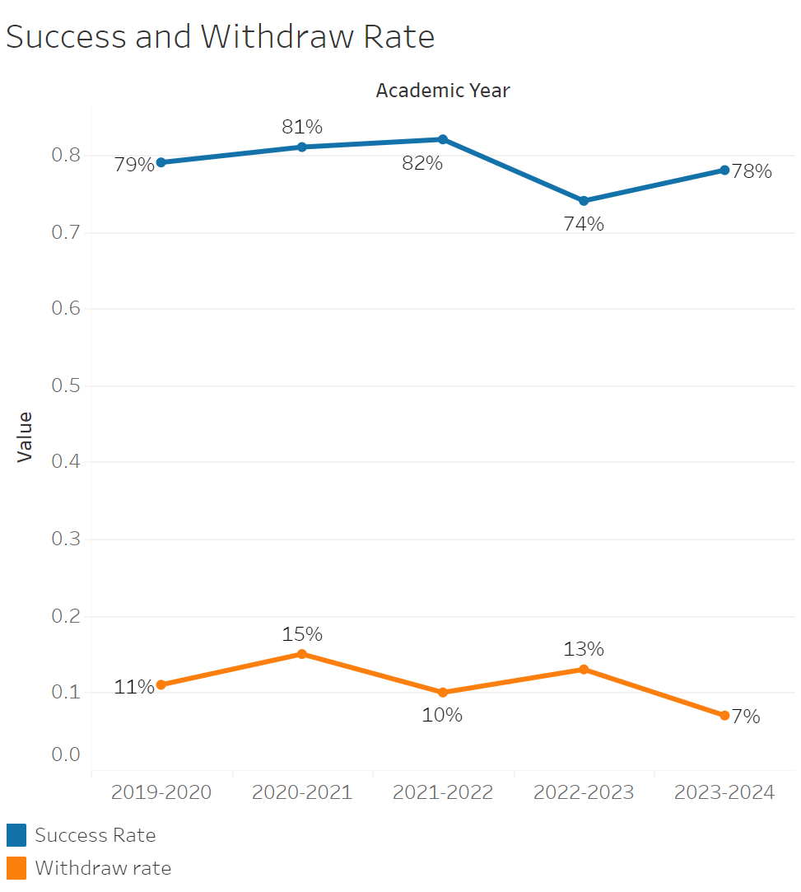
The success rate had a slight incline from 79% to 82% between 2019-2020 and 2021-2022. It then declined to 74% by 2022-2023. In 2023-2024 there was a slight recovery to 78%. Withdraw rates appear to have a pattern of rising and falling every other year. Although overall, they seem to be trending down since in 2019-2020 it was at 11% and by 2023-2024 it was at 7%.

OCEN-100 had the lowest withdraw rate of 7% and the highest success rate of 85%. OCEN-101 on the other hand, had the highest withdraw rate of 17% and the lowest success rate of 71%.

8B. Student Equity
One of the goals of the College’s Student Equity plan is to close the performance gaps for disproportionately impacted students. Use the data provided by PRIE that indicates which groups are experiencing a disproportionate impact in your program. Which gaps are most important for improving outcomes in your program? How can the college help you address these gaps? What changes could be made?
OVERALL EQUITY

The Equity and Disproportionate Impact (DI) dashboard was used to identify subgroups that may have been disproportionately impacted in Oceanography in the most recent academic year (2023-2024). The three metrics used to examine potential disproportionate impact were enrollment rates (referred as access), success rates, and withdraw rates. The rate for each subgroup was compared to either the college-wide rate (access) or the overall program-level rate (success and withdraws). The difference between the two rates is known as the ‘gap’ and may be referred to as a performance gap or equity gap. Student subgroups that may have been disproportionately impacted in Oceanography appear below (see Table 1-2).

Access
Access is an indicator of what student subgroups are enrolling in courses, based on unique student counts. Enrollment data revealed one student subgroup was underrepresented in Oceanography classes compared to the college-wide population (see Table 1). Less than Part-Time students are underrepresented in Oceanography. The proportion of Less than Part-Time students in Oceanography across all course modalities was 24 percentage points lower than the proportion of female students enrolled college-wide.

Table 1.

SubGroup | Gap
Less than Part-Time | -24%

Success
Success is the rate at which different student subgroups pass courses and is based on enrollments. The success rate for different subgroups in Oceanography was compared to the overall success rate in Oceanography. The difference between the two rates (the gap) revealed three subgroups may have been disproportionately impacted (see Table 2). For example, the success rate for Hispanic male students in Oceanography was 14 percentage points lower than the overall success rate in Oceanography during the 2023-2024 academic year.
Table 2.

SubGroup | Gap
Hispanic - Male | -14%
Hispanic | -9%
First Generation | -8%

8C. Completion – Success Online
The college has a goal of improving success in online courses. Using the data provided by PRIE, what significant gaps do you see in success between online/hybrid and non-online courses? What changes could be made to reduce these gaps? If your program does not offer online/hybrid courses, please write “not applicable”.

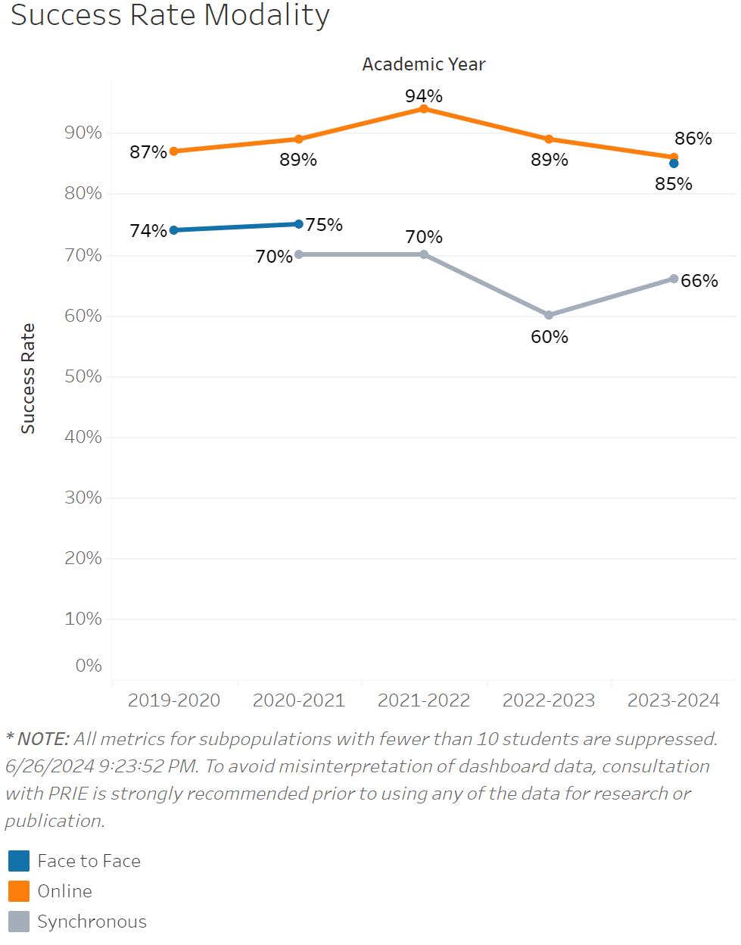
The online success rate rose from 87% to 94% between 2019-2020 to 2021-2022. The success rates then fell down to 86% by 2023-2024 close to its prior bottom. Synchronous class success rates were consistently below that of face to face classes. Between 2021-2022 and 2022-2023 success rates dropped form 70% to 60%. In 2023-2024 they recovered slightly to 66% but not back to the peak of 70%.

Source: https://canadacollege.edu/prie/dashboards/disproportionate-impact.php
Source: https://canadacollege.edu/prie/dashboards/disproportionate-impact.php
Source: https://canadacollege.edu/prie/dashboards/disproportionate-impact.php

