Engineering
Comprehensive Program Review Questionnaire Data
7A. Enrollment Trends
Use the data provided by PRIE to examine your enrollments by department or courses. Describe trends in headcount, FTES, and load. If applicable, describe any other enrollment data that is relevant to your program
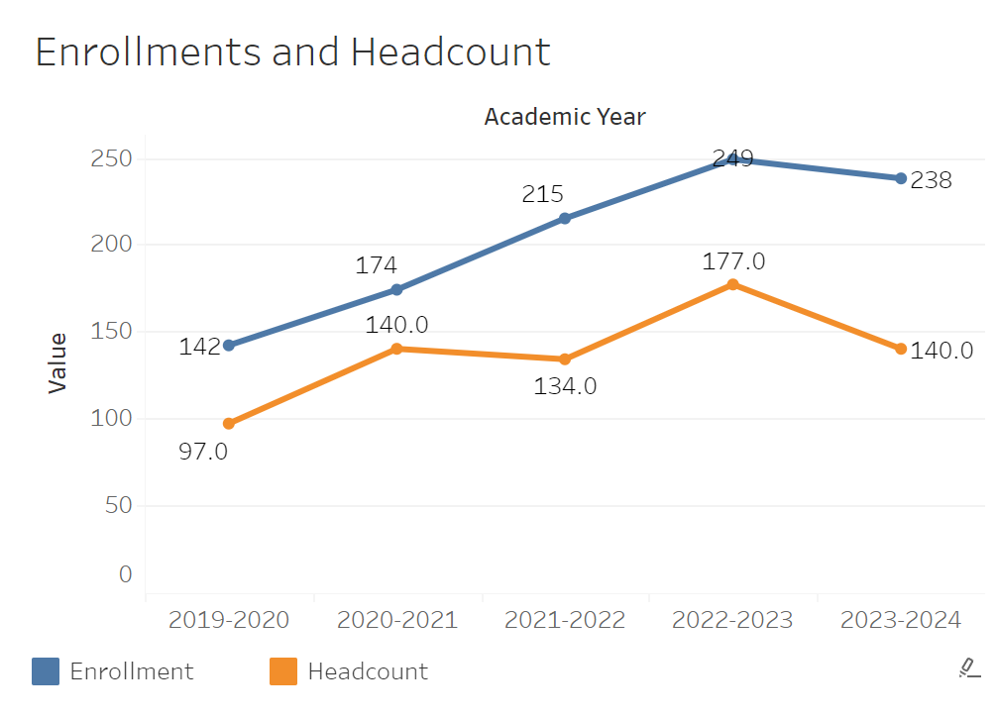
Enrollments for Engineering have been on a consistent rising from 142 in 2019-2020 to 249 in 2022-2023. There was only a slight dip in 2023-2024. Headcount didn’t appear to follow the exact trend although there was a general incline from 97 to 177 between 2019-2020 and 2022-2023. It then dipped more significantly in 2023 to 140, though not quite to the 97 that was there before.
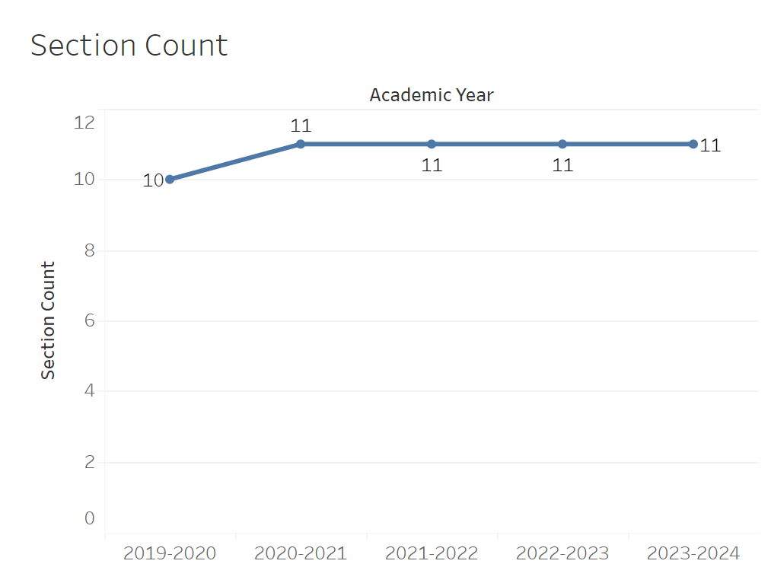
The section count has remained completely flat aside from jumping from 10 to 11 between 2010-2020 and 2020-2021.

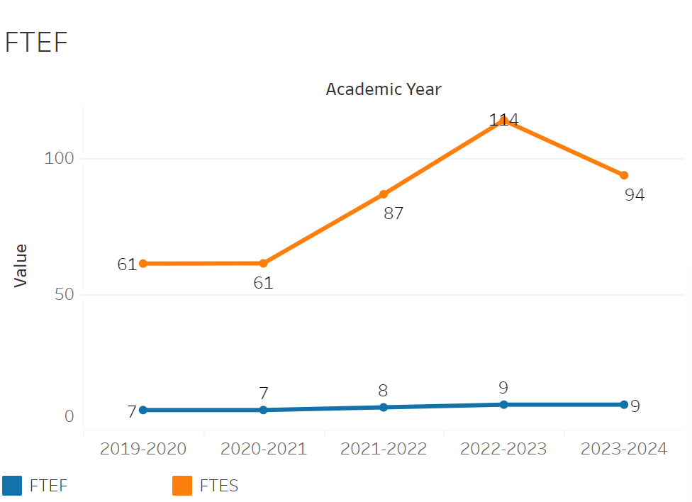
FTEF moved from 2 to 3 in 2020-2021 for Engineering. It them remained flat aside from a brief jump to 4 in 2022-2023. FTES has been on a consistent rise every single year from 2019-2020 to 2023-2024 going from 23 to 49.
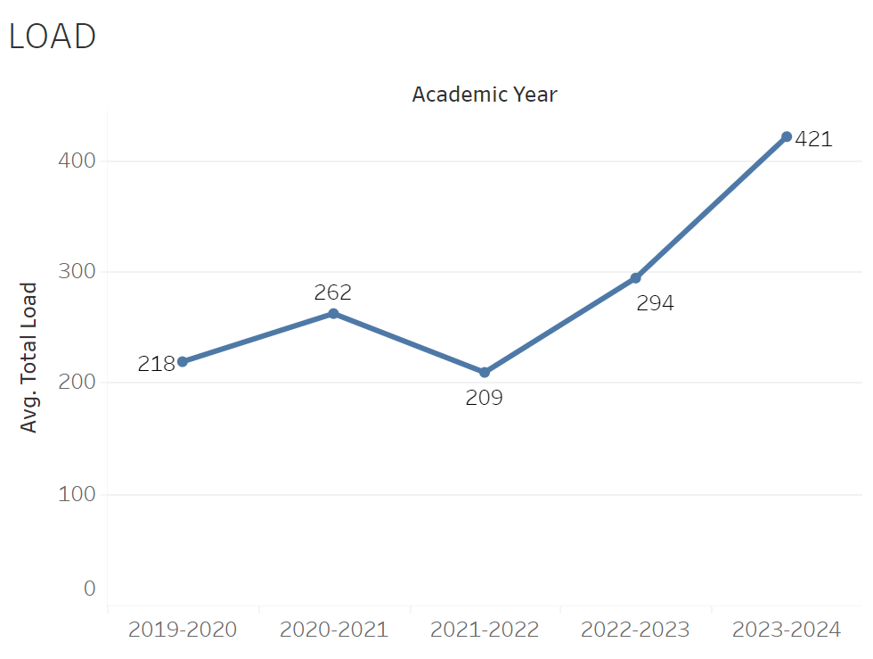
Load changed relatively little between 2019-2020 and 2021-2022 ranging from 209 to 262 in no apparent pattern. However, past 2021-2022, it then jumped significantly from 209 to 421 by 2023-2024.
8A. Access & Completion
Describe the student completion and success rate in your courses and/or program using the data provided by PRIE. Look at your course offerings, in the last program review cycle was it possible for a student to complete your certificates or degrees while only completing courses at Cañada College? How can the college help you improve student completion and success? What changes could be made?

Note: See the Course Enrollment & Success Detail Report for additional course-level data. This report can be found on PRIE’s Data Dashboards & Packets page under the program name.
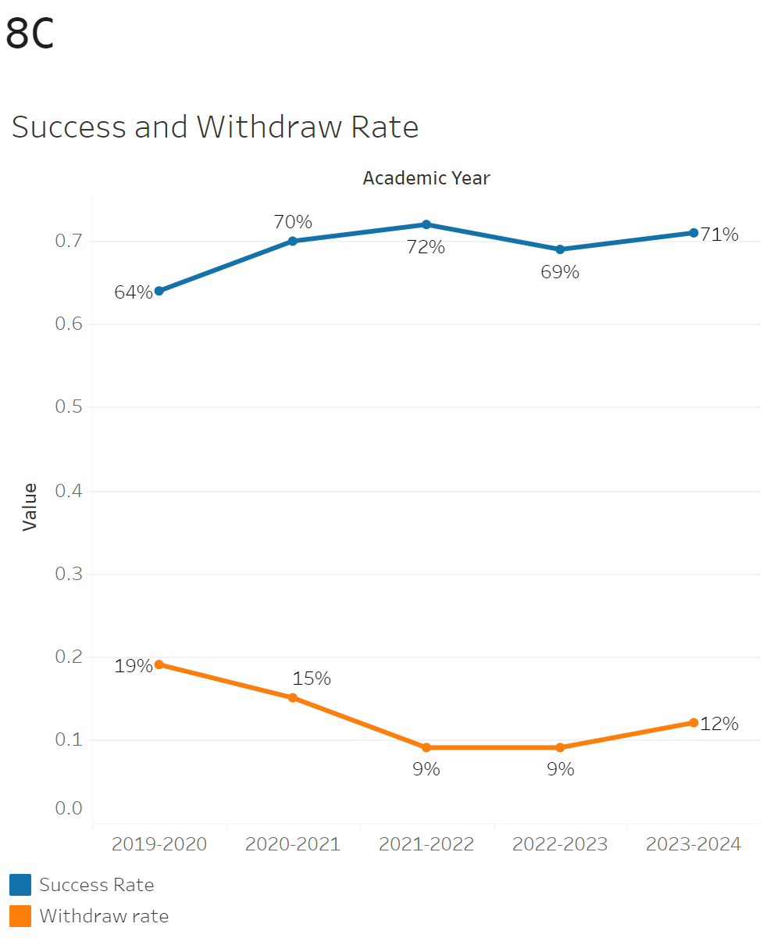
Success rates had a steep drop from 94% to 79% between 2019-2020 and 2020-2021. After that point it rose to 89% in 2021-2022. It then flattened out to around 84-85% after that point. Withdrawals followed roughly the same trend. They increased from 6% to 17% between 2019-2020 and 2020-2021. They then dipped down to 10% by 2023-2024.

ENGR-695 and ENGR-240 had the lowest withdrawal rates at 0% while ENGR-215 had the highest at 24%. ENGR-695 and ENGR-240 also had the highest success rates of 100% while ENG-215 had the lowest at 70%.
8B. Student Equity
One of the goals of the College’s Student Equity plan is to close the performance gaps for disproportionately impacted students. Use the data provided by PRIE that indicates which groups are experiencing a disproportionate impact in your program. Which gaps are most important for improving outcomes in your program? How can the college help you address these gaps? What changes could be made?
OVERALL EQUITY

The Equity and Disproportionate Impact (DI) dashboard was used to identify subgroups that may have been disproportionately impacted in Engineering in the most recent academic year (2023-2024). The three metrics used to examine potential disproportionate impact were enrollment rates (referred as access), success rates, and withdraw rates. The rate for each subgroup was compared to either the college-wide rate (access) or the overall program-level rate (success and withdraws). The difference between the two rates is known as the ‘gap’ and may be referred to as a performance gap or equity gap. Student subgroups that may have been disproportionately impacted in Engineering appear below (see Table 1-2).

Access
Access is an indicator of what student subgroups are enrolling in courses, based on unique student counts. Enrollment data revealed one student subgroup was underrepresented in Engineering classes compared to the college-wide population (see Table 1). For instance, female students are underrepresented in Engineering. The proportion of female students in Engineering across all course modalities was 42 percentage points lower than the proportion of female students enrolled college-wide.
Table 1.
SubGroup | Gap
Female | -42%

Success
Success is the rate at which different student subgroups pass courses and is based on enrollments. The success rate for different subgroups in Engineering was compared to the overall success rate in Engineering. The difference between the two rates (the gap) revealed four subgroups may have been disproportionately impacted (see Table 2). For example, the success rate for Hispanic students in Engineering was 10 percentage points lower than the overall success rate in Engineering during the 2023-2024 academic year.
Table 2.
SubGroup | Gap
Hispanic | -10%
Hispanic - Male | -13%
23-28 | -21%
Unreported - First Generation | -19%

8C. Completion – Success Online
The college has a goal of improving success in online courses. Using the data provided by PRIE, what significant gaps do you see in success between online/hybrid and non-online courses? What changes could be made to reduce these gaps? If your program does not offer online/hybrid courses, please write “not applicable”.

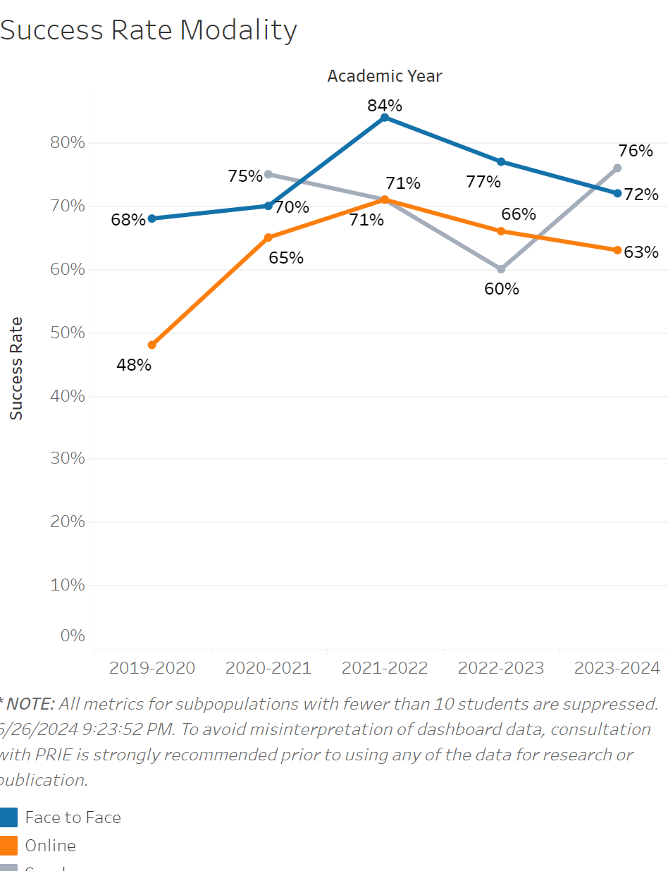
The success rate for in person classes dropped significantly from 94% in 2019-2020 to 78% in 2020-2021. However, it quickly recovered and even reached 100% by 2022-2023. Success rates dipped down to 90% after that point in 2023-2024. Online class success rates briefly surged from 83% in 2020-2021 to 100% in 2021-2022. However, they then dropped to 74% by 2023-2024 going well below the in-person success rate. Synchronous classes stayed in the 81-87 percent range by the end of 2021-2022, but then dropped significantly to 68% in 2022-2023. It has since only recovered slightly to 70%.

Source: https://canadacollege.edu/prie/dashboards/disproportionate-impact.php

