Fashion Design
Comprehensive Program Review Questionnaire Data
7A. Enrollment Trends
Use the data provided by PRIE to examine your enrollments by department or courses. Describe trends in headcount, FTES, and load. If applicable, describe any other enrollment data that is relevant to your program

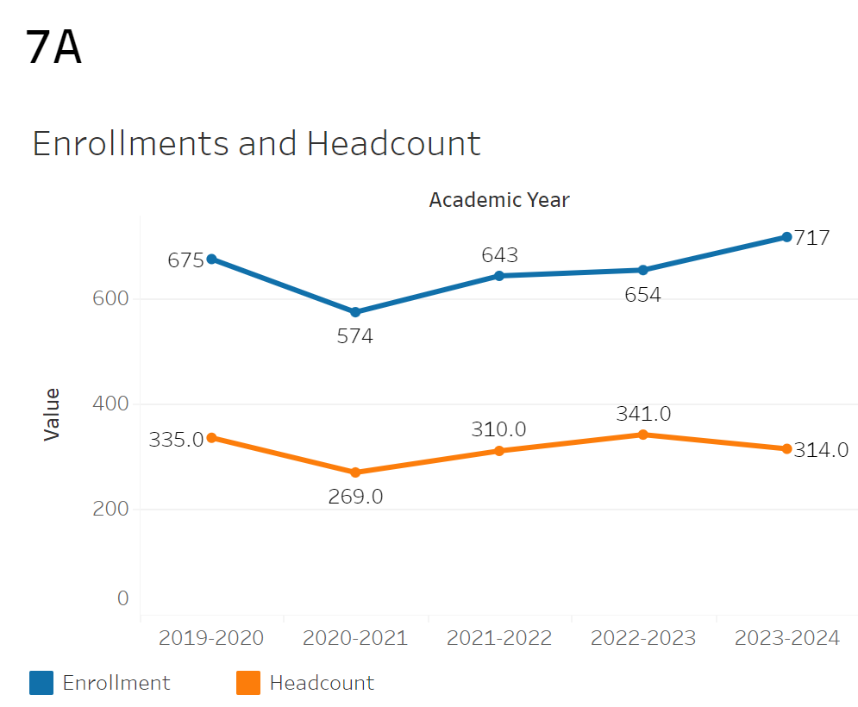
Enrollment and headcount has remained relatively flat with a slight increase across the four years for enrollments along with a slight decrease for headcount. Enrollment rose from 675 in 2019-2020 to 717 in 2023-2024. Meanwhile, headcount decreased from 335 to 314 between 2019-2020 and 2023-2024.

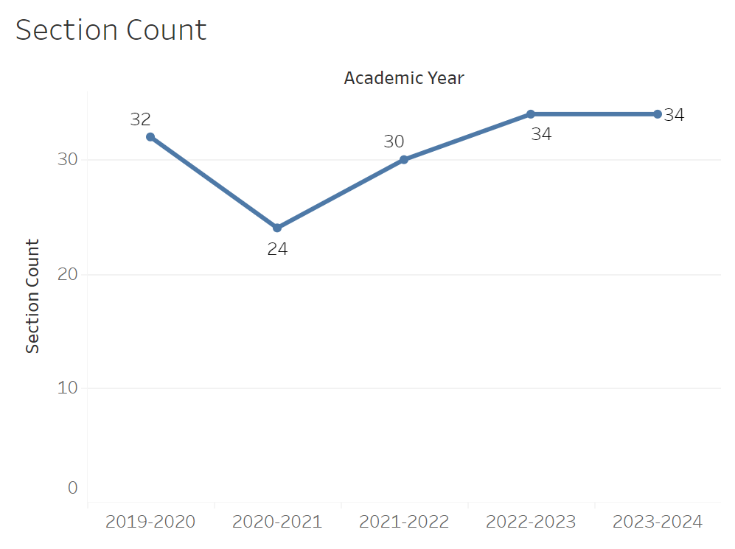
Section count declined from 32 to 24 between 2019-2020 and 2020-2021. It then increased up to 34 by 2022-2023 and remained there in 2023-2024.

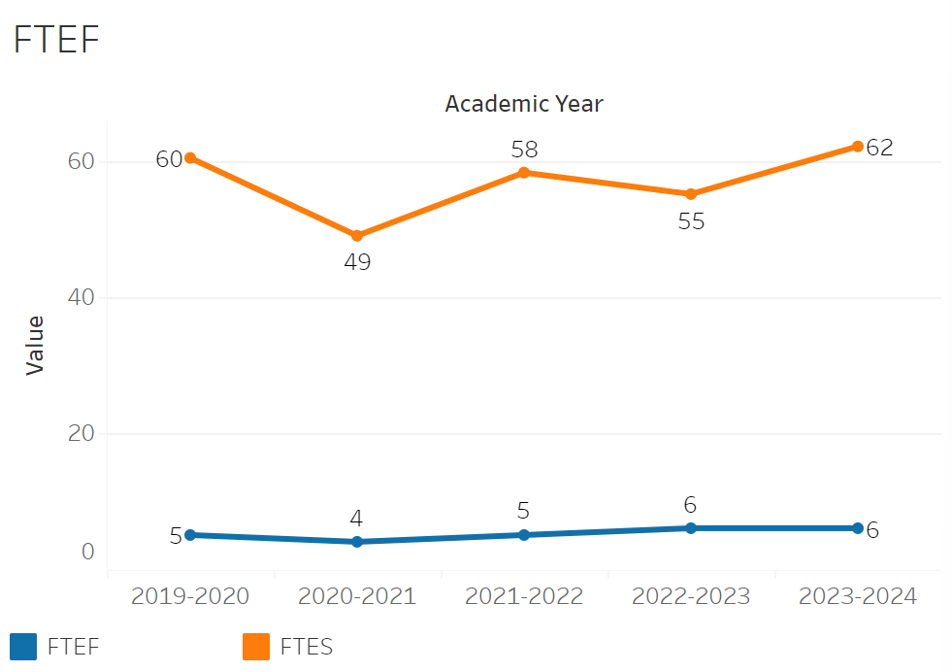
FTEF declined from 5 to 4 between 2019-2020 and 2020-2021. It then increased to 6 between then and 2022-2023 where it remained since.

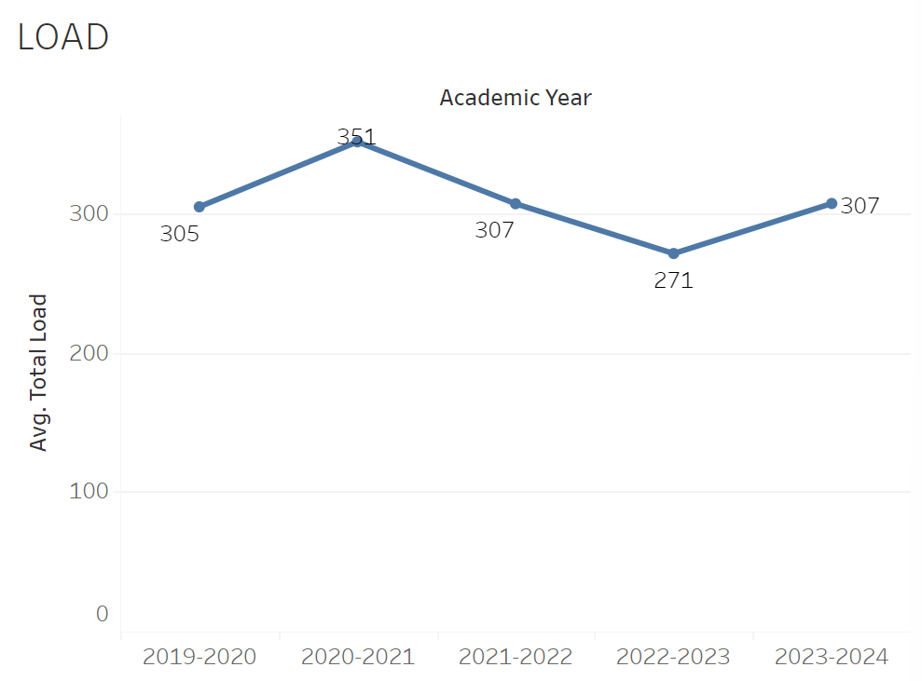
Load increased from 305 to 351 between 2019-2020 and 2020-2021. It then declined to 271 by 2022-2023. Finally, the load increased to 307 by 2023-2024.

8A. Access & Completion
Describe the student completion and success rate in your courses and/or program using the data provided by PRIE. Look at your course offerings, in the last program review cycle was it possible for a student to complete your certificates or degrees while only completing courses at Cañada College? How can the college help you improve student completion and success? What changes could be made?

Note: See the Course Enrollment & Success Detail Report for additional course-level data. This report can be found on PRIE’s Data Dashboards & Packets page under the program name.

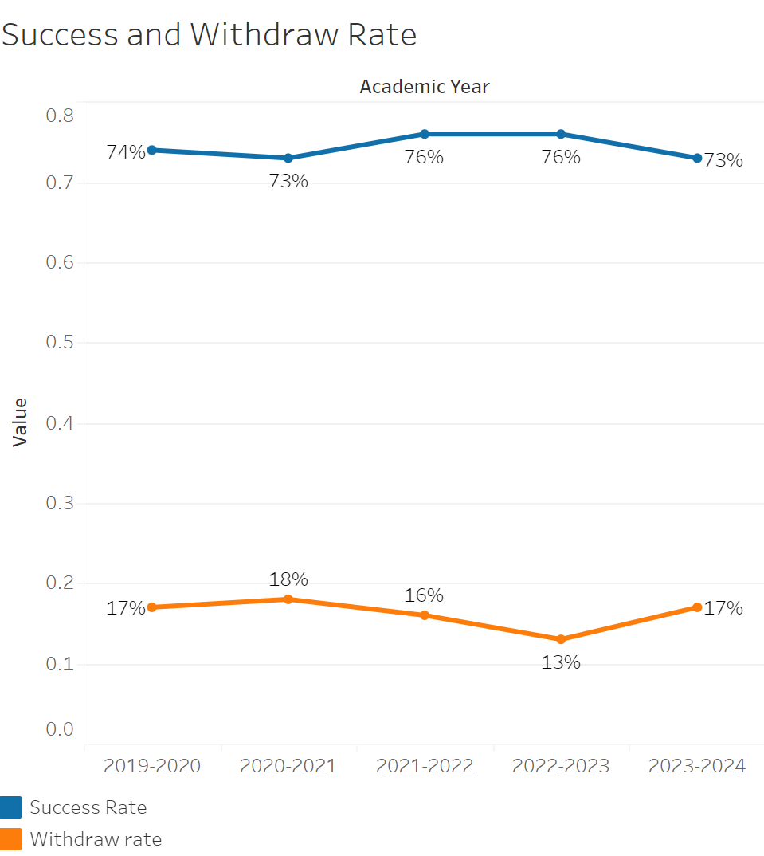
The success rate has remained essentially flat between 2019-2020 and 2023-2024 only fluctuating between 73% and 76% in no apparent trend. Withdraw rates also remained relatively flat between 16-18% with one exception of 13% in 2022-2023.

FASH-196 had the highest withdraw rate of 43% while FASH-167, 178, 199, and 163 all had the lowest withdraw rate of 0%. FASH-199 had the highest success rate of 100% along with FASH-226 and 196 having the lowest at 54%.

8B. Student Equity
One of the goals of the College’s Student Equity plan is to close the performance gaps for disproportionately impacted students. Use the data provided by PRIE that indicates which groups are experiencing a disproportionate impact in your program. Which gaps are most important for improving outcomes in your program? How can the college help you address these gaps? What changes could be made?
OVERALL EQUITY

The Equity and Disproportionate Impact (DI) dashboard was used to identify subgroups that may have been disproportionately impacted in Fashion Design in the most recent academic year (2023-2024). The three metrics used to examine potential disproportionate impact were enrollment rates (referred as access), success rates, and withdraw rates. The rate for each subgroup was compared to either the college-wide rate (access) or the overall program-level rate (success and withdraws). The difference between the two rates is known as the ‘gap’ and may be referred to as a performance gap or equity gap. Student subgroups that may have been disproportionately impacted in Fashion Design appear below (see Table 1-3).
Access
Access is an indicator of what student subgroups are enrolling in courses, based on unique student counts. Enrollment data revealed three student subgroups were underrepresented in Fashion Design classes compared to the college-wide population (see Table 1). For instance, Hispanic students are underrepresented in Fashion Design. The proportion of Hispanic students in Fashion Design across all course modalities was 17 percentage points lower than the proportion of Hispanic students enrolled college-wide.

SubGroup | Gap
Male | -26%
Hispanic | -17%
18-22 | -21%

Success
Success is the rate at which different student subgroups pass courses and is based on enrollments. The success rate for different subgroups in Fashion Design was compared to the overall success rate in Fashion Design. The difference between the two rates (the gap) revealed seven subgroups may have been disproportionately impacted (see Table 2). For example, the success rate for Hispanic male students in Fashion Design was 35 percentage points lower than the overall success rate in Fashion Design during the 2023-2024 academic year.

SubGroup | Gap
Male | -15%
Filipino | -10%
Unknown Race/Eth | -19%
Hispanic - Male | -35%
18-22 | -17%
23-28 | -10%
Low Income | -21%

Withdraws
Withdraws is the rate at which a student withdraws from a course, with higher numbers being worse, as they indicate greater withdraw rates. The withdraw rates for subgroups in Fashion Design was compared to the overall withdraw rate for the program. One subgroup had a withdraw rate that were higher than the overall rate, suggesting this group possibly experienced disproportionate impact in Fashion Design. Unknown Race/Eth students were disproportionately impacted in Fashion Design during the 2023-2024 academic year. Unknown Race/Eth students had withdraw rates 17 percentage points higher than the average withdraw rate for Fashion Design.

SubGroup | Gap | Gap Type
Unknown Race/Eth | 17% | Withdraws

EQUITY BY INSTRUCTIONAL MODALITY
Success
Success is the rate at which different student subgroups pass courses and is based on enrollments. The success rate for different subgroups in Fashion Design was compared to the overall success rate in Fashion Design. The difference between the two rates (the gap) revealed six subgroups may have been disproportionately impacted (see Table 1). For example, the success rate for Hispanic students in face to face classes for Fashion Design was 13 points lower than the overall success rate in Fashion Design during the 2023-2024 academic year.
Table 1.
SubGroup | ONLINE | FACE TO FACE | HYBRID | SYNC
Hispanic |  | -13%
18-22 |  | -19%
Low Income |  | -25%
Unknown Race |  |  |  | -27%
Unreported First Generation |  |  |  | -22.60%
Low Income |  |  |  | -16%

Withdraws
Withdraws is the rate at which a student withdraws from a course, with higher numbers being worse, as they indicate greater withdrawal rates. The withdrawal rates for subgroups in Fashion Design was compared to the overall withdrawal rate for the program. One subgroup had withdrawal rates that were higher than the overall rate, suggesting this group experienced disproportionate impact in Fashion Design. Unknown Race students were disproportionately impacted in Fashion Design during the 2023-2024 academic year. Unknown Race students in Synchronous Fashion Design classes had withdrawal rates 20 percentage points higher than the average withdrawal rate for Fashion Design.
Table 2.
SubGroup | ONLINE | FACE TO FACE | HYBRID | SYNC
Unknown Race |  |  |  | 20%

8C. Completion – Success Online
The college has a goal of improving success in online courses. Using the data provided by PRIE, what significant gaps do you see in success between online/hybrid and non-online courses? What changes could be made to reduce these gaps? If your program does not offer online/hybrid courses, please write “not applicable”.

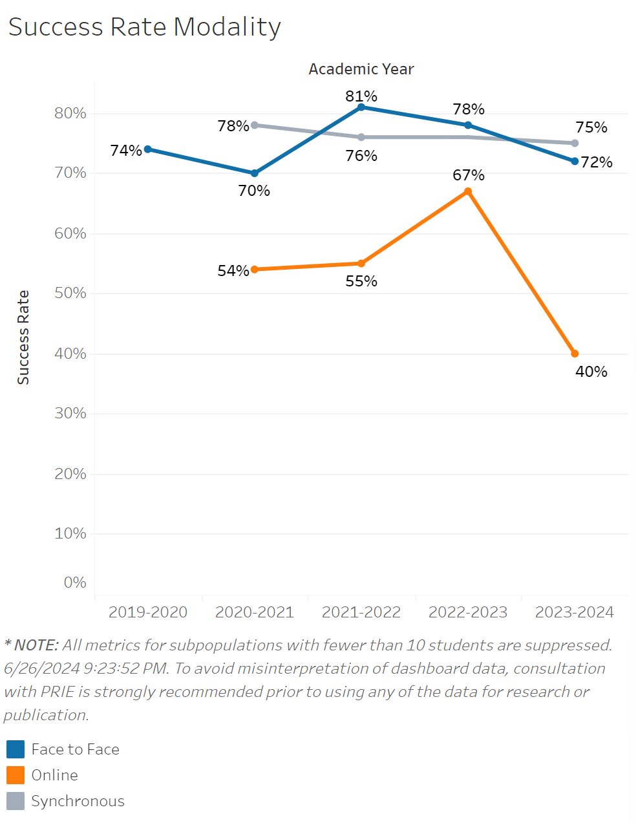
The success rate for in person classes had a significant increase from 70% in 2020-2021 to 81% in 2021-2022. After that point it declined down to 72% by 2023-2024 going below synchronous class success rates. Synchronous class success rates remained flat overall only going between 75-78%. Online class success rate were consistently well below in person class success rates even though they fluctuated quite a bit. The success rate for online classes went from 54 to 67% between 2020-2021 and 2022-2023. They then sharply declined to 40% in 2023-2024.

Source: https://canadacollege.edu/prie/dashboards/disproportionate-impact.php

