Interior Design
Comprehensive Program Review Questionnaire Data (v2)
7A. Enrollment Trends
Use the data provided by PRIE to examine your enrollments by department or courses. Describe trends in headcount, FTES, and load. If applicable, describe any other enrollment data that is relevant to your program
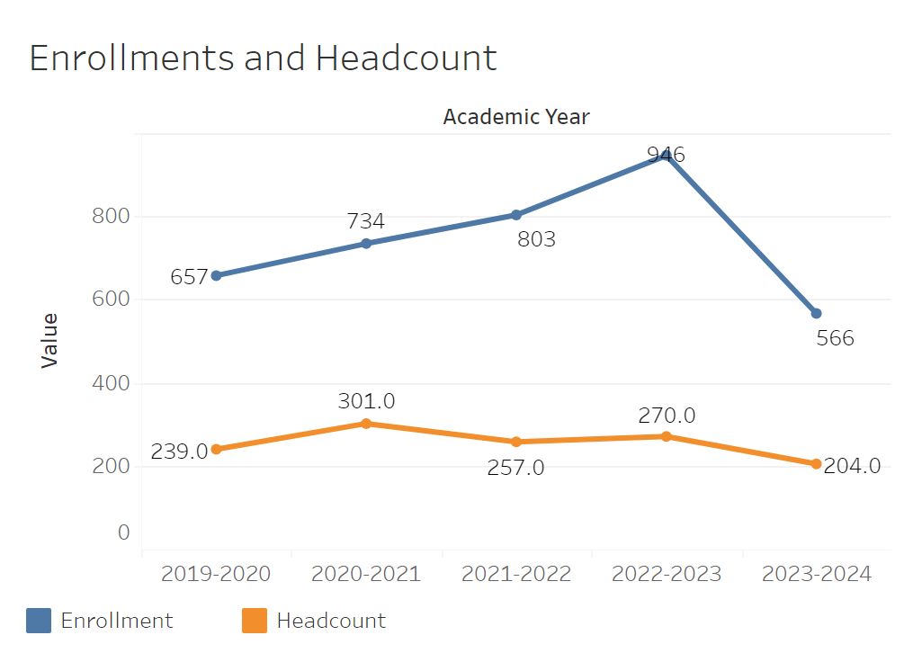
Between 2019-2020 and 2022-2023 overall enrollments increased from 657 to 946. After that point it then declined significantly to 566 in the 2023-2024 academic year. Headcount has remained relatively flat overall.
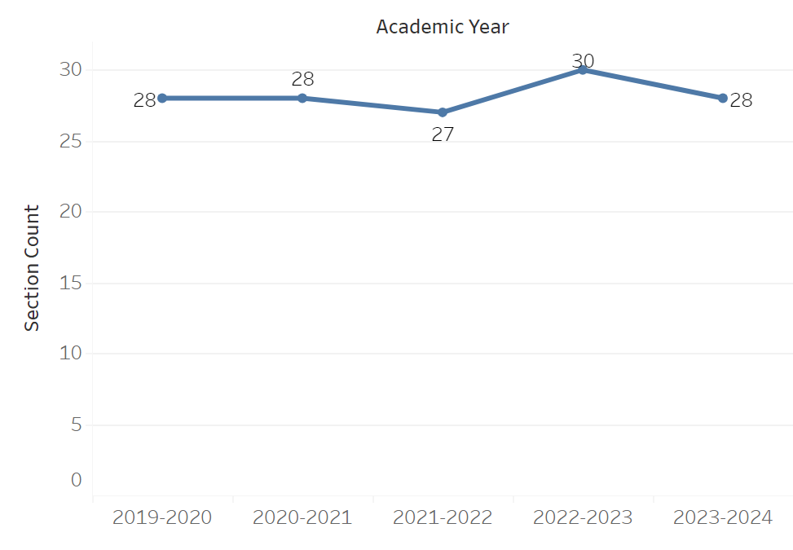
Overall section count has remained flat for the most part with the only notable incline being 27 to 30 in 2022-2023. It then went back down to the usual range of 28 in 2023-2024.
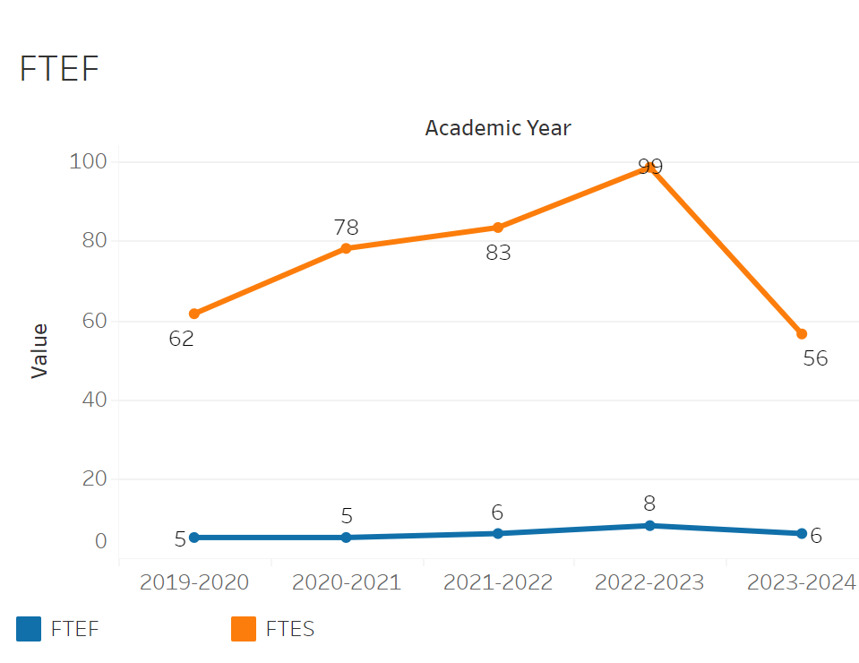
FTEF went from five to eight between 2020-2021 and 2022-2023. It then dipped down to six in 2023-2024. This appears to be roughly in line with the enrollment trend. FTES on the other hand also follows the enrollment trend. Between 2019-2020 and 2022-2023 it went from 61.58 to 98.61. However, there was a large dip to 56.47 in 2023-2024 hitting an all time low.
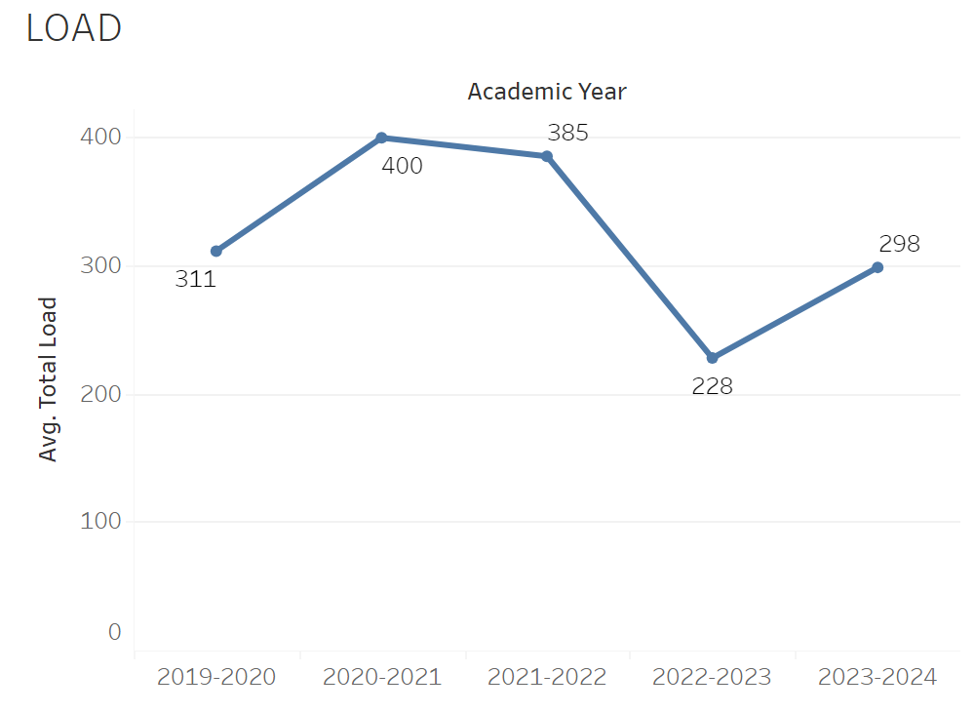
Load inclined from 311 to 400 between the 2019-2020 and 2020-2021 academic years. It then remained relatively flat and then sharply declined between 2021-2022 and 2022-2023 to 228 from 385. Finally, it inclined to 298 in 2023-2024.

8A. Access & Completion
Describe the student completion and success rate in your courses and/or program using the data provided by PRIE. Look at your course offerings, in the last program review cycle was it possible for a student to complete your certificates or degrees while only completing courses at Cañada College? How can the college help you improve student completion and success? What changes could be made?

Note: See the Course Enrollment & Success Detail Report for additional course-level data. This report can be found on PRIE’s Data Dashboards & Packets page under the program name.

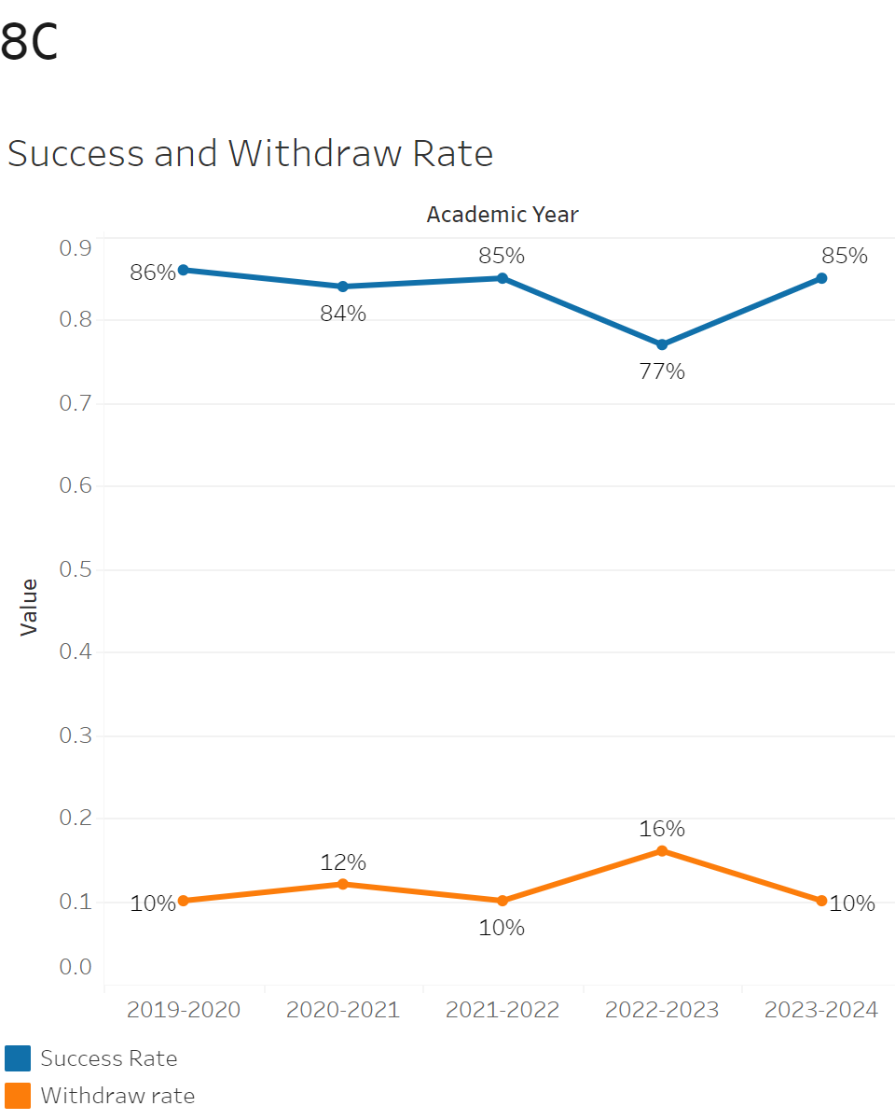
The overall success rate has remained flat for the most part. It tends to hover around 83-86%. however there was a notable dip in 2022-2023 to 77% which quickly recovered to 83%. Withdrawals were also flat hovering around 10-12% with an increase in 2022-2023 to 16%. It then dropped back down to 11% afterwards.

Withdrawal Rates ranged from 0% in INTD-695 to 29% in INTD 301. On the other hand, Course success rates ranged from 100% in INTD-695 to 71% in INTD 301.

8B. Student Equity
One of the goals of the College’s Student Equity plan is to close the performance gaps for disproportionately impacted students. Use the data provided by PRIE that indicates which groups are experiencing a disproportionate impact in your program. Which gaps are most important for improving outcomes in your program? How can the college help you address these gaps? What changes could be made?
OVERALL EQUITY

The Equity and Disproportionate Impact (DI) dashboard was used to identify subgroups that may have been disproportionately impacted in Interior Design in the most recent academic year (2023-2024). The three metrics used to examine potential disproportionate impact were enrollment rates (referred as access), success rates, and withdraw rates. The rate for each subgroup was compared to either the college-wide rate (access) or the overall program-level rate (success and withdraws). The difference between the two rates is known as the ‘gap’ and may be referred to as a performance gap or equity gap. Student subgroups that may have been disproportionately impacted in Interior Design appear below (see Table 1-2).
Access
Access is an indicator of what student subgroups are enrolling in courses, based on unique student counts. Enrollment data revealed three student subgroups were underrepresented in Interior Design classes compared to the college-wide population (see Table 1). For instance, male students are underrepresented in Interior Design. The proportion of male students in Interior Design across all course modalities was 31 percentage points lower than the proportion of male students enrolled college-wide.
Table 1.
SubGroup | Gap
Male | -31%
18-22 | -19%
Less than Part-Time | -29%
Success
Success is the rate at which different student subgroups pass courses and is based on enrollments. The success rate for different subgroups in Interior Design was compared to the overall success rate in Interior Design. The difference between the two rates (the gap) revealed one subgroup may have been disproportionately impacted (see Table 2). In Interior Design, tthe success rate for Less than Part-Time students in Interior Design was 11 percentage points lower than the overall success rate in Interior Design during the 2023-2024 academic year.
Table 2.
SubGroup | Gap | Gap Type
Less than Part-Time | -11% | Success
EQUITY BY INSTRUCTIONAL MODALITY
Success
Success is the rate at which different student subgroups pass courses and is based on enrollments. The success rate for different subgroups in Interior Design was compared to the overall success rate in Interior Design. The difference between the two rates (the gap) revealed one subgroup may have been disproportionately impacted (see Table 1). For example, the success rate for aged 23-28 students in synchronous classes for Interior Design was 26 points lower than the overall success rate in Interior Design during the 2023-2024 academic year.
Table 1.
SubGroup | ONLINE | FACE TO FACE | HYBRID | SYNC
23-28 |  |  |  | -26%

8C. Completion – Success Online
The college has a goal of improving success in online courses. Using the data provided by PRIE, what significant gaps do you see in success between online/hybrid and non-online courses? What changes could be made to reduce these gaps? If your program does not offer online/hybrid courses, please write “not applicable”.
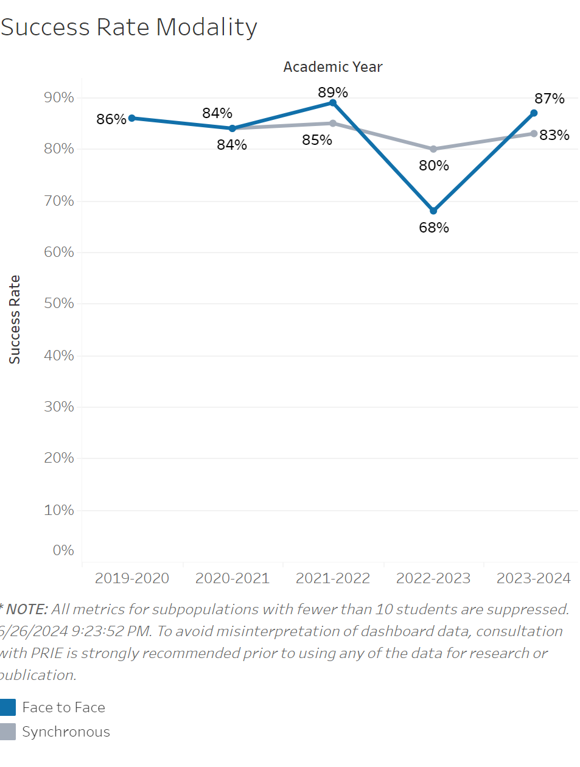
The success rate for face to face classes in Interior Design has remained relatively flat overall ranging from 89%-84%. However, there was a significant decline in face to face success in 2022-2023 which dipped down to 68%. It then rose back to its normal range in 2023-2024. Synchronous classes declined slightly over time going from 84% in 2020-2021 to 80% in 2023-2024.

Source: https://canadacollege.edu/prie/dashboards/disproportionate-impact.php

