Mathematics
Comprehensive Program Review Questionnaire Data
7A. Enrollment Trends
Use the data provided by PRIE to examine your enrollments by department or courses. Describe trends in headcount, FTES, and load. If applicable, describe any other enrollment data that is relevant to your program

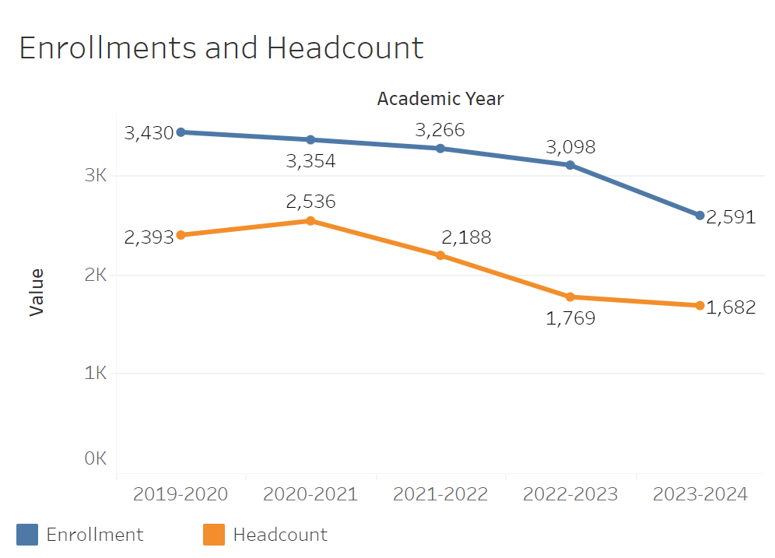
Enrollments have been trending consistently down in Math all 5 years recorded. The decline was relatively minimal every year aside from the drop in 2023-2024 where it went from 3,098, the academic year prior, to 2,591. Headcount followed roughly the same trajectory going from 2,393 in 2019-2020 to 1,682 2023-2024.

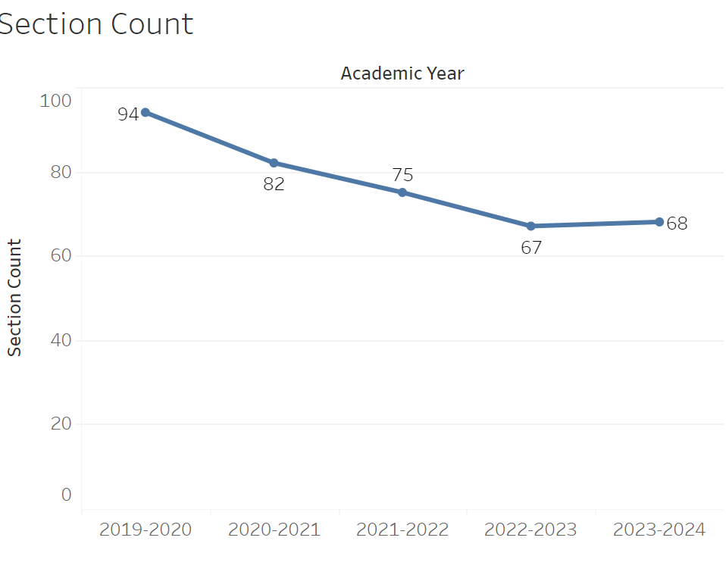
Section count has also roughly followed the enrollment trend. It has declined every year apart from 2023-2024 going from 94 to 68.
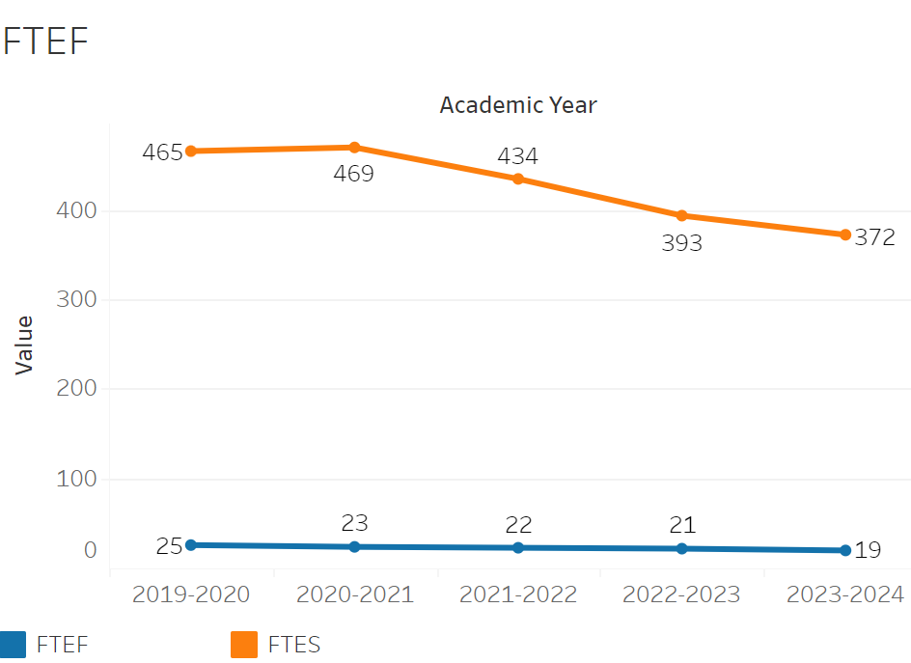
FTEF has declined consistently every year, going from 25 in 2019-2020 to 20 in 2023-2024. This follows the same trend as enrollment. FTES has consistently gone down every year apart from 2020-2021 where it went from 465.2 in 2019-2020 to 469.3. By 2023-2024, it had reached 371.7.

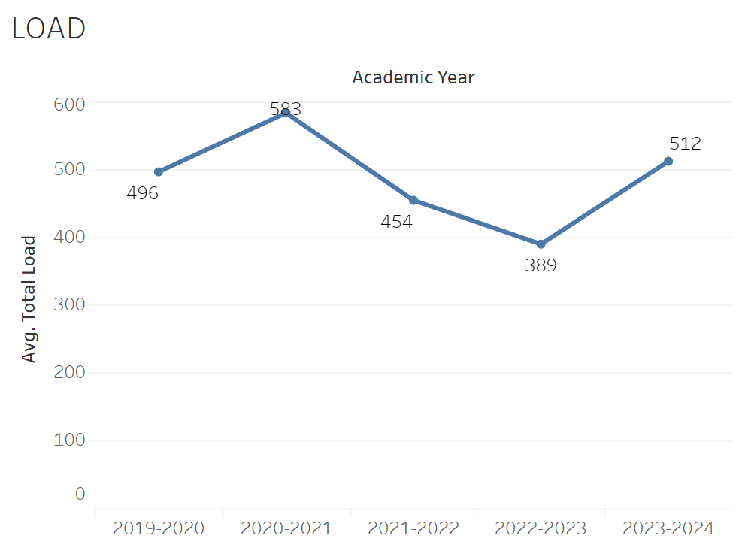
Load initially jumped from 496 to 583 between 2019-2020 and 2020-2021. However, it then declined to 389 between 2020-2021 and 2022-2023. Load then sharply increased to 512 in 2023-2024.

8A. Access & Completion
Describe the student completion and success rate in your courses and/or program using the data provided by PRIE. Look at your course offerings, in the last program review cycle was it possible for a student to complete your certificates or degrees while only completing courses at Cañada College? How can the college help you improve student completion and success? What changes could be made?

Note: See the Course Enrollment & Success Detail Report for additional course-level data. This report can be found on PRIE’s Data Dashboards & Packets page under the program name.

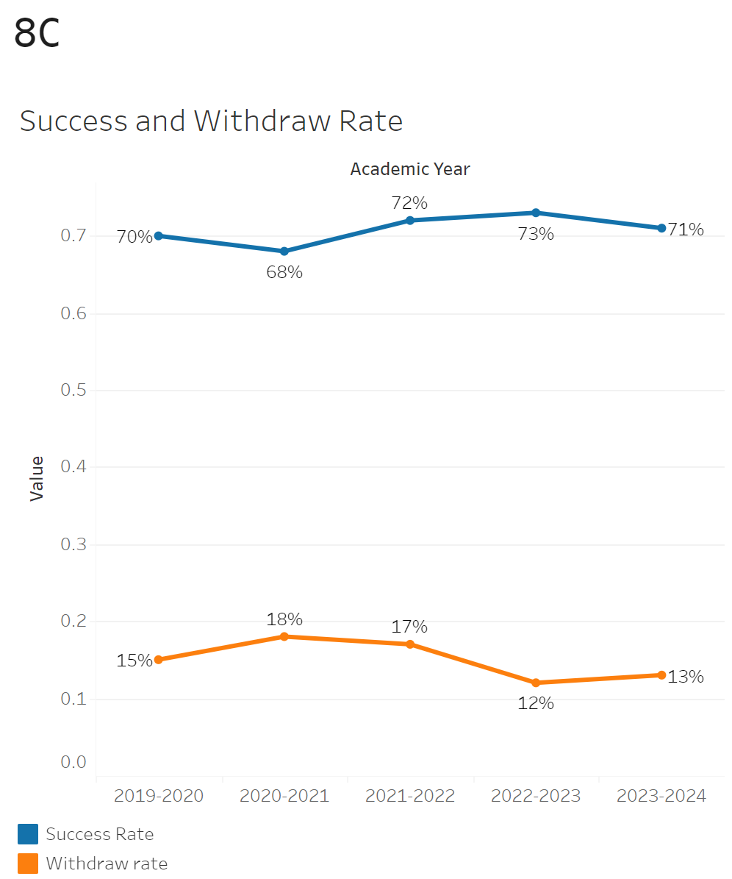
Success rates have remained relatively flat overall. Although starting in 2021-2022 success rates consistently remained above 70% where before it was below that point. Withdrawals are essentially the same story although there was a more significant decline from 17% to 12% in 2022-2023.

The minimum withdraw rate was 0% in MATH-695 while the maximum withdraw rate was 28% in Math 811. The minimum success rate was 40% in MATH-145 while the highest was 100% in MATH-695.
8B. Student Equity
One of the goals of the College’s Student Equity plan is to close the performance gaps for disproportionately impacted students. Use the data provided by PRIE that indicates which groups are experiencing a disproportionate impact in your program. Which gaps are most important for improving outcomes in your program? How can the college help you address these gaps? What changes could be made?

OVERALL EQUITY
The Equity and Disproportionate Impact (DI) dashboard was used to identify subgroups that may have been disproportionately impacted in Mathematics in the most recent academic year (2023-2024). The three metrics used to examine potential disproportionate impact were enrollment rates (referred as access), success rates, and withdraw rates. The rate for each subgroup was compared to either the college-wide rate (access) or the overall program-level rate (success and withdraws). The difference between the two rates is known as the ‘gap’ and may be referred to as a performance gap or equity gap. Student subgroups that may have been disproportionately impacted in Mathematics appear below (see Table 1-3).

Access
Access is an indicator of what student subgroups are enrolling in courses, based on unique student counts. Enrollment data revealed two student subgroups were underrepresented in Mathematics classes compared to the college-wide population (see Table 1). For instance, female students are underrepresented in Mathematics. The proportion of female students in Mathematics across all course modalities was 11 percentage points lower than the proportion of female students enrolled college-wide.
Table 1.
SubGroup | Gap
Female | -11%
Not Low Income | -6%

Success
Success is the rate at which different student subgroups pass courses and is based on enrollments. The success rate for different subgroups in Mathematics was compared to the overall success rate in Mathematics. The difference between the two rates (the gap) revealed eight subgroups may have been disproportionately impacted (see Table 2). For example, the success rate for Hispanic students in Mathematics was 10 percentage points lower than the overall success rate in Mathematics during the 2023-2024 academic year.
Table 2.
SubGroup | Gap
Hispanic | -10%
Hispanic - Female | -10%
Hispanic - Male | -10%
23-28 | -7%
50-59 | -28%
First Generation | -9%
Foster Youth | -24%
Low Income | -8%

Withdraws
Withdraws is the rate at which a student withdraws from a course, with higher numbers being worse, as they indicate greater withdraw rates. The withdraw rates for subgroups in Mathematics was compared to the overall withdraw rate for the program. Six subgroups had withdraw rates that were significantly higher than the overall rate, suggesting these groups experienced disproportionate impact in Mathematics. First generation students were disproportionately impacted in Mathematics during the 2023-2024 academic year. First generation students had withdraw rates 4 percentage points higher than the average withdraw rate for Mathematics.
Table 3.
SubGroup | Gap
Hispanic - Female | 5%
23-28 | 6%
29-39 | 12%
50-59 | 22%
First Generation | 4%
Foster Youth | 36%

EQUITY BY INSTRUCTIONAL MODALITY
Success
Success is the rate at which different student subgroups pass courses and is based on enrollments. The success rate for different subgroups in Mathematics was compared to the overall success rate in Mathematics. The difference between the two rates (the gap) revealed twenty seven subgroups may have been disproportionately impacted (see Table 1). For example, the success rate for Hispanic students in online classes for Mathematics was 14 points lower than the overall success rate in Mathematics during the 2023-2024 academic year.
Table 1.
SubGroup | ONLINE | FACE TO FACE | HYBRID | SYNC
Hispanic |  | -10%
Pacific Islander |  | -22%
Hispanic - Female |  | -10%
Hispanic Male |  | -10%
Pacific Islander - Female |  | -26%
23-28 |  | -8%
40-49 |  | -22%
50-59 |  | -37%
First Generation |  | -10%
Low Income |  | -9%
Male |  |  | -14%
Hispanic - Male |  |  | -22%
Hispanic | -14%
Hispanic - Female | -13%
Hispanic -Male | -16%
23-28 | -15%
29-39 | -28%
First Generation | -14%
Full-Time | -15%
Hispanic |  |  |  | -7%
Hispanic -Female |  |  |  | -12%

Withdraws
Withdraws is the rate at which a student withdraws from a course, with higher numbers being worse, as they indicate greater withdrawal rates. The withdrawal rates for subgroups in Mathematics was compared to the overall withdrawal rate for the program. Six subgroups had withdrawal rates that were higher than the overall rate, suggesting these groups experienced disproportionate impact in Mathematics. First Generation students were disproportionately impacted in Mathematics during the 2023-2024 academic year. For example, First Generation students in online classes had withdrawal rates 11 percentage points higher than the average withdrawal rate for Mathematics.
Table 2.
SubGroup | ONLINE | FACE TO FACE | HYBRID | SYNC
23-28 |  | 8%
50-59 |  | 27%
First Generation |  | 4%
29-39 | 26%
First Generation | 11%
Full-Time | 14%

8C. Completion – Success Online
The college has a goal of improving success in online courses. Using the data provided by PRIE, what significant gaps do you see in success between online/hybrid and non-online courses? What changes could be made to reduce these gaps? If your program does not offer online/hybrid courses, please write “not applicable”.

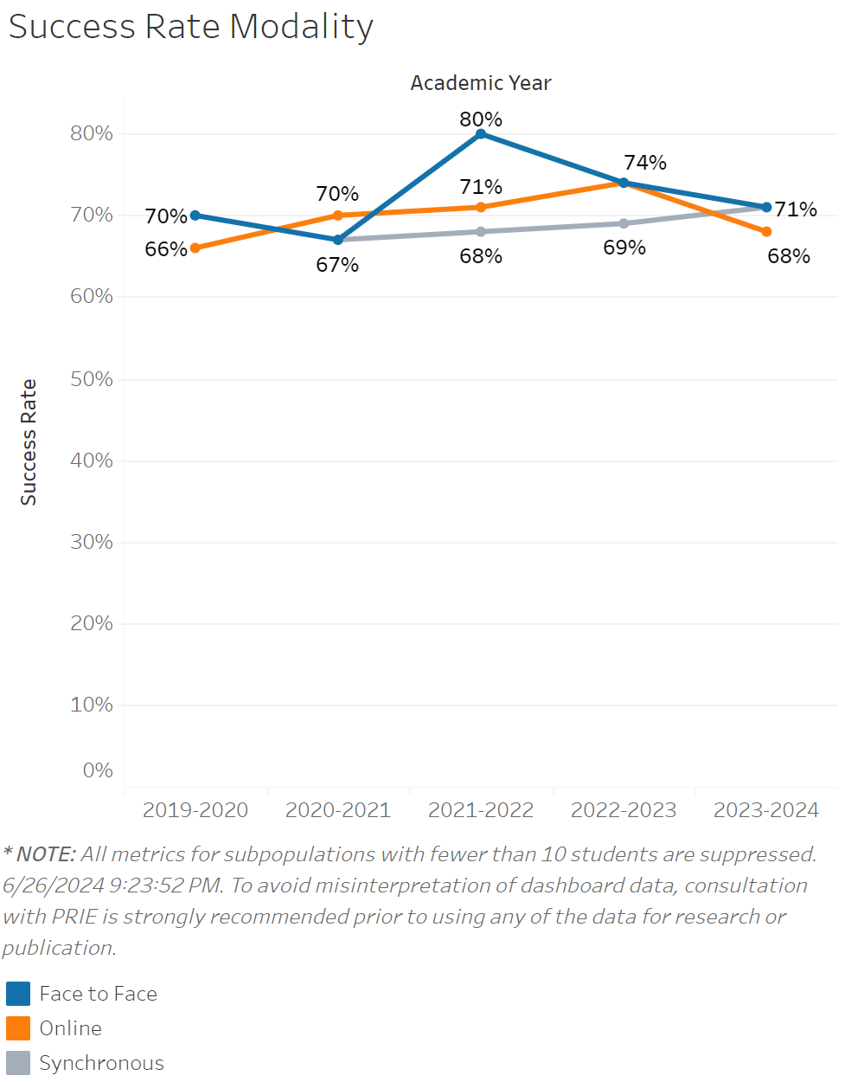
Success rates for in person classes in Mathematics had a significant jump from 67% to 80% between 2020-2021 and 2021-2022. It then declined from that peak to 74% in 2022-2023 and then down to 72% in 2023-2024. Online classes were on a consistent up trend in success rates going from 66% in 2019-2020 to 74% in 2022-2023. However, there was a sharp decline to 68% in 2023-2024. Synchronous class success rates have been on a slow but consistent rise in success going from 67% in 2020-2021 to 71% in 2023-2024.

Source: https://canadacollege.edu/prie/dashboards/disproportionate-impact.php

