Physics
Comprehensive Program Review Questionnaire Data
7A. Enrollment Trends
Use the data provided by PRIE to examine your enrollments by department or courses. Describe trends in headcount, FTES, and load. If applicable, describe any other enrollment data that is relevant to your program
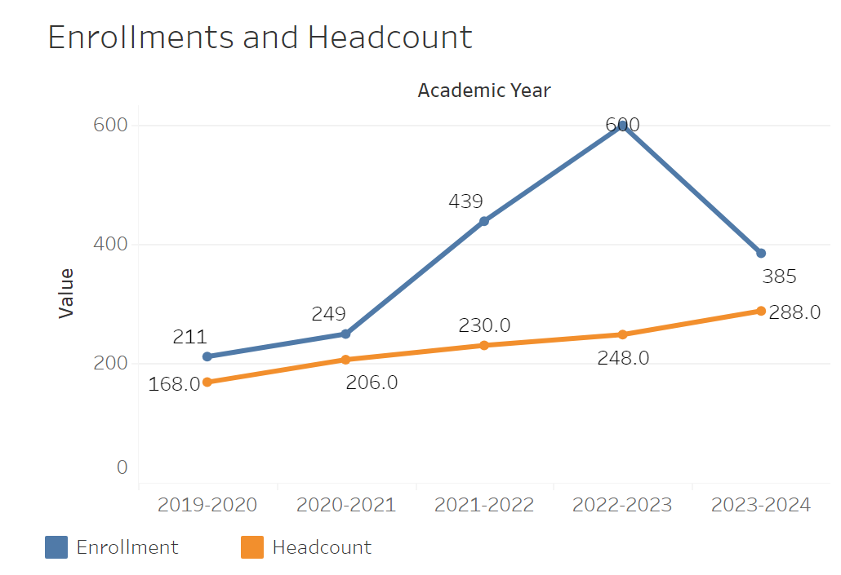
Overall enrollments in Physics rose quite significantly between 2020-2021 and 2022-2023 going from 249 to 680. It then declined steeply between 2022-2023 and 2023-2024 from 680 to 385. Headcount has steadily increased from 168 to 288 between 2019-2020 and 2023-2024.
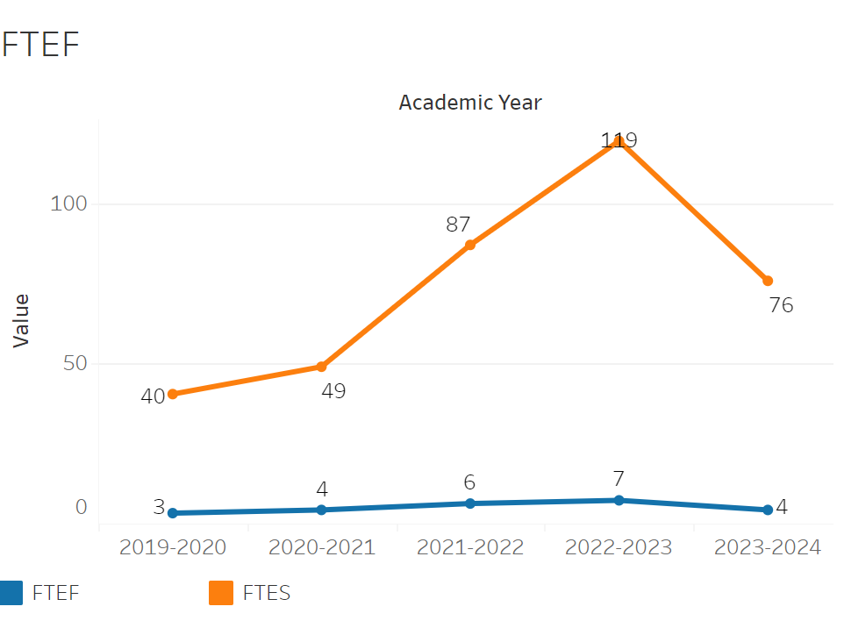
FTEF is roughly in line with the enrollment trend. FTEF rose between 2019-2020 and 2022-2023 from 3 to 7. It then sharply decreased in 2023-2024 from 7 to 4. FTES rose from 40 to 119 between 2019-2020 to 119 in 2022-2023. It then fell to 76 in 2023-2024.

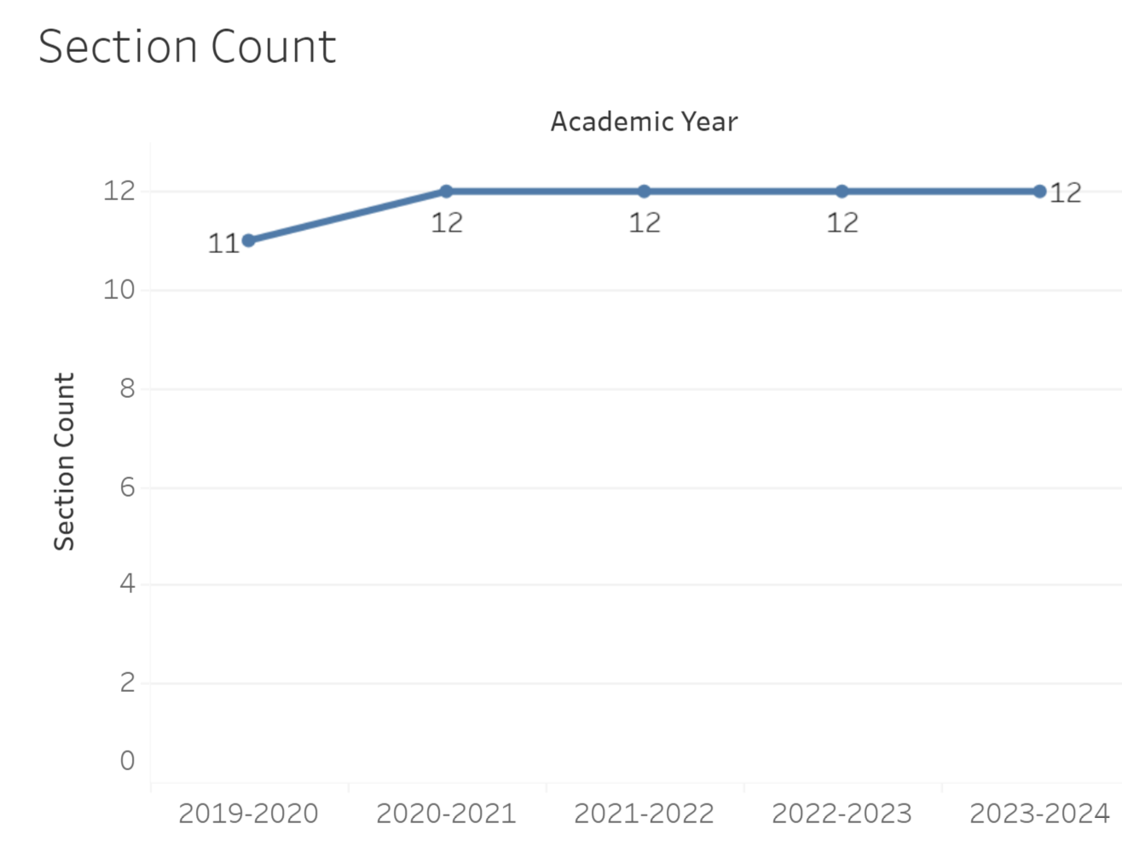
Section Count has remained constant with the exception of 2019-2020 where it was 11 instead of 12.
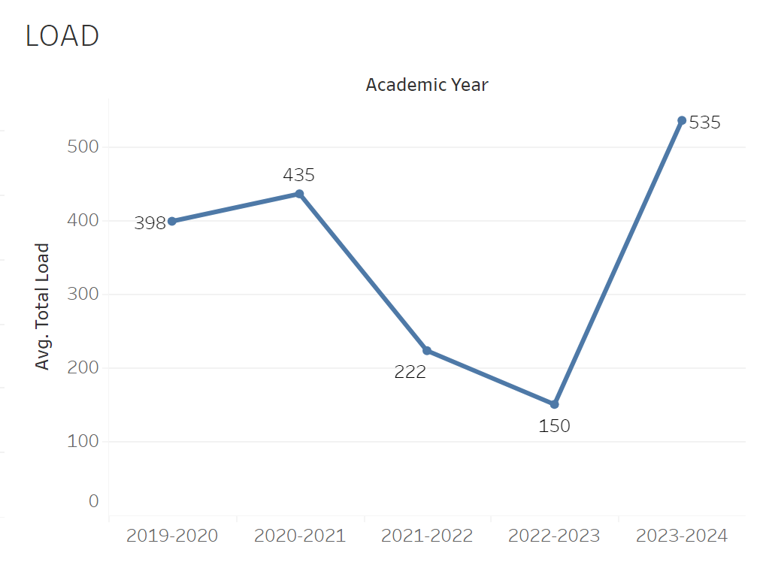
Load has fluctuated quite significantly between 2019-2020 and 2023-2024. Between 2020-2021 and 2022-2023 there was a sharp decline in load from 435 to 150. The load then inclined to an all time high of 535 in 2023-2024.

8A. Access & Completion
Describe the student completion and success rate in your courses and/or program using the data provided by PRIE. Look at your course offerings, in the last program review cycle was it possible for a student to complete your certificates or degrees while only completing courses at Cañada College? How can the college help you improve student completion and success? What changes could be made?

Note: See the Course Enrollment & Success Detail Report for additional course-level data. This report can be found on PRIE’s Data Dashboards & Packets page under the program name.

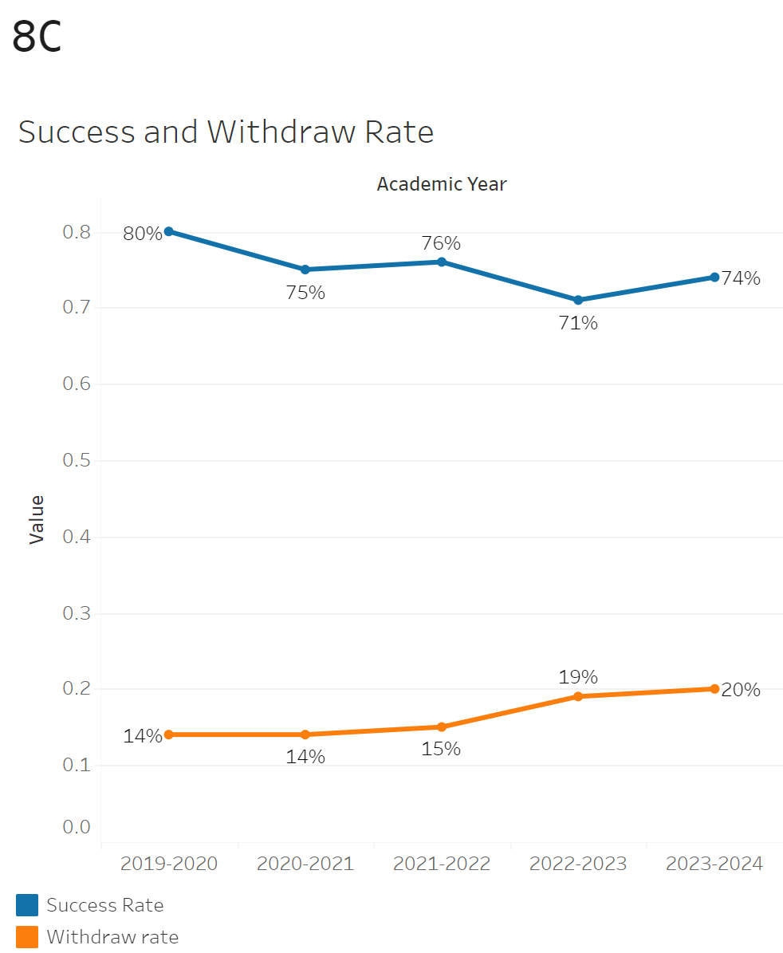
The success rate appears to be relatively stable although trending downwards slightly. The success rate went from 80% to 74% between 2019-2020 to 2023-2024. The withdrawal rate was flat between 2019-2020 and 2021-2022. It then picked up to 19% in 2022-2023 and then 21% in 2023-2024.

Physics 250 had the lowest success rate of 51% and highest withdraw rate of 33%. Physics 405 and 270 had the lowest withdraw rate of 4%. Physics 405 has the highest success rate of 95%.
See also the Course Enrollment Report on the PRE Data Dashboards and Packets website.
8B. Student Equity
One of the goals of the College’s Student Equity plan is to close the performance gaps for disproportionately impacted students. Use the data provided by PRIE that indicates which groups are experiencing a disproportionate impact in your program. Which gaps are most important for improving outcomes in your program? How can the college help you address these gaps? What changes could be made?
OVERALL EQUITY

The Equity and Disproportionate Impact (DI) dashboard was used to identify subgroups that may have been disproportionately impacted in Physics in the most recent academic year (2022-2023). The three metrics used to examine potential disproportionate impact were enrollment rates (referred as access), success rates, and withdraw rates. The rate for each subgroup was compared to either the college-wide rate (access) or the overall program-level rate (success and withdraws). The difference between the two rates is known as the ‘gap’ and may be referred to as a performance gap or equity gap. Student subgroups that may have been disproportionately impacted in Physics appear below (see Table 1-3).

Access
Access is an indicator of what student subgroups are enrolling in courses, based on unique student counts. Enrollment data revealed three student subgroups were underrepresented in Physics classes compared to the college-wide population (see Table 1). For instance, female students are underrepresented in Physics. The proportion of female students in Physics across all course modalities was 23 percentage points lower than the proportion of female students enrolled college-wide.
Table 1.
SubGroup | Gap
Female | -23%
Hispanic | -12%
First Generation | -9%

Success
Success is the rate at which different student subgroups pass courses and is based on enrollments. The success rate for different subgroups in Physics was compared to the overall success rate in Physics. The difference between the two rates (the gap) revealed two subgroups may have been disproportionately impacted (see Table 2). For example, the success rate for Hispanic male students in Physics was 13.3 percentage points lower than the overall success rate in Physics during the 2023-2024 academic year.
Table 2.
SubGroup | Gap
Hispanic | -15%
Hispanic Male | -13%

Withdraws
Withdraws is the rate at which a student withdraws from a course, with higher numbers being worse, as they indicate greater withdraw rates. The withdraw rates for subgroups in Physics was compared to the overall withdraw rate for the program. One subgroup had withdraw rates that were significantly higher than the overall rate, suggesting this group experienced disproportionate impact in Physics. Hispanic students were disproportionately impacted in Physics during the 2023-2024 academic year. Hispanic students had withdraw rates 11 percentage points higher than the average withdraw rate for Physics.
SubGroup | Gap
Hispanic | 11%
EQUITY BY INSTRUCTIONAL MODALITY
Success
Success is the rate at which different student subgroups pass courses and is based on enrollments. The success rate for different subgroups in Physics was compared to the overall success rate in Physics. The difference between the two rates (the gap) revealed two subgroups may have been disproportionately impacted (see Table 1). For example, the success rate for Hispanic students in Face to Face classes for Physics was 19 points lower than the overall success rate in Physics during the 2023-2024 academic year.
Table 1.
SubGroup | ONLINE | FACE TO FACE | HYBRID | SYNC
Hispanic |  | -19%
Hispanic - Male |  | -19%

8C. Completion – Success Online
The college has a goal of improving success in online courses. Using the data provided by PRIE, what significant gaps do you see in success between online/hybrid and non-online courses? What changes could be made to reduce these gaps? If your program does not offer online/hybrid courses, please write “not applicable”.

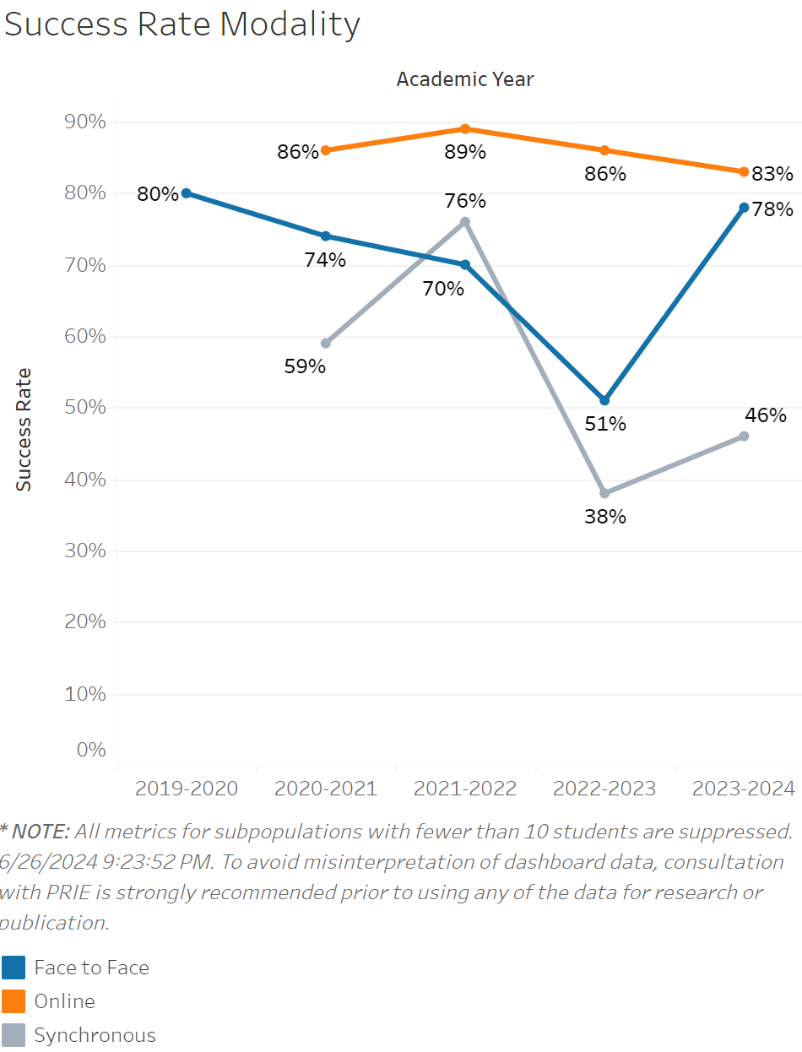

The overall success rate for online courses in Physics has remained steady and high for the most part. There was a small but notable increase in success in 2021-2022 from 86% to 89% and then a decline past that all the way down to 83% in 2023-2024. The success rate for face to face classes on the other hand, has fluctuated quite a bit. In 2019-2020, face to face classes had an all time high success rate of 80%. It then steadily dipped down to 70% between then and 2021-2022. In 2022-2023 it sharply dropped to 51% and recovered to 77% in 2023-2024. The success rate for synchronous classes was the most inconsistent, going from 59% to 76% in 2021-2022. It then dropped to 38% in 2022-2023 and rose to 44% in 2023-2024.

Source: https://canadacollege.edu/prie/dashboards/disproportionate-impact.php

