**Anthropology**

**Comprehensive Program Review Questionnaire Data & Sources 2025-26**

**6: Enrollment Trends and Changes**

**Trends, significant changes, and any disproportionate enrollment impacts in course offerings**

Please consult the *Course Enrollment Report* posted for your discipline on the [PRIE website](https://canadacollege.edu/prie/data-dashboards.php).

**Any disproportionate enrollments of student subpopulations indicated in PRIE data**

|  |  |  |
| --- | --- | --- |
| **Student Sub-Population** | **Overall Course Enrollment Equity Gaps** | **Year of Gap** |
| Less than Part-Time | -22.2% | 2024-25 |
| -27.5% | 2023-24 |
| -26.0% | 2022-23 |
| -28.9% | 2021-22 |
| -25.7% | 2020-21 |
| Online | -11.2% | 2023-24 |
| -8.8% | 2021-22 |

Cañada defines less than part-time students as those taking 6 or fewer units. Anthropology has seen disproportionately fewer enrollments from less than part-time students than the rest of the college every year for the last five years.

The program also saw disproportionately fewer online enrollments than the college as a whole during the 2021-22 and 2023-24 academic years.

**Trends in headcount, FTES, and load**

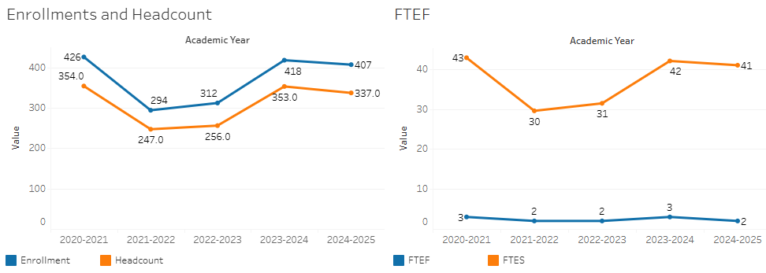

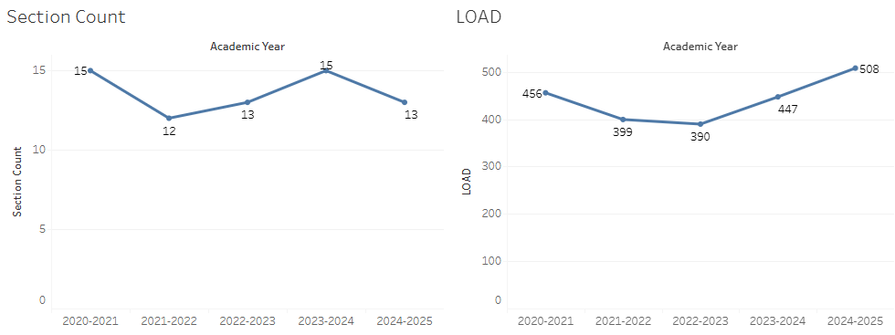

Enrollments have rebounded from a dramatic dip in 2021-22 and 2022-23. Additionally there seems to be sufficient sections to meet the demand of the enrollments after the rebound.

### 7A. Current Retention and Success Data

Describe the retention and student success rates in your courses and any disproportionate enrollment impacts using the data provided by PRIE.

**Overall Success and Withdraw Rates (retention rates are the inverse of withdraw rates):**

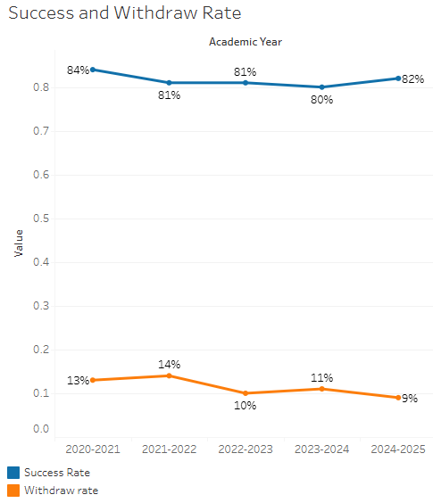

Success rates remain high, while withdraw rates are slowly declining.

**Course Success Rates: Equity Gaps**

|  |  |  |
| --- | --- | --- |
| **Student Sub-Population** | **Overall Course Success Rates Equity Gaps** | **Year of Gap** |
| Latina Female | 9.9% | 2024-25 |
| Students Ages 40-49 in Evening Courses | -45.9% | 2023-24 |
| Hybrid | -27.1% |  |
|  |  |

**Course Retention Rates: Equity Gaps**

There are no equity gaps in retentions rates in Anthropology.

Please check the [Equity & Disproportionate Impact Dashboard](https://canadacollege.edu/prie/dashboards/disproportionate-impact.php) on the PRIE website to look for equity gaps by specific course.

### 7B. Online Success

The college has a goal of improving success in online courses. Using the data provided by PRIE, what significant gaps do you see in success between different course modalities: asynchronous, synchronous, hybrid, and face-to-face courses? Analyze any disproportionate online course retention and success rates by modality.

Please consult the *Course Enrollment Report* posted for your discipline on the [PRIE website](https://canadacollege.edu/prie/data-dashboards.php) to review student success at the course level. For the discipline as a whole, the course success rates by modality are:

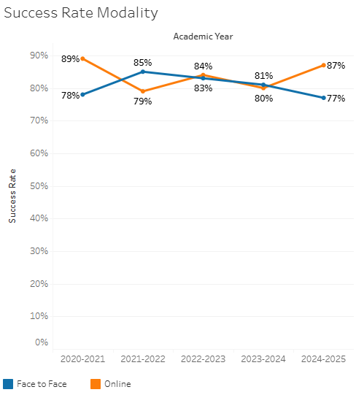

Both online and face to face sections maintain high success rates, with online occasionally exceeding face to face success rates

**Course Success Rates: Equity Gaps by modality**

|  |  |  |  |  |  |  |
| --- | --- | --- | --- | --- | --- | --- |
| **Student Sub-Population** | **Overall** | **Online Courses (ASYNC)** | **Face-to-Face Courses** | **Hybrid Courses** | **Synchronous Courses (SYNC)** | **Year of Equity Gap** |
| White Non-Hispanic Male |  | -27.1% |  |  |  | 2020-21 |
| Latina Female |  |  | -9.9% |  |  | 2024-25 |