**Communication Studies**

**Comprehensive Program Review Questionnaire Data & Sources 2025-26**

**6: Enrollment Trends and Changes**

**Trends, significant changes, and any disproportionate enrollment impacts in course offerings**

Please consult the *Course Enrollment Report* posted for your discipline on the [PRIE website](https://canadacollege.edu/prie/data-dashboards.php).

**Any disproportionate enrollments of student subpopulations indicated in PRIE data**

|  |  |  |
| --- | --- | --- |
| **Student Sub-Population** | **Overall Course Enrollment Equity Gaps** | **Year of Gap** |
| Female | -7.6% | 2023-24 |

Female students, enrollments were fewer for one year.

**Trends in headcount, FTES, and load**

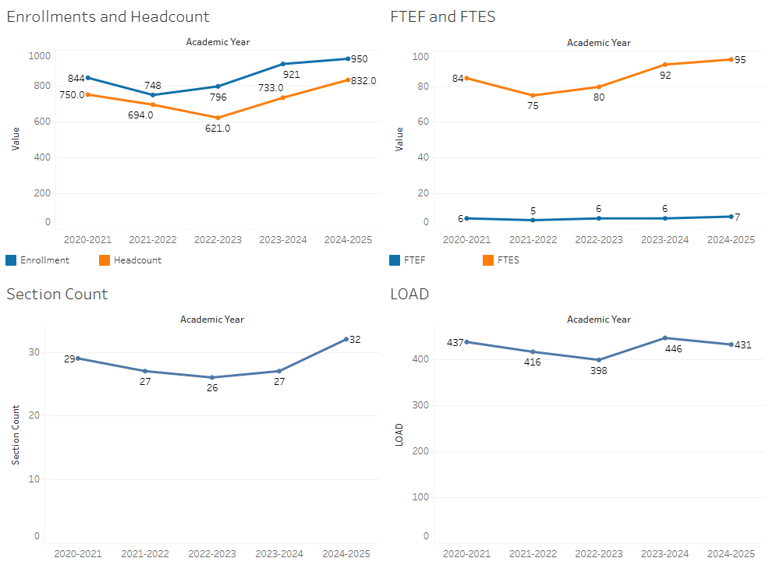

Enrollment in Communications has rebounded after dipping in 2022-2023. There was a dramatic increase in sections offered in 2024-2025 that met student demand, as the Load remained stable in this time period.

### 7A. Current Retention and Success Data

Describe the retention and student success rates in your courses and any disproportionate enrollment impacts using the data provided by PRIE.

**Overall Success and Withdraw Rates (retention rates are the inverse of withdraw rates):**

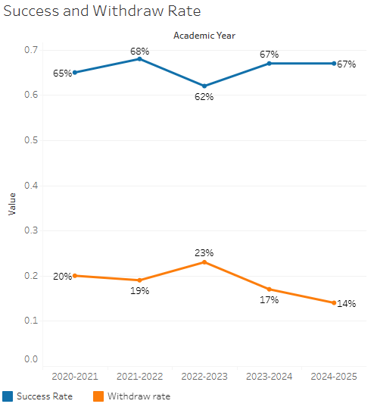

With the exception of 2022-2023, success rates remain stable and withdraw rates appear to be declining.

**Course Success Rates: Equity Gaps**

|  |  |  |
| --- | --- | --- |
| **Student Sub-Population** | **Overall Course Success Rates Equity Gaps** | **Year of Gap** |
| Pacific Islander | -47.8% | 2024-25 |
| -32.7% | 2023-24 |
| Black-Non-Hispanic-Female | -31.4% | 2020-21 |
| Hispanic- Female | -7.7% | 2022-23 |
| -7.9% | 2020-21 |
| Hispanic – Male | -8.3% | 2024-25 |
| -9.0% | 2022-23 |
| Pacific Islander-Female | -39.5% | 2023-24 |
| 40-49 (Age Group) | -14.1% | 2021-22 |
| First Generation | -5.6% | 2022-23 |
| -7.2% | 2021-22 |
| -5.2% | 2020-21 |
| Low Income | -7.3% | 2022-23 |
| Hybrid | -7.5% | 2023-24 |
| -8.1% | 2022-23 |
| Synchronous | -9.3% | 2020-21 |

**Course Retention Rates: Equity Gaps**

|  |  |  |
| --- | --- | --- |
| **Student Sub-Population** | **Overall Course Withdraw Rates Equity Gaps** | **Year of Gap** |
| 40-49 (Age Group) | 18.6% | 2024-25 |
| Disability | 13.9% | 2023-24 |
| Synchronous | 10.1% | 2020-21 |

Please check the [Equity & Disproportionate Impact Dashboard](https://canadacollege.edu/prie/dashboards/disproportionate-impact.php) on the PRIE website to look for equity gaps by specific course.

### 7B. Online Success

The college has a goal of improving success in online courses. Using the data provided by PRIE, what significant gaps do you see in success between different course modalities: asynchronous, synchronous, hybrid, and face-to-face courses? Analyze any disproportionate online course retention and success rates by modality.

Please consult the *Course Enrollment Report* posted for your discipline on the [PRIE website](https://canadacollege.edu/prie/data-dashboards.php) to review student success at the course level. For the discipline as a whole, the course success rates by modality are:

**Course Success Rates: Equity Gaps by modality**

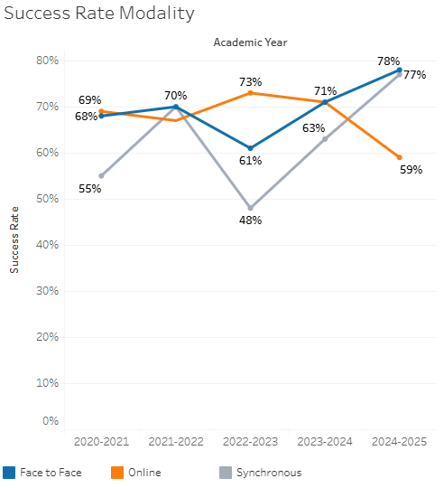

Online instruction showed generally good success rates until 2024-2025. Success rates in face to face courses were relatively stable, with the exception of 2022-2023.

As all of the program’s courses were offered in a face-to-face modality in 2024-25, the equity gap identified here is the same as that identified in the overall success rate calculation.

|  |  |  |  |  |  |  |
| --- | --- | --- | --- | --- | --- | --- |
| **Student Sub-Population** | **Overall** | **Online Courses (ASYNC)** | **Face-to-Face Courses** | **Hybrid Courses** | **Synchronous Courses (SYNC)** | **Year of Equity Gap** |
| Pacific Islander |  |  | -48.1% |  |  | 2024-25 |
| Hispanic Male |  |  | -9.0% |  |  | 2024-25 |
| Hispanic |  | -8.6% |  |  |  | 2022-23 |
| Filipino-Female |  | -31.4% |  |  |  | 2021-22 |
| Hispanic-Female |  | -10.9% |  |  |  | 2020-21 |
| First Generation |  | -8.8% |  |  |  | 2021-22 |
| Low Income |  | -10.9% |  |  |  | 2021-22 |