**Ethnic Studies**

**Comprehensive Program Review Questionnaire Data & Sources 2025-26**

**6: Enrollment Trends and Changes**

**Trends, significant changes, and any disproportionate enrollment impacts in course offerings**

Please consult the *Course Enrollment Report* posted for your discipline on the [PRIE website](https://canadacollege.edu/prie/data-dashboards.php).

**Any disproportionate enrollments of student subpopulations indicated in PRIE data**

There are no enrollment gaps in Ethnic Studies.

**Trends in headcount, FTES, and load**

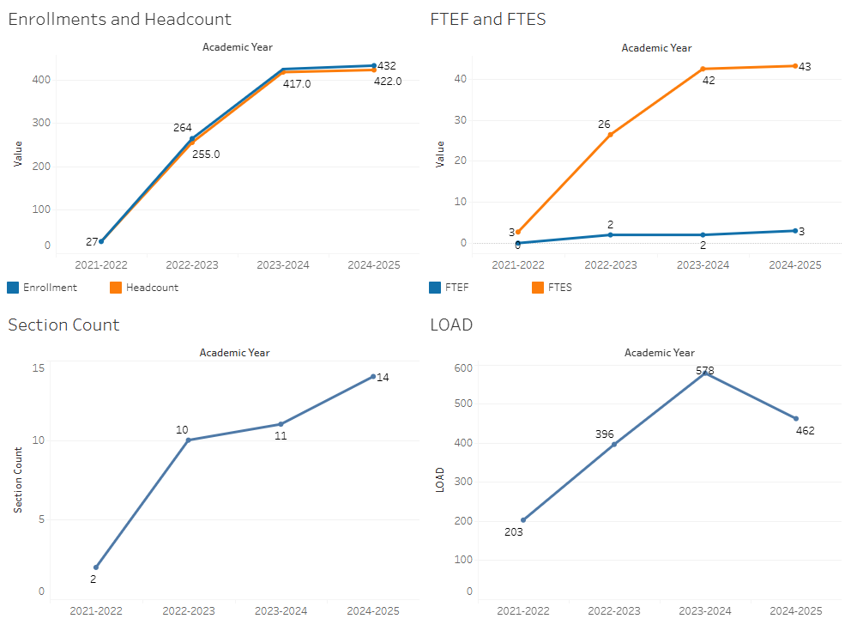

After initial growth years, enrollments appear to be stabilizing. Right sizing the number of sections offered will continue to be important, as demand is determined.

### 7A. Current Retention and Success Data

Describe the retention and student success rates in your courses and any disproportionate enrollment impacts using the data provided by PRIE.

**Overall Success and Withdraw Rates (retention rates are the inverse of withdraw rates):**

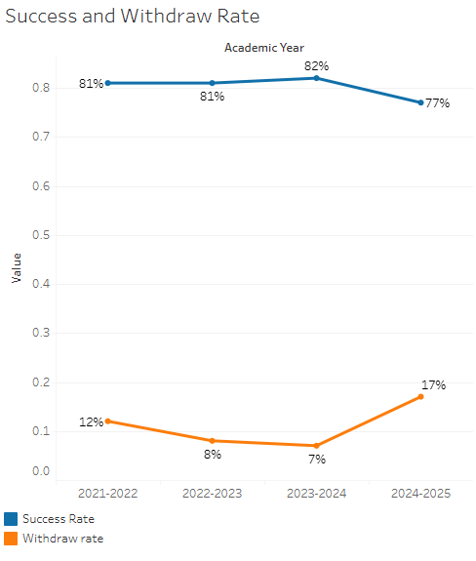

Success rates remain stable, though there was a dramatic uptick in withdrawals in 2024-2025.

**Course Success Rates: Equity Gaps**

There are no success rate gaps in Ethnic Studies.

**Course Retention Rates: Equity Gaps**

There are no equity gaps in retentions rates in Ethnic Studies.

Please check the [Equity & Disproportionate Impact Dashboard](https://canadacollege.edu/prie/dashboards/disproportionate-impact.php) on the PRIE website to look for equity gaps by specific course.

### 7B. Online Success

The college has a goal of improving success in online courses. Using the data provided by PRIE, what significant gaps do you see in success between different course modalities: asynchronous, synchronous, hybrid, and face-to-face courses? Analyze any disproportionate online course retention and success rates by modality.

Please consult the *Course Enrollment Report* posted for your discipline on the [PRIE website](https://canadacollege.edu/prie/data-dashboards.php) to review student success at the course level. For the discipline as a whole, the course success rates by modality are:

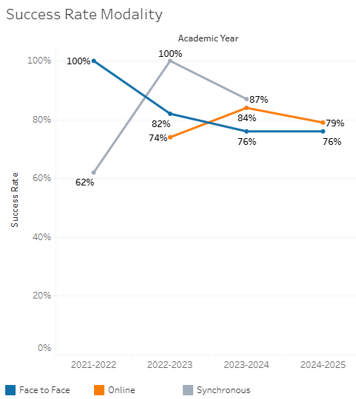

Success rates online and face to face have begun to stabilize at satisfactory levels.

**Course Success Rates: Equity Gaps by modality**

There are no equity gaps by modality in Ethnic Studies.