**Political Science**

**Comprehensive Program Review Questionnaire Data & Sources 2025-26**

**6: Enrollment Trends and Changes**

**Trends, significant changes, and any disproportionate enrollment impacts in course offerings**

Please consult the *Course Enrollment Report* posted for your discipline on the [PRIE website](https://canadacollege.edu/prie/data-dashboards.php).

**Any disproportionate enrollments of student subpopulations indicated in PRIE data**

|  |  |  |
| --- | --- | --- |
| **Student Sub-Population** | **Overall Course Enrollment Equity Gaps** | **Year of Gap** |
| Female | -6.8% | 2021-22 |
| -6.8% | 2020-21 |
| Low Income | -14.4% | 2024-25 |
| -16.9% | 2023-24 |
| -11.7% | 2022-23 |
| -11.4% | 2022-21 |
| -7.8% | 2020-21 |

Cañada defines less than part-time students as those taking 6 or fewer units. Political Science has seen disproportionately fewer enrollments from

**Trends in headcount, FTES, and load**

After a brief dip in 2022-2023, enrollment has rebounded and appears to be stabilizing. Additionally the number of sections appears to be close to right sized as the overall load is rebounding.

### 7A. Current Retention and Success Data

Describe the retention and student success rates in your courses and any disproportionate enrollment impacts using the data provided by PRIE.

**Overall Success and Withdraw Rates (retention rates are the inverse of withdraw rates):**

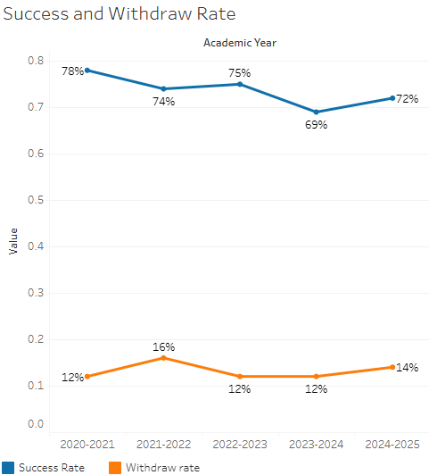

Overall success rates have slightly decreased over time, but the withdraw rate has remained stable.

**Course Success Rates: Equity Gaps**

|  |  |  |
| --- | --- | --- |
| **Student Sub-Population** | **Overall Course Success Rates Equity Gaps** | **Year of Gap** |
| Black Non-Hispanic | -22.0% | 2024-25 |
| White Non-Hispanic | -13.3% | 2021-22 |
| Black Non-Hispanic Male | -28.4% | 2024-25 |
| White Non-Hispanic Male | -11.9% | 2021-22 |
| 29-39 Age Group | -18.5% | 2023-24 |
| -18.0% | 2022-23 |
| -16.8% | 2021-22 |
| 40-49 Age Group | -37.9% | 2021-22 |
| First Generation | -6.2% | 2021-22 |
| Veteran | -30.1% | 2022-23 |
| Foster Youth | -65.0% | 2023-24 |
| Low Income | -10.6% | 2023-24 |
| -14.9% | 2021-22 |
| Face-to-Face | -12.3% | 2024-25 |
| -20.2% | 2023-24 |
| -12.0% | 2020-21 |

**Course Retention Rates: Equity Gaps**

|  |  |  |
| --- | --- | --- |
| **Student Sub-Population** | **Overall Course Withdraw Rates Equity Gaps** | **Year of Gap** |
| White Non-Hispanic | 16.2% | 2021-22 |
| White Non-Hispanic Female | 16.3% | 2021-22 |
| White Non-Hispanic Male | 16.2% | 2021-22 |
| 29-39 Age Group | 16.2% | 2021-22 |
| 40-49 Age Group | 39.5% | 2021-22 |
| First Generation | 6.3% | 2021-22 |
| Low Income | 10.0.% | 2021-22 |
| Face to Face | 14.3% | 2023-24 |

Please check the [Equity & Disproportionate Impact Dashboard](https://canadacollege.edu/prie/dashboards/disproportionate-impact.php) on the PRIE website to look for equity gaps by specific course.

### 7B. Online Success

The college has a goal of improving success in online courses. Using the data provided by PRIE, what significant gaps do you see in success between different course modalities: asynchronous, synchronous, hybrid, and face-to-face courses? Analyze any disproportionate online course retention and success rates by modality.

Please consult the *Course Enrollment Report* posted for your discipline on the [PRIE website](https://canadacollege.edu/prie/data-dashboards.php) to review student success at the course level. For the discipline as a whole, the course success rates by modality are:

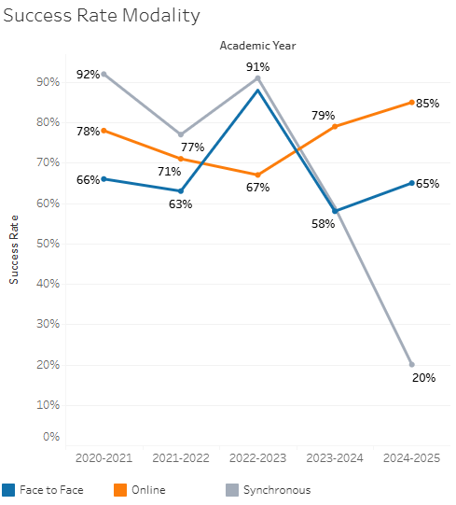

Online success rates have been good, but face to face success rates have been more erratic, often below the college average.

**Course Success Rates: Equity Gaps by modality**

|  |  |  |  |  |  |  |
| --- | --- | --- | --- | --- | --- | --- |
| **Student Sub-Population** | **Overall** | **Online Courses (ASYNC)** | **Face-to-Face Courses** | **Hybrid Courses** | **Synchronous Courses (SYNC)** | **Year of Equity Gap** |
| Black Non-Hispanic |  |  | -22.0% |  |  | 2024-25 |
| Black Non-Hispanic Male |  |  | -28.4% |  |  | 2024-25 |
| Unknown Race/Eth |  | -31.5% |  |  |  | 2023-24 |
| White Non-Hispanic |  | -15.2% |  |  |  | 2021-22 |
| White Non-Hispanic Female |  | -21.7% |  |  |  | 2021-22 |
| 29-39 (Age Group) |  | -20.6% |  |  |  | 2022-23 |
|  | -18.4% |  |  |  | 2021-22 |
| 40-49 (Age Group) |  | -39.2% |  |  |  | 2021-22 |
| Veteran |  | -34.2% |  |  |  | 2022-23 |
| Low Income |  | -15.8% |  |  |  | 2021-22 |