**Psychology**

**Comprehensive Program Review Questionnaire Data & Sources 2025-26**

**6: Enrollment Trends and Changes**

**Trends, significant changes, and any disproportionate enrollment impacts in course offerings**

Please consult the *Course Enrollment Report* posted for your discipline on the [PRIE website](https://canadacollege.edu/prie/data-dashboards.php).

**Any disproportionate enrollments of student subpopulations indicated in PRIE data**

|  |  |  |
| --- | --- | --- |
| **Student Sub-Population** | **Overall Course Enrollment Equity Gaps** | **Year of Gap** |
| Male | -8.0% | 2024-25 |
| -8.7% | 2023-24 |
| -9.6% | 2022-23 |
| -7.2% | 2021-22 |
| -11.2% | 2020-21 |

There are persistent gaps in Male student enrollment in Psychology.

**Trends in headcount, FTES, and load**

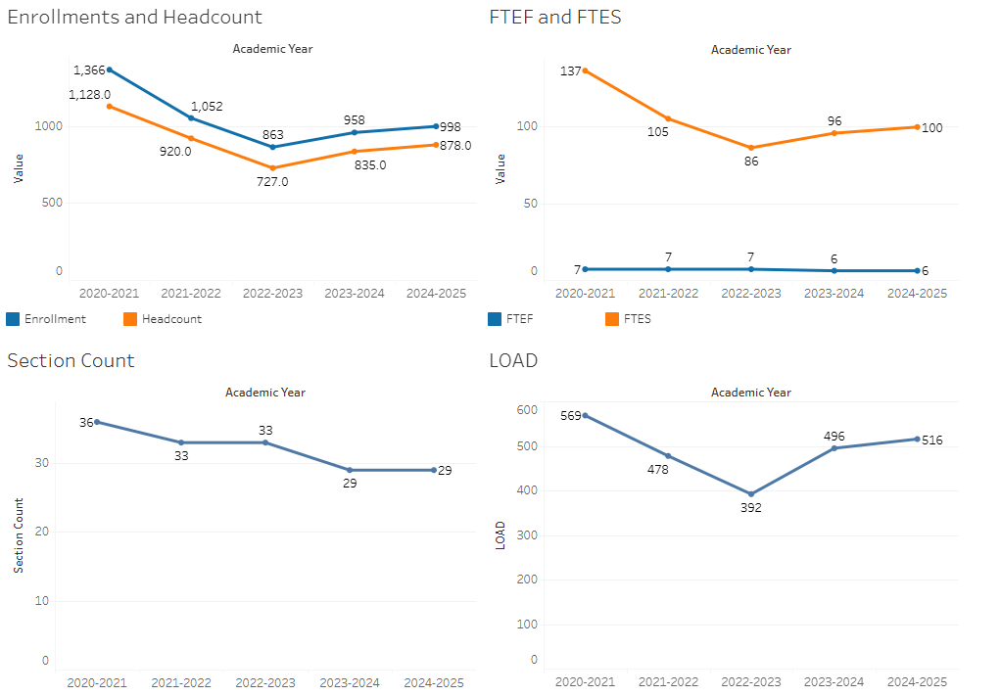

Psychology saw declines until 2022-2023, but rebounded and stabilized in recent years. The number of sections offered appears to be meeting student demand.

### 7A. Current Retention and Success Data

Describe the retention and student success rates in your courses and any disproportionate enrollment impacts using the data provided by PRIE.

**Overall Success and Withdraw Rates (retention rates are the inverse of withdraw rates):**

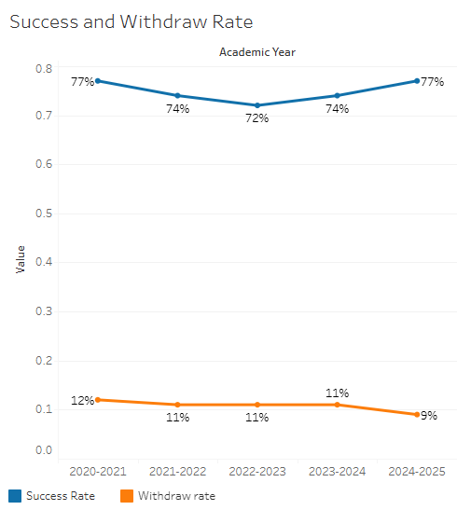

Success rates have remained generally stable. Withdraw rates have seen a slight decline in this time period.

**Course Success Rates: Equity Gaps**

|  |  |  |
| --- | --- | --- |
| **Student Sub-Population** | **Overall Course Success Rates Equity Gaps** | **Year of Gap** |
| Black Non-Hispanic | -19.4% | 2021-22 |
| -18.1% | 2020-21 |
| Hispanic | -5.0% | 2024-25 |
| -7.2% | 2023-24 |
| 6.1% | 2022-23 |
| 8.3% | 2021-22 |
| 5.1% | 2020-21 |
| Black Non-Hispanic Female | -24.5% | 2021-22 |
| -21.6% | 2020-21 |
| Hispanic-Female | -5.5% | 2024-25 |
| -7.3% | 2023-24 |
| -6.0% | 2022-23 |
| -9.2% | 2021-22 |
| -5.4% | 2020-21 |
| 23-28 Age Group | -7.7% | 2023-24 |
| Disability | -10.9% | 2020-21 |
| First Generation | -7.5% | 2023-24 |
| 9.3% | 2021-22 |
| Foster Youth | -35.1% | 2023-24 |
| Low Income | -9.1% | 2023-24 |
| Synchronous | -13.1% | 2024-25 |

**Course Retention Rates: Equity Gaps**

There are no equity gaps in retentions rates in Psychology.

Please check the [Equity & Disproportionate Impact Dashboard](https://canadacollege.edu/prie/dashboards/disproportionate-impact.php) on the PRIE website to look for equity gaps by specific course.

### 7B. Online Success

The college has a goal of improving success in online courses. Using the data provided by PRIE, what significant gaps do you see in success between different course modalities: asynchronous, synchronous, hybrid, and face-to-face courses? Analyze any disproportionate online course retention and success rates by modality.

Please consult the *Course Enrollment Report* posted for your discipline on the [PRIE website](https://canadacollege.edu/prie/data-dashboards.php) to review student success at the course level. For the discipline as a whole, the course success rates by modality are:

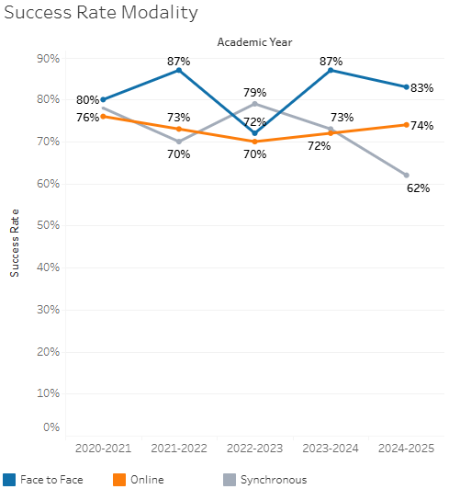

Online success rates generally have fallen below face to face success rates, though the remain close to the collegewide average.

**Course Success Rates: Equity Gaps by modality**

|  |  |  |  |  |  |  |
| --- | --- | --- | --- | --- | --- | --- |
| **Student Sub-Population** | **Overall** | **Online Courses (ASYNC)** | **Face-to-Face Courses** | **Hybrid Courses** | **Synchronous Courses (SYNC)** | **Year of Equity Gap** |
| Hispanic |  |  | -5.0% |  |  | 2024-25 |
| Hispanic Female |  |  | -5.5% |  |  | 2024-25 |
| 23-28 Age Group |  |  | -12.4% |  |  | 2023-24 |
| Disability |  |  |  | -28.5% |  | 2020-21 |
| First Generation |  |  |  | -11.9% |  | 2023-24 |
| Black Non-Hispanic |  | -27.5% |  |  |  | 2021-22 |
|  | -29.3% |  |  |  | 2020-21 |
| Hispanic |  | -8.3% |  |  |  | 2021-22 |
| Black Non-Hispanic Female |  | -31.7% |  |  |  | 2021-22 |
|  | -33.2% |  |  |  | 2020-21 |
| Filipino- Female |  | -28.1% |  |  |  | 2022-23 |
| Hispanic-Female |  | -8.3% |  |  |  | 2022-23 |
|  | -9.6% |  |  |  | 2021-22 |
|  | -7.9% |  |  |  | 2020-21 |
| Disability |  | -24.5% |  |  |  | 2021-22 |
| First Generation |  | -9.0% |  |  |  | 2021-22 |
| Low Income |  | -15.1% |  |  |  | 2023-24 |
|  | -11.0% |  |  |  | 2021-22 |
| Hispanic |  |  |  |  | -10.5% | 2020-21 |
| First Generation |  |  |  |  | -8.4% | 2021-22 |