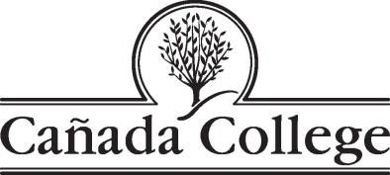
PBC Strategic Enrollment Management Committee
MEETING MINUTES
Wednesday, September 25, 2019
Building 8 - Room 110
9:00 – 10:00 a.m.

Agenda Item | Discussion Lead
Agenda Overview | Robinson and Engel
Follow up items: | PRIE – skipped so more time could be reserved for presentations and discussion
ESL and ACCEL  - History of the ESL Department  - How is Cañada program unique (community partnerships)  - How Dept. is different from SKY and CSM  - Who are our ESL students? (off campus ESL and on-campus (level) ESL students)  - Number of students (by level)  - Educational Goals  - Descriptive statistics  - Enrollment patterns  - Areas for growth in ESL  - Role of ACCEL (what is ACCEL)  - Role of ESL and ACCEL Retention Specialists  - Opportunities: partnership with Sequoia Adult School (supporting Cañada instructors) | Alicia Aguirre, ESL Coordinator  Janet Ramirez, Transition Coordinator, ACCEL  Diana Espinoza, ESL Retention Specialist  See slides presented.  ESL  Program has seen some decline in enrollment. The number of courses and sections offered is far fewer than in 2016, as are the number of locations – now 3 in Redwood City and 2 in Menlo Park.  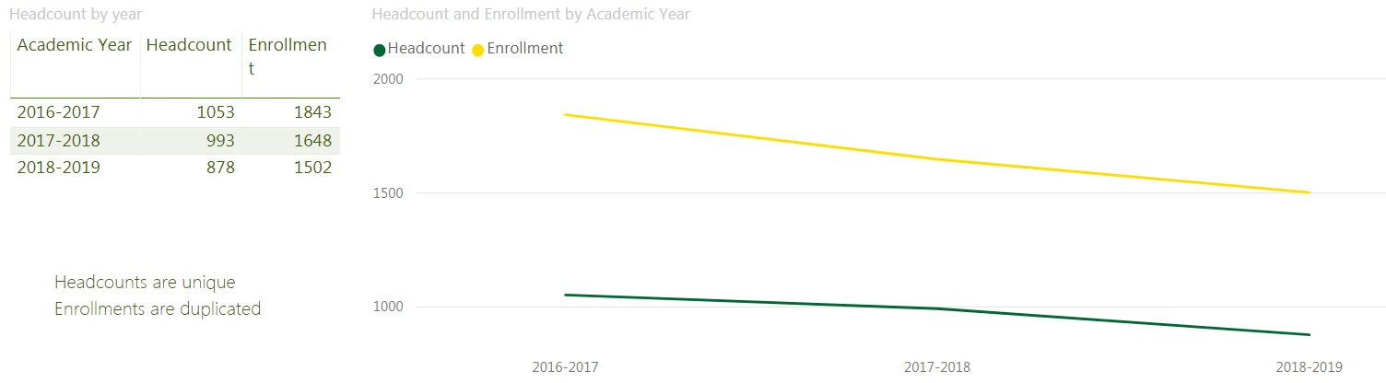  Request of presenters: more help with recruitment and outreach.  Opportunities:  - Collaborate with other disciplines to align schedule and class offerings  - Math  - CBOT  - Human Development (ECE)  - STEM  - Fashion Design  - Library  - Create Academic support workshops for ESL students  - Writing and Grammar  - Technology  - College and Career Readiness  - Time management  - Study Skills  - Offer ESL JAMS every semester day and evening  - Bring back ESL SLAMmers!  ACCEL program (for Adult education students): serves about 88 students:  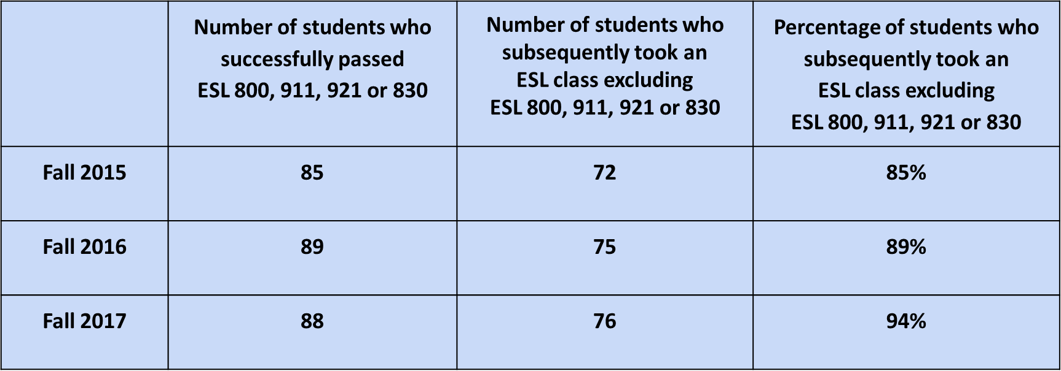
Menlo Park | Julian Branch, Workforce Director  Menlo Park:  - The Menlo Park facility and courses are funded by a grant from the City of Menlo Park that goes through the year 2031.  - Menlo Park is currently open M-F 7 a.m. to 9 p.m. and is closed on Saturday and Sunday  - At one point, the college had a full time ESL instructor teaching 100% at Menlo Park.  - Now there are much more limited offerings and fewer sections  Julian Branch proposed:  - Increasing the number of courses offered at Menlo Park in 3 categories:  - ESL  - General Education  - Workforce development (short term certificates for working adults)  - Needs more analysis: which courses would we offer there and why?  - Are there course pairs we could offer?  - Zip code analysis of courses taken by students who are residents in nearby zip codes needs to be broken out by mode of instruction (what are they taking online?)  - In terms of the workforce development certificate, Jonathan Bissel’s area is piloting them. If they seem to work, the programs can go through the process of getting academic approval.  - Do we also want a Redwood City location? Again, what would we offer there and how would it be staffed?  - Start an Opthalmic Dispensing program through the Business Department? We used to have one in Menlo Park and it was very successful (Jeanne: It was discontinued when the faculty member retired….)
Aligning and Scaling Outreach | Arellano, Pérez - skipped
ADJOURN

