Art & Art History
Comprehensive Program Review Data Packet

7A. Enrollment Trends
Use the data provided by PRIE to examine your enrollments by department or courses. Describe trends in headcount, FTES, and load. If applicable, describe any other enrollment data that is relevant to your program
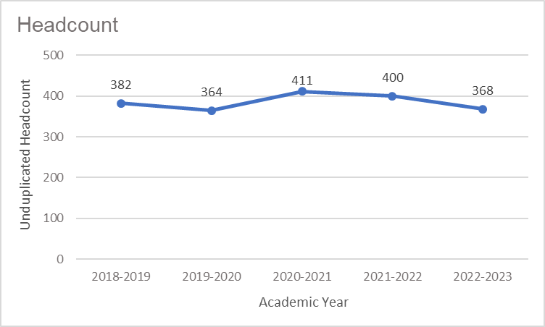
Headcount in Art and Art History was down 3.7% in 2022-2023 compared to 2018-2019 (368 vs. 382, respectively). Headcount peaked in 2020-2021 with 411 students, and dipped to a five-year low of 364 students in 2019-2020.

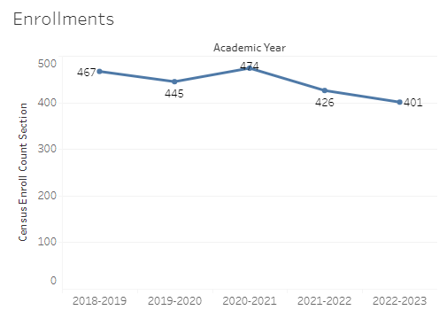
Enrollment in Art and Art History was down 14% in 2022-2023 compared to five years ago in 2018-2019 (401 vs. 467, respectively). Art enrollment reached a five-year high in 2020-2021 with 474 enrollments and a five-year low of 401 enrollments in 2022-2023.
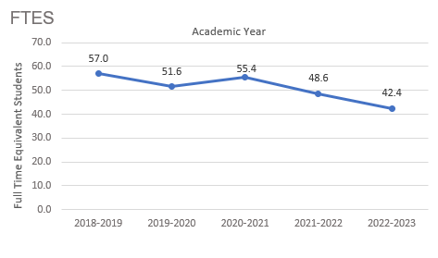
Full-time equivalent students (FTES) in Art was down 26% in the most recent academic year (2022-2023) compared to five years ago (2018-2019), a decrease of 14.6 FTES.

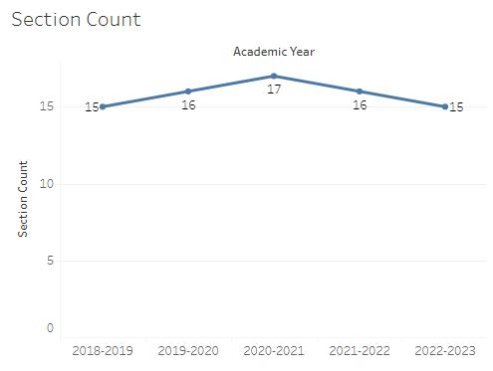
The number of sections offered in Art went from 15 in 2018-2019 to a five-year high of 17 sections in 2020-2021. By 2022-2023 the number of sections offered in Art was back to 15.

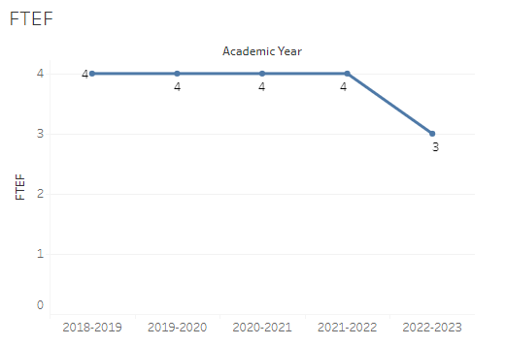
The number of full-time equivalent faculty (FTEF) in Art and Art History remained at 4 for four years, then decreased to 3 in 2022-2023.

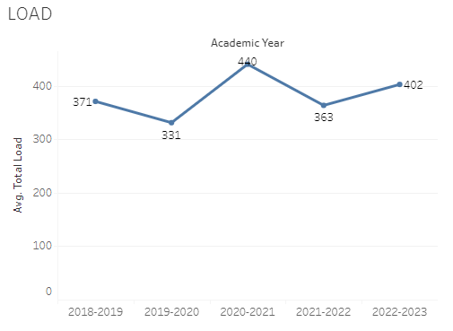
Load in Art fluctuated over the last five academic years with a low of 331 in 2019-2020 and a high of 440 in 2020-2021. The load for Art faculty was 402 in the most recent academic year (2022-2023).

8A. Access & Completion
Describe the student completion and success rate in your courses and/or program using the data provided by PRIE. Look at your course offerings, in the last program review cycle was it possible for a student to complete your certificates or degrees while only completing courses at Cañada College? How can the college help you improve student completion and success? What changes could be made?

Note: See the Course Enrollment & Success Detail Report for additional course-level data. This report can be found on PRIE’s Data Dashboards & Packets page under the program name.

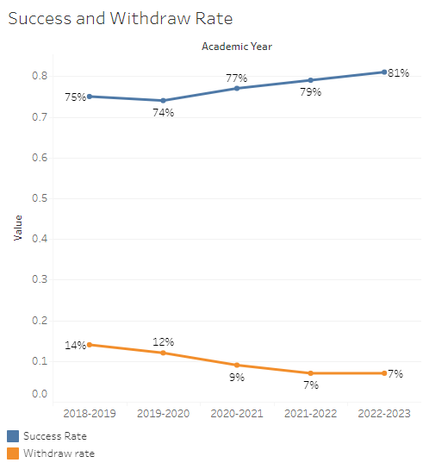
The overall success rate in Art and Art History increased from 75% in 2018-2019 to 81% in 2022-2023. Withdraw rates followed the inverse of success rates. Withdraw rates decreased over the last five years with 14% of Art enrollments resulting in a ‘W’ grade in 2018-2019 compared to 7% in 2022-2023.
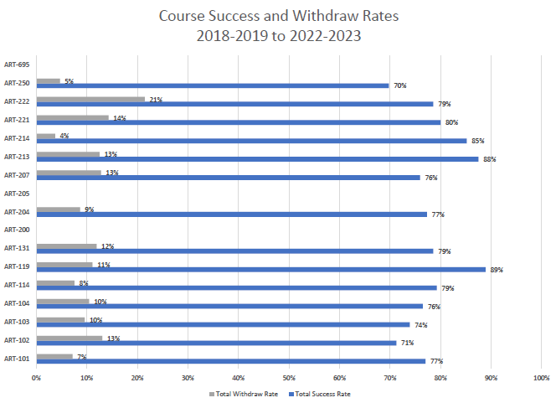
Course success rates ranged from a minimum of 70% in ART 250 to a maximum of 89% in ART 119. Withdraw rates for individual courses ranged from a max of 21% in ART 222 to a minimum of 4% in ART 214.

8B. Student Equity
One of the goals of the College’s Student Equity plan is to close the performance gaps for disproportionately impacted students. Use the data provided by PRIE that indicates which groups are experiencing a disproportionate impact in your program. Which gaps are most important for improving outcomes in your program? How can the college help you address these gaps? What changes could be made?

The Equity and Disproportionate Impact (DI) dashboard was used to identify subgroups that may have been disproportionately impacted in Art and Art History classes in the most recent academic year (2022-2023). The three metrics used to examine potential disproportionate impact were enrollment rates (referred as access), success rates, and withdraw rates. The rate for each subgroup was compared to either the college-wide rate (access) or the overall program-level rate (success and withdraws). The difference between the two rates is known as the ‘gap’ and may be referred to as a performance gap or equity gap. Student subgroups that may have been disproportionately impacted in Art appear below (see Table 1-3).
Access
Access is an indicator of what student subgroups are enrolling in courses, based on unique student counts. Enrollment data revealed two student subgroups were underrepresented in Art and Art History classes compared to the college-wide population (see Table 1). For instance, the proportion of students in Art with a unit load considered ‘less than part-time’ (fewer than 6 units) was 36.2 percentage points lower than the proportion of ‘less than part-time’ students enrolled college-wide.
Table 1.
Student Subgroup | Gap
Unit load - Less than part-time (less than 6 units) | -36.2
Not low income | -8.4

Success
Success is the rate at which different student subgroups pass courses and is based on enrollments. The success rate for different subgroups in Art was compared to the overall success rate in Art. The difference between the two rates (the gap) revealed three subgroups may have been disproportionately impacted (see Table 2). For example, the success rate for Hispanic males enrolled in hybrid sections was 29.7 percentage points lower than the overall success rate in Art during the 2022-2023 academic year.
Table 2.
Student Subgroup | Gap
Course modality Hybrid: Hispanic Males | -29.7
Course modality Hybrid: Males | -21.5
Veterans | -26.1

Withdraws
Withdraws is the rate at which a student withdraws from a course, with higher numbers being worse, as they indicate greater withdraw rates. The withdraw rates for subgroups in Art and Art History were compared to the overall withdraw rate for the program. There was no evidence of DI for withdraw rates in Art.

8C. Completion – Success Online
The college has a goal of improving success in online courses. Using the data provided by PRIE, what significant gaps do you see in success between online/hybrid and non-online courses? What changes could be made to reduce these gaps? If your program does not offer online/hybrid courses, please write “not applicable”.
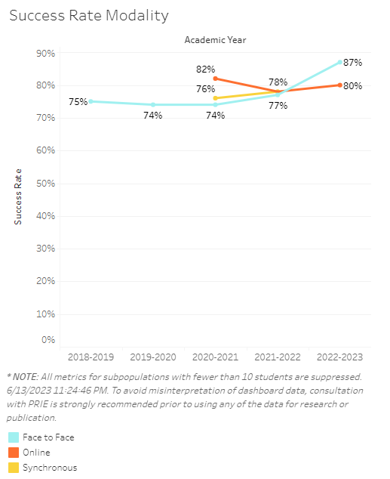
In 2020-2021, success rates for face-to-face sections in Art were eight percentage points lower than success rates for online Art sections (74% vs. 82%, respectively). Over the next two academic years success rates in face-to-face Art sections increased steadily and surpassed online/hybrid success rates by seven percentage points in 2022-2023 (87% vs. 80%, respectively).
The equity and disproportionate impact data presented in the previous section (see 8B. Student Equity) revealed male students and particularly Hispanic males enrolled in hybrid/online Art sections had success rates 21-30 percentage points lower than the overall success in hybrid/online Art sections.

Source: https://canadacollege.edu/prie/dashboards/disproportionate-impact.php

