Music
Comprehensive Program Review Data Packet
7A. Enrollment Trends
Use the data provided by PRIE to examine your enrollments by department or courses. Describe trends in headcount, FTES, and load. If applicable, describe any other enrollment data that is relevant to your program
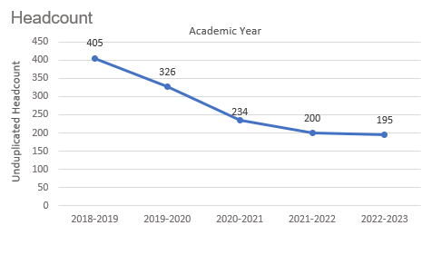
Headcount in Music was down 51.9% in 2022-2023 (195 students) compared to 2018-2019 (405 students). Headcount declined steadily for four academic years then started to flatten out in the most recent academic year.

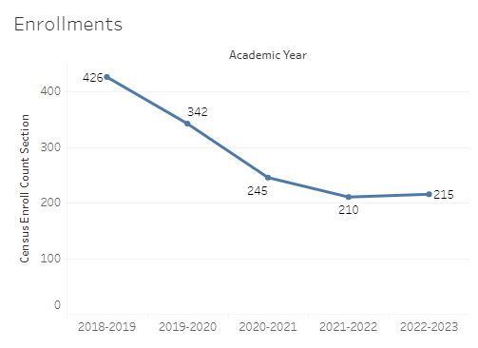
Enrollment in Music was down 49.5% in 2022-2023 compared to five years ago in 2018-2019. Music enrollment started with a high of 426 in 2018-2019 and ended with 215 enrollments in 2022-2023.

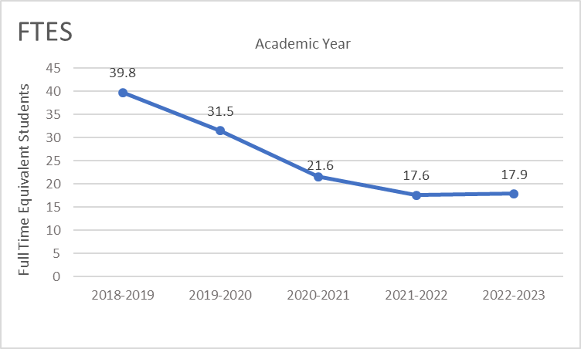
Full-time equivalent students (FTES) in Music was down 55% in the most recent academic year (2022-2023) compared to five years ago (2018-2019), a decrease of 21.9 FTES.

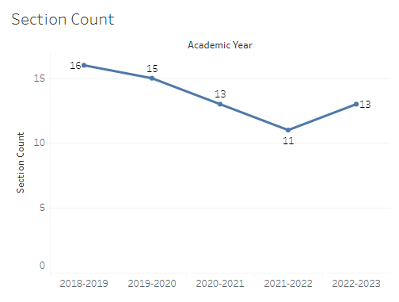
The number of sections offered in Music decreased yearly four academic years, followed by a slight increase in the most recent academic year. The section count went from a high of 16 sections in 2018-2019 to a low of 11 sections in 2021-2022, then up to 13 sections in 2022-2023.

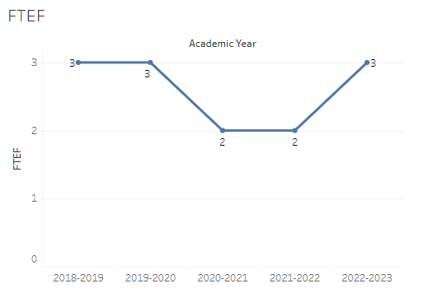
The number of full-time equivalent faculty (FTEF) in Music went from 3 in 2018-2019 and 2019-2020 down to 2 for two academic years, before returning to 3 FTEF in 2022-2023.

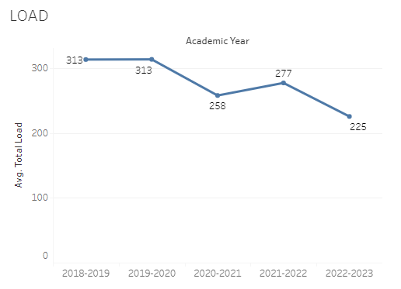
Load in Music fluctuated over the last five academic years with a high of 313 for two academic years (2018-2019 and 2019-2020) and a low of 225 in the most recent academic year (2022-2023).

8A. Access & Completion
Describe the student completion and success rate in your courses and/or program using the data provided by PRIE. Look at your course offerings, in the last program review cycle was it possible for a student to complete your certificates or degrees while only completing courses at Cañada College? How can the college help you improve student completion and success? What changes could be made?

Note: See the Course Enrollment & Success Detail Report for additional course-level data. This report can be found on PRIE’s Data Dashboards & Packets page under the program name.

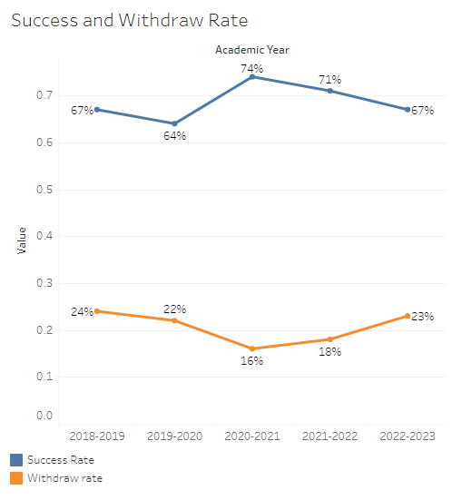
The overall success rate in Music ranged from a high of 74% in 2020-2021 to a low of 64% in 2019-2020. The success rate in Music for the most recent academic year was 67%. Withdraw rates in Music started at 24% in 2018-2019 then dropped over the next two years to a low of 16% before increasing to 23% in the most recent academic year (2022-2023).
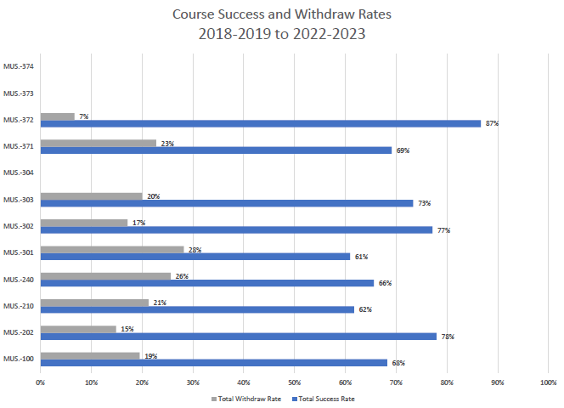
Course success rates in Music ranged from a minimum of 61% in MUS 301 to a maximum of 87% in MUS 372. Withdraw rates in Music ranged from a max of 28% in MUS 301 to a minimum of 7% in MUS 372.

8B. Student Equity
One of the goals of the College’s Student Equity plan is to close the performance gaps for disproportionately impacted students. Use the data provided by PRIE that indicates which groups are experiencing a disproportionate impact in your program. Which gaps are most important for improving outcomes in your program? How can the college help you address these gaps? What changes could be made?

The Equity and Disproportionate Impact (DI) dashboard was used to identify subgroups that may have been disproportionately impacted in Music in the most recent academic year (2022-2023). The three metrics used to examine potential disproportionate impact were enrollment rates (referred as access), success rates, and withdraw rates. The rate for each subgroup was compared to either the college-wide rate (access) or the overall program-level rate (success and withdraws). The difference between the two rates is known as the ‘gap’ and may be referred to as a performance gap or equity gap. Student subgroups that may have been disproportionately impacted in Music appear below (see Table 1-3).
Access
Access is an indicator of what student subgroups are enrolling in courses, based on unique student counts. Enrollment data revealed four student subgroups were underrepresented in Music classes compared to the college-wide population (see Table 1). For instance, female students are underrepresented in Music. The proportion of female students in Music across all course modalities was 19.2 percentage points lower than the proportion of female students enrolled college-wide.

Table 1.
Student Subgroup | Gap
Unit Load: Less than Part-time (less than 6 units) | -30.3
Course Modality: Face-to-face - Females | -23.6
Course Modality: Online - Females | -16.5
Females | -19.2

Success
Success is the rate at which different student subgroups pass courses and is based on enrollments. The success rate for different subgroups in Music was compared to the overall success rate in Music. The difference between the two rates (the gap) revealed five subgroups may have been disproportionately impacted (see Table 2). For example, the success rate for Hispanic male students in Music was 22 percentage points lower than the overall success rate in Music during the 2022-2023 academic year.

Table 2.
Student Subgroup | Gap
Course Modality: Face-to-face - Hispanic Males | -27.1
Hispanic Males | -22.0
Course Modality: Face-to-face - Hispanic | -17.5
Low Income | -17.0
Hispanic | -16.2

Withdraws
Withdraws is the rate at which a student withdraws from a course, with higher numbers being worse, as they indicate greater withdraw rates. The withdraw rates for subgroups in Music was compared to the overall withdraw rate for the program. Five subgroups had withdraw rates that were significantly higher than the overall rate, suggesting these groups experienced disproportionate impact in Music. Hispanic students and particularly Hispanic males were disproportionately impacted in music during the 2022-2023 academic year. Hispanic students had withdraw rates 15.3 percentage points higher than the average withdraw rate for Music.
Table 3.
Student Subgroup | Gap
Course Modality: Face-to-face - Hispanic Males | +25.2
Course Modality: Face-to-face - Hispanic | +18.5
Hispanic Males | +19.3
Hispanic | +15.3
Low Income | +16.1

8C. Completion – Success Online
The college has a goal of improving success in online courses. Using the data provided by PRIE, what significant gaps do you see in success between online/hybrid and non-online courses? What changes could be made to reduce these gaps? If your program does not offer online/hybrid courses, please write “not applicable”.
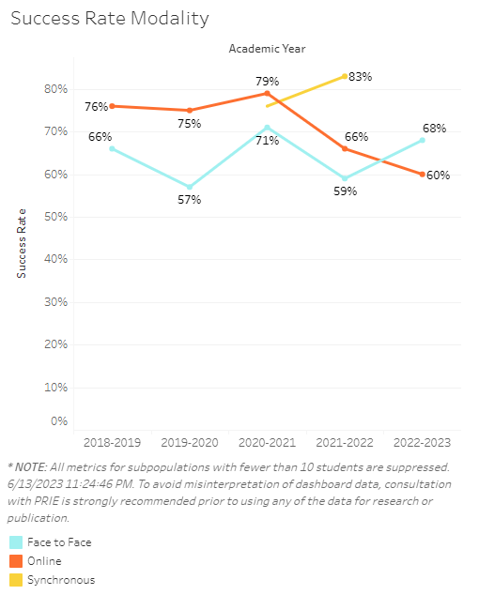
For four academic years success in online music classes was 8–18 percentage points higher than face-to-face music sections. Then in 2022-2023 online success rates dropped 8 percentage points below face-to-face success rates.

Source: https://canadacollege.edu/prie/dashboards/disproportionate-impact.php

