Theatre Arts
Comprehensive Program Review Data Packet
7A. Enrollment Trends
Use the data provided by PRIE to examine your enrollments by department or courses. Describe trends in headcount, FTES, and load. If applicable, describe any other enrollment data that is relevant to your program
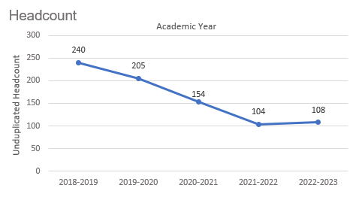
Headcount in Theatre Arts was down 55% in 2022-2023 (108 students) compared to 2018-2019 (240 students). Headcount declined steadily for four academic years then increased slightly in the most recent academic year.

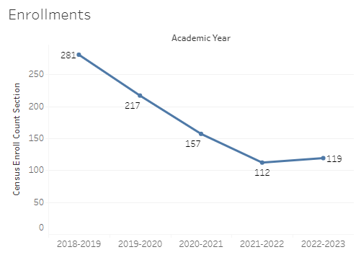
Enrollment in Theatre Arts was down 57.7% in 2022-2023 compared to five years ago in 2018-2019. The enrollment count started at 281 in 2018-2019 (a five-year high) and dipped to a low of 112 in 2021-2022, before it ended at 119 in the most recent academic year.

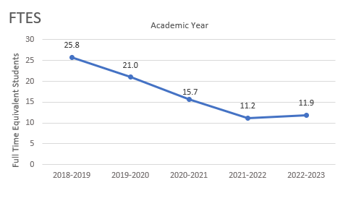
The number of full-time equivalent students (FTES) in Theatre Arts was down 53.9% in the most recent academic year (2022-2023) compared to five years ago (2018-2019), a decrease of 13.9 FTES.

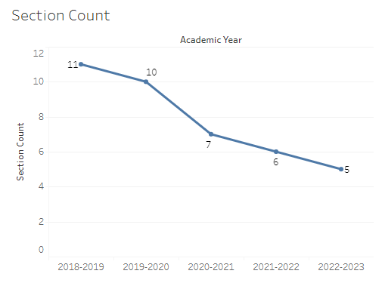
The section counts for Theatre Arts decreased steadily for five academic years, starting at 11 sections in 2018-2019 and ending with 5 sections in 2022-2023.

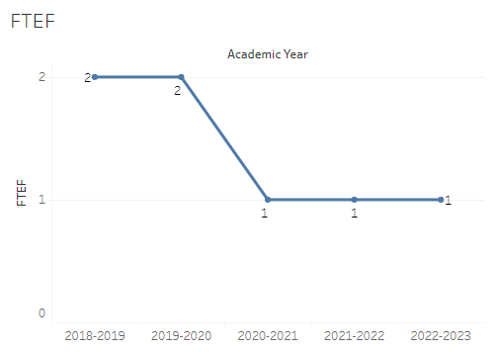
The number of full-time equivalent faculty (FTEF) in Theatre Arts went from 2 in 2018-2019 and 2019-2020 to 1 FTEF for the next three academic years.

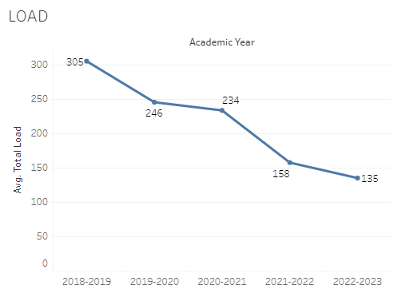
Load in Theatre Arts dropped steadily over the last five academic years with a high of 305 in 2018-2019 and a low of 135 in 2022-2023.

8A. Access & Completion
Describe the student completion and success rate in your courses and/or program using the data provided by PRIE. Look at your course offerings, in the last program review cycle was it possible for a student to complete your certificates or degrees while only completing courses at Cañada College? How can the college help you improve student completion and success? What changes could be made?

Note: See the Course Enrollment & Success Detail Report for additional course-level data. This report can be found on PRIE’s Data Dashboards & Packets page under the program name.

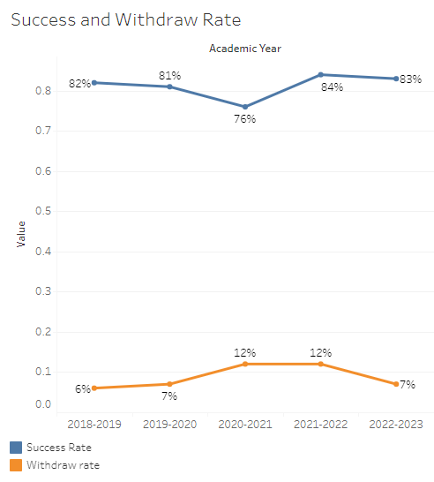
Overall success rates in Theatre Arts were fairly stable for four academic years, hovering between 81-84%. The success rate in Theatre Arts dipped to a five-year low of 76% in 2020-2021. Overall withdraw rates started at 6-7% for two academic years then spiked to 12% for two years before returning to 7% in the most recent academic year.
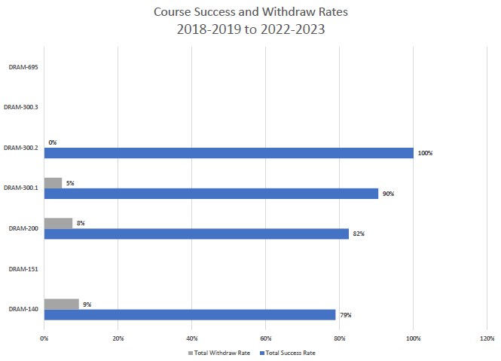
Course success rates in Theatre Arts ranged from a minimum of 79% in DRAM 140 to a maximum of 100% in DRAM 300.2. Withdraw rates in Theatre Arts ranged from a max of 9% in DRAM 140 to a minimum of 5% in DRAM 300.1 (DRAM 300.2 was excluded as all students successfully completed the course).

8B. Student Equity
One of the goals of the College’s Student Equity plan is to close the performance gaps for disproportionately impacted students. Use the data provided by PRIE that indicates which groups are experiencing a disproportionate impact in your program. Which gaps are most important for improving outcomes in your program? How can the college help you address these gaps? What changes could be made?

The Equity and Disproportionate Impact (DI) dashboard was used to identify subgroups that may have been disproportionately impacted in Theatre Arts in the most recent academic year (2022-2023). The three metrics used to examine potential disproportionate impact were enrollment rates (referred as access), success rates, and withdraw rates. The rate for each subgroup was compared to either the college-wide rate (access) or the overall program-level rate (success and withdraws). The difference between the two rates is known as the ‘gap’ and may be referred to as a performance gap or equity gap. Student subgroups that may have been disproportionately impacted in Theatre Arts appear below (see Table 1-3).
Access
Access is an indicator of what student subgroups are enrolling in courses, based on unique student counts. Enrollment data revealed one student subgroup was underrepresented in Theatre Arts classes compared to the college-wide population (see Table 1). The proportion of students in Theatre Arts with a unit load considered ‘less than part-time’ (fewer than 6 units) was 42.8 percentage points lower than the proportion of ‘less than part-time’ students enrolled college-wide.
Table 1.
Student Subgroup | Gap
Unit Load - Less than part-time (less than 6 units) | -42.8

Success
Success is the rate at which different student subgroups pass courses and is based on enrollments. The success rate for different subgroups in Theatre Arts was compared to the overall success rate in Theatre Arts. The difference between the two rates (the gap) revealed one subgroup may have been disproportionately impacted (see Table 2). The success rate for students age 23 – 28 was 30.3 percentage points lower than the overall success rate in Theatre Arts during the 2022-2023 academic year.
Table 2.
Student Subgroup | Gap
Age 23-28 | -30.3

Withdraws
Withdraws is the rate at which a student withdraws from a course, with higher numbers being worse, as they indicate greater withdraw rates. The withdraw rates for subgroups in Theatre Arts was compared to the overall withdraw rate for the program. No disproportionate impact was found for withdraws in Theatre Arts.

8C. Completion – Success Online
The college has a goal of improving success in online courses. Using the data provided by PRIE, what significant gaps do you see in success between online/hybrid and non-online courses? What changes could be made to reduce these gaps? If your program does not offer online/hybrid courses, please write “not applicable”.
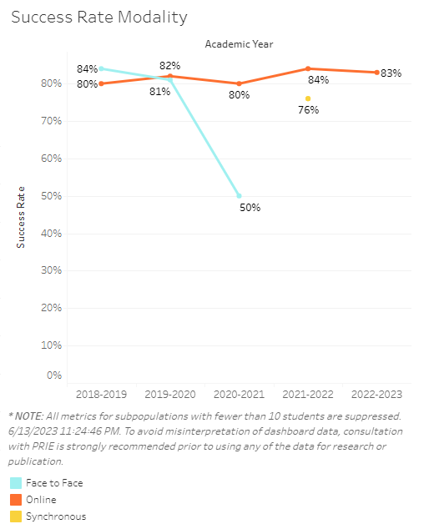
Success rates for online Theatre Arts sections were at or above the success rates for face-to-face sections during the last five academic years.

Source: https://canadacollege.edu/prie/dashboards/disproportionate-impact.php

