ADMINISTRATIVE PROCEDURES
San Mateo County Community College District

Subject: International Travel and Conference Expense Procedures
Revision Date: 07/2014
This administrative procedure document is an integral part of the District’s Rules and Regulation section
8.55 and is subject to change when laws and regulations in the areas of conference attendance, travel and meals expenses change.

- Purpose and Scope
Employees traveling on international business trips authorized by the colleges or the District must follow these procedures.

- Transportation
Economy class or any discounted class airfare shall be used for all reservations. Upgrading to more expensive class is allowed but only at employee’s expense. Any special accommodations require pre-approval by the supervisor in order to be reimbursed by the District. In all cases, the decision to pay a higher fare must take into consideration the best interest of the College/District.
A copy of the reservation should be provided along with the Conference Expense Reimbursement form.
All travel reservations should be made using a procurement card whenever possible.
If a trip is canceled, every effort must be made to recover the credit. The following situations describe the factors to consider when reimbursing for cancellations:
A. When the cancellation of the trip was within the traveler’s control and:
i. No credit is issued – the traveler must reimburse the District for the cost of the ticket.
ii. A credit is issued – the credit must be used for SMCCCD business travel or the traveler must reimburse the District.
B. When the cancellation of the trip was outside of the traveler’s control and:
i. No credit is issued – the District will cover the cost of the ticket.
ii. A credit is issued – the credit must be used for SMCCCD business travel or the traveler can “buy” the credit from the District for personal use. If the credit can’t be used, the District will absorb the cost of the ticket.
If expenses are incurred due to employee’s negligence when making travel reservations they should be reimbursed to the District promptly.
Any travel vouchers/credits earned due to changes in reservations remain the property of the District and should be used for future business flights within the same fiscal year whenever possible.

- Lodging, Meals and Incidental Expenses: Per Diem
In order to provide simplicity in recordkeeping and to promote uniformity in the reimbursements across the world, the District will use a Per Diem rate that covers lodging, meals and incidental expenses. District employees may be reimbursed for expenses on a Per Diem basis up to the maximum full daily rate established by the U.S. Department of State for foreign travel.
Prior to the trip, the District employee will be given an advance equivalent to the per-diem amount multiplied by the number of business travel nights for both lodging and meal/incidental expenses.
Note: Because the District is providing a per diem amount in advance, District employees should not use a procurement card for these expenses. If a procurement card is accidentally used for expenses covered by the per diem amount, the employee should reimburse the District for the actual expenses posted on the procurement card.

Any extra days prior or after the conference should be at the employee’s personal expense.

Charges for failure to cancel hotel reservations in a timely manner or for double bookings should not be reimbursed, or if paid on a procurement card should be reimbursed to the District promptly.

- Meals
Meals must be incurred during business travel and based on allowable per diem rates which include:
- Basic cost of meal (breakfast, lunch and dinner) – excludes alcohol consumption
- Sales tax
- Reasonable customary tip/gratuity( a reasonable 10%-15% tip is allowed on total food costs)

- Business-related meals
Meals with existing or potential external business partners are considered business-related meals and a procurement card could be used to cover them. If the procurement card is used for business-related meals, the employee’s reimbursement will be adjusted by the per-diem portion of that meal. A detailed receipt including the names of the participants and the purpose of the meeting is required in order to be qualified as a District covered expenses.
When dining with another District employee or agent who receives reimbursement for his/her expenses, if one of the employees covers the cost of the other, the employee who did not pay will have his/her reimbursement adjusted by the per diem portion of that meal.
- Incidentals
Below are examples of items considered to be incidental expenses – these are not considered miscellaneous expenses and should not be charged on Pro-card:
Fees and tips given to baggage carriers, bellhops, hotel maids, stewards | Tips (for personal services received)
Late Check-Out Fees | Foreign transaction fees (credit cards)
 | Telephone Calls (other than official business)

For business trips of over 10 business days, an up to 300.00 reimbursement for laundry, dry cleaning, pressing expenses is allowed and has to be substantiated by actual receipts.
(Guidelines for incidentals adapted from GSA/Federal Travel Regulations – Publications 300 & 301 http://www.gsa.gov/portal/category/21222 and http://www.irs.gov/pub/irs-regs/perdiemfaq%26a.prn.pdf )
Per-diem Rates
- As published by the U.S. Department of State
  - FTR Appendix B (Breakdown of Meals/Incidentals)
- Use the “Other” category if the foreign location visited is not listed
- Meal breakdown is 15% for breakfast, 25% for lunch, 40% for dinner, and 20% for incidental expense of total daily Meal and Incidental Expense rate (M&IE)
Per-diem Reimbursement Guidelines
- Provide a detailed daily itinerary (see Appendix A) which notes the date(s), locations visited and the business purpose of the trip.
- Provide a detailed list of the Per Diem rates claimed (see Appendix B). Daily meal allowance(s) are allowable according to the following time guidelines:
Employee can claim per-diem depending on the flight times as followed:
Flight time starts…employee can claim | Breakfast | Lunch | Dinner
Before 12 noon | X | X | X
Between 12 noon and 6pm |  | X | X
After 6pm |  |  | X

Return flight time starts… employee can claim at departure city rate | Breakfast | Lunch | Dinner
Before 12 noon | X
Between 12 noon and 6pm | X | X
After 6pm | X | X | X
* If on-flight meals are provided, the meal portion of per-diem should not be claimed in lieu of the on-flight meals.
* Incidental per-diem should be adjusted accordingly depending on the flight times (i.e. returning flight before noon ½ of incidental per-diem should be allowed).
* For the departure day the employees will be allowed one meal at the domestic per-diem level to cover meal expenses that the employees may incur prior to boarding on the international flight. Similar, the employees will be allowed one meal at the domestic per-diem level to cover meal expenses that the employees may incur right after the flight arrives in the US. The portion of the domestic per-diem (breakfast – $10.00, lunch – $15.00, dinner – $30.00) will depend on the take-off/landing times of the airplanes.
When visiting more than one city in one day, use the per diem rate for the business location with overnight stay.
The daily per diem rate must be adjusted for the following situations:
Deductions for Meals Included in Registration Fees:
When a meal has been paid for as a part of a registration fee, a deduction must be made from the applicable per diem rate.
Deductions for Non-Business Days:
Any personal/non-business days should not be included. Weekends are allowable if the business spans Saturday and Sunday.
- Insurance for travelers

Employees - District employees eligible for benefits are routinely covered 24 hours a day, worldwide, against accidental death or dismemberment and other accidents and incidents while on an official business trip. District provided medical insurance covers international traveling, therefore check with Human Resources prior to purchasing additional medical travel insurance. If coverage is provide through the District medical insurance, purchase of any additional travel and medical insurance coverage is considered an out-of-pocket, unreimbursable expense. If a procurement card is used for these expenses, the employee should reimburse the District promptly.

Vehicles - when private vehicles/rental cars are used on District business, the employees are responsible for maintaining adequate liability insurance coverage.
Travelers using rental cars should include Supplemental Liability Insurance (SLI) and Loss Damage Waiver (LDW) when renting.

- Traveler Tips and Miscellaneous Expenses
- Receipts are not required if claiming meals and lodging per diem (no procurement cards should be used when requesting per-diem).
- Reimbursement of meals per diem is not allowable if an airline meal was provided.
- Room service should be avoided whenever possible due to the extra charges it incurs.
- Use the per diem rate for the first business location where you will spend the night for day of departure.
- Use the per diem rate for the last business location where you stayed overnight for day of return.
- No international per-diem should be claimed upon return to US.
- If the procurement card is used for business-related meals, the employee’s reimbursement will be adjusted by the per-diem portion of that meal. Submittal of an itemized receipt is required with the business purpose of the meeting and names of attendees noted on the receipt.
- If the District agent pays for the business meal with the District employee, the employee cannot request per diem reimbursement for these meals.
- The procurement cardholder is obligated to obtain a detailed receipt for all pro-card charges.
- Detailed receipts and proof of payment should be provided for all business related expenses in order to be reimbursed. An explanation/description of the expense should be included on all receipts. In case of missing receipts or proof of payment, detailed explanation should be provided and it is subject to District’s review for reimbursement approval. For example, a used pre-paid phone card is not considered sufficient proof of purchase and therefore is subject to District’s approval for payment.
- For any cash payments a detailed receipt with explanation must be provided. In case of missing receipts, the reimbursement amount limit and approval will be at District’s discretion.
- All other reasonable miscellaneous expenses are reimbursable when they are ordinary and necessary to accomplish the official business purpose of a trip. For any out-of-ordinary miscellaneous expense prior or during the trip, a detailed receipt and explanation should be provided and reimbursement is subject to District’s review for reimbursement approval.
- As much as possible, the employee should only pay for their own travel expenses and avoid combining other employees’ expenses with his/her own travel expenses.
- Whenever the employees use their procurement cards for personal service expenses, the employee should reimburse the District promptly.
- When advance reservations are made with procurement cards (registration, travel, etc.) for events happening in the following fiscal year, the information must be forwarded to Accounts Payable in a timely manner, so it can be set as a prepayment for the following fiscal year.
- If an employee receives a travel reimbursement by a third party for the travel expenses, the third party reimbursement should be deposited back to the District as a refund of expenditures in the appropriate travel expense account used for the trip. Consequently, the employee should complete the Conference Expense Reimbursement form to document all travel expenses and will be reimbursed according to these policies and procedures.

- Reporting and Reimbursement Procedures
Compliance with IRS Rules:

The District’s travel and conference procedures are designed to meet the Internal Revenue Services (IRS) definition of an “accountable plan”. Reimbursements made in accordance with an accountable plan are not reported as taxable wages on the employee’s Form W-2. Adherence to these policies and procedures ensures that business travel reimbursement will remain income tax free. Failure to follow these procedures may result in amounts being reported as taxable income to the traveler. Under the accountable plan, travel advances and reimbursement of expenses must meet three requirements:
- Advances may only be made for approved business expenses, and provided to an employee within 30 days prior to the trip.
- Travelers must provide an adequate accounting or substantiation of their actual travel related expenses within 30 days following the trip.
- Employees must return any advance amounts in excess of substantiated expenses as soon as possible after the travel is completed.

(The amount of reimbursement for lodging, meals and incidentals to be allowed may not exceed the daily maximum per-diem rates. Any reimbursements to the employee beyond the per-diem portion for lodging, meals and incidental are treated by IRS as taxable income and should be reported on the employee’s W2.) Reference: http://www.irs.gov/pub/irs-pdf/p15.pdf (Page 15 - “Per Diem or other fixed allowance”)

Required Documentation:
Employees must keep a record of and substantiate their travel and entertainment expenses by submitting a completed Statement of Conference Expense form (along with all required documentation) to the Accounts Payable office within reasonable time after completing their travel.
The conference expense form should be supported by sufficient information to establish the business purpose of the travel, the dates and location of the travel as well as detailed, itemized, original receipts for all reimbursable expenses as well as any expenses charged to the purchasing card.
The following documentation should be provided along with the Statement of Conference Expense form:
      - Itemized receipts for all travel related expenses (transportation, registration, etc.)
      - Conference/event agenda/schedule
      - Flight reservations
      - Detailed Daily Trip Itinerary
      - Travel Expense Detail spreadsheet
The complete package with all required approvals will be forwarded to AP for review and processing. In case of any discrepancies or departures from the District International Travel and Conference Expense Procedures, the AP staff is required to complete an Audit Findings form. The Audit Findings form requires the acknowledgment and approval of the employee and their supervisor prior to processing the reimbursement.
The District’s International Travel and Conference Expense Procedures have been prepared using as reference the Internal Revenue Service and General Service Administration publications and have been adapted to reflect the District’s specifics.
Appendix A – Example of Detailed Daily Trip Itinerary

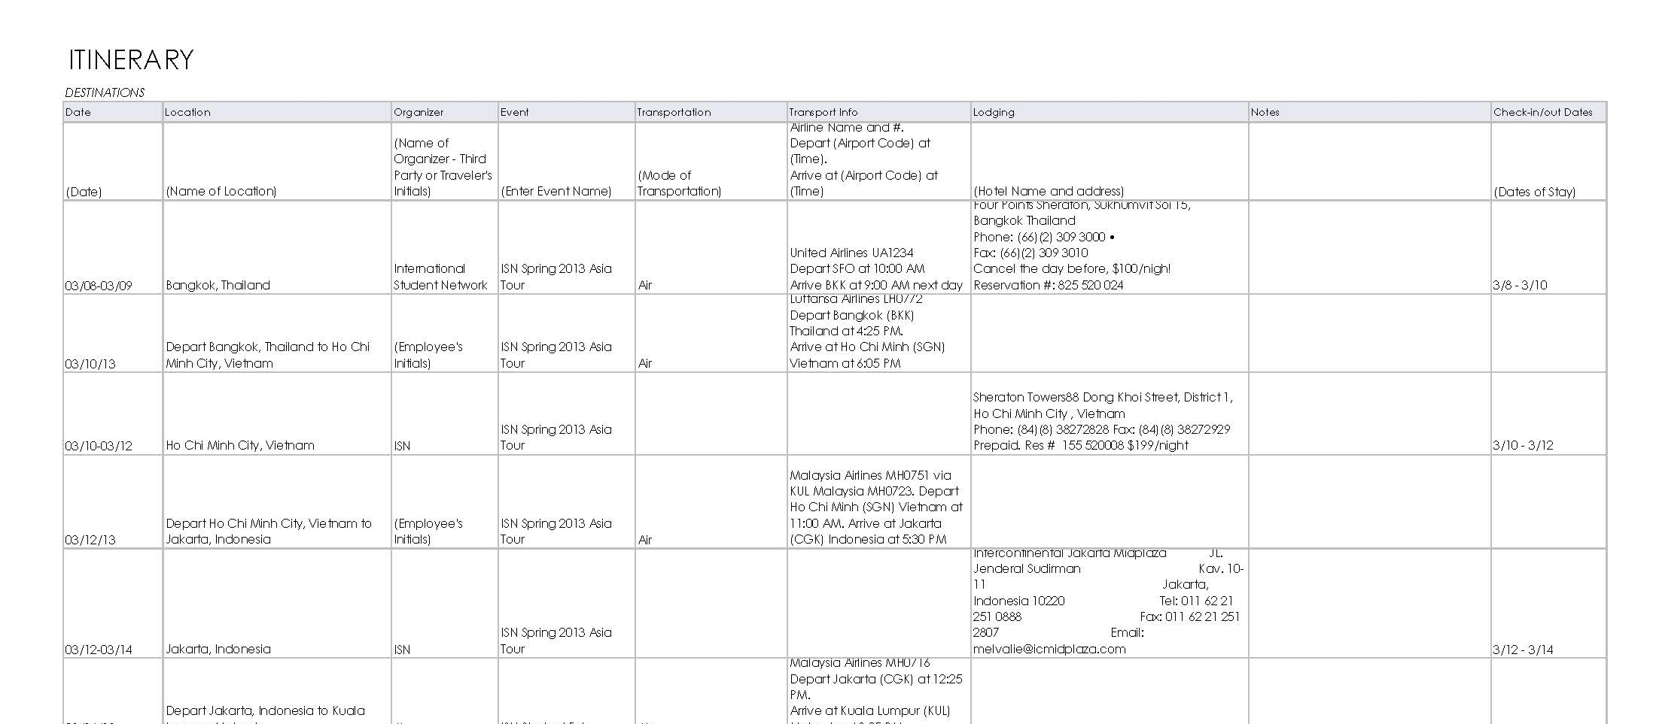
Business Purpose: Attend ISN Spring 2013 Asia Tour for International Student Recruitment Dates of Travel: 3/07 – 30/13

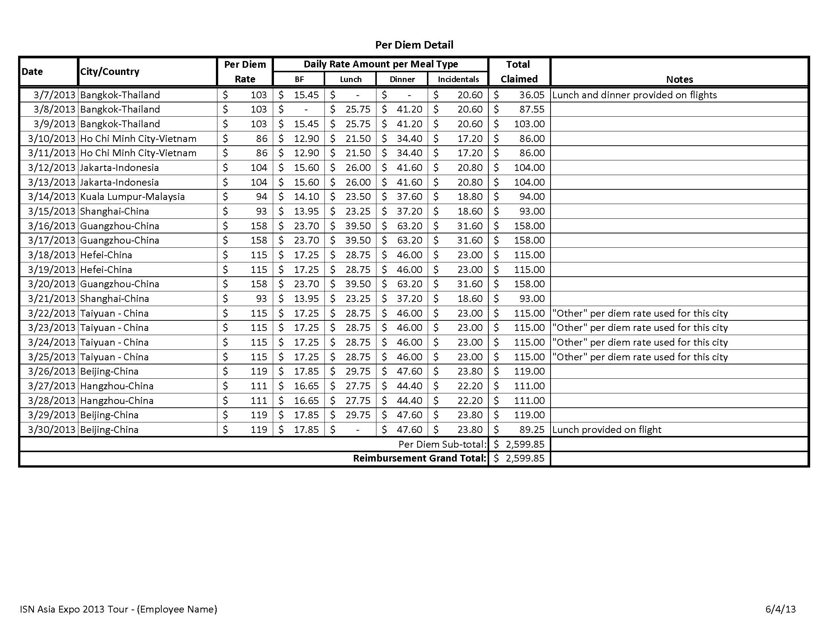
Appendix B – Example Detailed List of Per Diem Rates Claimed

Appendix B: Conference and Travel Federal Guidelines web links
- IRS Pub 43 Travel, Entertainment, Gift, and Card Expenses
  - Travel outside the United States, see page 7.
- IRS Pub 15 (Circular E) Employer’s Tax Guide –
  - Per diem as accounted for expense definition, see Page 15 “Per diem or other fixed allowance”
- U.S. Department of State Per Diem Rates:
  - Foreign Per Diem Rates by Location
  - FTR Appendix B (Breakdown of Meals/Incidentals)
- Guidelines for incidentals adapted from GSA/Federal Travel Regulations –
  - Publications 300 & 301 http://www.gsa.gov/portal/category/21222
  - http://www.irs.gov/pub/irs-regs/perdiemfaq%26a.prn.pdf )

