PRIE Data Dashboards for
Instructional Program Review
Feel free to contact the PRIE Office with any questions: canprie@smccd.edu
Accessing Dashboards
The dashboards are located on PRIE’s website, pictured below. I have also linked them here.
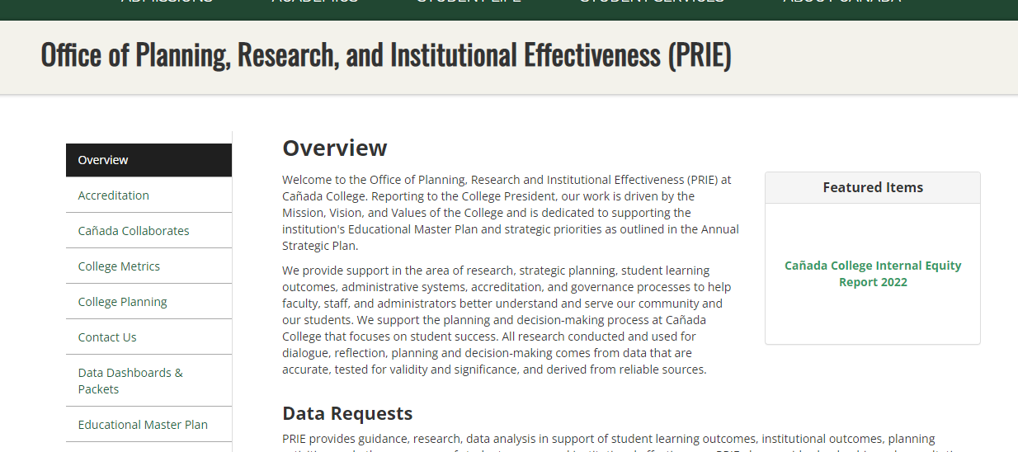

The three main dashboards at the top are the Student Enrollment, Course Outcomes, and Equity Dashboard.
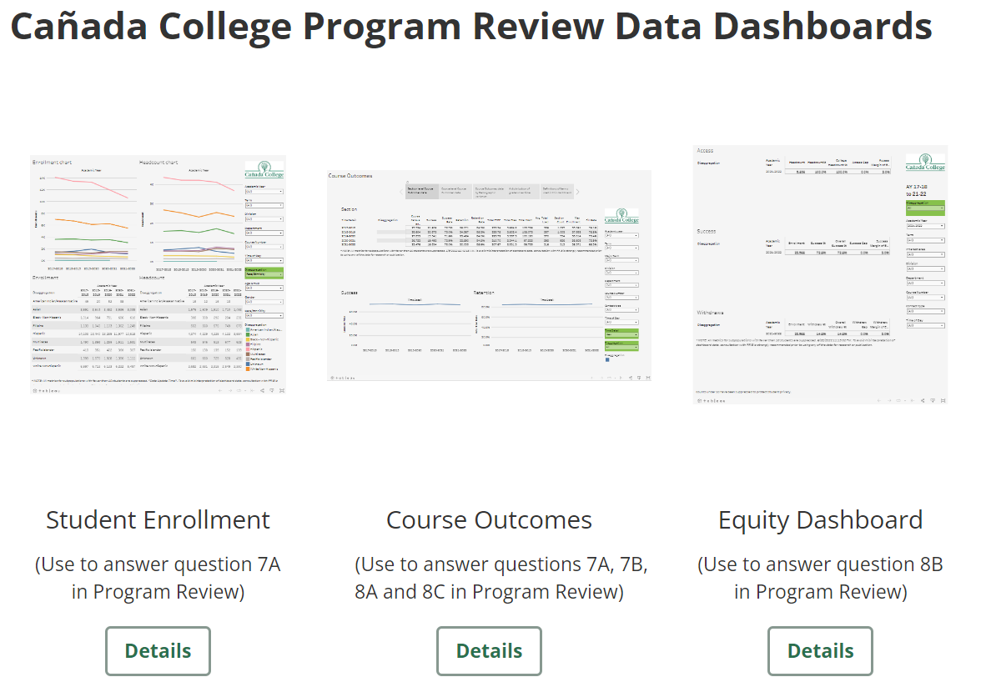
- Student Enrollment provides Headcount and enrollment information that can be disaggregated by demographic variables.
- Course outcomes details many metrics about a given department or course, such as Success Rate, Retention rate, FTES, FTEF, LOAD, section counts, and Fill rates. This also allows for examining course level outcomes by demographic variables.
- Equity and Disproportionate Impact provides analysis of Disproportionate Impact across Access, Success, and Withdraw rates. Disaggregated items in red text are showing statistical Disproportionate Impact for that subgroup.
General Dashboard Features
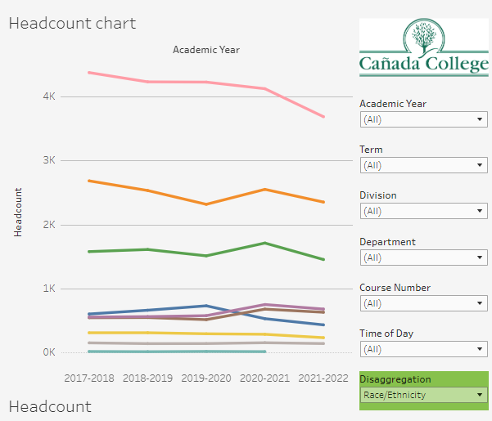
2
1
Most dashboards will have both Filters (1) and Disaggregations (2). A filter will remove data from the dashboard. E.g., unchecking 2017-2018 in the Academic Year filter will remove that whole year’s worth of data. This is how you drill down to specific Divisions/Departments/Courses. Filters will always be black text with a white background.
Disaggregations allow you to compare the given data across a given metric. In the above picture, Headcount is being disaggregated by Race/Ethnicity, allowing comparison of headcounts across the race/ethnicity variables. Disaggregations will always be black text on a green background, to distinguish them from standard filters.
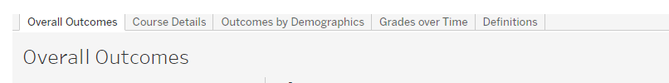
Some dashboards have multiple pages. This is displayed at the top of the dashboard, and each of these sections is a different page. The current page will be displayed in white (Overall Outcomes in this example).
Program Review Questions
7A – general information on Enrollment trends and trends disaggregated by demographics can be found in Student Enrollment. FTES and LOAD information can be found in Course Outcomes.
7B – In addition to the trend data described above, Course level offerings can be found in Course Outcomes in the “Course Details” tab.
8A – In addition to the data packets, Course Outcomes has multiple different ways to examine completion and success rates. Overall department success and retention can be found on the “Overall Outcomes,” while individual courses can be compared in the “Course Details” tab. Course outcomes can also be compared by different demographics in the “Outcomes by Demographics” tab. Finally, the distributions of different grades can be compared in the “Grades over Time” tab.
8B – The Equity and Disproportionate Impact dashboard provides the DI information for Access, Success, and Withdraw rate disaggregations. The data in the packets was pulled from this dashboard.
8C – In addition to the data packet, this information can be found in the Course Outcomes dashboard by disaggregating on contact type.

Student Enrollments
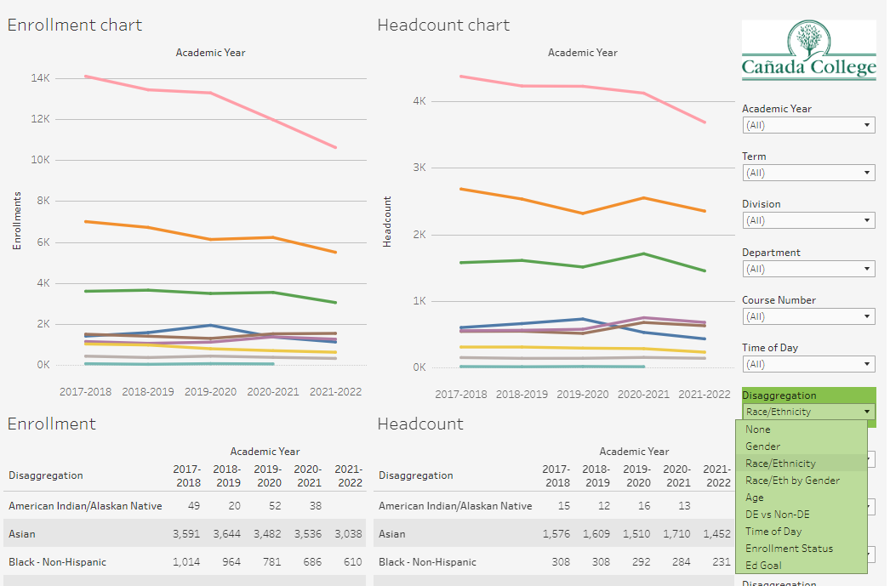
To examine enrollment and headcount trends, first select your department(s) and then select a variable to disaggregate on. The disaggregation will create a line in the graph, and a row in the table for each level of that variable (e.g., one line and row for each race/ethnicity as pictured). Flat lines indicate stable enrollment or headcount, while increasing or decreasing lines indicate a tend of increasing or decreasing enrollment or headcount.

Course Outcomes
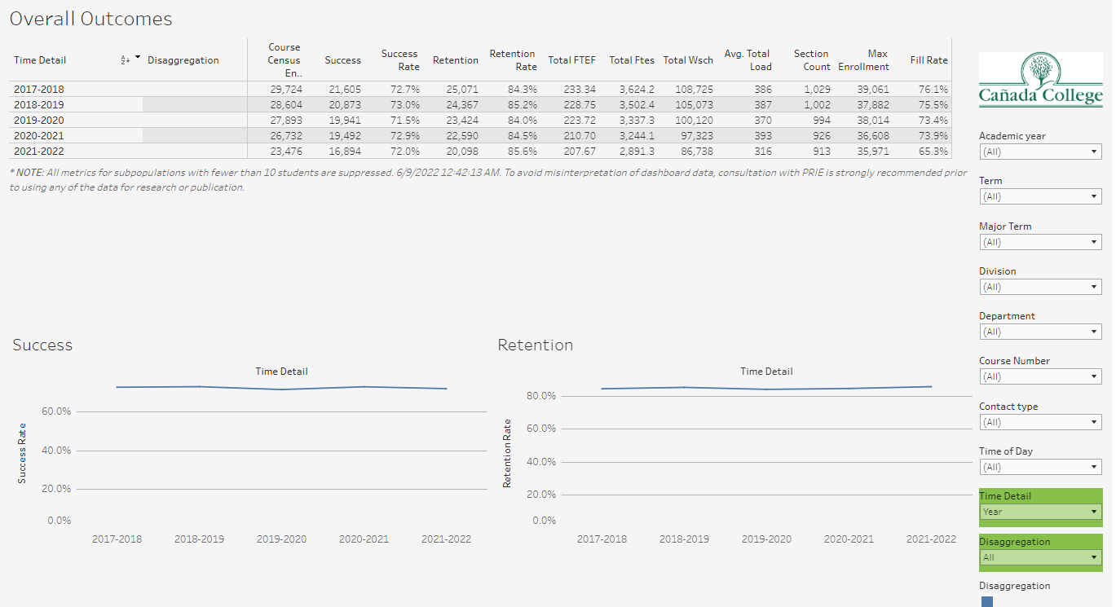
On the Overall Outcomes tab, you can view trends for many metrics. Start by selecting your department(s) and then pick whether you want to view the metrics in the Year level of detail or Semester level of detail with the Time Detail Disaggregation. You can also disaggregate across some Section Characteristics to view in the table and also the differences in Success and Retention.
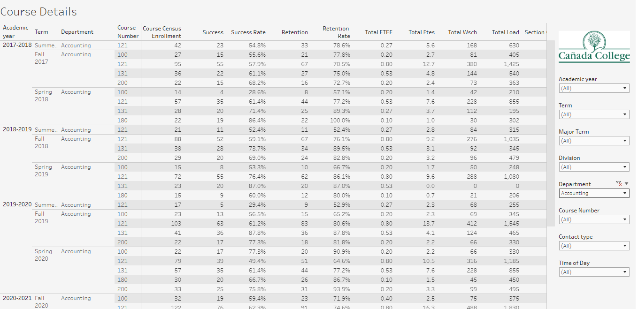
In Course Details you can compare courses over time, across many metrics. Select your department(s) (Accounting has been selected in the example above). You can also select specific courses to focus on, by selecting them from the Course Number filter.
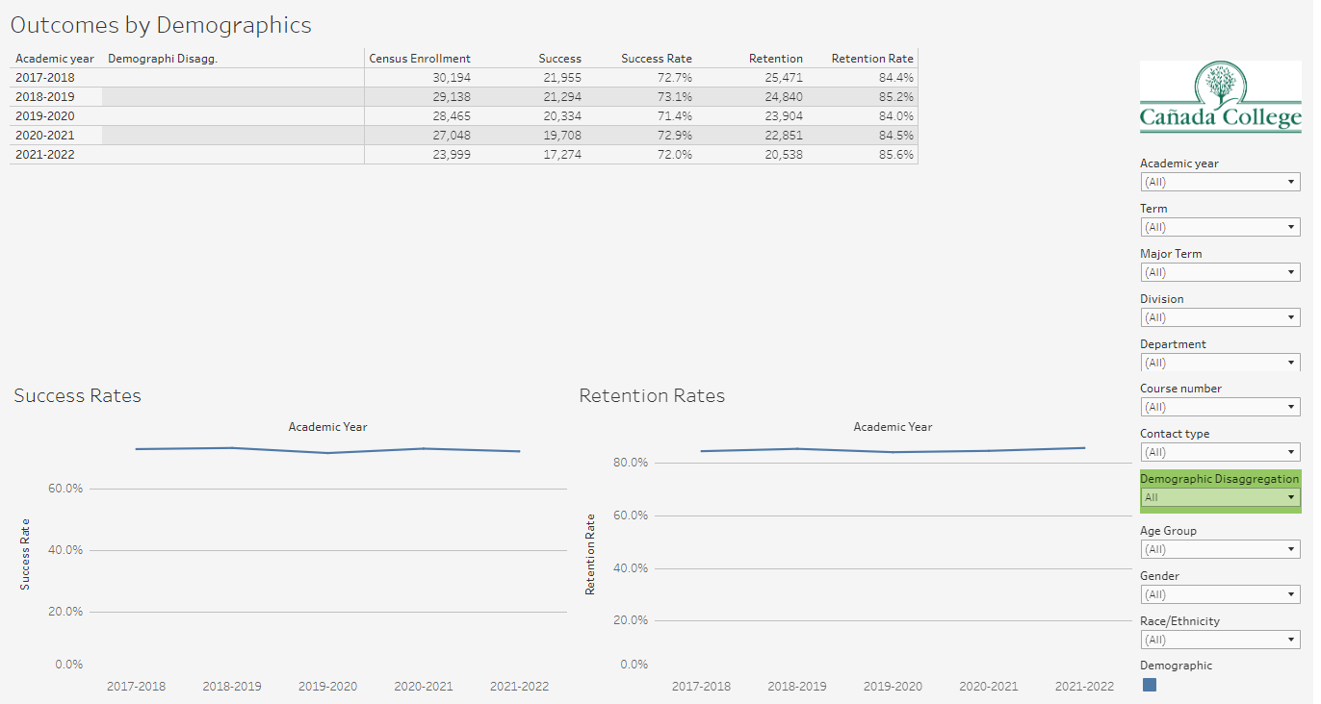
In the Outcomes by Demographics tab you can examine the longitudinal Success and Retention rates for multiple demographic sub-groups in a similar manner to the Student Enrollment dashboard with each subgroup getting a separate row in the table and line on the chart. You can also filter out different demographics. For instance, if you select Race/Ethnicity in the demographics and filter to just Males, you can examine trends for Male students of the various Race/Ethnicity subgroups.
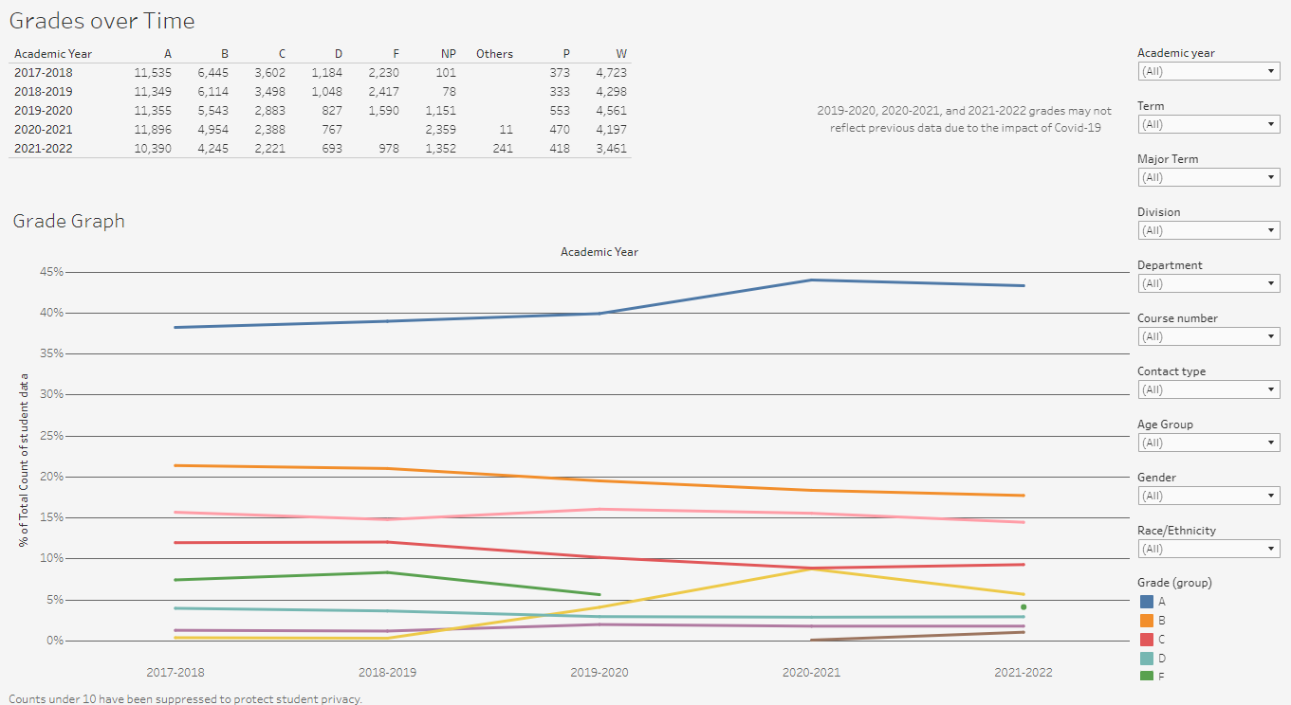
In the Grades over Time dashboard you can view the breakdown of grades by Department or Course number.
Equity & Disproportionate Impact
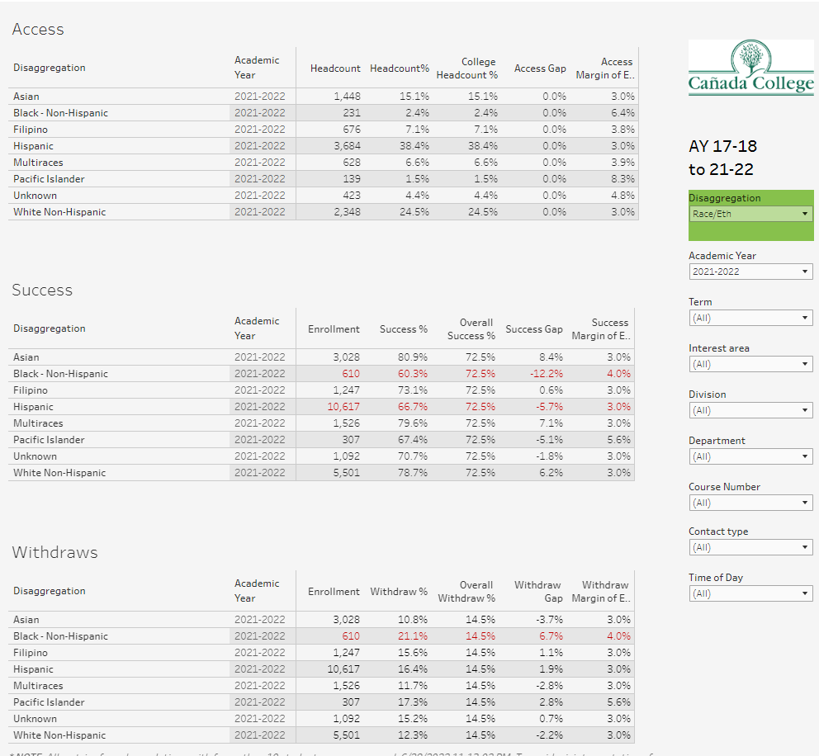
The Equity & Disproportionate Impact dashboard will show any disproportionate impact that exceeds the Margin of Error in the Access, Success, and Withdraw rate metrics. The margin of error is related to the sample size in question, so smaller populations have larger Margins of Error. Once you have selected your Department(s) and optionally specific courses, you can use the disaggregation to explore any disproportionate impact that may appear. If the gap between the subgroup and the average rate is greater than the Margin of Error, the text will be displayed in red, indicating Disproportionate Impact (Show for Black – Non-Hispanic and Hispanic students for the Success Metric and Black Non-Hispanic students for the withdraw rate metric).
Access is an indicator of what student subgroups are enrolling in your courses, based on unique student counts. Success is the rate at which different student subgroups pass courses and is based on enrollments. Withdraws is the rate at which a student withdraws from a course, and higher numbers are worse, as they indicate greater withdraw rates.

