SAMPLE JOB DESCRIPTION
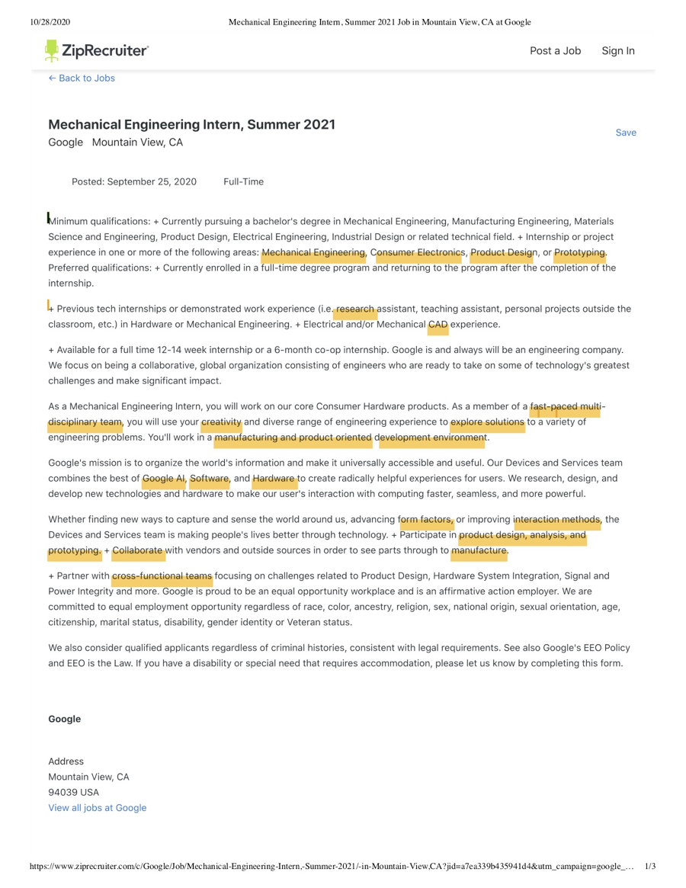

RESUME TEMPLATE (PAGE 1)
FIRST NAME LAST NAME
Redwood City, CA 94061 | professionalemailname@email.com | (555) 555-555

INTERNSHIP/ JOB TITLE
Aspiring Mechanical Engineer with an educational background in favorite class #1, favorite class #2, and favorite class #3. Demonstrated skills in transferable skill #1, transferable skill #2, transferrable skill #3. Strong technical knowledge of technical skill #1, technical skill #2, and technical skill #3. Recognized for the ability to successfully collaborate with peers and co-workers. Proven history of showcasing flexibility and adaptability and excelling and exceeding expectations in fast-paced environments.

CORE COMPETENCIES / SKILLS:
Consumer Hardware Products Solution Focused Interaction Methods
Research Design Concepts Team Oriented Product Prototyping Manufacturing Development Creative Problem Solver Hardware System Integration

Technical Skills: Creo | MATLAB | AutoCAD | GD&T | LabVIEW | SolidWorks
Special Skills: Fluent in Spanish (reading, writing, and speaking) | One Space Designer

EDUCATION:
Bachelors of Science in Mechanical Engineering Expected Graduation Date: FALL 2020
San Jose State University – San Jose, CA

Engineering Major Expected Transfer Date: SEPT. 2020
Cañada College – Redwood City, CA

Relevant Coursework : Engineering Graphics, Engineer Dynamics, Materials Science, Related course 4, Related Course 5

Professional development and continuing education units: Python & SQL, Data Science, Digital Manufacturing, Course 4, Course 5

PROFESSIONAL EXPERIENCE:
Title FALL 2020 - PRESENT
Company Name, City, State
- Key Accomplishment Statement
- Key Accomplishment Statement
- Key Accomplishment Statement

STEM Tutor SPRING 2020 - PRESENT
Cañada College – Redwood City, CA
- Clarify topics of Engineering Dynamics, Trigonometry, and Pre-Calculus concepts to STEM students through virtual tutoring sessions, enhancing study tips and class organization skills
- Facilitate exam review sessions to effectively conceptualize complex problems related to functions, function families, compositions, inverse combinations, and vectors
- Lead group study sessions on weekly basis to clarify the process of getting correct answers, resulting in improved learning experiences and retaining content knowledge

RESUME TEMPLATE (PAGE 2)
FIRST NAME LAST NAME
Redwood City, CA 94061 | professionalemailname@email.com | (555) 555-555

Peer Mentor FALL 2019 – FALL 2020
Cañada College – Redwood City, CA
- Provided one-on-one peer support to mentor over 8+ first year students on navigating campus resources and receive academic support on semester basis
- Implemented effective strategies to increase student engagement through events and community activities, further enhancing their STEM learning experience
- Led as a role model for peers, resulting in increase of student motivation and persistence in achieving their educational goals

Selected STEM Job Shadow Student FALL 2018
Cañada College – Redwood City, CA
- Learned professional development skills, participated in STEM career exploration, and gained advanced communication techniques to strengthen personal branding skills
- Visited 4 STEM corporations, engaged with key employees who shared products, services, and “day in the life” experiences in their line of work
- Generated insightful and relevant questions to further expand comprehension of specific job tasks, further enhancing career knowledge within mechanical engineering field

PROJECTS:
Introduction to Engineering Term Project SPRING 2020
Cañada College – Redwood City, CA
- Key Accomplishment Statement
- Key Accomplishment Statement
- Key Accomplishment Statement
- Key Accomplishment Statement

Speed Reducer Design Project FALL 2019
Cañada College – Redwood City, CA
- Collaboratively worked with group to design a high-precision, epicyclic gear reducer to transmit power to hydraulic pump efficiently powering all hydraulic systems for commercial aircraft
- Demonstrated project to a class of 30 peers and at STEM tech conference
- Managed team to meet tight deadlines which led to project being awarded first place in Student Tech Fair

VOLUNTEER EXPERIENCE:
Robotics Teaching Volunteer, Wizbotz MAY 2018 – MAY 2019
Community Pantry Volunteer, San Mateo Second Harvest Food Bank MAY 2018 – MAY 2019

ACTIVITIES AND HONORS:
Vice President, Society of Hispanic Professional Engineers MAY 2017 - MAY 2020
National Science Foundation Scholar, Cañada College AUG. 2018 - MAY 2020
Selected Research Poster Presenter, SACNAS National Conference OCT. 2019

Cover Letter Sample Template
FIRST NAME LAST NAME
Redwood City, CA 94061 | professionalemailname@email.com | (555) 555-555

First Name Last Name
Redwood City, CA 94061
professionalemailname@email.com
(555) 555-555

Date

Company Name
123 Redwood City Way
Redwood City, CA 94061

Dear Hiring Manager,

I am excited to be applying for the Mechanical Engineer Internship position at Company ABC. When I was a young kid, I believed I was destined to pursue a career where I would build and design complex technological products. Company ABC brings edgy hardware products to life through cross functional teamwork and creativity in exploring solutions within engineering deisgn problems utilizing CAD, a software tool I enjoy utilizing to create unique projects. Currently, I am working towards an AS in Engineering at Canada College, I anticipate to transfer by next Fall 2021 to continue my studies and receive my BS in Mechanical Engineering. Studious and open-minded, every day I uncover new research developed in technology and hardware to learn about ways to make user interactions more seamless, faster, and powerful in impact for consumers. With my experience and passion for software and hardware projects I hope to add further value as a Mechanical Engineering intern to your company.

Having worked as an STEM Tutor for Canada College, I was able to tutor other engineering students taking Calculus mathematics courses. During my role here, I was tasked with taking a caseload of student weekly to tutor students in mathematical concepts, Each week, I checked in with students about course content and hardware projects within their engineering dynamics class. Within this role, I have had the opportunity to immerse myself in AI technology projects and have worked with students to support them with product design elements a key facet to this role when working cross-functionally within the team. Additionally, I have collaboratively worked with my classmates to design a high-precision, epicyclic gear reducer to transmit power to hydraulic pumps efficiently powering all hydraulic systems. This project has allowed me to gain knowledge on improving interaction methods, a key function of this internship role. I have a strong work ethic, ability to handle multiple projects at once, and a yearning to never stop learning. Asking the right questions has also been a strong suit of mine to produce quality final product projects. Between my schooling, engineering projects, and STEM work experience, I feel am a qualified candidate for this position.

Thank you for your valuable time and consideration. I am sincerely looking forward to learning more details about the Mechanical Engineer position and about the great work that Company ABC is conducting. Please do not hesitate to reach out to me in order to inquire further about any of my many qualifications listed on my resume. I look forward to speaking with you and the management team in the near future.

Sincerely,
First Name Last Name

