Effects of the Mechanical Properties for Annealed Additive Manufactured Thermoplastics
Juan Lopez, Travis Welch, Jose Reyna, Philip Kent Velbis
Dr. Teh, Alex Furlanic
Cañada College
San Francisco State University

Abstract
There has been an increase in the use of 3D printers in recent years. When objects are 3D printed using PLA they tend to not be strong, due to the way they are printed; fused deposition modeling (FDM) where there is material printed over material. To solve this we will anneal the objects to make them tougher. In order to do this, we learned the basics of 3D printing. Using Solidworks, we created samples with specific measurements and printing specs from Cura. We measure the samples thickness using calipers. After this we will calculate the density of each of the samples and then anneal them. Annealing means that we will heat the object to release the internal stress within the object to make the 3D printed object more durable. We will anneal the samples 3 different temperatures each all the same time. The 3 temperatures we will use are 60,75, and 90 degrees. The annealed object will then be placed in a tensile test which will give us the data we need to see its strength. After that, we chose the best temperature and anneal new samples with that temperature with different times to pick the best one. Then, it was compared with a non-annealed sample by using a tensile tester and comparing the graphs and data. This will result in a significant change in the mechanical properties of the annealed 3D printed object. With our data results, we will be able to conclude that annealing is very useful for making strong durable 3D printed objects made of PLA.

Introduction
3D printers have revolutionized the world in several industries, there are many ways the technology can be used. The world has benefited from additive manufacturing, but there is still an issue with the strength of the printed objects. There are several types of 3D printing, some using lasers and some using electronic beams. Fused Deposition Modeling(FDM) has been the most popular due to the ease of use. 3D printed objects when printed have weak bonds because the technology or technique(FDM) used in producing the 3D prints. The reason for that with FDM is because material is printed on top of each other creating bonds that might be weak is due to little air gaps in between the material. Although there are other materials that are also 3D printable, such as kevlar, carbon fiber, fiberglass etc, more common 3D printers do not support such materials. It can also be more expensive and PLA is the most common material used in 3D Printing. Research consists of the effects on heating printed objects for a period of time to see the effects on its yield strength, ultimate strength, fracture strength, elastic modulus, ductility, resilience, toughness, and new technologies that are coming out that could help out in the 3D printing industry (Rapid Liquid printing), trying to implement what we could into our research. There has been other research like this, but that research focused more on the rate of recrystallization. Where our research is focusing on the effects of annealing a 3D printed object made of PLA and comparing the mechanical properties.

Approach/ Methods

Specimen Specifications

For our specimen we needed to be consistent with our prints and experiments. We also had to consider others repeating our experiments and would need the same dimensions. The American Society for Testing and Materials(ASTM) was the source for our specimen dimensions, we used the ASTM d638 type 1. The reason we chose to use this is because there is a standard for testing plastics using a tensile testing machine. Based on the ASTM recommendations, this version will show the best results for what our treatment to the printed object will be.

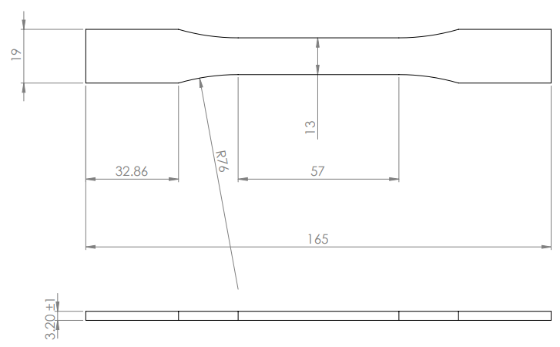
Figure A- ASTM design specifications for a d638 type 1
Figure A shows the dimensions that we used from the ASTM d638. All measurements are in millimeters. We considered reducing the thickness to account for error during the print, but in most of our prints the thickness was on average 3.3mm. We were satisfied that we did not have to alter our design to meet the requirements for the standard 3.20±0.1mm.

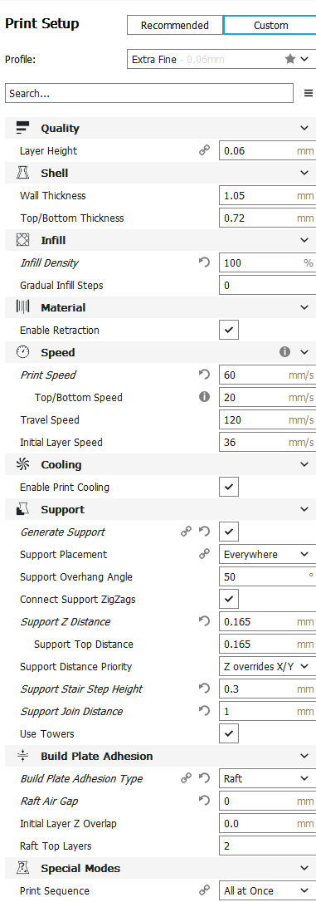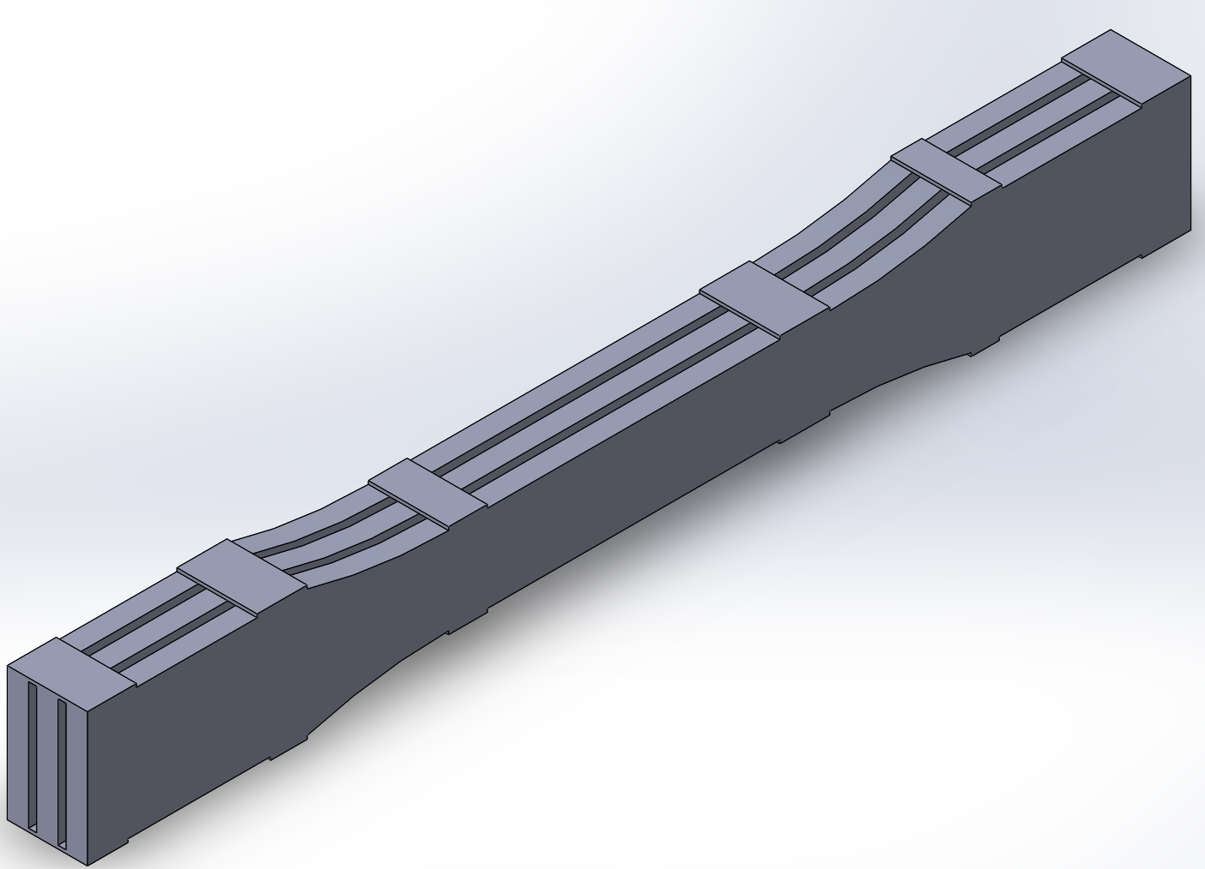
Figure B1- settings on Cura software Figure B2- solidworks design of our specimen print

After we made a design that worked Figure B2, we were able to start the printing process where we used Cura to configure settings. At first we wanted the layer height to be .06mm,figure B1, but we had to change it to .1mm near the end. Along with many other settings we used to make our print file we made a 100% infill.

Printing

When we started to print the specimen we began to print them in the very middle of the printer in a set of three, all of them side by side. We began to experience different issues with failed prints. With each set of three taking around 14 hours we would watch the print while we could but the failures would happen a few hours into the print, half way, and near the end. We couldn’t really find out when they would fail or why. When we would see the print in the morning we would find any three of them tipped over, the specimen still standing but the printer nozzle got caught up on something and continued to print on nothing rather than the specimen. After having many failed prints for different reasons, we decided to shorten the gauge length of the specimen by 19mm, that way it would be less likely for the print to fall over.
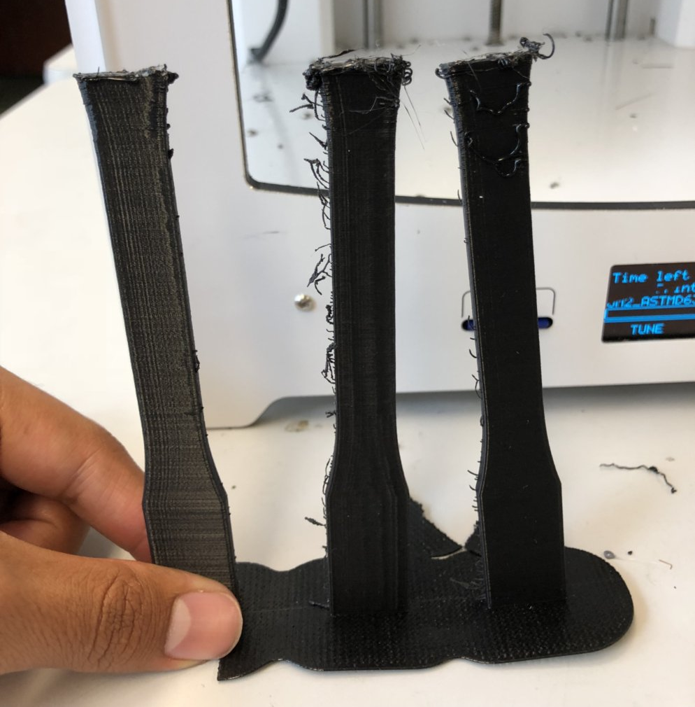
Figure C- Failed printing design where specimen got knocked over
Figure C shows the specimen side by side in a failed print where the specimen stayed upward but the nozzle was printing on mid air rather than the on the specimen. This was one of our first versions of the print design.
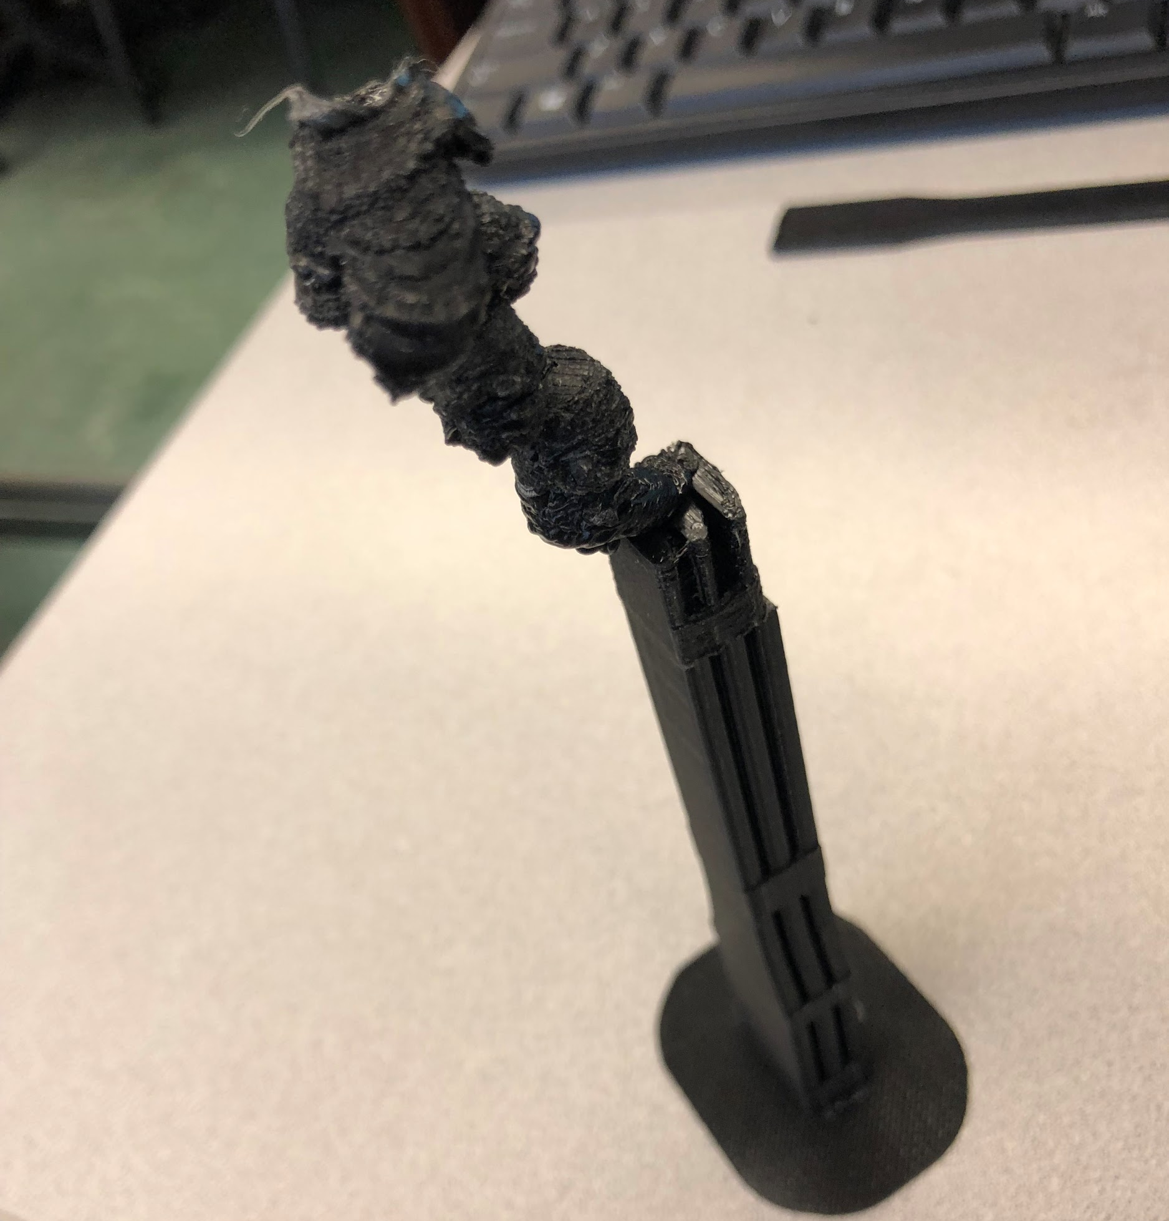
Figure D-Failed print, where the nozzle got stuck to the specimen
Figure D shows another failed print, this time the print failed due to the whole print moving somehow during the print that caused the nozzle to print on the edge of one specimen. The way this print failed could clog up the printer and break it, so we were concerned about our printers every time a print went in.

Layer Bonding

We are treating the prints to relieve as much of the internal stress as possible to make each layer closer together. When the specimen is printed flat on the print bed the grain is lengthwise, when we put that into the tensile testing machine you aren’t testing the strength of the layer bond, you’re testing the strength of the plastic and essentially stretching it instead of a clean break.
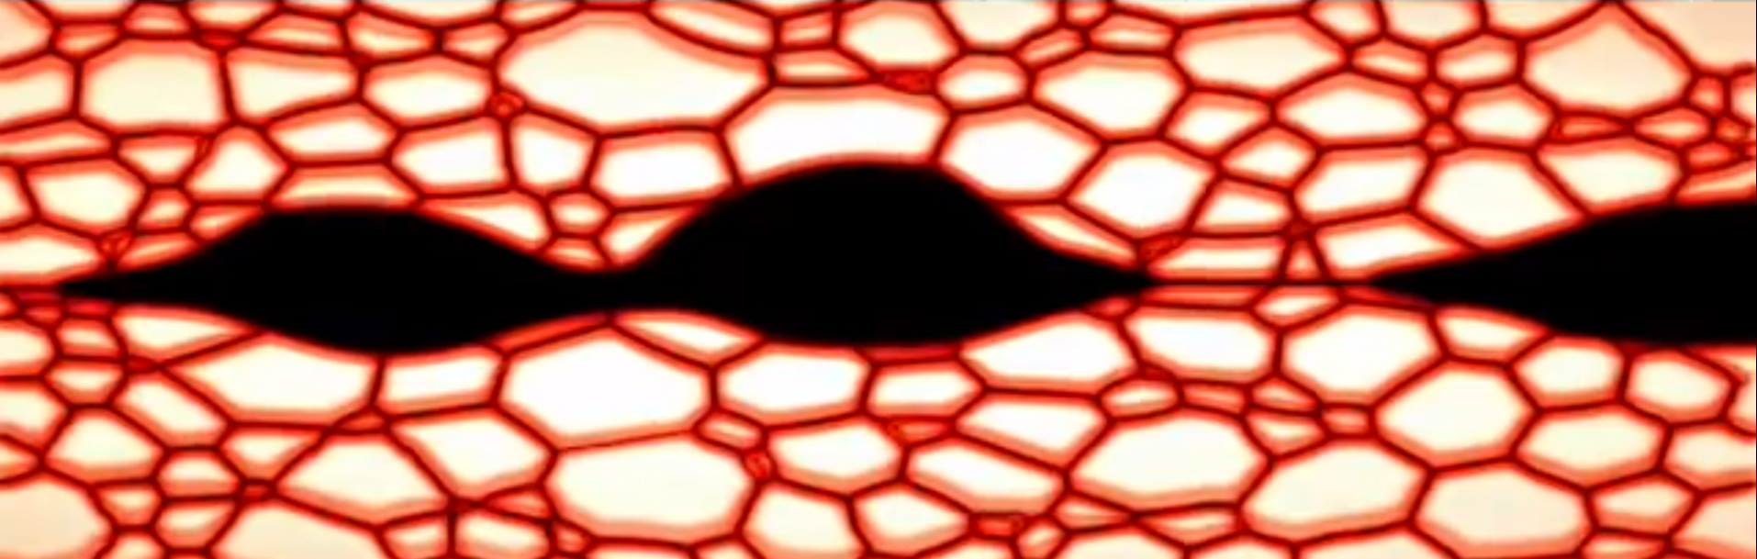
Figure E1
Figure E1 shows in between the layers that are being printed on top of each other before getting treated.

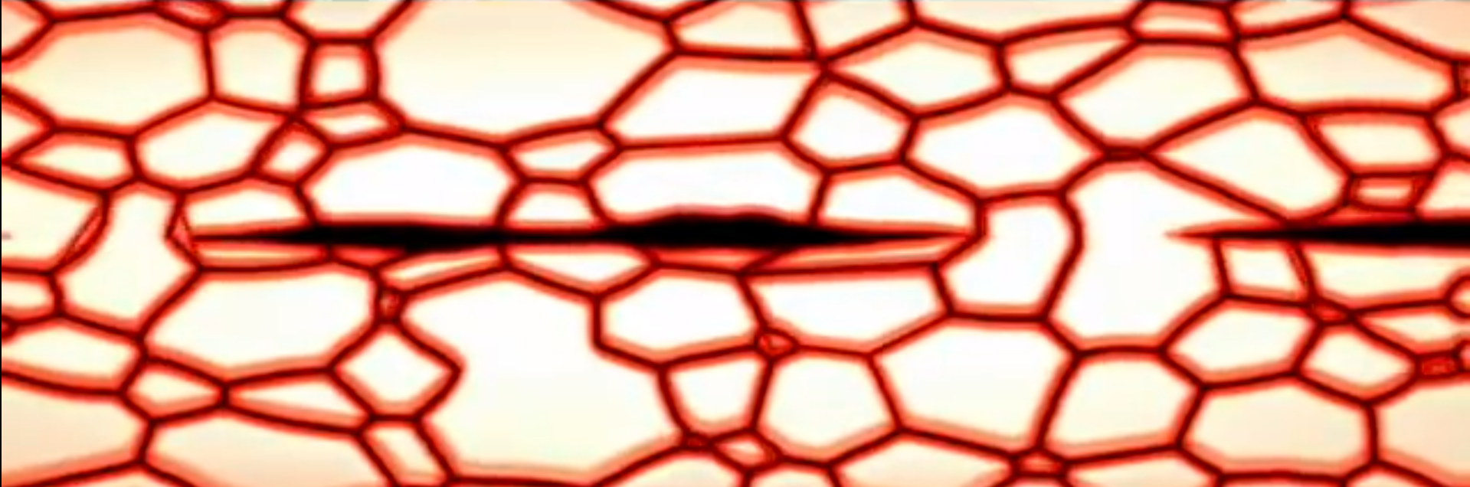
Figure E2
Figure E2 shows in between the layers that are being printed on top of each other after getting treated. The goal is to completely get rid of the air gaps within the print, where there is higher internal stress around each gap. If you are annealing metals it tends to do the opposite of what were trying to do. When you anneal a metal it usually softens the metal for cold working

Annealing Trail #1 Design
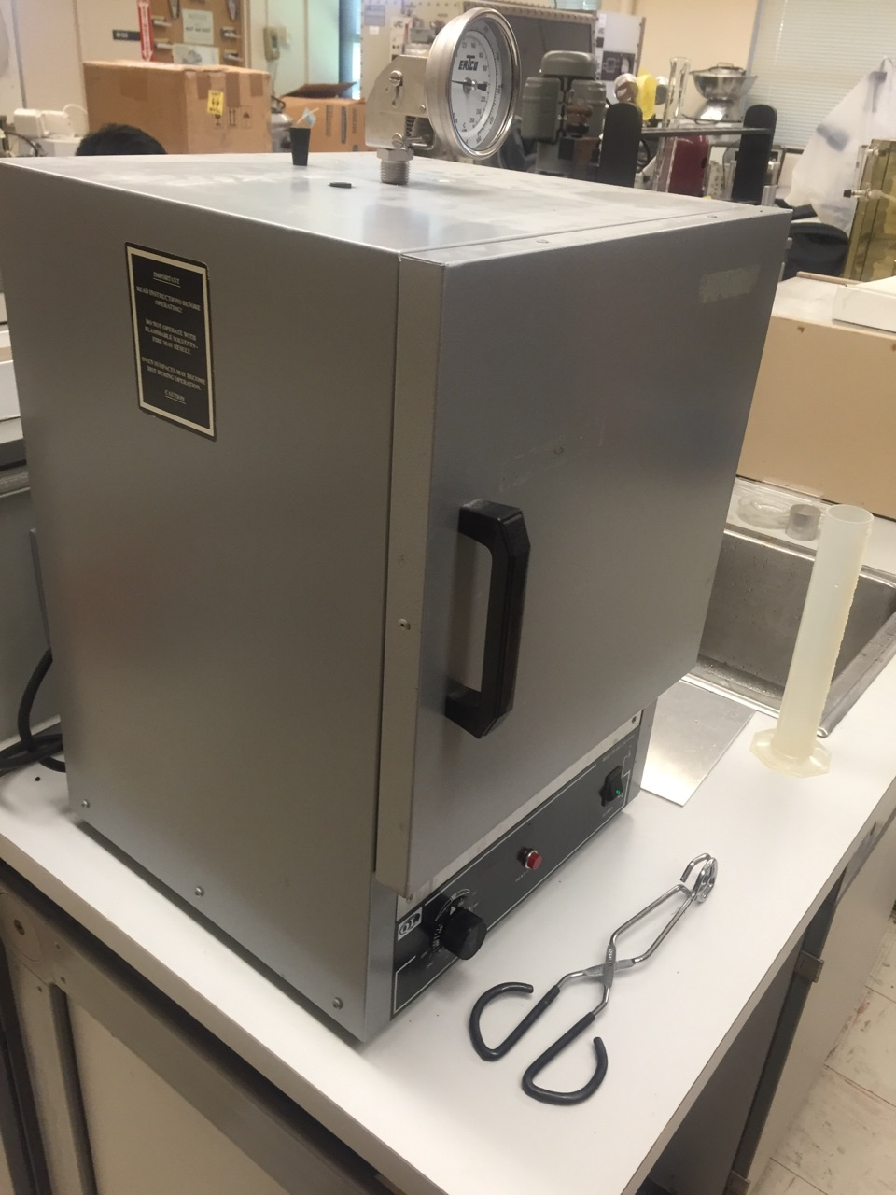
Annealing polymers near their melting point will allow the material to recrystallize again to reform its structure. Which can lead to the following of an increase in tensile modulus, an increase in yield strength, a reduction in ductility within the specimen itself. Thus it is critical that the correct temperature chosen at which it is annealed at as well as the time. These temperatures should be between two temperatures, the upper critical and the lower critical temperature. This is consistent with about ⅓ to ½ of the total melting point of the material being used for the annealing process. The melting temperature for PLA is between 180-200 C and we used 190 C throughout the entirety of printing all our samples. Therefore leaving us to choose temperatures between the temperatures of 60-90 degrees celsius. The oven used is from a company called Quincy Lab Incorporated, And is a Model GC Series Lab Oven.

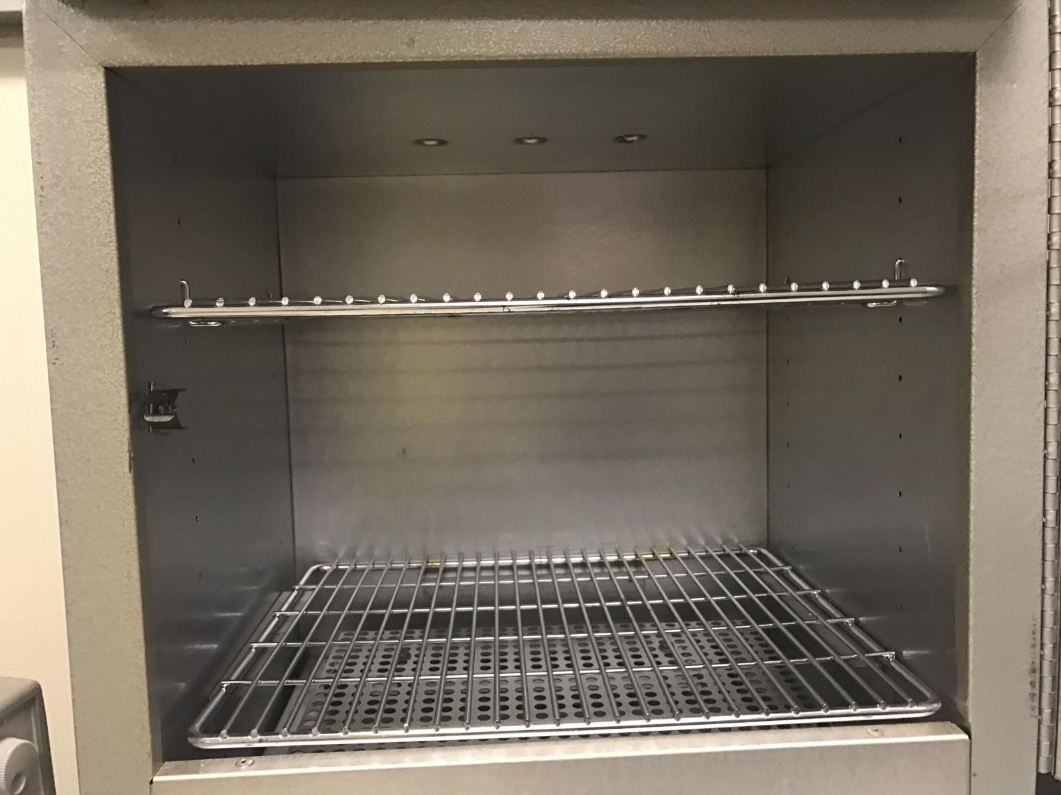
Figure F1 Figure F2

We used a Quincy Labs Model GC oven Figure F1. As you can see in Figure F2 above are of the oven and the environment in which we annealed the samples. There are three exhaust ports on the top of the oven one of which is used to have the temperature gauge through. The oven would find a consistent temperature within plus or minus 4 degrees after conducting a couple tests using the machine. When inserting the samples there would be a relatively small but noticeable, drop in temperature, but the interior would rise back with in a couple minutes to our testing temperature.

Annealing Trails
For our first annealing trial, 60 minutes in the oven would be our constant, while we chose three temperatures in our temperature range of 60-90 degrees celsius. In the sense of knowing we are gonna test more samples, based of the best results of the temperature from the first trial, the second trail consists of temperature being consistent and the time being varied. In Figure G1 , found on the next page, are all examples from this first trial, giving a good visuals of the approach we used. Of course right below in Table 1 is our complete layout so it is easily seen how we went about all our trials and more explanations can be found below, for the Annealing trial 2, and also the For testing purposes.

Table 1
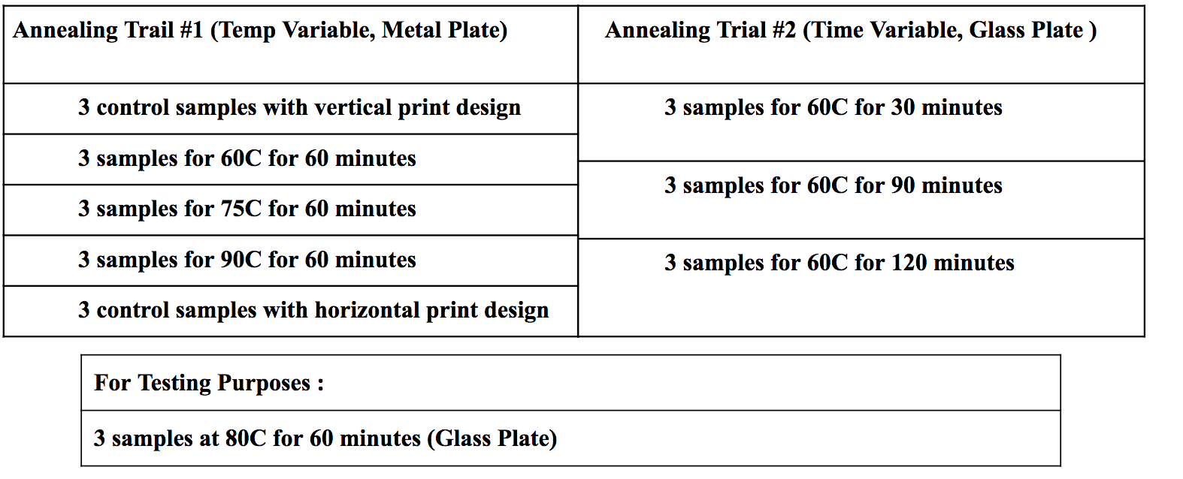

For the second Annealing Trial (Found in Table 1) using the results and analysis from the first trial we have determined that we want to explore even further into the process. Thus for the first trial we used a metal plate (Figure G3 found in next page) for the annealing process, and looking at the results we want to use the glass plate instead for this go around to decrease the amount of warping. Taking this approach, we are trying to find the most optimal means of annealing conditions, therefore giving a solid basis of which we can conclude the best annealing design for PLA material in 3D printing. Also during this trial we ended up doing each annealing session with the glass plate (Figure H2 found in next page) on for the times and got much less warping thus we can conclude that the glass plate (Figure H1 found in next page), and annealing at 60C is the most optimal way to conduct the annealing process. Thus the only thing left to do is figure if we vary the time will that play a role on the results for tensile testing.
Figure G1 Figure G2 Figure G3
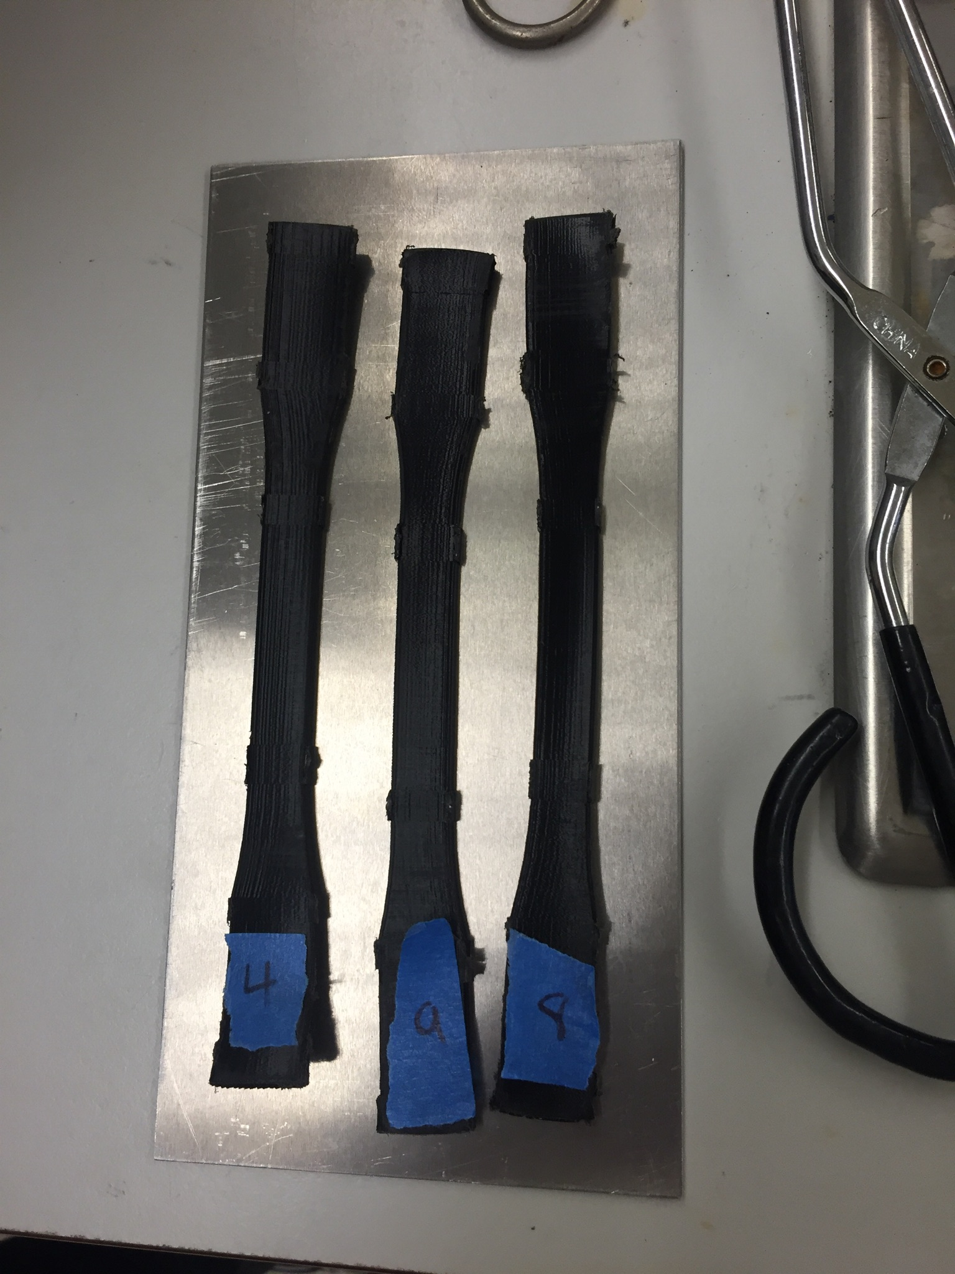
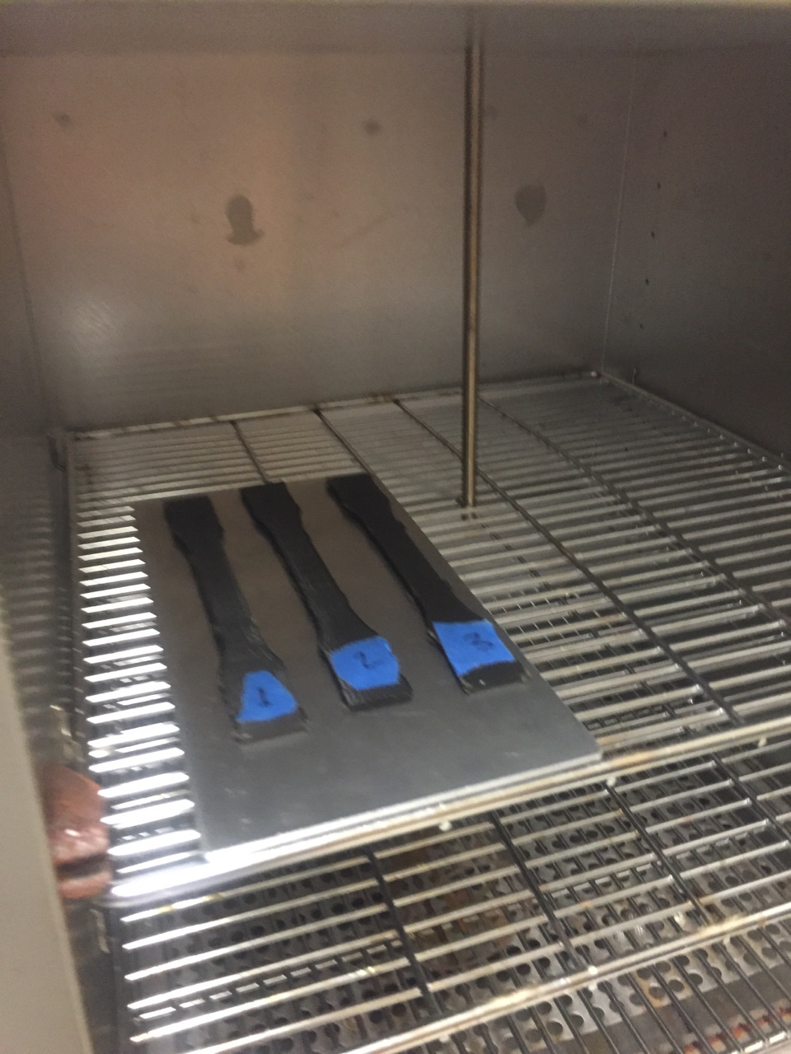
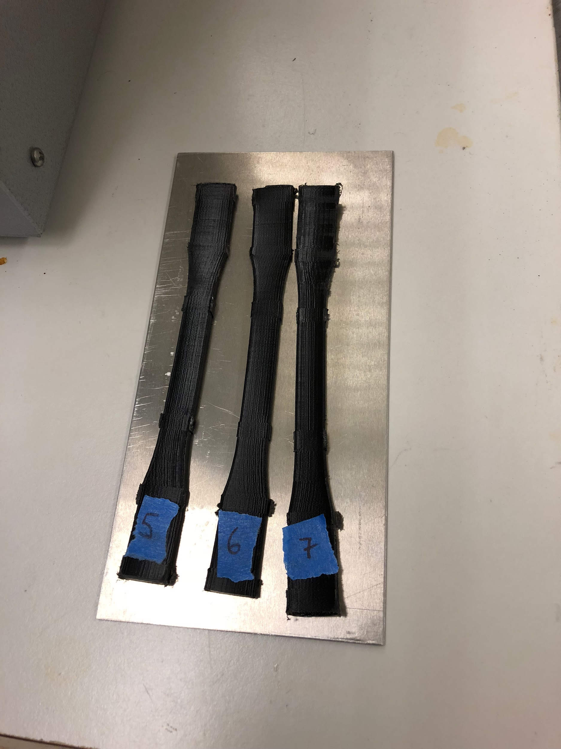
Figure G1- specimens loaded in side the oven , Figure G2- specimens post annealing at 75 C for 60 mins, Figure G3- specimens post annealing at 60 C for 60 mins
For this testing of the above, it was done using a metal base plate for the samples to be cooked on with in the oven. Using this metal plate method, the samples tend to have a bit of warping and this warping mainly occurred towards the ends of them where they have the most surface area. So for testing purposes we tried another batch using 3 more specimens using a glass plate instead, using the temperature below.
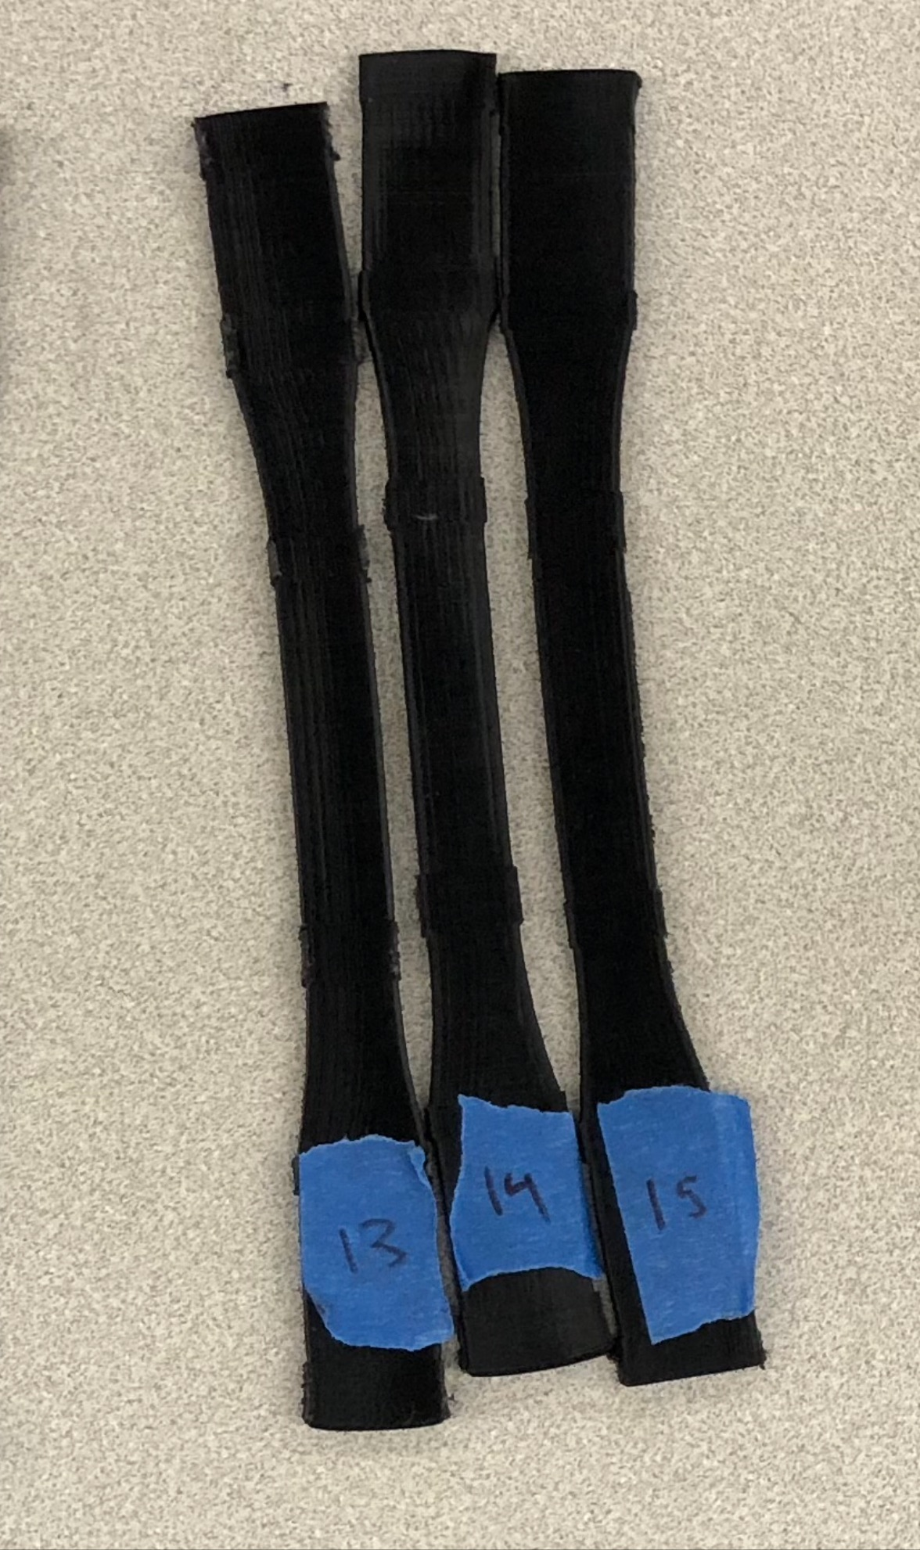
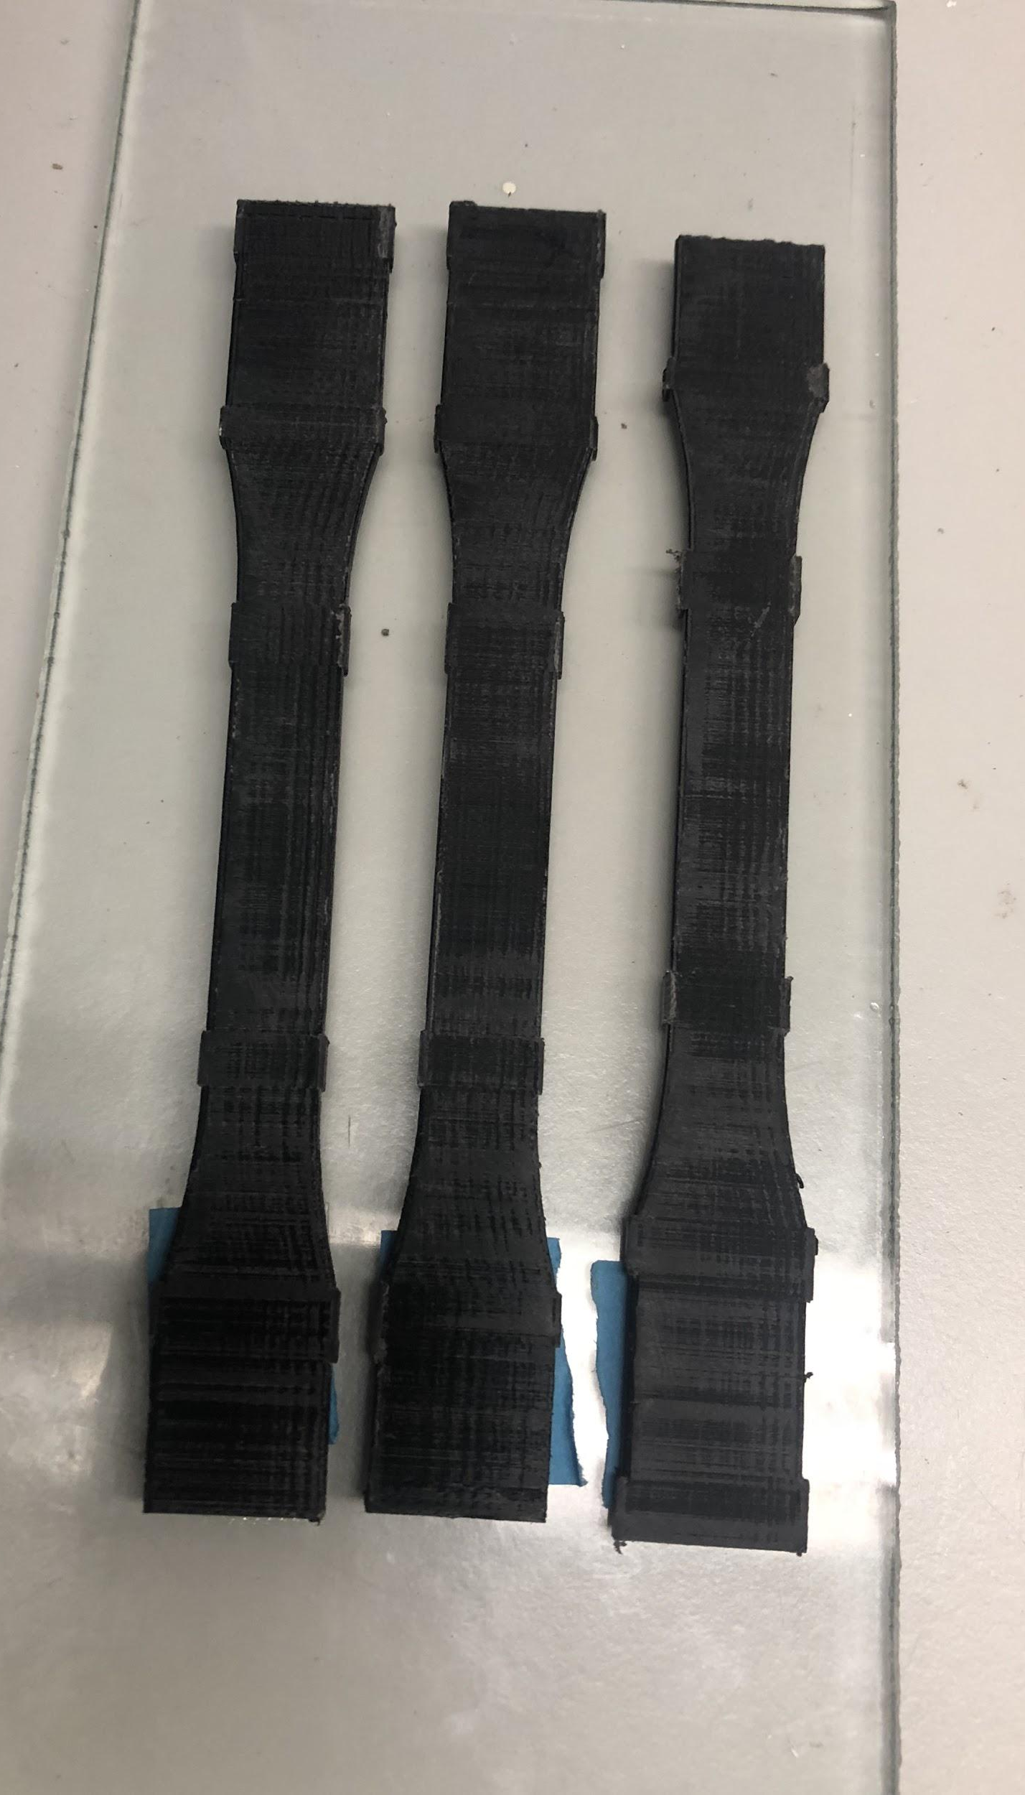
Figure H1 Figure H2

Figure H1- specimens on the glass plate Figure H2- shows specimens post annealing at 80C for 60 mins on a glass plate

Tensile Testing
In testing we were looking at a few things. One was the raw data, another was the way that the specimen broke. When you put a material in a tensile testing machine depending on what it is, it could stretch out where there would be necking. For Batches 1-6 consists with the annealing trial 1, and for Batches 7-9 coincide with annealing trial two on the glass plate.
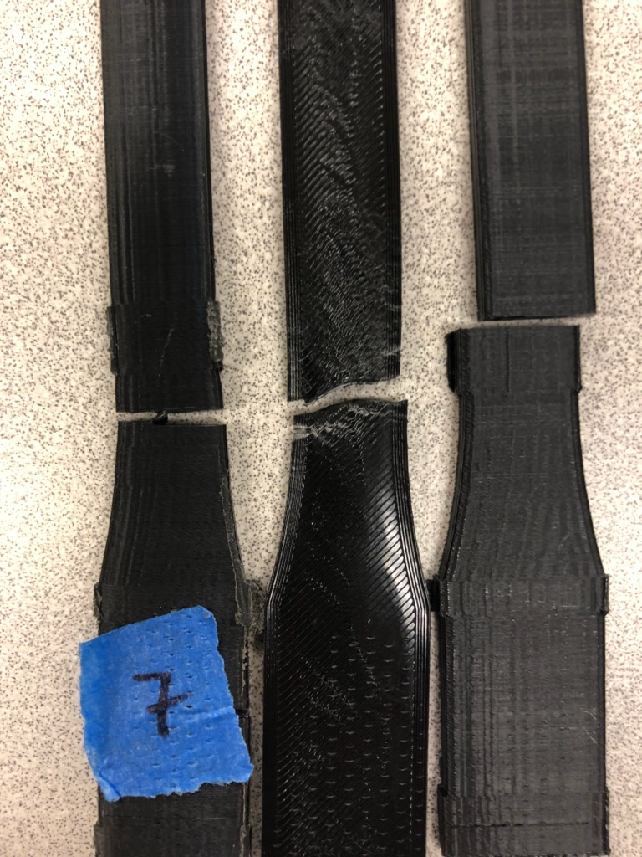
Figure I- Annealed specimen(left), flat print(middle), control(right)
Figure I shows the effects of tensile testing on the specimen. On the far right it shows the specimen that was annealed at 60℃ for 1 hour. In the middle it shows the specimen that was printed flat on the print bed, and the plastic was printed lengthwise compared to side-to-side on all the other specimen. The most right that was our control sample where no treatment done. You can see that there is a clear difference in how each specimen broke. The middle specimen had the most visual effects visually on the piece, where it was getting stretched out and necking occurs. On the very right the control sample broke very cleanly, meaning that there was no resistance to breaking compared to the others.
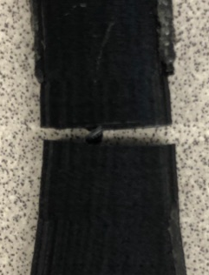
Figure J
Figure J shows the sample that was treated at 60℃ for 1 hour after the tensile testing. We can see that there is some effects of annealing. Though it is similar to the control sample where there was clean break; there is some plastic in between holding it together. This shows that the annealing process in Figure E1 and Figure E2 slightly brought the layers together.

When conducting the tensile testing we compare our tested data to the original control group, that way we can see if there is any improvements or setbacks in the annealed specimen. As you can see below our results from our control run in a Strain versus Stress style graph witch basically helps us understand if there was somewhat of a difference of control and annealed specimen.
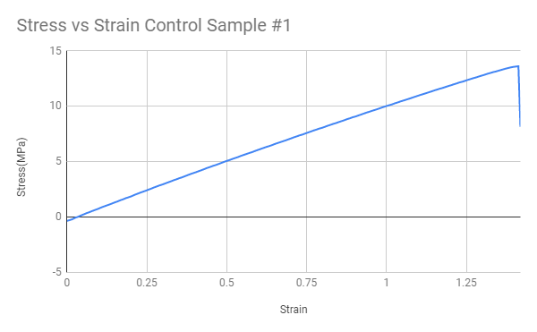
Graph 1- Stress vs Strain graph of control sample #1
In our first set of annealing and tensile testing we found that batch two which was annealed at 60C for 60 minutes, had an average toughness that was overall much better than the other temperatures. The average toughness can be a measurement of how ductile and also how much stress one specimen can consume before completely fracturing. Thus this measurement is calculated by taking small individual areas under and all along the curve, therefore the sum of these area will give us a approximate area underneath the curve. As you can see below our sample #7 specifically is within batch two and gave us some of the best results.
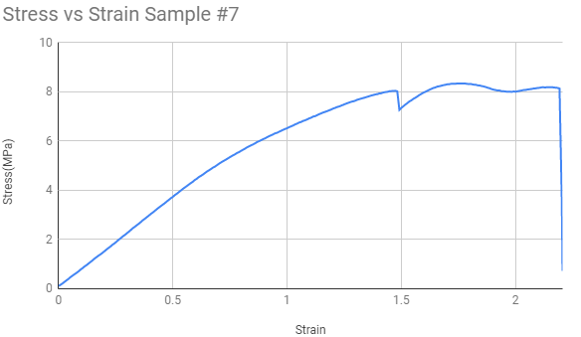
Graph 2- Stress vs Strain graph of sample #7

As the Horizontal control is just a simple comparison where we actually test the strongest configuration of the 3d printed specimen, thus we can’t use the data from this batch to make any conclusions but is definitely an interesting comparison.
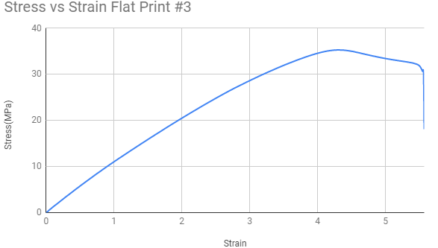
Graph 3- Stress vs Strain graph of a flat printed specimen
After testing our flat samples we saw that it took more time for the sample to break compared to the control. Just from looking at Graph 3 we can see that the stress goes up to around 35 MPa.
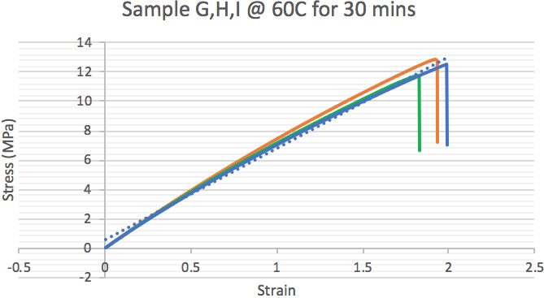
Graph 4-Stress vs Strain graph where the orange is specimen g, blue is specimen h, green is specimen i
Table 1- Calculations taken from data

We took the data that we got from tensile testing and we calculated Elastic modulus (E), Yield Strength, Ultimate Strength, Fracture Strength, Resilience, and toughness shown in Table 1. Sample 5 was broken when we were trying to put it into the tensile testing machine. We wanted to see the material properties before and after annealing so that we can look at more than one property.
Graph 4-Stress vs Strain graph where the orange is specimen G, blue is specimen H, green is specimen I

Results and Analysis
Table 2- Sample number, Temperature, Time, Average toughness(Area Under The Curve), and Elastic Modulus at 60°C annealing temperature
Sample | Temp°C | Time(s) | Avg. Toughness(J. m−3) | E(N/m^2)
5 | Discarded
6 | 60C +- 2 | 1 hour | 11.8819 | 8.2354
7 | 60C +- 2 | 1 hour | 12.9595 | 3.5181
A | 60C | 90 min | 4.3187 | 9.3963
B | 60C | 90 min | 4.8013 | 8.4051
C | 60C | 90 mins | 4.5289 | 9.0318
D | 60C | 2 hours | 4.6399 | 8.673
E | 60C | 2 hours | 2.7423 | 8.7697
F | 60C | 2 hours | 5.7344 | 9.0262
G | 60C | 30min | 13.5277 | 6.2604
H | 60C | 30min | 11.7707 | 6.4404
I | 60C | 30min | 13.5416 | 6.6812

Table 3 -Sample number, Temperature, Time, Average toughness(Area Under The Curve), and Elastic Modulus at 1 hour annealing time excluding the control
Sample | Temp°C | Time(s) | Avg. Toughness(J. m−3) | E(N/m^2)
Control 1 | Control | Control | 5.4156 | 8.7361
Control 2 | Control | Control | 3.0337 | 8.5051
Control 3 | Control | Control | 5.9739 | 9.8356
4 | 75C +- 4 | 1 hour | 3.173 | 6.5251
8 | 75C +- 4 | 1 hour | 5.5208 | 7.4468
9 | 75C +- 4 | 1 hour | 3.7327 | 7.5206
10 | 90C +- 3 | 1 hour | 5.0606 | 20.562
11 | 90C +- 3 | 1 hour | 2.2774 | 12.403
12 | 90 C+- 3 | 1 hour | 2.7872 | 13.673
13 | 80C | 1 hour | 3.3279 | 7.9999
14 | 80C | 1 hour | 3.874 | 7.591
15 | 80C | 1 hour | 4.8145 | 7.2425
Horizontal 1 | N/A | N/A | 128.908 | 5.695
Horizontal 2 | N/A | N/A | 90.5521 | 8.0527
Horizontal 3 | N/A | N/A | 131.017 | 6.2465

After running all the tests and analysing the numbers we saw that annealing the specimen at 60℃ worked best in terms of toughness in these tests Table 2. The most significant data we found from our tests was at 60℃ for 30 min where the average toughness reached up to 13.5416 J*m^3. Comparing to a control sample reaching up to 9.9739 and low of 3.0337 A Table 3 we can say that annealing a 3D printed object using PLA for 30 min at 60℃ will help the toughness of the object. We also saw that the horizontal print held up a significant amount more than any other configuration of annealing time and temperature reaching a high of 131.017J*m^3.
Table 4- Calculations taken from data
 | E(PA) | Yield Strength | Ultimate Strength | Fracture Strength | Resilience | Toughness
Control 1 | 8.7361 | 9.61865 | 9.66624 | 5.5874 | 5.2952 | 5.4156
Control 2 | 8.5051 | 7.23817 | 7.39282 | 0.64309 | 3.0799 | 3.0337
Control 3 | 9.8356 | 13.58389 | 13.61945 | 8.15482 | 9.3803 | 5.9739
Sample 5 | Discarded
Sample 6 | 7.452 | 8.23538 | 12.67432 | 12.55432 | 4.550555807 | 11.881882
Sample 7 | 3.5181 | 4.95694 | 8.3413 4 | 8.13384 | 3.492119918 | 12.959492
Sample 4 | 7.4626 | 6.5251 | 6.56681 | 6.44392 | 2.8527 | 3.173
Sample 9 | 7.4568 | 9.1599 | 9.2023 | 5.21298 | 5.626 | 5.5208
Sample 8 | 7.9563 | 7.5206 | 7.58189 | 1.47577 | 3.5544 | 3.7327
Sample 10 | 20.562 | 21.83633 | 14.56679 | 14.43456 | 11.5948183 | 5.060567
Sample 11 | 16.403 | 21.96084 | 8.70292 | 8.6902 | 14.70092341 | 2.277376
Sample 12 | 13.673 | 15.6388725 | 9.78102 | 9.76123 | 8.943696814 | 2.78716
Sample 13 | 7.9999 | 7.3279 | 7.3679 | 0.6733 | 3.3571 | 3.3279
Sample 14 | 7.591 | 8.0351 | 7.4122 | 4.9527 | 4.2526 | 3.874
Sample 15 | 7.2425 | 8.1689 | 8.2215 | 0.6112 | 4.6069 | 4.8145

We took the data that we got from tensile testing and we calculated Elastic modulus (E), Yield Strength, Ultimate Strength, Fracture Strength, Resilience, and toughness shown in Table 4. Sample 5 was broken when we were trying to put it into the tensile testing machine. We wanted to see the material properties before and after annealing so that we can look at more than one property.

Conclusion
Throughout the summer we have tested out many different specimen in order to see if what we are trying to find is true or not and to find the best configuration. After working on finding results for this project we found that annealing a 3D printed object could help the toughness of the object. Looking at our graphs and comparing them with each other we can see that the control specimen are brittle, and some of the annealed also looked like they were brittle still but other specimen looked ductile. We have done research for people to use our finding to help with their own prints.

Future Work
In the future we would like to have a good configuration for specimen so that we can have a 100% rate for successful prints, where now we figured it out late into the research. If we have enough specimen that we can anneal and tensile test it, we can have enough samples of a variety of temperatures and times to find the perfect configuration. We would also like to have an oven that can consistently heat under 50℃.

Acknowledgment

This project is supported by the US Department of Education through the Minority Science and Engineering Improvement Program (MSEIP, Award No. P120A150014); and through the Hispanic-Serving Institution Science, Technology, Engineering, and Mathematics (HSI STEM) Program, Award No. P031C110159.

We would also like to thank Amelito Enriquez for helping each of us get to this point where we are conducting research for Canada College and San Francisco State University. Thanks for all the help along the way.

References
https://conservancy.umn.edu/bitstream/handle/11299/169793/RosplockM.pdf?sequence=1
https://community.ultimaker.com/topic/15440-annealing-printed-parts-directly-in-the-ultimaker/
https://onlinelibrary.wiley.com/doi/full/10.1002/app.27261
https://youtu.be/5EhMYMr834o

