
Employee Office Technology Devices

Overview: District ITS recommends a standard office technology configuration for employees, and the College has instructional equipment funds to cover the cost of a standard technology devices for all regular employees. ‘Devices’ include computers, laptops, docking stations, monitors, printers, and accessories. Employees may determine which computing device (computer or laptop) best meets the requirements of their job duties, and ITS will support 1 device per employee. If an employee requests technology above and beyond the standard due to preference, the additional expenses will be covered by division funds. This also includes multiple monitors and color printers.

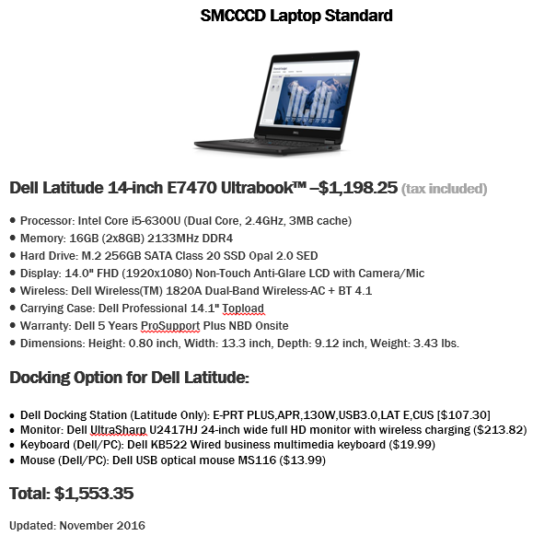

New Devices: For new employees, the supervisor should request a quote from ITS for a standard computer or laptop configuration (note: allow up to 6 weeks for new computers to be installed. ITS does not provide ‘loaners’). New technology will be included in the College replacement cycle.

Replacement Devices: The College uses a 5-year replacement cycle for computers/laptops, meaning every five years employee computers will be replaced (as funding allows). This process will be initiated automatically by ITS in April/May for replacement to occur prior to the start of the subsequent Fall semester. If an employee requires a replacement outside of the replacement cycle (e.g., computer malfunctions or is stolen), the employees supervisor should request a quote with an explanation for the exception to IT and the budget office. This action will initiate the replacement process.

Technology purchases using external funds: If a division receives external funding allowing the purchase of technology devices, the external funding should be used before using College IT funds. Please follow the grant guidelines to make sure technology purchases are allowed. Technology purchased for employees in accordance with ITS standards will be placed in the replacement schedule.

Exceptions: If an employee requires technology in excess of the District standard as a result of their job duties, College technology equipment funds may cover the costs.

