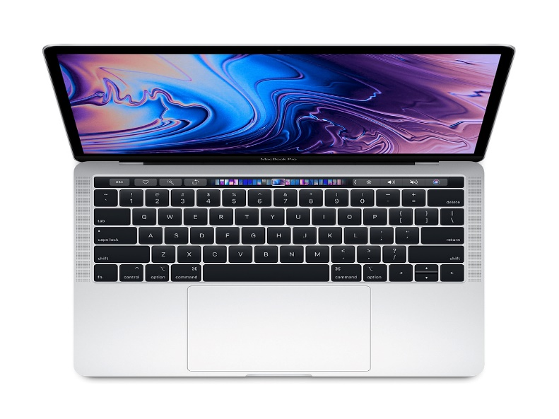 | MacBook Pro 13-inch with Touch Bar Silver: 2.4GHz quad‑core 8th generation Intel Core i5 processor, Turbo Boost up to 4.1GHz  Part Number Z0WS - $ 2,260.51 (*estimated Tax included)  -Processor: 2.4GHz quad-core 8th-generation Intel Core i5  -Memory: 16GB 2133MHz LPDDR3 memory  -Hard Drive: 256GB SSD storage  -Optical Drive: None  - -Four Thunderbolt 3 ports  -Force Touch Trackpad  -Four Thunderbolt 3 ports  -Touch Bar and Touch ID  -Backlit Keyboard - US English  AppleCare+ for 13-inch MacBook Pro Part Number S6202LL/A  Dimensions: Height: 0.95 inch, Width: 12.78 inches, Depth: 8.94 inches, Weight: 3 pounds
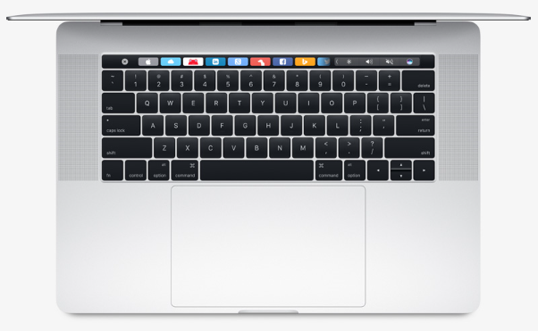 | MacBook Pro 16-inch: 2.6GHz 8-core Intel Core i9 processor, Turbo Boost up to 5.0GHz Part Number: Z0Y1 $3,372.71 (*estimated tax included)  -2.4GHz 8-core Intel Core i9, Turbo Boost up to 5.0GHz  -AMD Radeon Pro 5300M with 4GB of GDDR6 memory  -32GB 2666MHz DDR4 memory  -512GB SSD storage  -Retina display with True Tone  -(065-C87W) - Four Thunderbolt 3 ports  -Touch Bar and Touch ID  -Backlit Keyboard - US English  AppleCare+ for 16-inch MacBook Pro Part Number S6127LL//A  Dimensions: Height: 0.64 inch, Width: 14.09 inches, Depth: 9.68 inches, Weight: 4.3 pounds
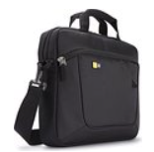 | Carrying Case for Macs: Case Logic AUA-314 $18.77  (*tax included)
Docking Option for Macs: | - Monitor: Dell UltraSharp U2415 24-inch Wide Full HD Monitor with 16:10 aspect ratio [$241.21] Product details  - Dell USB-C Mobile Adapter DA300- USB-C to HDMI/VGA/Ethernet/USB Dell Part#: 470-ACWN 49.99 Product Details  - Magic Keyboard with Numeric Keypad - US English - Silver  (MQ052LL/A) Product Details  - Magic Mouse 2 - Silver [Add 79.00 USD] Product Details
 | Apple USB SuperDrive Product Number : MD564LL/A $86.11 (*tax included)
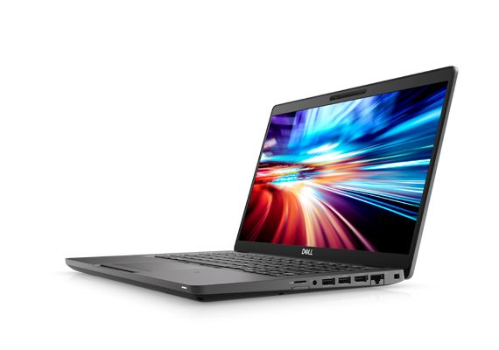 | Dell Latitude 14-inch 5400 Ultrabook™ --$1,953.99 (*tax included)  Processor: Intel Core i7-8665U (4 Core, 8MB Cache, 1.9GHz)  Memory: 32GB (2x16GB) 2133MHz DDR4  Hard Drive: M.2 512GB PCIe NVMe Class 40 SSD  Display: 14" FHD (1920 x 1080) Anti-Glare, Camera & Mic, WLAN/WWAN Capable, touch  Wireless: Intel® Dual-Band Wireless-AC 9560 Wi-Fi + BT 4.2 Wireless Card (2x2)  Carrying Case: Dell Professional Briefcase 14  Warranty: 5 Years ProSupport Plus NBD Onsite  Adapter: Dell Adapter - USB-C to HDMI/VGA/Ethernet/USB 3.0  Dimensions: Height: 0.72” | Width: 13.03” | Depth: 8.7” | Weight: 3.01 lbs.
Docking Option for Dell Latitude: | -- Dell Docking Station (Latitude Only): Dell Thunderbolt™ Dock WDTB19 - 180W [$218.93] Product details  - Monitor: Dell UltraSharp U2415 24-inch Wide Full HD Monitor [$240.19] Product details  - Display Cable: Mini DP to HDMI Cable [$8.69] Product details  - Keyboard (Dell/PC): Dell KB522 Wired Business Multimedia Keyboard [$16.41] Product details  - Mouse (Dell/PC): Dell USB Optical Mouse - MS116 [$12.03] Product details
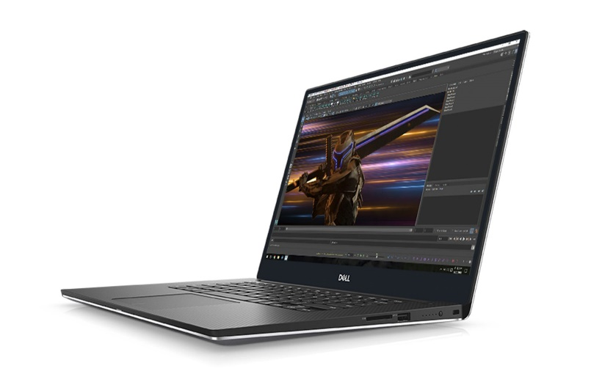 | Dell Precision 5540 Mobile Workstation -- $2,714.48 (*tax included)  Processor: Intel® Core i7-9850H (6 Core 2.60GHz, 4.6GHz Turbo, 12MB 45W)  Memory: 32GB (2x16G) 2666MHz DDR4 Non-ECC SDRAM  Hard Drive: 512GB M.2 PCIe Solid State Drive Class 40  Display: 15.6" UltraSharp UHD IGZO(3840x2160) Touch Wide View LED-backlit with Premium Panel Guarantee with 2X2 Antenna  Graphics: Nvidia Quadro T2000 w/ 4GB GDDR5  Wireless: Intel WiFi Link 8265 2x2 802.11ac+BT 4.2  Warranty: Dell 5 Years ProSupport Plus NBD Onsite  Adapter: Dell Adapter - USB-C to HDMI/VGA/Ethernet/USB 3.0  Carrying Case: Targus Meridian II Topload  Dimensions: Height: 0.44” | Width: 14.05” | Depth: 9.26” | Weight: 3.93 lbs.
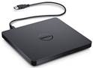 | Dell External USB Slim DVD+/-RW Optical Drive Dell Part# : DW775 $39.41 (*tax included)
Docking Option for Dell Precision Mobile Workstation: | -- Dell Docking Station (Latitude Only& Precision Only): Dell Thunderbolt™ Dock WDTB19 - 180W [$218.93] Product details  - Monitor: Dell UltraSharp U2415 24-inch Wide Full HD Monitor [$240.19] Product details  - Display Cable: Mini DP to HDMI Cable [$8.69] Product details  - Keyboard (Dell/PC): Dell KB522 Wired Business Multimedia Keyboard [$16.41] Product details  - Mouse (Dell/PC): Dell USB Optical Mouse - MS116 [$12.03] Product details
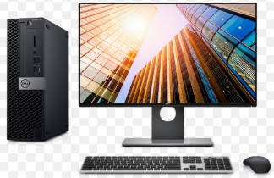 | Dell OptiPlex 7070 SFF i7 Full (CPU with 24-inch Monitor) $1,644.62 (*tax included)  Processor: Intel Core™ i7-9700 (8 Cores/12MB/12T/up to 4.6GHz/65W)  Memory: 32GB 4X8GB DDR4 2666MHz UDIM  Hard Drive: M.2 512GB PCIe NVMe Class 40 SSD  Video Card: AMD Radeon™ RX 550, 4GB, LP (DP/mDP/mDP)  Monitor: Dell UltraSharp U2415 24-inch Wide Full HD with 16:10 aspect ratio  CD/DVD: 8x DVD+/-RW 9.5mm Optical Disk Drive  Keyboard: Dell KB522 Business Multimedia Keyboard  Mouse: Dell MS116 Wired Mouse  Warranty: 5 Years ProSupport Plus NBD Onsite
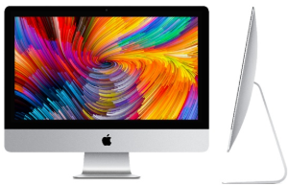 | 21.5-inch iMac: 3.2GHz 6-core 8th-generation Intel Core i7 Part Number: Z0VY  $2,198.66 (*tax included)  -Processor: (065-C7GP) - 3.2GHz 6-core 8th-generation Intel Core i7 processor, Turbo Boost up to 4.6GHz  -Memory: (065-C6YV) - 16GB 2666MHz DDR4 Onboard Memory  -Storage: (065-C700) - 256GB SSD storage  -Graphics: (065-C7GW) - Radeon Pro 560X with 4GB GDDR5 memory  -Mouse and Trackpad: (065-C6XC) - Apple Magic Mouse 2  -Apple Keyboard and Documentation: (065-C6XH) - Magic Keyboard - US English  AppleCare Protection 4-Year Plan for iMac Part Number S7735LL/A
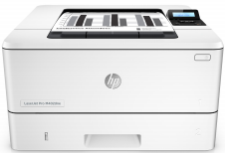 | Personal Printer: HP LaserJet Pro Printer M404dne Black & White $269.35 (*tax included)  Memory: 256MB DRAM  Connection: 1 Hi-Speed USB 2.0; 1 Host USB; 1 Gigabit Ethernet 10/100/1000T network  Duty Cycle: Up to 80,000 pages  HP 3y Next Business Day Exchange  Product Dimension W x D x H: 15 x 14.06 x 8.5 in
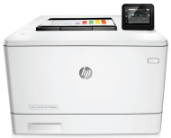 | Personal Printer: Color HP LaserJet Pro Printer M454dne $540.61 (*tax included)  Memory: 256MB DRAM  Connection: 1 Hi-Speed USB 2.0; 1 Host USB; 1 Gigabit Ethernet 10/100/1000T network  Duty Cycle: Up to 80,000 pages  Print Quality: Up to 600 x 600 dpi  HP 3y Next Business Day Exchange  Product Dimension (W x D x H): 16.2 x 18.5 x 11.6 in
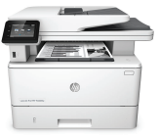 | Personal Printer: HP LaserJet Pro Printer M428fdn Black & White $508.85 (*tax included)  Functions: Print, copy, scan, fax, email  Memory: 512MB DRAM  Connection: 1 Hi-Speed USB 2.0; 1 Host USB; 1 Gigabit Ethernet 10/100/1000T network  Duty Cycle: Up to Duty Cycle: 80,000 pages month  Print Quality: Up to 600 x 600 dpi  HP 3y Next Business Day Exchange  Product Dimension: 16.54 x 15.35 x 12.72 in
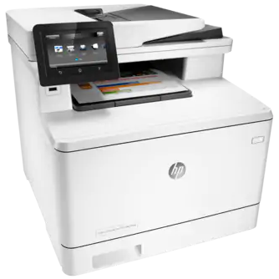 | Workgroup Printer: Color HP LaserJet Pro M479fdn MFP $796.34 (*tax included)  Functions: Print, copy, scan, fax, email  Memory: 1.25 GB (Printer), 500 MB (Scanner)  Print Quality: Up to 600 x 600 dpi  Connection: 1 Hi-Speed USB 2.0; 1 Host USB; 1 Gigabit Ethernet 10/100/1000T network  Duty Cycle: Up to 50,000 pages/month  Scanner\Fax\Copier Up to 600 dpi  Scan to email; scan to folder; scan to USB drive  HP 3y Next Business Day  Product Dimension: 16.4 x 18.6 x 15.7 in
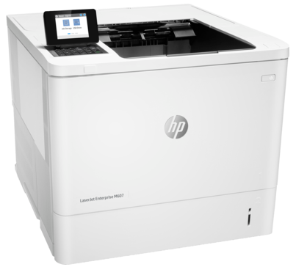 | Workgroup Printer: HP LaserJet Enterprise M607dn Black & White  $ 1,118.01 (*tax included)  Memory: 512MB  Print Quality: Up to 1200 x 1200 dpi  Connection: 1 Hi-Speed USB 2.0; 1 Host USB; 1 Gigabit Ethernet 10/100/1000T network  Duty Cycle: Up to 250,000 pages month  HP 3y Next Business Day  Product Dimension: 16.54 x 15.35 x 12.72 in
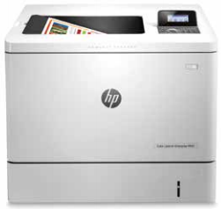 | Workgroup Printer: HP Color LaserJet Enterprise M553dn $892.35 (*tax included)  Memory: 1GB  Print Quality: Up to 1200 x 1200 dpi  Connection: 1 Hi-Speed USB 2.0; 1 Host USB; 1 Gigabit Ethernet 10/100/1000T network  Duty Cycle: Up to 80,000 pages month  HP 3y Next Business Day  Product Dimension: 18 x 18.9 x 15.7 in
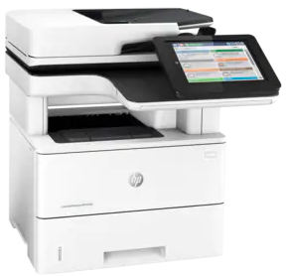 | Workgroup Printer: Multifunction  HP LaserJet Enterprise MFP M528dn Black & White $ 2,334.61 (*tax included)  Functions: Print, copy, scan, fax, email  Memory: 1.25 GB (Printer), 500 MB (Scanner)  Print Quality: Up to 1200 x 1200 dpi  Connection: 1 Hi-Speed USB 2.0; 1 Host USB; 1 Gigabit Ethernet 10/100/1000T network  Duty Cycle: Up to 150,000 pages/month  Scanner\Fax\Copier Up to 600 dpi  HP 3y Next Business Day  Product Dimension: 18.98 x 19.52 x 19.55 in
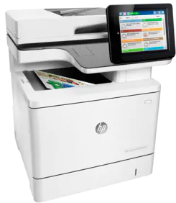 | Workgroup Printer: Multifunction  HP Color LaserJet Enterprise MFP M577dn  $ 3,321.96 (*tax included)  Functions: Print, copy, scan, fax, email  Memory: 1.25 GB (Printer), 500 MB (Scanner)  Print Quality: Up to 1200 x 1200 dpi  Connection: 1 Hi-Speed USB 2.0; 1 Host USB; 1 Gigabit Ethernet 10/100/1000T network  Duty Cycle: Up to 80,000 pages/month  Scanner\Fax\Copier Up to 600 dpi  HP 3y Next Business Day  Product Dimension: 18.98 x 19.84 x 22.95 in

*** Due to ongoing manufacturer changes as results of upgrades or industry resource availability, please note that all prices and device models are subject to change ***

